**1. Introduction**

**1.1 Project Overview**

The Online Book Store Responsive Website is a web-based application designed to provide users with an easy and convenient way to browse, search, and purchase books online. The website offers a wide range of books across various genres, and users can create accounts to manage their orders and preferences.

The primary objective of the Online Bookstore project is to create an intuitive and user-friendly web application that allows customers to explore, search, and purchase a wide range of books from various genres. The platform integrates key e-commerce functionalities such as user registration, secure login, dynamic product catalog, shopping cart management, secure payment processing, and order tracking.

**1.2 Objectives**

The primary objectives of this project are to:

- Develop a user-friendly and responsive web interface for the online book store.

- Enable users to browse, search, and view details about books.

- Allow users to add books to their shopping carts and proceed with secure checkout.

- Implement user authentication and authorization to ensure secure access.

- Create a robust database to store book information, user profiles, and order history.

**1.3 Scope**

The project scope includes the development of a fully functional online book store website with the following features:

- User registration and authentication.

- Book browsing and searching.

- Detailed book pages with descriptions, reviews, and ratings.

- Shopping cart functionality.

- Order management for users and administrators.

- Responsive design for optimal user experience on different devices.

**2. Technologies Used**

**2.1 HTML**

HTML (Hypertext Markup Language) is used to structure the content and layout of the web pages.

**2.2 PHP**

PHP (Hypertext Preprocessor) is used for server-side scripting to handle user requests, process data, and interact with the database.

**2.3 JavaScript**

JavaScript is used to add interactivity and dynamic behaviour to the website, enhancing user experience.

**2.4 CSS**

CSS (Cascading Style Sheets) is used for styling the web pages and ensuring a visually appealing design.

**2.5 MySQL**

MySQL is used as the relational database management system to store and manage book information, user profiles, and order history.

**2.6 Hardware Requirements:**

1)Computer: A computer with sufficient processing power and memory to handle web server and database operations.

2)Web Server: You'll need a web server software to host your PHP scripts and serve the HTML content. Common choices include Apache, Nginx, or Microsoft Internet Information Services (IIS).

3)Database Server: A MySQL database server is required to store and manage the employee data. This can be hosted locally or remotely.

**2.7 Software Requirements:**

Internet connection is required

**Browsers:**

* Microsoft edge,
* Google Chrome,
* Mozilla Firefox, so on

**3. System Architecture**

**3.1 Frontend**

The frontend of the website is built using HTML, CSS, and JavaScript. It provides the user interface for interacting with the online bookstore.

**3.2 Backend**

The backend is developed using PHP to handle user requests, process forms, and manage user authentication. It communicates with the database to retrieve and update data.

**3.3 Database**

MySQL is used to create a database that stores information about books, user profiles, orders, and other relevant data.

**4. Features**

**4.1 User Registration and Authentication**

Users can register for an account, providing their details, and log in securely to access their profiles and make purchases.

**4.2 Search Books**

Users can search for specific titles or authors.

**4.3 Book Details and Reviews**

Each book has a dedicated page displaying its details, including description, price, reviews, and ratings.

**4.4 Shopping Cart**

Users can add books to their shopping carts, review the cart contents, and proceed to checkout.

**4.5 Order Management**

Users and administrators can view and manage order history, including order status and details.

**4.6 Responsive Design**

The website is responsive, adapting to different screen sizes and devices for a seamless user experience.

**5. Implementation**

**5.1 Frontend Development**

The frontend is developed using HTML, CSS, and JavaScript to create visually appealing and interactive web pages.

**5.2 Backend Development**

PHP is used to implement server-side logic, handle user requests, and interact with the database.

**5.3 Database Design**

The MySQL database is designed to store information about books, users, orders, and reviews, with appropriate relationships and indexes.

**6. Challenges**

- Implementing secure user authentication and authorization.

- Designing a user-friendly and intuitive shopping cart system.

- Ensuring data consistency and integrity in the database.

- Achieving a seamless and responsive design across various devices.

**7. Future Enhancements**

- Integration of third-party payment gateways for secure online transactions.

- Implementation of a recommendation system based on user preferences and browsing history.

- Social media integration for sharing book recommendations and reviews.

- Enhancement of the administrator dashboard for better order management.

**9.Results:**



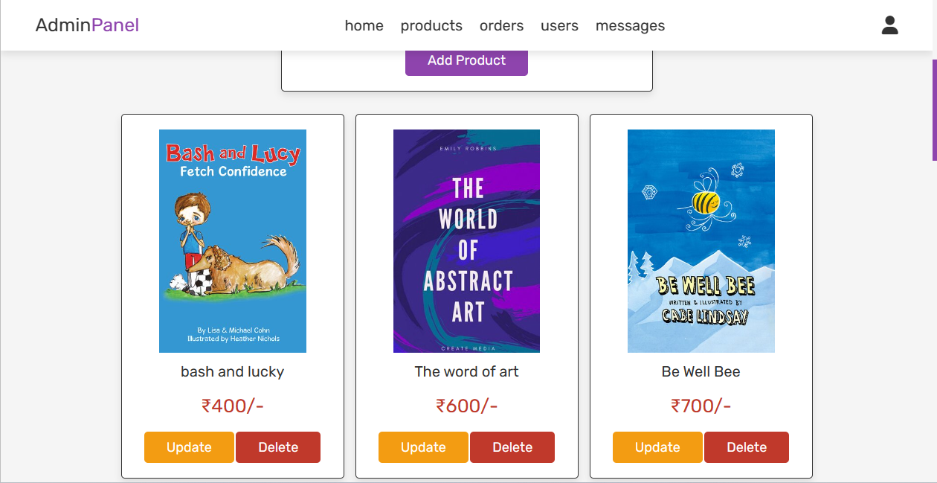

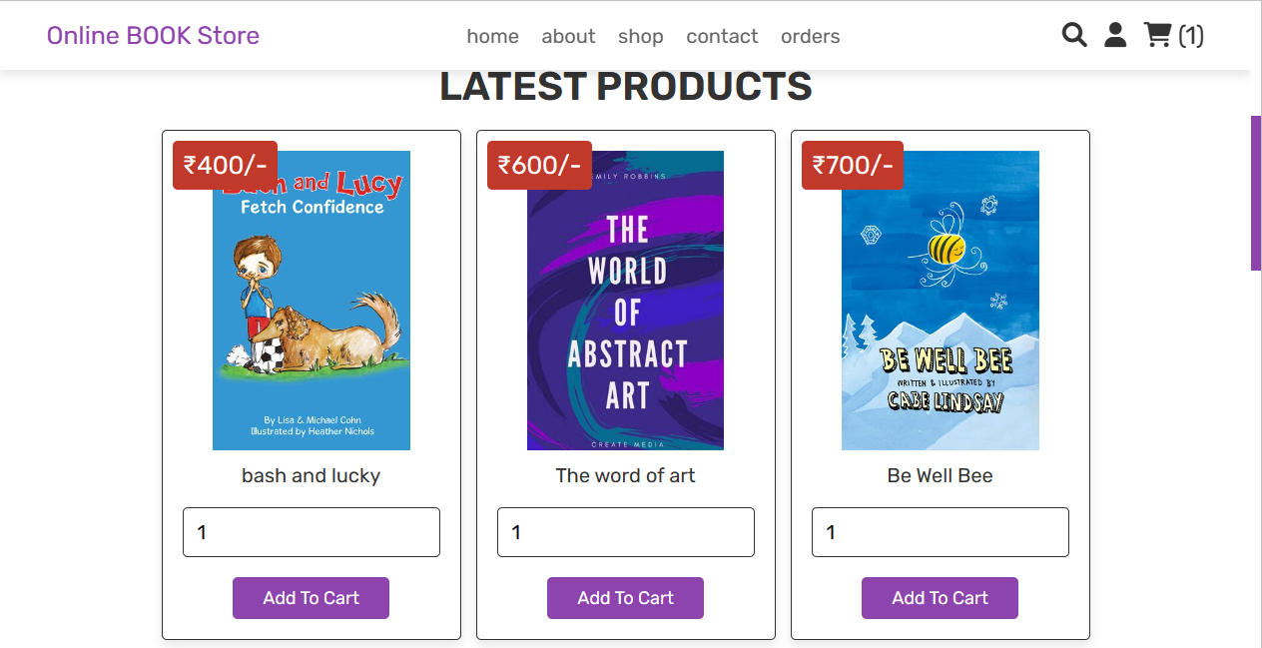



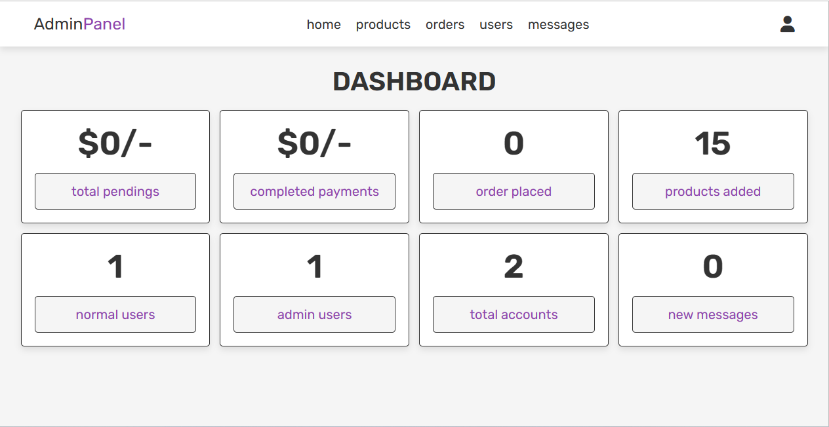





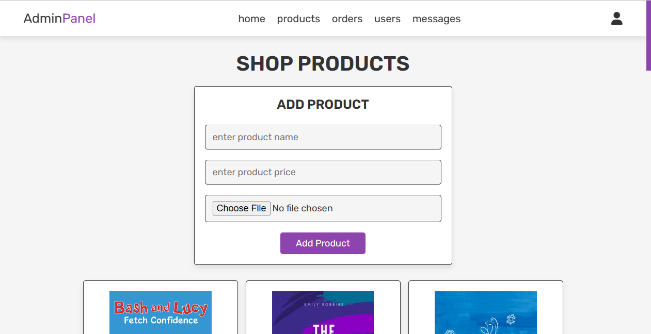

**9. Conclusion**

The Online Book Store Responsive Website project successfully develops an interactive and user-friendly platform for buying books online. By leveraging HTML, PHP, JavaScript, CSS, and MySQL, the project achieves its objectives of providing a seamless browsing experience, secure user authentication, and efficient order management. The Online Bookstore project emphasizes responsive web design to ensure seamless functionality across a range of devices, including desktops, tablets, and smartphones. The project aims to provide an engaging and visually appealing user interface, enhancing user experience and encouraging repeated visits.

**10.References**

* www.w3schools.com/html/
* www.w3schools.com/css/
* developer.mozilla.org/en-US/docs/Web/JavaScript
* www.w3schools.com/php/
* phptherightway.com