**MANGODB**

MongoDB is a document database with the scalability and flexibility that you want with the querying and indexing that you need. It has been built on a scale-out architecture that has become popular with developers of all kinds for developing scalable applications with evolving data schemas. As a document database, MongoDB makes it easy for developers to store structured or unstructured data.

* **Structured Data:** The information is typically organized in a specific format, often using tables with rows and columns. This makes it easier to search, filter, and analyze the data
* **Database Management System (DBMS):** This is the software that acts like the filing cabinet manager. It allows you to store, retrieve, update, and manage all the data within the database.
* **Data Types:** Databases can hold various kinds of information, including text, numbers, images, videos, and more



Fig: A SIMPLIFIED FIGURE OF DATABASE

* The picture above of the medical shop represents an organized system for storage.
* "It takes time to store, but once it is arranged, it is ready to use easily.
* What if we don’t have database!!



* Every tablet shown in the picture is dumped in one place.
* "If we ask for a particular tablet, we have to wait a day because it's unorganized."
* SQL VS NOSQL

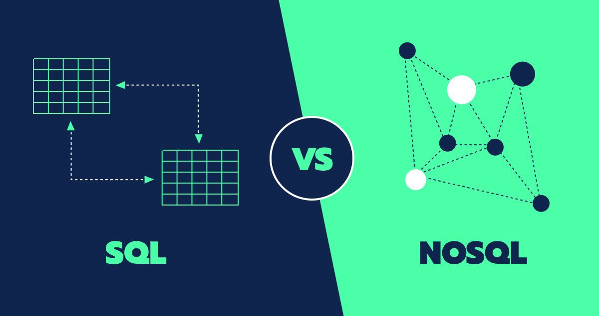

* SQL (Structured Query Language) Databases:

Structure: SQL databases are table-based. They store data in rows and columns, similar to a

spreadsheet.

Schema: They use a fixed schema, meaning you must define the structure of your data (like

columns and data types) before you can store anything.

Queries: They use SQL to interact with the database, which is a standardized language for

managing and manipulating data.

Examples: Popular SQL databases include MySQL, PostgreSQL, Oracle, and SQL Server.

Best for: They are great for applications that require complex queries and transactions, such as

financial systems and enterprise applications.

* NoSOL (Not Only SOL) Databases:

Structure: NoSQL databases are more flexible and can store data in various formats like

documents, key-value pairs, graphs, or wide-columns.

Schema: They use a dynamic schema, allowing you to store data without defining the structure

beforehand. You can change the structure of your data without downtime.

Queries: They use different query languages depending on the database type. For example,

MongoDB uses a JSON-like query language.

Examples: Popular NoSQL databases include MongoDB (document-based), Redis (key-value),

Neo4j (graph), and Cassandra (wide-column).

Best for: They are ideal for applications that need to handle large volumes of unstructured data,

such as big data applications, real-time web apps, and content management systems.