Day - 1

What is JIRA?
JIRA is a project management and issue-tracking tool developed by Atlassian.
It is mainly used by software development, testing, and business teams to plan, track, manage, and complete work in an organized and transparent way.
Simple Definition
JIRA is a tool used to track work items like tasks, bugs, and user stories throughout their lifecycle.
Why JIRA is used
- JIRA helps teams to:
- Plan work (sprints, backlogs)
- Track bugs and issues
- Monitor progress in real time
- Collaborate efficiently
- Follow Agile methodologies like Scrum and Kanban
What can you track in JIRA?
- In JIRA, work is tracked as Issues, such as:
- Bug – a defect in the application
- Task – a general piece of work
- Story – a user requirement
- Epic – a large feature containing multiple stories
Who uses JIRA?
- Developers
- Automation & Manual Test Engineers
- Scrum Masters
- Product Owners
- Project Managers
- IT Support Teams
Real-World Example
A tester finds a login bug → creates a Bug issue in JIRA → developer fixes it → tester verifies → issue marked Done.
Key Point for Interviews
JIRA is a tool, not a methodology.
Agile is the methodology; JIRA helps teams implement Agile.
JIRA Products (Fundamentals)
JIRA provides three core products, each designed for a specific type of work.
1. Jira Software
- Used for software development
- Supports Agile methodologies (Scrum & Kanban)
- Tracks stories, tasks, bugs, and epics
- Used by developers, testers, Scrum Masters
2. Jira Service Management (JSM)
- Used for IT service and support
- Manages incidents, service requests, problems, and changes
- Supports SLA tracking
- Used by IT and helpdesk teams
3. Jira Work Management
- Used for business and non-technical teams
- Tracks general tasks and workflows
- Used by HR, Marketing, Finance, Operations teams
One-Line Summary (Exam Ready)
Jira Software is for development, Jira Service Management is for IT support, and Jira Work Management is for business teams.
Agile Basics (Fundamentals)
What is Agile?
Agile is a software development approach that focuses on building software in small, incremental steps with continuous feedback and improvement.
Simple definition:
Agile means delivering working software frequently and adapting quickly to change.
Why Agile is Used
- Agile helps teams to:
- Deliver software faster
- Adapt to changing requirements
- Improve collaboration
- Get early customer feedback
- Reduce project risk
Agile Manifesto (Core Values)
- Agile is based on 4 core values:
- Individuals and interactions over processes and tools
- Working software over comprehensive documentation
- Customer collaboration over contract negotiation
- Responding to change over following a plan
Agile Principles (High Level)
- Agile promotes:
- Continuous delivery
- Frequent feedback
- Sustainable development
- Technical excellence
- Self-organizing teams
Agile vs Waterfall (Basic Comparison)
Waterfall | Agile
Linear process | Iterative process
Fixed requirements | Flexible requirements
Late testing | Continuous testing
Late delivery | Early & frequent delivery

Agile Frameworks
Agile is implemented using frameworks. The two most common are:
1. Scrum
Work is divided into Sprints (1–2 weeks)
Defined roles, events, and artifacts
Best for planned, iterative development

2. Kanban
Continuous workflow
Visual board (To Do → In Progress → Done)
No fixed sprints
Best for ongoing work and support
Key Agile Terms
Sprint: Fixed time period for work
Backlog: List of all work items
Increment: Working product output
WIP: Work in Progress limit
Interview One-Liner ⭐
Agile is an iterative development approach that delivers working software frequently and adapts to change.

JIRA account creation
How to use JIRA?
Let’s see how to use JIRA, from the very beginning(creating an Atlassian account).
Step 1: Creating an Atlassian Account
1. Go to the signup page of Atlassian enter the required user credentials asked on the site and then click on the SignUp button.
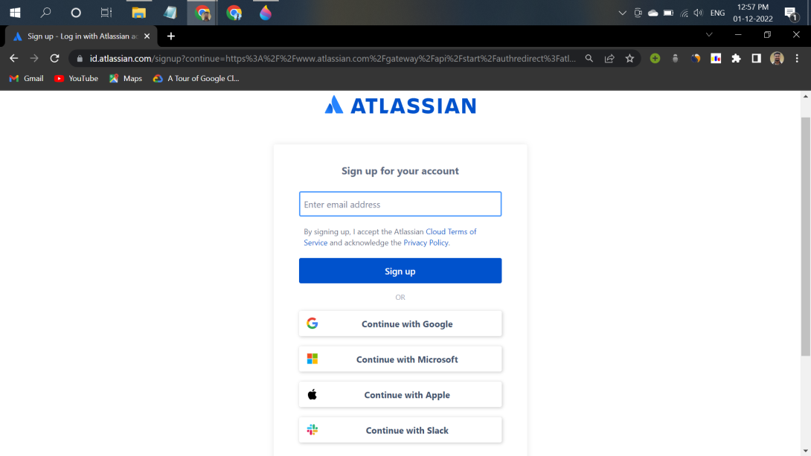
Signup Page
2. To complete the setup and login, click the verification link in the email box.
3. Set up your Atlassian account.
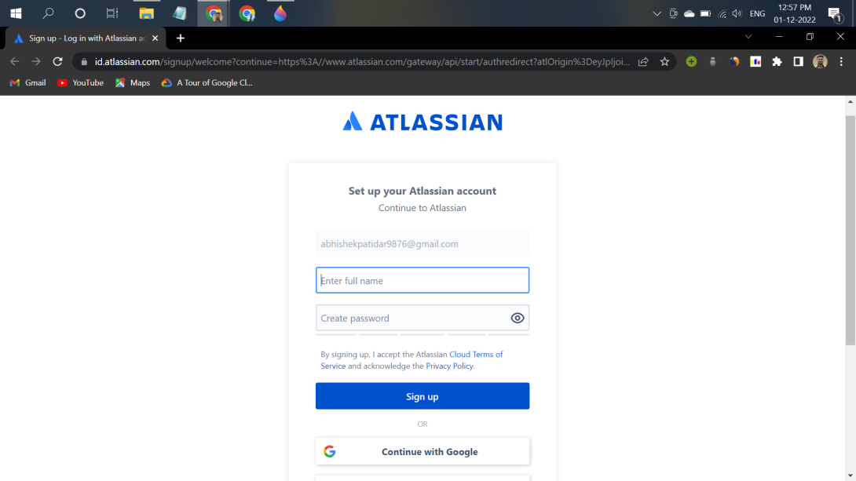
Page after clicking verify in the mail
4. Click on signup after filling details. The account has been created. The user is automatically redirected to the home page.
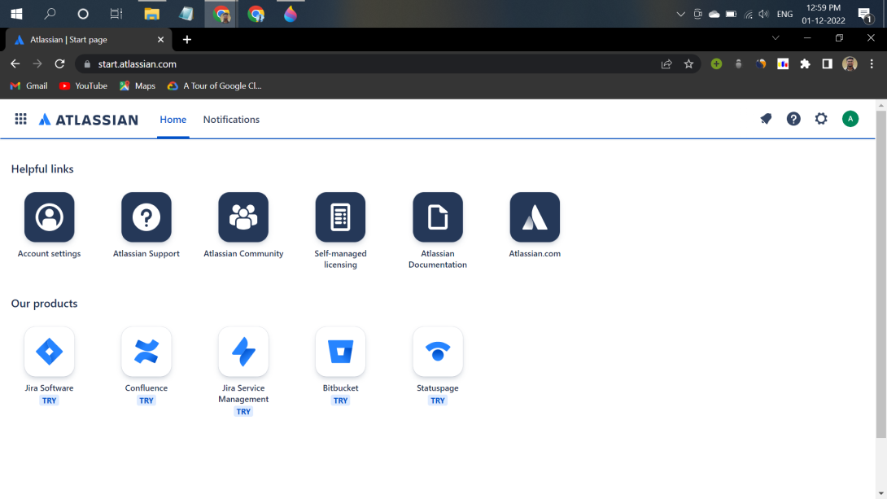

Home page
Step 2: Creating a new Project
1. Log in to your Atlassian account.
2. On the home page click on the Jira software and fill required details.
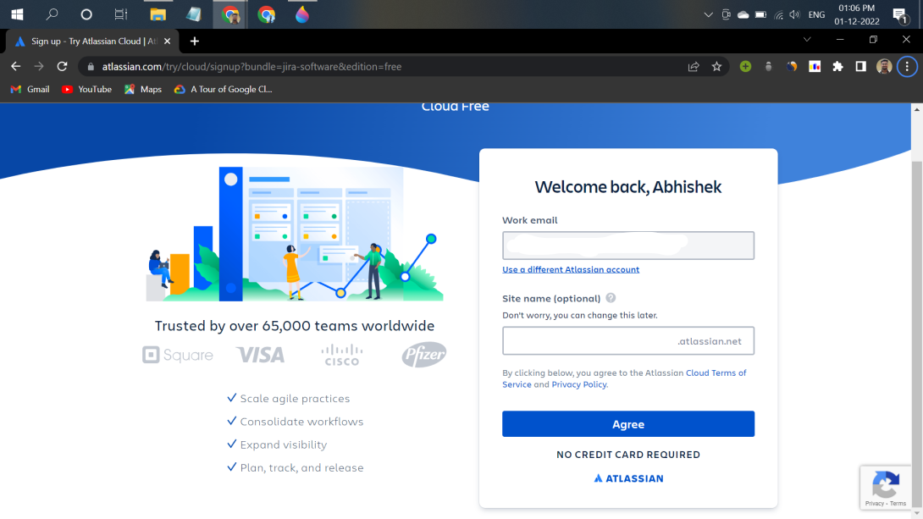
Jira Software
3. Answer some basic questions asked there to set up JIRA personally for your team.
4. Select your project name and template framework like Scrum or Kanban, etc. for your project.
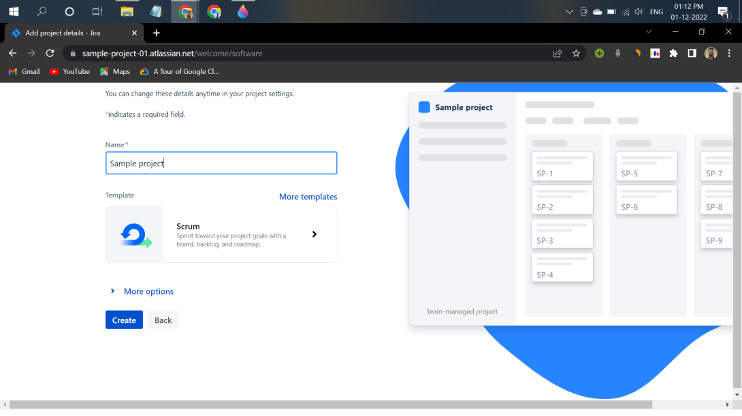
Project Details
5. After completing the above steps, the following screen will be displayed:
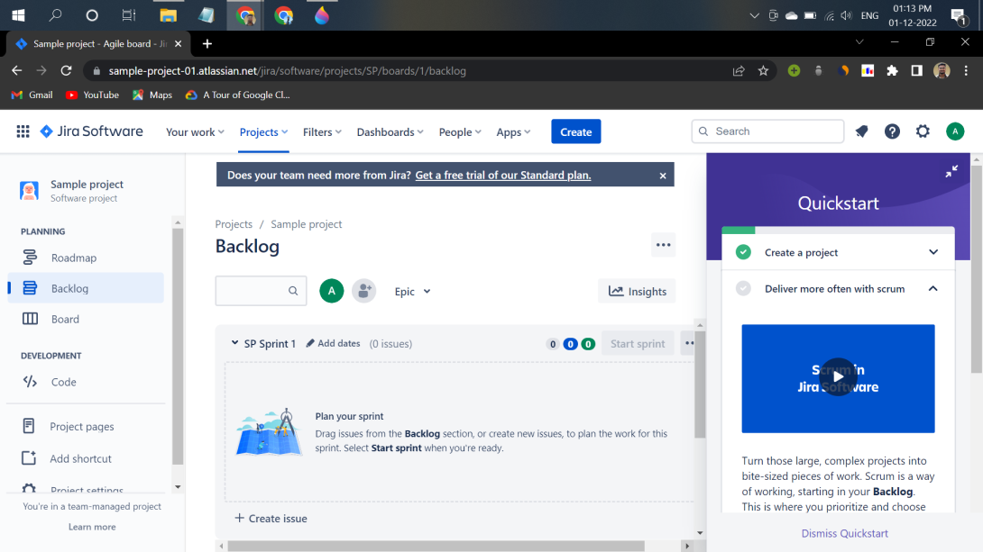

Day-1 focused on JIRA fundamentals, product understanding, Agile basics, and successful account setup.

