MEDICINAL PLANT IDENTIFICATION USING YOLOV8

ABSTRACT

—In preserving the physical and psychological state of persons, ayurvedic medicines have an important role. The research aims to identify indigenous ayurvedic medicinal plant species using deep learning techniques. The social relevance of the proposal is so high as it would solve the problems of a wide range of stakeholders like physicians, pharmacy, government, and public. The identification of rare plant species may lead to a significant impact on the research associated with medical and other related areas. Another application can be the identification of plant species in forest and remote areas, where access to humans is limited. In such cases, the image of a particular plant species may be captured using drones and further analyzed. Currently, a lot of research work has been going on in the area of plant species identification using machine learning algorithms. The performance of Convolutional Neural Network (CNN), and pretrained models VGG16, and VGG19 has been compared for leaf identification problem. The dataset proposed in this research work contains indigenous medicinal plants of Kerala. The dataset consists of leaf images of 64 medicinal plants. CNN obtained a classification accuracy of 95.79%. VGG16 and VGG19 achieve an acc

TABLE OF CONTENTS

CHAPTER | TITLE | PAGE NO
 | ABSTRACT
 | INTRODUCTION
 | - General Introduction
 | - Project Objectives
 | - Problem Statement
 | SYSTEM PROPOSAL
 | - Existing System
 | - Disadvantages
 | - Proposed System
 | 2.2.1 Advantages
 | - Literature Survey
 | SYSTEM DIAGRAMS
 | - Architecture Diagram
 | - Flow Diagram
 | - UML Diagrams
 | IMPLEMENTATION
 | - Modules
 | - Modules Description
 | SYSTEM REQUIREMENTS
 | - Hardware Requirements
 | - Software Requirements
 | - Software Description
 | - Testing of Products
 | CONCLUSION AND FUTURE ENHANCEMENT
 | - Conclusion
 | - Future Enhancement
 | SAMPLE CODING AND SAMPLE SCREENSHOT
 | REFERENCES
- INTRODUCTION
  - General Introduction
Ayurveda is an ancient medical science that works hand in hand with the medicinal plants. There is a huge problem that most people cannot recognize these medicinal plants and thus are not able to take advantage of herbal power to cure diseases. Experts are needed to recognize ayurvedic medicines and sometimes they’re also in dilemma about the species of plants. There are various advancements in technology. Deep Learning and Machine Learning helps machines to do the tasks which humans do but with much ease. There are several Machine Learning applications available that recognize humans, objects, trees, animals, etc. But the necessity for a recognizer is increasing in the field of Ayurveda. Because the experts are very less and the use is increasing day by day. Thus we propose a system that recognizes ayurvedic plants just by a single image of its leaf. This can have a large impact on laymen in day to day use, within the field of education and also among researchers. Also, it will unite everyone to take this field of Ayurveda ahead
Leaves being the most sensitive part of Medicinal Plant s show disease symptoms at the earliest. The crops need to be monitored against diseases from the very first stage of their life-cycle to the time they are ready to be harvested. Initially, the method used to monitor the Medicinal Plant s from diseases was the traditional naked eye observation that is a time-consuming technique which requires experts to manually monitor the crop fields. In the recent years, a number of techniques have been applied to develop automatic and semi-automatic Medicinal Plant disease detection systems and automatic detection of the diseases by just seeing the symptoms on the Medicinal Plant leaves makes it easier as well as cheaper. These systems have so far resulted to be fast, inexpensive and more accurate than the traditional method of manual observation by farmers In most of the cases disease symptoms are seen on the leaves, stem and fruit. The Medicinal Plant leaf for the detection of disease is considered which shows the disease symptoms. There are many cases where farmers do not have a fully compact knowledge about the crops and the disease that can get affected to the crops. This paper can be effectively used by farmers thereby increasing the yield rather than visiting the expert and getting their advice. The main objective is not only to detect the disease using image processing technologies. It also directs the user directly to an e-commerce website where the user can purchase the medicine for the detected disease by comparing the rates and use appropriately according to the directions given. A feature-based approach is proposed here which tries to overcome the limitations of previous work in terms of accuracy and portability and the essence of the research lies in provision of high accuracy and portability to mobile devices. The proposed approach is a prototype system which is based on Medicinal Plant Village database having 38 classes. The system is able to identify the leaf as healthy and diseased and then categorize it into one of the diseases, present in the database. In order to identify additional symptoms or disease, such cases need to be added in the database and retraining the system will enable to identify those disease categories as well.

  - Project Objectives
- To apply and implement the new algorithm to monitor the growth of the crop and detect the diseased part in the Medicinal Plant .
- To incorporate the global optimization strategy for enhancing the optimal solution.
- To modify the existing solution more efficiently to solve this problem is more genuine way.

  - Problem Statement
The main purpose is detect the diseased part of the Medicinal Plant. Thus leaf has been one of the most important features while studying Plants property. Leaf classification is believed to be the most important step in studying plant diversification. An efficient plant recognition system will help the medical field as well as Botanic researches and Ayurvedic studies. This research proposes an efficient method of classification of Ayurveda plants. This solution will fill the gap between the knowledge possessed by the Ayurvedic practitioner and other people. Plant classification is considered a challenging problem because of the variety and the similarity of plants in nature

- SYSTEM PROPOSAL
  - Existing System
In existing system propose a Long Short Term Memory neural network algorithm to accomplish the leaf disease classiﬁcation task. Medicinal Plant disease recognition is an interesting and practical topic. However, this problem has not been sufficiently explored due to the lack of systematically investigation and large-scale dataset. The most challenging step in constructing such a dataset is providing a reasonable structure from both the agriculture and image processing perspective.

    - Disadvantages
- It convert the images as a data frame and predict using data mining technique.
- LSTMs are prone to over fitting and it is difficult to apply the dropout algorithm to curb this issue.
- Dropout is a regularization method where input and recurrent connections to LSTM units are probabilistically excluded from activation and weight updates while training a network.

  - Proposed System
The proposed model is introduced to overcome all the disadvantages that arise in the existing system. This system will increase the accuracy of the neural network results by classifying the leaf disease digital image dataset using Deep learning algorithm. It enhances the performance of the overall classification results. Predict the leaf disease image is to find the accuracy more reliable. basic CNN, AlexNet, and GoogLeNet is compared, concerning the accuracy and elapsed time. Each model has its layers of convolution and computational complexity. GoogLeNet attains a better accuracy rate compared to basic CNN and Alexnet, which are 100%. But, GoogLeNet has the longest processing time because of the number of layers and deeper learning process. GoogLeNet can be utilized for when there is no issue with longer processing time.

    - Advantages
- DENSENET121 is improves the screening accuracy using digital images.
- Less time duration to identifying disease from the leaf images.
- Large area coverage: Remote sensing allows coverage of very large areas which enables regional surveys on a variety of themes and identification of extremely large features.

  - LITERATURE SURVEY
Title: Medicinal Plant Disease Prediction using Machine Learning Algorithms
Year: 2018
Author: G. Prem Rishi Kranth, M. Hema Lalitha, Laharika Basava and Anjali Mathur
Methodology
In the above information about prediction of Medicinal Plant disease a dataset is taken with 11 attributes and 310 rows. With the data different techniques like decision tree, Naive Bayes, Neural network and different plots like box plot, bar plot are performed. By performing the techniques it is concluded that, Here some statistical tests are performed to find out possible output predictions with the help of some inbuilt dataset and compared with the techniques with the help of the data set. While techniques are compared, other techniques may be better or poor. But the accuracy differs from each sample taken from dataset.
Advantage
The automated method for the detection of disease affected on leaf is one of the important research areas as it provides many advantages in saving the fruit. Disadvantage
when using DL to identify fry size, not only are there many kinds of fish but their body shape and posture of each growth stage are also quite different, which necessitates high requirements for data collection and DL training

Title: Leaf disease Detection and Climatic Parameter Monitoring of Medicinal Plant s Using IoT
Year: 2015
Author: Dr. G. H. Agrawal, Prof. S. G. Galande, Shalaka R. Londhe
Methodology
We have actualized a framework which indicates usage for Internet of Things utilized for observing general climatic parameters conditions by method for minimal effort, effectively accessible detecting framework. The depiction about the incorporated system building design and the interconnecting components for solid estimation of parameters by savvy sensors and transmission of information through web is being displayed in straightforward dialect. By surveying past writing we came to realize that there is have to advise rancher about wellbeing state of his field specifically by means of web so all outcomes are straightforwardly sent to agriculturist through send letters charge in Matlab.
Advantage
Controlling substantial zone of yields, and subsequently this framework naturally identify side effects of sickness when they show up on Medicinal Plant clears out
Disadvantage
They rely heavily on the internet and are unable to function effectively without it.

Title: The boosting approach to machine learning: An overview" in Nonlinear estimation and classification.
Year: 2014
Author: R.E.Scahpire
Methodology
Boosting is a general method for improving the accuracy of any given learning algorithm. Focusing primarily on the AdaBoost algorithm, this chapter overviews some of the recent work on boosting including analyses of AdaBoost’s training error and generalization error boosting’s connection to game theory and linear programming; the relationship between boosting and logistic regression extensions of AdaBoost for multiclass classification problems; methods of incorporating human knowledge into boosting; and experimental and applied work using boosting
Advantage
They have several advantages over parametric classifiers such as discriminate analysis. The advantage of this work is to compare the performance of all three neural networks on the basis of its accuracy, time taken to build model, and training data set size.
Disadvantage
The most common problem in the Field of automatic diagnostic is the diagnostics using fast and accurate algorithm which doesn’t require long time to run and give accurate and correct results.

Title: Support vector clustering
Year: 2012
Author: A. Ben-Hur, D. Horn, H. T. Siegelmann, V. Vapnik
Methodology
Data points are mapped by means of a Gaussian kernel to a high dimensional feature space, where we search for the minimal enclosing sphere. This sphere, when mapped back to data space, can separate into several components, each enclosing a separate cluster of points. We present a simple algorithm for identifying these clusters. The width of the Gaussian kernel controls the scale at which the data is probed while the soft margin constant helps coping with outliers and overlapping clusters. The structure of a dataset is explored by varying the two parameters, maintaining a minimal number of support vectors to assure smooth cluster boundaries.
Advantage
A unique advantage of our algorithm is that it can generate cluster boundaries of arbitrary shape, whereas other algorithms that use a geometric representation are most often limited to hyper-ellipsoids
Disadvantage
We do not compute the whole adjacency matrix, but only adjacencies with support vectors.

Title: Land cover change assessment using decision trees support vector machines and maximum likelihood classification algorithms
Year: 2017
Author: J. R. Otukei, T. Blaschke
Methodology
Land cover change assessment is one of the main applications of remote sensed data. A number of pixel based classification algorithms have been developed over the past years for the analysis of remotely sensed data. The most notable include the maximum likelihood classifier (MLC), support vector machines (SVMs) and the decision trees (DTs). The DTs in particular offer advantages not provided by other approaches. They are computationally fast and make no statistical assumptions regarding the distribution of data. The challenge to using DTs lies in the determination of the “best” tree structure and the decision boundaries.
Advantage
A unique advantage of our algorithm is that it can generate the classification process by SVM, DT.
Disadvantage
We don’t get the correct accuracy for the process.

Title: ImageNet Classification with Deep Convolutional Neural Networks
Year: 2013
Author: Alex Krizhevsky, Ilya Sutskever and Geoffrey E. Hinton
Methodology
Our results show that a large, deep convolutional neural network is capable of achieving record breaking results on a highly challenging dataset using purely supervised learning. It is notable that our network’s performance degrades if a single convolutional layer is removed. For example, removing any of the middle layers results in a loss of about 2% for the top-1 performance of the network. So the depth really is important for achieving our results. To simplify our experiments, we did not use any unsupervised pre-training even though we expect that it will help, especially if we obtain enough computational power to significantly increase the size of the network without obtaining a corresponding increase in the amount of labelled data. Thus far, our results have improved as we have made our network larger and trained it longer but we still have many orders of magnitude to go in order to match the infer temporal pathway of the human visual system. Ultimately we would like to use very large and deep convolutional nets on video sequences where the temporal structure provides very helpful information that is missing or far less obvious in static images. Advantage
- Remote sensing is a relatively cheap and constructive method reconstructing a base map in the absence of detailed land survey methods.
Disadvantage
- Sometimes large scale engineering maps cannot be prepared from satellite data which makes remote sensing data collection incomplete.

Title: iCassava 2019 Fine-Grained Visual Categorization Challenge
Year: 2019
Author: Ernest Mwebaze, Timnit Gebru, Andrea Frome, Solomon Nsumba, Jeremy Tusubira and Chris Omongo
Methodology
We presented a dataset of cassava Medicinal Plant s annotated with the types of disease inflicting the Medicinal Plant s, as well as an unlabeled set of cassava images taken by farmers. Our dataset and accompanying Kaggle challenge hope to encourage the computer vision community to work on problems that affect the very serious issue of food security. Fine-grained image classification can be used to help small-holder farmers monitor their Medicinal Plant s and increase yields. While the research community has made significant improvements in fine-grained image classification using large training data, as can be seen in our setting, many real world problems require the use of smaller datasets and semisupervised methods to leverage unlabeled images. Advantage
- Unsupervised learning solves the problem by learning the data and classifying it without any labels.
Disadvantage
- A loose definition of clustering could be “the process of organizing objects into groups whose members are similar in some way”.

- SYSTEM DIAGRAMS

  - ARCHITECTURE DIAGRAM

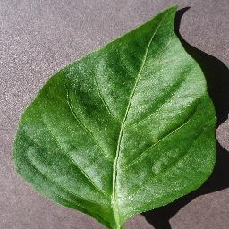
CLASSIFICATION
SELECT AND VIEW DATASET
DATASET
PREDICTION
PRE-PROCESSING

RESULT GENERATION
FEATURE SELECTION

  - FLOW DIAGRAM

View Data
Select Dataset
Start

Data Preprocessing
Visualization

Rescale
Result Generation
Accuracy

Feature Selection

classification
Densnet121

  - UML Diagram

USECASE DIAGRAM

USER
Prediction
Classification
Feature Selection
Pre-Processing
Image Dataset
Start

SYSTEM

ER DIAGRAM

DATA SELECTION & LOAD

Feature Selection
CLASSIFICATION

RESULT
GENERATION
Load image Dataset
Resizing
Splitting
Start

CLASS DIAGRAM

Analysis
Result Generation ()
DATASET
Select dataset ()
Import dataset ()
View dataset ()

DATA PREPROCESSING
Resize the images
Feature Selection
Splitting the training and testing dataset ()

Classification
Medicinal Plant leaf Disease Classification ()
Prediction ()

SEQUENCE DIAGRAM

Feature selection
Classification
Splitting
Prediction
Select
Select dataset

Load dataset
Start
Result Generation

ACTIVITY DIAGRAM

INPUT IMAGE DATA

PRE-PROCESSING

FEATURE SELECTION

TESTING DATASET
TRAINING DATASET

PLANT LEAF DISEASE CLASSIFCATION

- IMPLEMENTATIONS
  - Modules
- Data Selection and Loading
- Data Preprocessing
- Future Selection
- Classification
- Prediction
- Result Generation

  - Modules Description
DATA SELECTION AND LOADING
- The data selection is the process of selecting the data for MEDICINAL PLANT VILLAGE dataset.
- In this project, LEAF digital images are used to classify the disease.
- The dataset which contains the information about the Medicinal Plant leaf disease digital images.

DATA PREPROCESSING
- Image Data pre-processing is the process of getting rescale data from the dataset.
    - Resize image dataset
    - Getting data
- Resize image dataset: Rescale the leaf digital images size into 64*64.
- Getting data: That categorical data is defined as variables with a finite set of rescaled values. That most deep learning algorithms require array input and output variables.

SPLITTING DATASET INTO TRAIN AND TEST DATA
- Data splitting is the act of partitioning available data into two portions, usually for cross-validate purposes.
- One Portion of the data is used to develop a predictive model and the other to evaluate the model's performance.
- Separating image data into training and testing sets is an important part of evaluating image processing models.
- Typically, when you separate a data set into a training set and testing set, most of the image data is used for training, and a smaller portion of the data is used for testing.

CLASSIFICATION
DenseNet121 (Dense Convolutional Network) is an architecture that focuses on making the deep learning networks go even deeper, but at the same time making them more efficient to train, by using shorter connections between the layers. DenseNet121 is a convolutional neural network where each layer is connected to all other layers that are deeper in the network, that is, the first layer is connected to the 2nd, 3rd, 4th and so on, the second layer is connected to the 3rd, 4th, 5th and so on. This is done to enable maximum information flow between the layers of the network. To preserve the feed-forward nature, each layer obtains inputs from all the previous layers and passes on its own feature maps to all the layers which will come after it.
PREDICTION
- It’s a process of predicting the leaf disease from the dataset.
- This project will effectively predict the data from dataset by enhancing the performance of the overall prediction results.

RESULT GENERATION

The Final Result will get generated based on the overall classification and prediction. The performance of this proposed approach is evaluated using some measures like,
- Accuracy

- SYSTEM REQUIREMENTS
  - Hardware Requirement
- System : Pentium IV 2.4 GHz
- Hard Disk : 200 GB
- Mouse : Logitech.
- Keyboard : 110 keys enhanced
- Ram : 4GB
  - Software Requirement
- O/S : Windows 7.
- Language : Python
- Front End: Anaconda Navigator - Spyder

  - Software Description
Python
Python is one of those rare languages which can claim to be both simple and powerful. You will find yourself pleasantly surprised to see how easy it is to concentrate on the solution to the problem rather than the syntax and structure of the language you are programming in. The official introduction to Python is Python is an easy to learn, powerful programming language. It has efficient high-level data structures and a simple but effective approach to object-oriented programming. Python's elegant syntax and dynamic typing, together with its interpreted nature, make it an ideal language for scripting and rapid application development in many areas on most platforms. I will discuss most of these features in more detail in the next section.
Features of Python
Simple
Python is a simple and minimalistic language. Reading a good Python program feels almost like reading English, although very strict English! This pseudo-code nature of Python is one of its greatest strengths. It allows you to concentrate on the solution to the problem rather than the language itself.
Easy to Learn
As you will see, Python is extremely easy to get started with. Python has an extraordinarily simple syntax, as already mentioned.
Free and Open Source
Python is an example of a FLOSS (Free/Libré and Open Source Software). In simple terms, you can freely distribute copies of this software, read its source code, make changes to it, and use pieces of it in new free programs. FLOSS is based on the concept of a community which shares knowledge. This is one of the reasons why Python is so good - it has been created and is constantly improved by a community who just want to see a better Python.
High-level Language
When you write programs in Python, you never need to bother about the low-level details such as managing the memory used by your program, etc.
Portable
Due to its open-source nature, Python has been ported to (i.e. changed to make it work on) many platforms. All your Python programs can work on any of these platforms without requiring any changes at all if you are careful enough to avoid any system-dependent features.
You can use Python on GNU/Linux, Windows, FreeBSD, Macintosh, Solaris, OS/2, Amiga, AROS, AS/400, BeOS, OS/390, and # -*- coding: utf-8 -*-
z/OS, Palm OS, QNX, VMS, Psion, Acorn RISC OS, VxWorks, PlayStation, Sharp Zaurus, Windows CE and PocketPC!
You can even use a platform like Kivyto create games for your computer and for iPhone, iPad, and Android.
Interpreted
This requires a bit of explanation.
A program written in a compiled language like C or C++ is converted from the source language i.e. C or C++ into a language that is spoken by your computer (binary code i.e. 0s and 1s) using a compiler with various flags and options. When you run the program, the linker/loader software copies the program from hard disk to memory and starts running it.
Python, on the other hand, does not need compilation to binary. You just run the program directly from the source code. Internally, Python converts the source code into an intermediate form called byte codes and then translates this into the native language of your computer and then runs it. All this, actually, makes using Python much easier since you don't have to worry about compiling the program, making sure that the proper libraries are linked and loaded, etc. This also makes your Python programs much more portable, since you can just copy your Python program onto another computer and it just works!
Object Oriented
Python supports procedure-oriented programming as well as object-oriented programming. In procedure-oriented languages, the program is built around procedures or functions which are nothing but reusable pieces of programs. In object-oriented languages, the program is built around objects which combine data and functionality. Python has a very powerful but simplistic way of doing OOP, especially when compared to big languages like C++ or Java.
Extensible
If you need a critical piece of code to run very fast or want to have some piece of algorithm not to be open, you can code that part of your program in C or C++ and then use it from your Python program.
Embeddable
You can embed Python within your C/C++ programs to give scripting capabilities for your program's users.
Extensive Libraries
The Python Standard Library is huge indeed. It can help you do various things involving regular expressions, documentation generation, unit testing, threading, databases, web browsers, CGI, FTP, email, XML, XML-RPC, HTML, WAV files, cryptography, GUI (graphical user interfaces), and other system-dependent stuff. Remember, all this is always available wherever Python is installed. This is called the Batteries Included philosophy of Python.
Besides the standard library, there are various other high-quality libraries which you can find at the Python Package Index.
FEASIBILITY STUDY
The feasibility study is carried out to test whether the proposed system is worth being implemented. The proposed system will be selected if it is best enough in meeting the performance requirements.
The feasibility carried out mainly in three sections namely.
• Economic Feasibility
• Technical Feasibility
• Behavioural Feasibility
Economic Feasibility
Economic analysis is the most frequently used method for evaluating effectiveness of the proposed system. More commonly known as cost benefit analysis. This procedure determines the benefits and saving that are expected from the system of the proposed system. The hardware in system department if sufficient for system development.

Technical Feasibility
This study centre around the system’s department hardware, software and to what extend it can support the proposed system department is having the required hardware and software there is no question of increasing the cost of implementing the proposed system. The criteria, the proposed system is technically feasible and the proposed system can be developed with the existing facility.
Behavioural Feasibility
People are inherently resistant to change and need sufficient amount of training, which would result in lot of expenditure for the organization. The proposed system can generate reports with day-to-day information immediately at the user’s request, instead of getting a report, which doesn’t contain much detail.
  - Testing of Products
System testing is the stage of implementation, which aimed at ensuring that system works accurately and efficiently before the live operation commence. Testing is the process of executing a program with the intent of finding an error. A good test case is one that has a high probability of finding an error. A successful test is one that answers a yet undiscovered error.

Testing is vital to the success of the system. System testing makes a logical assumption that if all parts of the system are correct, the goal will be successfully achieved. . A series of tests are performed before the system is ready for the user acceptance testing. Any engineered product can be tested in one of the following ways. Knowing the specified function that a product has been designed to from, test can be conducted to demonstrate each function is fully operational. Knowing the internal working of a product, tests can be conducted to ensure that “al gears mesh”, that is the internal operation of the product performs according to the specification and all internal components have been adequately exercised.

UNIT TESTING:

Unit testing is the testing of each module and the integration of the overall system is done. Unit testing becomes verification efforts on the smallest unit of software design in the module. This is also known as ‘module testing’.
The modules of the system are tested separately. This testing is carried out during the programming itself. In this testing step, each model is found to be working satisfactorily as regard to the expected output from the module. There are some validation checks for the fields. For example, the validation check is done for verifying the data given by the user where both format and validity of the data entered is included. It is very easy to find error and debug the system.

INTEGRATION TESTING:

Data can be lost across an interface, one module can have an adverse effect on the other sub function, when combined, may not produce the desired major function. Integrated testing is systematic testing that can be done with sample data. The need for the integrated test is to find the overall system performance. There are two types of integration testing. They are:

i) Top-down integration testing. ii) Bottom-up integration testing.
TESTING TECHNIQUES/STRATEGIES:
WHITE BOX TESTING:

White Box testing is a test case design method that uses the control structure of the procedural design to drive cases. Using the white box testing methods, we
Derived test cases that guarantee that all independent paths within a module have been exercised at least once.

BLACK BOX TESTING:

- Black box testing is done to find incorrect or missing function

- Interface error

- Errors in external database access

- Performance errors.

- Initialization and termination errors

In ‘functional testing’, is performed to validate an application conforms to its specifications of correctly performs all its required functions. So this testing is also called ‘black box testing’. It tests the external behaviour of the system. Here the engineered product can be tested knowing the specified function that a product has been designed to perform, tests can be conducted to demonstrate that each function is fully operational.

SOFTWARE TESTING STRATEGIES

VALIDATION TESTING:

After the culmination of black box testing, software is completed assembly as a package, interfacing errors have been uncovered and corrected and final series of software validation tests begin validation testing can be defined as many,
But a single definition is that validation succeeds when the software functions in a manner that can be reasonably expected by the customer

USER ACCEPTANCE TESTING:
User acceptance of the system is the key factor for the success of the system. The system under consideration is tested for user acceptance by constantly keeping in touch with prospective system at the time of developing changes whenever required.

OUTPUT TESTING:

After performing the validation testing, the next step is output asking the user about the format required testing of the proposed system, since no system could be useful if it does not produce the required output in the specific format. The output displayed or generated by the system under consideration. Here the output format is considered in two ways. One is screen and the other is printed format. The output format on the screen is found to be correct as the format was designed in the system phase according to the user needs. For the hard copy also output comes out as the specified requirements by the user. Hence the output testing does not result in any connection in the system.

- CONCLUSION AND FUTURE ENHANCEMENT
  - Conclusion
In this study, the deep learning classifier is analyse the Medicinal Plant leaf disease images. The medicinal plant village data is taken as input data and applied into pre-processing method. In pre-processing method the images are resized and converted into array. Then it processed into feature selection method, in this method the dataset is split into training dataset and testing dataset. After that all the images are resized and convert into array. Finally the classification method is used to analysis the remote sensing scene from images. Deep learning algorithm of DENSENET121 is implemented and predict the result based on accuracy.

  - Future Enhancement
In feature, the implementation of work is enhance in web application or graphical user interface model. And it is easy to identify the diseased leaf images and provides the quick and better result by using this model.

- SAMPLE CODE

print("Medicinal Plant Identification using yolov8")
import numpy as np
import matplotlib.pyplot as plt
import os
import cv2
from sklearn.model_selection import train_test_split
from tensorflow.keras.models import Model
from tensorflow.keras import Input

from tensorflow.keras.layers import Dense, Dropout, Conv2D, BatchNormalization, GlobalAveragePooling2D
from tensorflow.keras.optimizers import Adam
from tensorflow.keras.applications import DenseNet121
from tensorflow.keras.utils import to_categorical
from numpy import argmax
from sklearn.metrics import confusion_matrix, classification_report
from mlxtend.plotting import plot_confusion_matrix

#==============================Input Data======================================
path = 'data/'

# categories
categories = ['Alpinia Galanga','Amaranthus Viridis','Artocarpus Heterophyllus','Azadirachta Indica' ,'Basella Alba','Brassica Juncea',]

# let's display some of the pictures
for category in categories:
fig, _ = plt.subplots(3,3)
fig.suptitle(category)
fig.patch.set_facecolor('xkcd:white')
for k, v in enumerate(os.listdir(path+category)[:9]):
img = plt.imread(path+category+'/'+v)
plt.subplot(3, 3, k+1)
plt.axis('off')
plt.imshow(img)
# cv2.imshow(' Image',img)
# cv2.waitKey(0)
# cv2.destroyAllWindows()
# plt.show()

shape0 = []
shape1 = []

for category in categories:
for files in os.listdir(path+category):
shape0.append(plt.imread(path+category+'/'+ files).shape[0])
shape1.append(plt.imread(path+category+'/'+ files).shape[1])
print(category, ' => height min : ', min(shape0), 'width min : ', min(shape1))
print(category, ' => height max : ', max(shape0), 'width max : ', max(shape1))
shape0 = []
shape1 = []

# initialize the data and labels
data = []
labels = []
imagePaths = []
HEIGHT = 65
WIDTH = 65
N_CHANNELS = 3

# grab the image paths and randomly shuffle them
for k, category in enumerate(categories):
for f in os.listdir(path+category):
imagePaths.append([path+category+'/'+f, k])

import random
random.shuffle(imagePaths)
print(imagePaths[:10])

# loop over the input images
for imagePath in imagePaths:
# load the image, resize the image to be HEIGHT * WIDTH pixels (ignoring aspect ratio) and store the image in the data list
image = cv2.imread(imagePath[0])
image = cv2.resize(image, (WIDTH, HEIGHT)) # .flatten()
data.append(image)

# extract the class label from the image path and update the
# labels list
label = imagePath[1]
labels.append(label)

# scale the raw pixel intensities to the range [0, 1]
data = np.array(data, dtype="float") / 255.0
labels = np.array(labels)

# Let's check everything is ok
fig, _ = plt.subplots(3,3)
fig.suptitle("Sample Input")
fig.patch.set_facecolor('xkcd:white')
for i in range(9):
plt.subplot(3,3, i+1)
plt.imshow(data[i])
plt.axis('off')
# cv2.imshow(' Image',data[1])
# cv2.waitKey(0)
# cv2.destroyAllWindows()
# # plt.title(categories[labels[i]])
# plt.show()

# partition the data into training and testing splits using 80% of
# the data for training and the remaining 20% for testing
(trainX, testX, trainY, testY) = train_test_split(data, labels, test_size=0.2, random_state=42)
# Preprocess class labels
trainY =to_categorical(trainY, 6)

print(trainX.shape)
print(testX.shape)
print(trainY.shape)
print(testY.shape)

#================================Classification================================
'''DENSENET121'''

def build_densenet():
densenet = DenseNet121(weights='imagenet', include_top=False)

input = Input(shape=(HEIGHT, WIDTH, N_CHANNELS))
x = Conv2D(3, (3, 3), padding='same')(input)

x = densenet(x)

x = GlobalAveragePooling2D()(x)
x = BatchNormalization()(x)
x = Dropout(0.5)(x)
x = Dense(256, activation='relu')(x)
x = BatchNormalization()(x)
x = Dropout(0.5)(x)

# multi output
output = Dense(6,activation = 'softmax', name='root')(x)

# model
model = Model(input,output)

model.compile(loss='categorical_crossentropy', optimizer="adam", metrics=['accuracy'])
model.summary()

return model

model = build_densenet()

model.fit(trainX, trainY, batch_size=32, epochs=10, verbose=1)
from tensorflow.keras.models import load_model, save_model

model.save("model.h5")

history=model.history.history
#Plotting the accuracy
train_loss = history['loss']
train_acc = history['accuracy']

# Performance graph
plt.figure()
plt.plot(train_loss, label='Loss')
plt.plot(train_acc, label='Accuracy')
plt.title('Performance Plot')
plt.legend()
plt.show()
# print("Accuracy of the Training CNN Algorithm is: 95.39")
print("Accuracy of the Testing CNN Algorithm is:",model.evaluate(trainX,trainY)[1]*100, "%")
#=============================Analytic Results=================================
pred = model.predict(testX)
predictions = argmax(pred, axis=1)
print('Classification Report')
cr=classification_report(testY, predictions,target_names=categories)
print(cr)
print('Confusion Matrix')
cm = confusion_matrix(testY, predictions)
print(cm)
#Confusion Matrix Plot
plt.figure()
plot_confusion_matrix(cm,figsize=(15,15), class_names = categories,
show_normed = True);

plt.title( "Model confusion matrix")
plt.style.use("ggplot")
plt.show()

#=================================Prediction===================================
from tkinter import filedialog
from keras.models import load_model
# model = load_model("model.h5")
test_data=[]
Image = filedialog.askopenfilename()
head_tail = os.path.split(Image)
fileNo=head_tail[1].split('.')
test_image_o = cv2.imread(Image)
test_image = cv2.resize(test_image_o, (WIDTH, HEIGHT))
#test_data.append(test_image)
# scale the raw pixel intensities to the range [0, 1]
test_data = np.array(test_image, dtype="float") / 255.0
test_data=test_data.reshape([-1,65, 65, 3])
pred = model.predict(test_data)
predictions = argmax(pred, axis=1) # return to label
print ('Prediction : '+categories[predictions[0]])
#Imersing into the plot
fig = plt.figure()
fig.patch.set_facecolor('xkcd:white')
plt.title(categories[predictions[0]])
plt.imshow(test_image_o)
#==============================================================================

- SAMPLE SCREENSHOT

IMAGE SELECTION
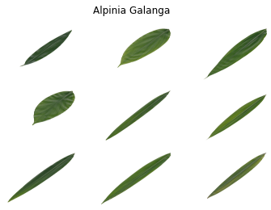
Figure 1. Select a image based on the Medicinal plant dataset

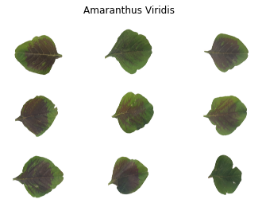
Figure 2. Select an image based on the Medicinal plant dataset

IMAGE PREPROCESSING

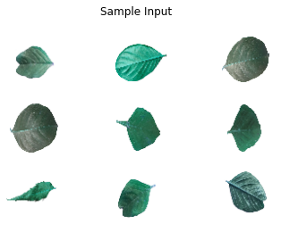
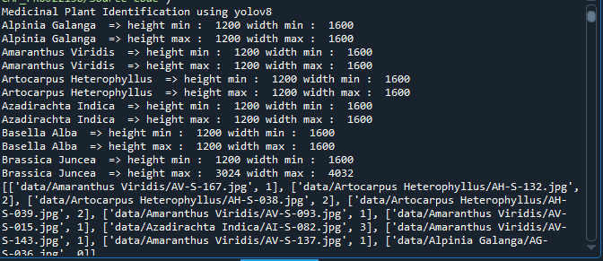

Figure 3 Resize image based on the Medicinal plant dataset

SPLITTING DATASET INTO TRAIN AND TEST DATA

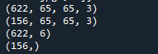
Figure 3 Using the Medicinal plant dataset, split images into 80% training and 20% testing

CLASSIFICATION
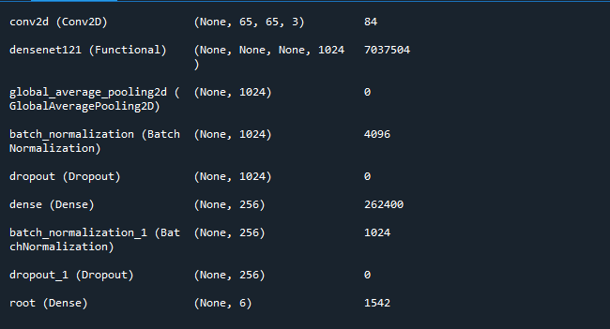
Figure 4 CNN Architecture Layer

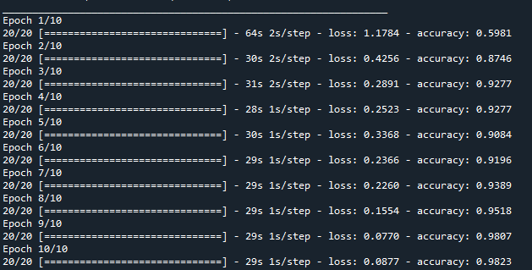
Figure 5 CNN Epochs 5

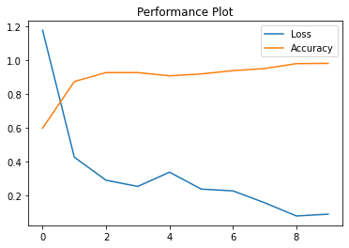

Figure 6 CNN based on accuracy and loss plot

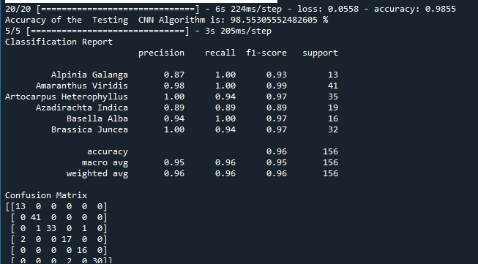\
Figure 7 CNN based on Classification Report

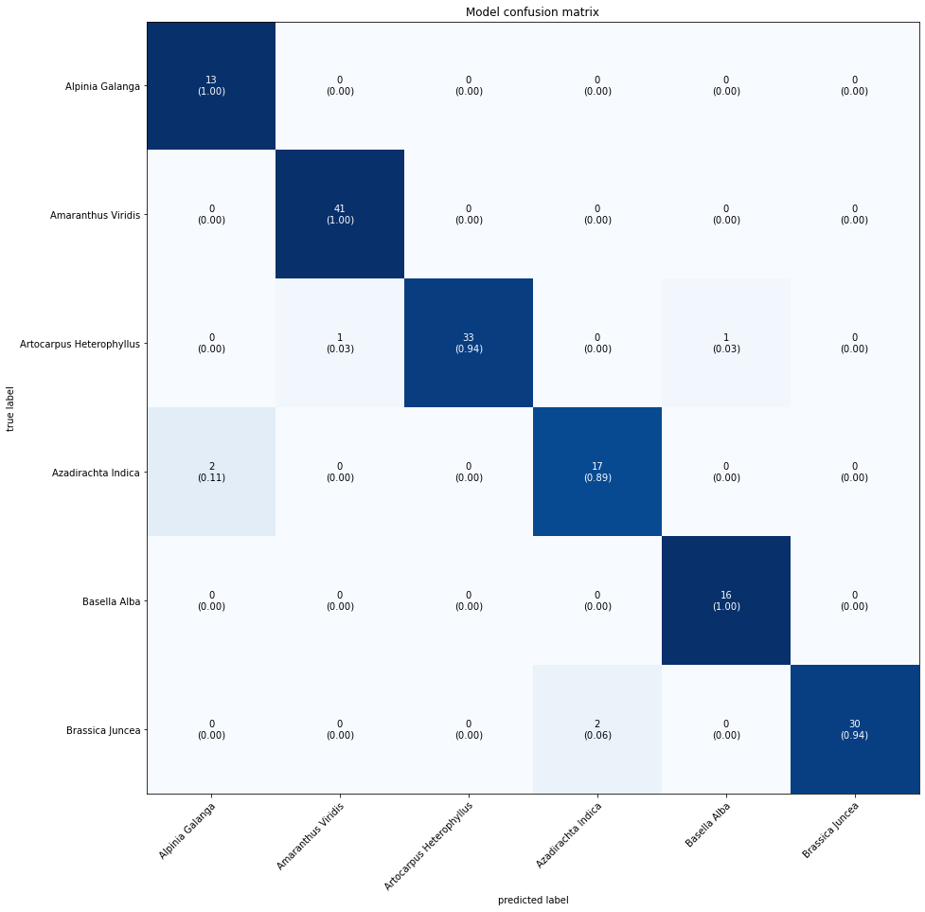
Figure 8 CNN based on Confusion Metrics

PREDICTION

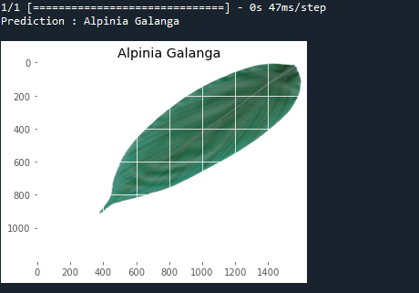

Figure 9 CNN according to the test image's prediction

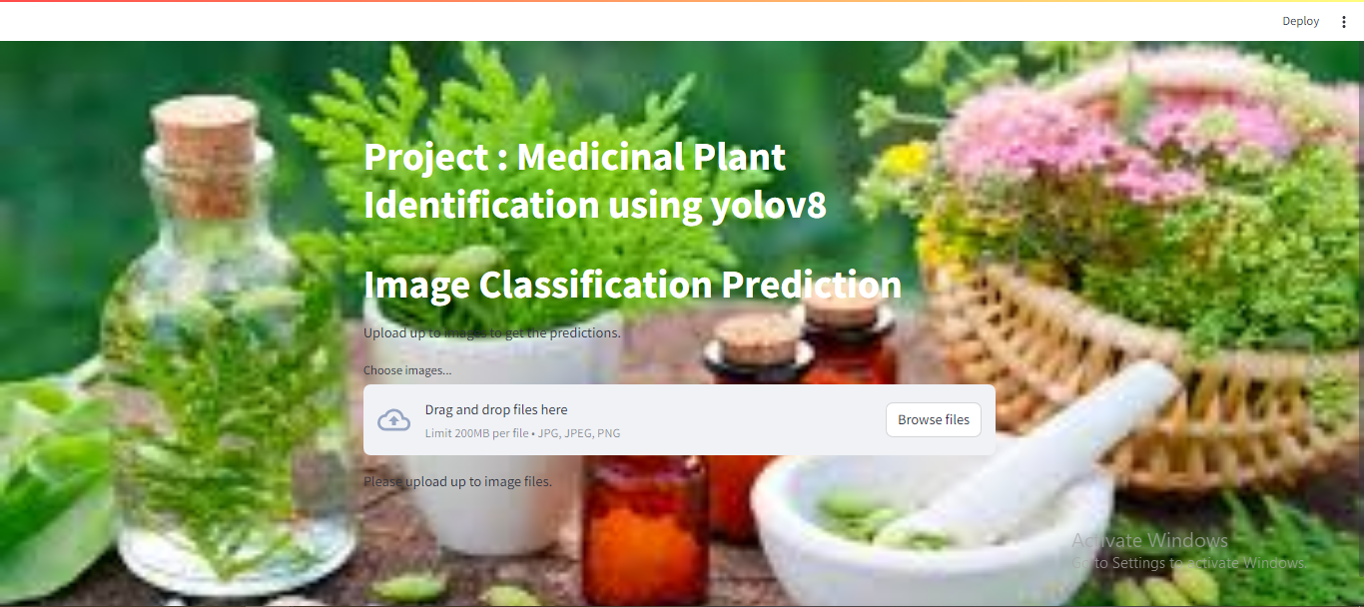

Figure 10 Webpage 1 on Medicinal Plant


Figure 11 Webpage 2 on Medicinal Plant

- REFERENCE

- Z. Li et al., “Non-invasive Medicinal Plant disease diagnostics enabled by smartphone-based fingerprinting of leaf volatiles,” Nature Medicinal Plant s, vol. 5, no. 8, pp. 856–866, Aug. 2019.
- G. Litjens et al., “A survey on deep learning in medical image analysis,” Med. Image Anal., vol. 42, pp. 60–88, Dec. 2017.
- W. Min, S. Jiang, L. Liu, Y. Rui, and R. Jain, “A survey on food computing,” ACM Comput. Surv., vol. 52, no. 5, pp. 92:1–92:36, 2019.
- E. Moen, D. Bannon, T. Kudo, W. Graf, M. Covert, and D. Van Valen, “Deep learning for cellular image analysis,” Nature Methods, vol. 16, no. 12, pp. 1233–1246, 2019.
- A. Krizhevsky, I. Sutskever, and G. E. Hinton, “ImageNet classification with deep convolutional neural networks,” in Proc. Neural Inf. Process. Syst., 2012, pp. 1106–1114.
- A. Bauer et al., “Combining computer vision and deep learning to enable ultra-scale aerial phenotyping and precision agriculture: A case study of lettuce production,” Horticulture Res., vol. 6, no. 1, pp. 1–12, Dec. 2019.
- S. Sladojevic, M. Arsenovic, A. Anderla, D. Culibrk, and D. Stefanovic, “Deep neural networks based recognition of Medicinal Plant diseases by leaf image classification,” Comput. Intell. Neurosci., vol. 2016, pp. 1–11, May 2016.
- J. Wang, L. Chen, J. Zhang, Y. Yuan, M. Li, and W. Zeng, “CNN transfer learning for automatic image-based classification of crop disease,” in Image and Graphics Technologies and Applications. Beijing, China: Springer, 2018, pp. 319–329.
- K. P. Ferentinos, “Deep learning models for Medicinal Plant disease detection and diagnosis,” Comput. Electron. Agricult., vol. 145, pp. 311–318, Feb. 2018.
- G. Wang, Y. Sun, and J. Wang, “Automatic image-based Medicinal Plant disease severity estimation using deep learning,” Comput. Intell. Neurosci., vol. 2017, pp. 1–8, Jul. 2017.
- M. RuBwurm and M. Korner, “Temporal vegetation modelling using long short-term memory networks for crop identification from mediumresolution multi-spectral satellite images,” in Proc. IEEE Conf. Comput. Vis. Pattern Recognit. Workshops (CVPRW), Jul. 2017, pp. 11–19.
- M. Brahimi, M. Arsenovic, S. Laraba, S. Sladojevic, K. Boukhalfa, and A. Moussaoui, “Deep learning for Medicinal Plant diseases: Detection and saliency map visualisation,” in Human and Machine Learning. Cham, Switzerland: Springer, 2018, pp. 93–117.
- W. Ge, X. Lin, and Y. Yu, “Weakly supervised complementary parts models for fine-grained image classification from the bottom up,” in Proc. IEEE/CVF Conf. Comput. Vis. Pattern Recognit. (CVPR), Jun. 2019, pp. 3034–3043.
- A. J. Wakeham, G. Keane, and R. Kennedy, “Field evaluation of a competitive lateral-flow assay for detection of alternaria brassicae in vegetable Brassica crops,” Medicinal Plant Disease, vol. 100, no. 9, pp. 1831–1839, Sep. 2016.
- A. K. Lees, L. Sullivan, J. S. Lynott, and D. W. Cullen, “Development of a quantitative real-time PCR assay for phytophthora infestans and its applicability to leaf, tuber and soil samples,” Medicinal Plant Pathol., vol. 61, no. 5, pp. 867–876, Oct. 2012.
- C. H. Bock, G. H. Poole, P. E. Parker, and T. R. Gottwald, “Medicinal Plant disease severity estimated visually, by digital photography and image analysis, and by hyperspectral imaging,” Crit. Rev. Medicinal Plant Sci., vol. 29, no. 2, pp. 59–107, Mar. 2010.
- F. Ahmad and A. Airuddin, “Leaf lesion detection method using artificial bee colony algorithm,” in Advances in Computer Science and its Applications, vol. 279. Beijing, China: Springer, 2014, pp. 989–995.
- S. Prasad, P. Kumar, and A. Jain, “Detection of disease using blockbased unsupervised natural Medicinal Plant leaf color image segmentation,” in Swarm, Evolutionary, and Memetic Computing. Beijing, China: Springer, 2011, pp. 399–406.
- A. Ramcharan, K. Baranowski, P. Mcclowsky, B. Ahmed, and D. P. Hughes, “Using transfer learning for image-based cassava disease detection,” Frontiers Medicinal Plant Sci., vol. 8, p. 1852, Oct. 2017.
- E. Mwebaze, T. Gebru, A. Frome, S. Nsumba, and J. Tusubira, “iCassava 2019 fine-grained visual categorization challenge,” 2019, arXiv:1908.02900. [Online]. Available: https://arxiv.org/abs/1908.02900

