SCREENSHOT

IMAGE SELECTION
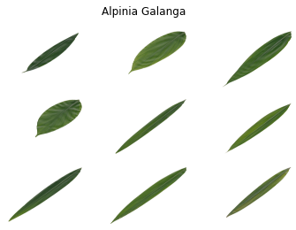
Figure 1. Select a image based on the Medicinal plant dataset

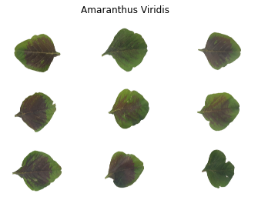
Figure 2. Select an image based on the Medicinal plant dataset

IMAGE PREPROCESSING

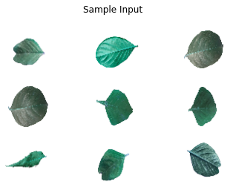
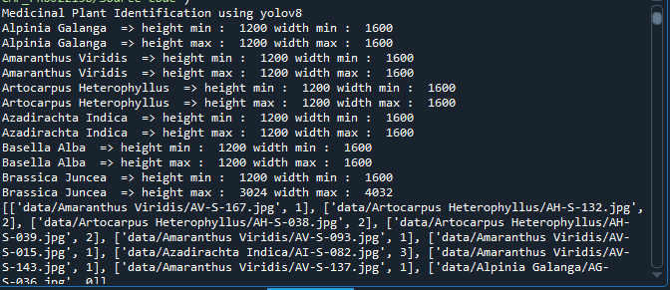

Figure 3 Resize image based on the Medicinal plant dataset

SPLITTING DATASET INTO TRAIN AND TEST DATA

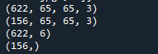
Figure 3 Using the Medicinal plant dataset, split images into 80% training and 20% testing

CLASSIFICATION
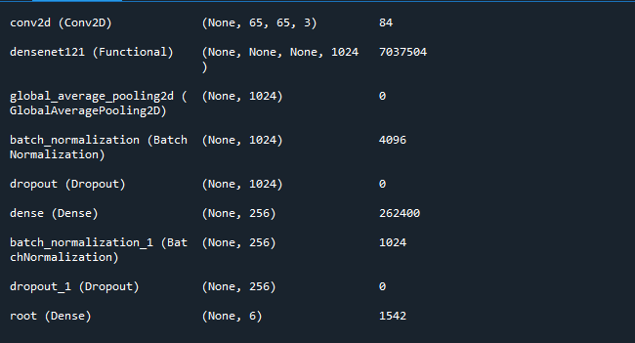
Figure 4 CNN Architecture Layer

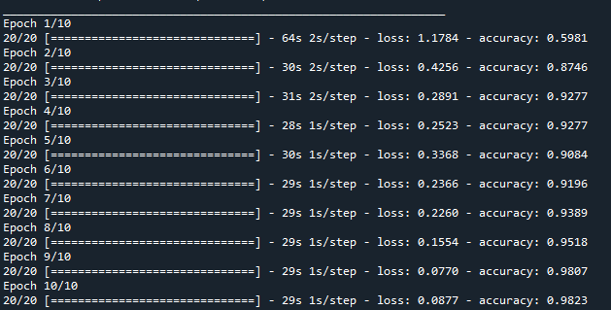
Figure 5 CNN Epochs 5

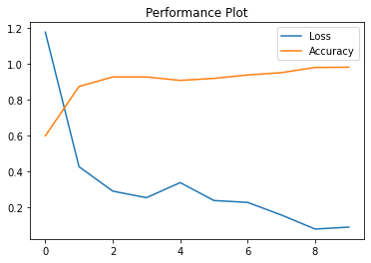

Figure 6 CNN based on accuracy and loss plot

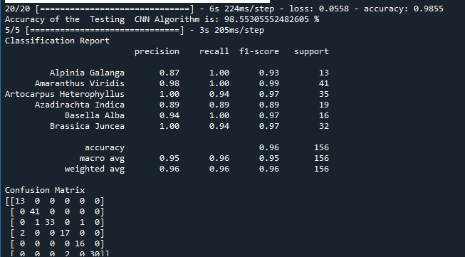\
Figure 7 CNN based on Classification Report

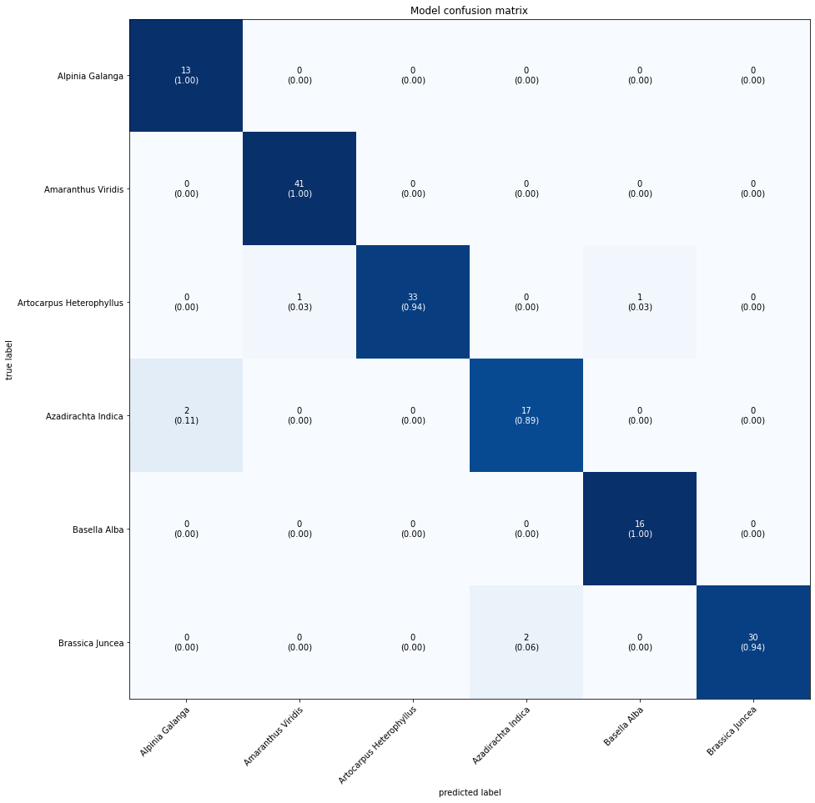
Figure 8 CNN based on Confusion Metrics

PREDICTION

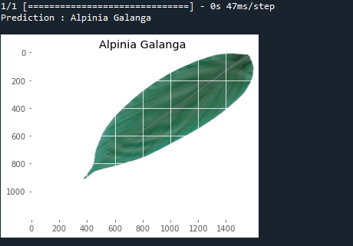

Figure 9 CNN according to the test image's prediction

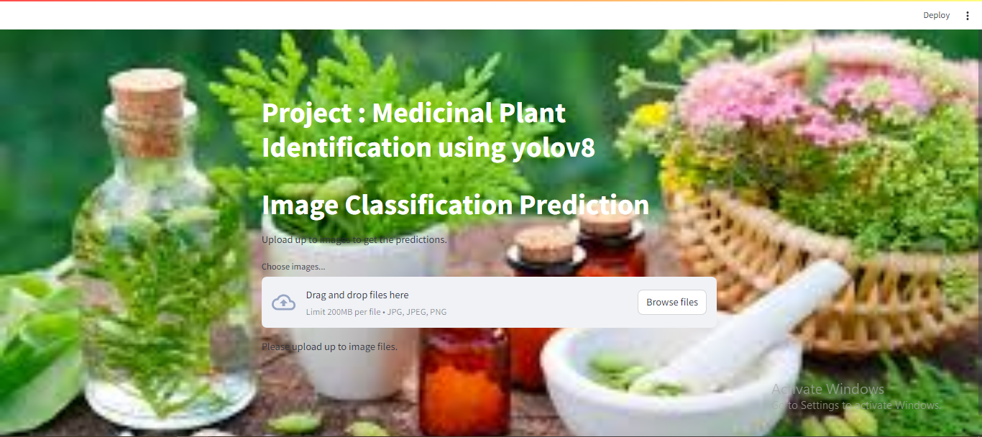

Figure 10 Webpage 1 on Medicinal Plant

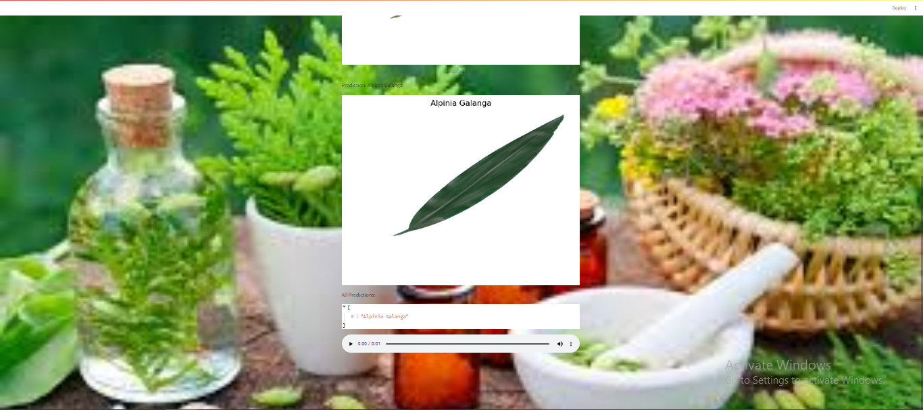
Figure 11 Webpage 2 on Medicinal Plant

