**DAILY ONLINE ACTIVITIES SUMMARY**

|  |  |  |  |  |  |  |  |  |
| --- | --- | --- | --- | --- | --- | --- | --- | --- |
| **Date:** | **19/05/2020** | | | | | **Name:** | **Chandana Patil** | |
| **Sem & Sec** | **6th Sem and A Sec** | | | | | **USN:** | **4AL17CS020** | |
| **Online Test Summary** | | | | | | | | |
| **Subject** | | **Computer Graphics and Visualization** | | | | | | |
| **Max. Marks** | | **60** | | **Score** | | | **54** | |
| **Certification Course Summary** | | | | | | | | |
| **Course** | **Machine Learning for Apps** | | | | | | | |
| **Certificate Provider** | | | **Alison** | | **Duration** | | | **6-7 Hours** |
| **Coding Challenges** | | | | | | | | |
| **Problem Statement:**  **1.** We have a Letter or a word then we need add some letters to it and need to find out shortest palindrome  **2.** Write a simple code to identify given linked list is palindrome or not by using stack. First take a Stack. Traverse through each node of the linked list and push each node value to Stack. | | | | | | | | |
| **Status: Completed** | | | | | | | | |
| **Uploaded the report in Github** | | | | | **Yes** | | | |
| **If yes Repository name** | | | | | **https://github.com/chandanapatil/OnlineCourse.git** | | | |
| **Uploaded the report in slack** | | | | | **Yes** | | | |

**Online Test:** 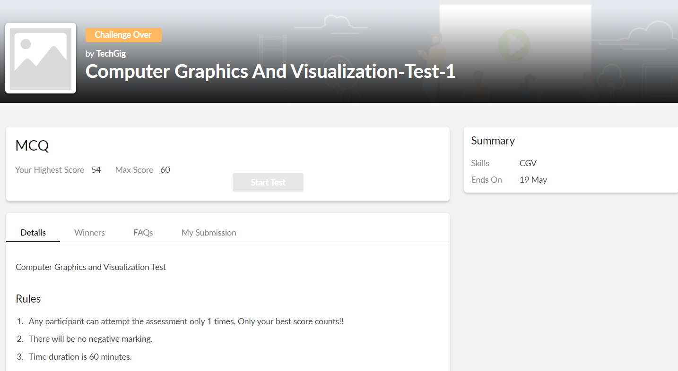

**Certification: These are the completed topics**

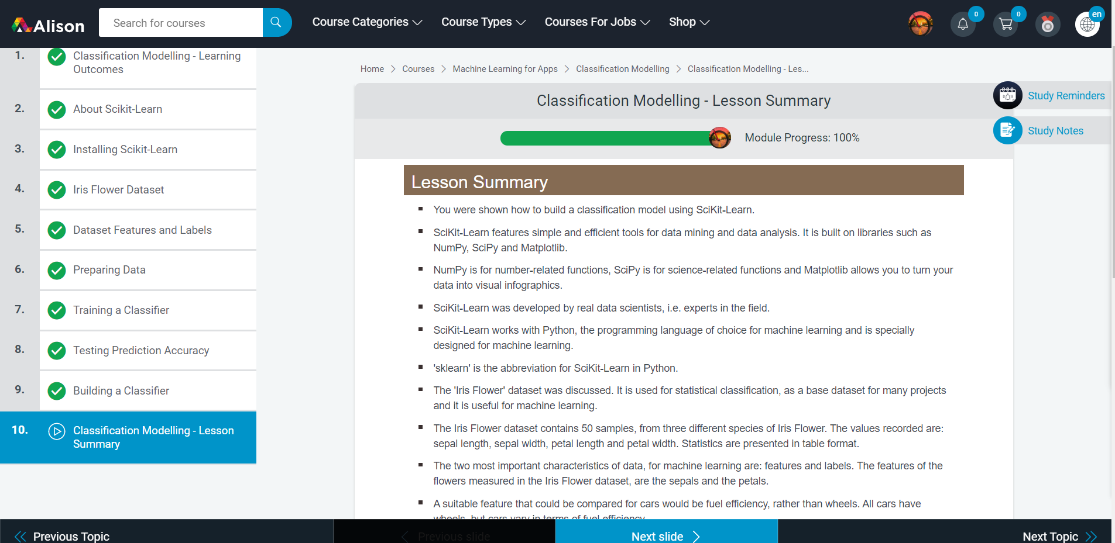

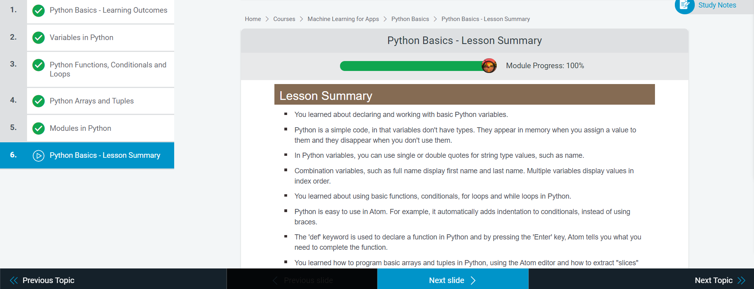

**OnlineCoding:**

**Prog1:** We have a Letter or a word then we need add some letters to it and need to find out shortest palindrome

For example we take "S": S will be the shortest palindrome string. If we take "xyz": zyxyz will be the shortest palindrome string, So we need to add some characters to the given string or character and find out what will be the shortest palindrome string by using simple java program.

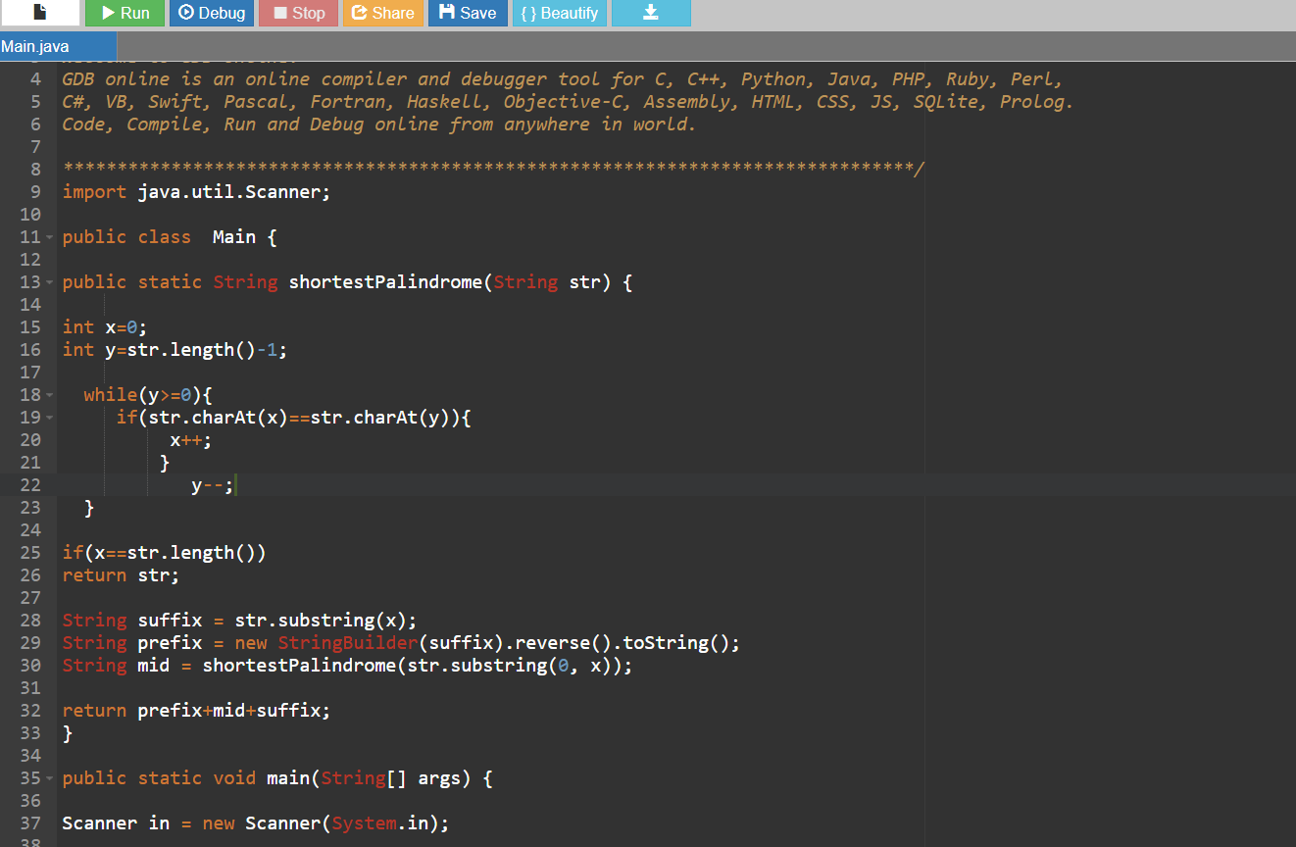

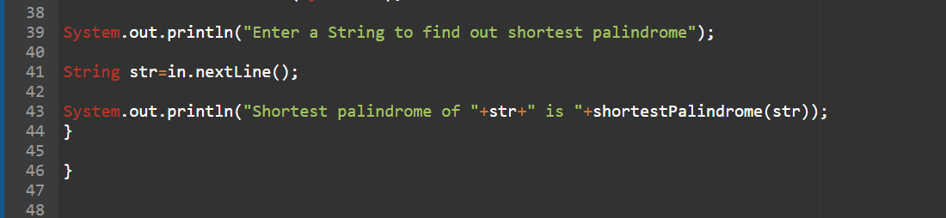

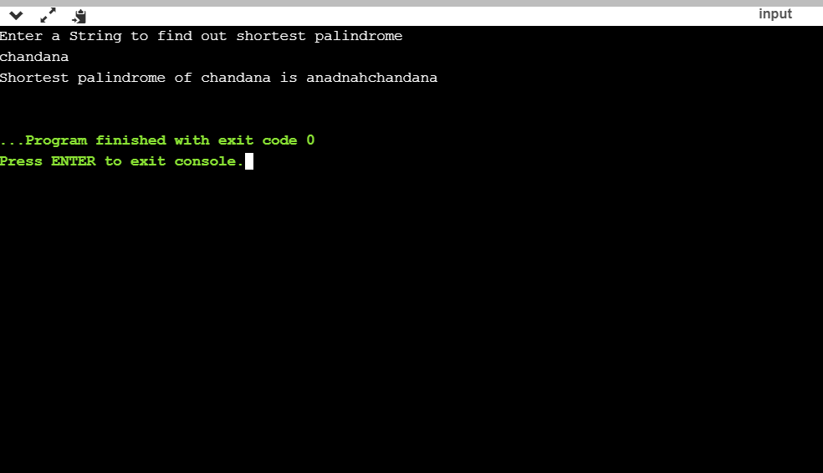

**Prog2:** Write a simple code to identify given linked list is palindrome or not by using stack.

First take a Stack. Traverse through each node of the linked list and push each node value to Stack.

Once the traversal & copying is done, iterate through linked list from head node again.

In each iteration, pop one stack element and compare with node value in respective iteration. It is expected to match stack popped value with node value.

In case of all matches, its a palindrome. Any one element mismatch makes it not a palindrome.

