**DAILY ONLINE ACTIVITIES SUMMARY**

|  |  |  |  |  |  |  |  |  |
| --- | --- | --- | --- | --- | --- | --- | --- | --- |
| **Date:** | **11-07-2020** | | | | | **Name:** | **Chandana Patil** | |
| **Sem & Sec** | **6th Sem & A Sec** | | | | | **USN:** | **4AL17CS020** | |
| **Pre-placement Training Summary** | | | | | | | | |
| **Subject** | |  | | | | | | |
| **Max. Marks** | | **-** | | **Score** | | | **-** | |
| **Online Certification Summary** | | | | | | | | |
| **Course** | - | | | | | | | |
| **Certificate Provider** | | |  | | **Duration** | | | **-** |
| **Coding Challenges** | | | | | | | | |
| **Problem Statement:**  This is output of C program to check whether a given character is a vowel or a consonant. | | | | | | | | |
| **Status: Completed** | | | | | | | | |
| **Uploaded the report in GitHub** | | | | | **Yes** | | | |
| **If yes Repository name** | | | | | **https://github.com/chandanapatil/OnlineCourse2.git** | | | |
| **Uploaded the report in slack** | | | | | **Yes** | | | |

Coding Challenges Details:

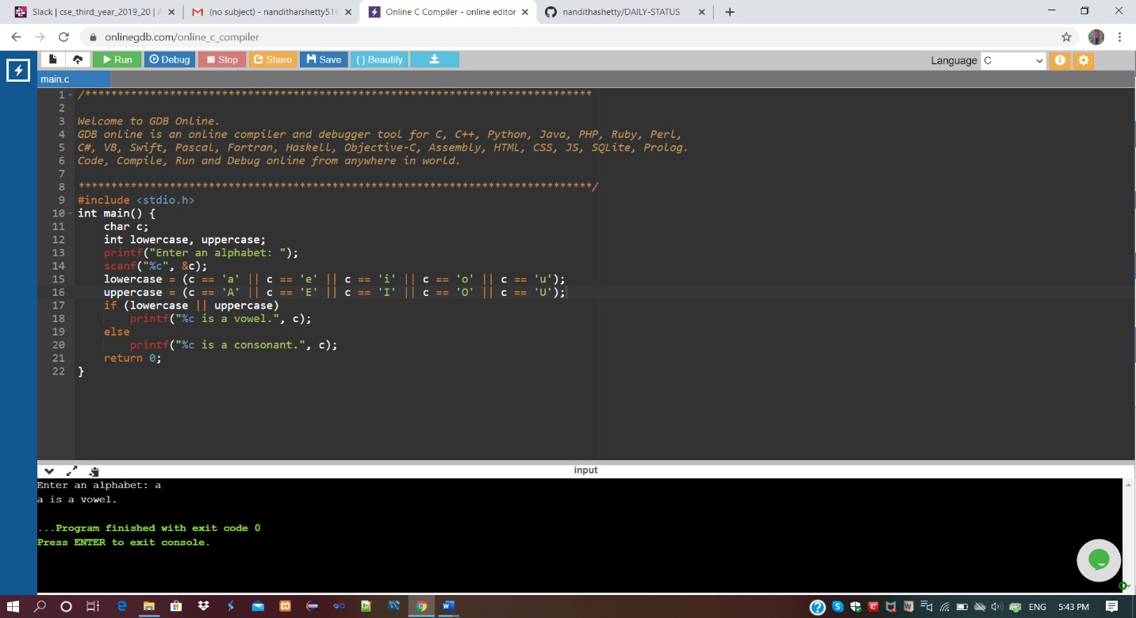1.This is output of C program to check whether a given character is a vowel or a consonant.

