**Chapter 3 – Team Project: Images and photography studio**

**Creating ER Diagrams for Team Project**

**Step 3.1- Make a list of all entities and their associated attributes.**

The entities appear here are:

Client

Emergency Contact

Inquiry

Order

Payment

Photography Package

Staff

Total Appointments

Weekly Schedule

In identifying the attributes for an entity, we try to find data items that tell a single fact about an entity instance. For the Client entity, we look for attributes whose value would tell us one piece of information about a client. Grouping the items from the data dictionary,

the attributes that seem to describe the

**Client**, are:

Client ID (Primary Key), Client Name, Client Email, Client Phone Number, Client Company Name, Client City, Client State, Client Street, Client Zip Code, Client Feedback, Client Signature. Examining these more closely, we see that some of them form composite attributes, including:

Clientname consisting of Client First name, Client Last name.

ClientAddress consisting of Client Street, Client City, Client State, Client Zip code.

**Emergency Contact**

The attributes that seem to describe the **Emergency Contact**, are:

Emergency Contact Name, Emergency Contact Email, Emergency Contact Phone Number

Client ID (Foreign Key referencing Entity 1: Client)

**Inquiry**

The attributes that seem to describe the **Inquiry**, are:

Inquiry ID (Primary Key), Inquiry Date, Event Date, Event Location, Event (No of Guests), Event Start Date, Event Start Day, Event Time, Event Type, Photographer Availability, Preferred Photographer, Price Expectations, Services Provided, Status of Order.

**Order**

The attributes that seem to describe the **Order**, are:

Order ID (Primary Key), Order Date, Order Status, Client ID (Foreign Key referencing Entity Client)

**Payment**

The attributes that seem to describe the **Payment,** are:

Payment Id, Payment Amount, Payment Date, Payment Method, Payment Remainder Email, Payment Remainder, Phone Number, Payment History, Payment History Amounts, Payment History Date, Late Payment Fee, Confirmation ID

**Photography Package**

The attribute that seems to describe the **Photography Package,** is:

Package Type

**Staff**

The attributes that seem to describe the **Staff,** are:

Staff Assigned ID (Primary Key), Staff Assigned Name, Staff Assigned Email, Staff Assigned Phone Number, Staff Assigned Batch Number

**Total Appointments**

The attribute that seems to describe the **Total Appointments,** is:

Total Appointments

**Weekly Schedule**

The attributes that seem to describe the **Weekly Schedule,** are:

Weekly Date (Composite Primary Key with Weekly Day), Weekly Day (Composite Primary Key with Weekly Date), Weekly Time Slots

**Step 3.2 - Make a list of relationships to be represented and any descriptive attributes for them.**

Each Inquiry is associated with one Client through the Client ID foreign key.

Each Inquiry is associated with one Order through the Inquiry ID foreign key.

Each Order is associated with one Client through the Client ID foreign key.

Each Weekly Schedule is associated with multiple Inquiries through the Weekly Date and Weekly Day composite primary keys.

Each Emergency Contact is associated with one Client through the Client ID foreign key.

By using these entities we may track and manage information about requests, orders, clients, employees, payments, and scheduling in photography studio by using these relationships, which show how the entities are connected in the data model.

**Step 3.3 - Draw an E-R diagram to represent the enterprise.**

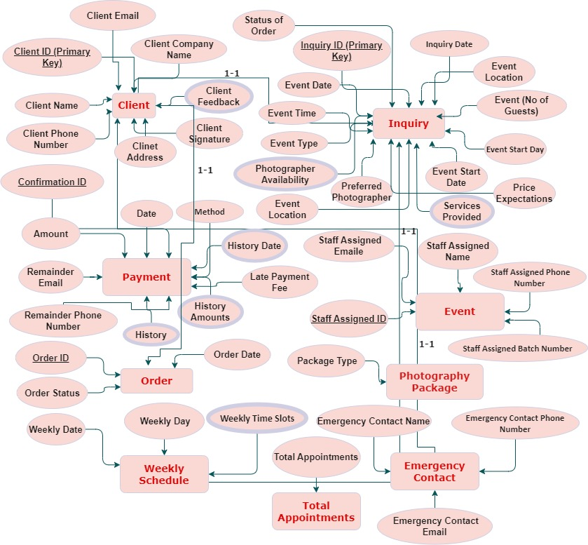

**Client**:

Client ID (Primary Key), Client Name, Client Email, Client Phone Number, Client Company Name, Client City, Client State, Client Street, Client Zip Code, Client Feedback, Client Signature.

**Emergency Contact:**

Emergency Contact Name, Emergency Contact Email, Emergency Contact Phone Number

Client ID (Foreign Key referencing Entity 1: Client)

**Inquiry:**

Inquiry ID (Primary Key), Inquiry Date, Event Date, Event Location, Event (No of Guests), Event Start Date, Event Start Day, Event Time, Event Type, Photographer Availability, Preferred Photographer, Price Expectations, Services Provided, Status of Order.

**Order:**

Order ID (Primary Key), Order Date, Order Status, Client ID (Foreign Key referencing Entity Client)

**Payment:**

Payment Id, Payment Amount, Payment Date, Payment Method, Payment Remainder Email, Payment Remainder, Phone Number, Payment History, Payment History Amounts, Payment History Date, Late Payment Fee, Confirmation ID

**Photography Package:**

Package Type

**Staff:**

Staff Assigned ID (Primary Key), Staff Assigned Name, Staff Assigned Email, Staff Assigned Phone Number, Staff Assigned Batch Number

**Total Appointments:**

Total Appointments

**Weekly Schedule:**

Weekly Date (Composite Primary Key with Weekly Day), Weekly Day (Composite Primary Key with Weekly Date), Weekly Time Slots

Certainly, here's the information provided, including the assumptions, given keys, entity attributes, and relationships, incorporated into the explanation:

**Creating the ERD for Your Image Photography Studio Using visio:**

We embarked on the journey of crafting an Entity-Relationship Diagram (ERD) for your image photography studio, employing the user-friendly and versatile visio platform for this pivotal task.

**Step 1: Entity Identification and Attribute Definition**

Our initial stride involved identifying the key entities that form the backbone of your photography studio's data model. These entities encompass 'Client,' 'Inquiry,' 'Payment,' 'Staff,' 'Order,' 'Photography Package,' 'Weekly Schedule,' 'Total Appointments,' and 'Emergency Contact.' With each entity carefully delineated, we proceeded to define their individual attributes, capturing vital information integral to your studio's operations.

**Step 2: Establishing Relationships**

A cornerstone of our ERD was the establishment of meaningful relationships between these entities. These relationships act as the conduits through which data flows, facilitating seamless interactions. We employed visio intuitive interface to visually represent these connections. By using lines connecting the entities, we clearly depicted how they interact and share information.

**Assumptions:**

In the design of our Entity-Relationship Diagram (ERD), we made several key assumptions to shape our data model effectively. Firstly, we assumed that each 'Client' may engage in multiple 'Inquiries' regarding photography services. These inquiries can vary in nature and include specific event details, preferred photographers, price expectations, and desired services. Furthermore, we assumed that a 'Client' may be associated with one or more 'Orders' for photography services. Each 'Order' can be related to a specific 'Inquiry' to maintain a clear connection between inquiries and bookings.

**Given Keys:**

Our ERD includes essential keys that uniquely identify each entity. For 'Client,' 'Inquiry,' 'Payment,' 'Staff,' 'Order,' 'Photography Package,' 'Weekly Schedule,' 'Total Appointments,' and 'Emergency Contact,' we assigned primary keys, such as 'Client ID,' 'Inquiry ID,' 'Payment Amount,' 'Staff Assigned ID,' 'Order ID,' 'Package Type,' 'Weekly Date,' 'Total Appointments,' and 'Emergency Contact Name,' respectively. These keys serve as the foundation for data integrity and efficient retrieval of information.

**Entity Attributes:**

Each entity in our ERD is associated with specific attributes that capture relevant information. For instance, the 'Client' entity includes attributes like 'Client Name,' 'Client Email,' 'Client Phone Number,' 'Client Company Name,' 'Client City,' 'Client State,' 'Client Street,' 'Client Zip Code,' 'Client Feedback,' and 'Client Signature.' These attributes comprehensively represent client details. Similarly, the 'Inquiry' entity includes attributes such as 'Inquiry Date,' 'Event Date,' 'Event Location,' 'Event Type,' and more, to provide a detailed overview of inquiry specifics.

**Relationships:**

Our ERD is designed to facilitate seamless interactions between entities. For example, the relationship between 'Client' and 'Inquiry' allows each 'Client' to initiate multiple 'Inquiries.' The 'Client ID' in the 'Inquiry' entity serves as a foreign key linking these two entities. Likewise, the 'Inquiry' entity is connected to 'Order' through the 'Inquiry ID' foreign key, signifying that each inquiry may lead to an order. Furthermore, 'Payment' records are associated with 'Inquiry' and 'Order,' allowing us to track payment details in the context of client inquiries and bookings.

In summary, visio emerged as a pivotal tool in our endeavor to design the ERD for your image photography studio. It enabled us to seamlessly identify entities, define attributes, establish relationships, and present a clear and concise visualization of your data model. Visio collaborative capabilities and versatile export options greatly contributed to our project's success in documenting and communicating your studio's data structure and operations effectively.

**Step 3.4 – Review and update the data dictionary and list of assumptions (as needed).**

**Data Dictionary:**

1. Booking date and time- The specific date and time on which the booking was made, or the appointment is scheduled.
2. Budget range- The client's budget range for photography services, helping the studio understand their financial expectations.
3. Budget Details-If the client has a specific budget amount in mind, they can provide it here for greater precision.
4. Client Company name- Company Name" field is especially useful when dealing with corporate clients or events, as it helps you differentiate between individual and corporate clients and provides important business context for your photography services.
5. Client City- The city of the mailing address of a client
6. Client email- Email address of the person making the inquiry.
7. Client id-Unique id given to each client.
8. Client name- Full name of the client making the inquiry.
9. Client phone no-Phone number of the person making the inquiry.
10. Client signature- The Official signature after meeting the manager of the studio.
11. Client State- The state of the mailing address of a client
12. Client city- The city of the mailing address of a client
13. Client Street- The street of the mailing address of a client
14. Client Zip code- The postal zip code of the mailing address of a client.
15. Client feedback- A space for clients to provide detailed feedback, comments, or reviews about their experience with your photography services.
16. Conformation id- A unique identifier or reference number for the payment confirmation.
17. Emergency contact email- The email address of the emergency contact person.
18. Emergency contact name- The name of the client's designated emergency contact person.
19. Emergency contact Phone number- The phone number of the emergency contact person.
20. Event Date- Date of the event or the desired photography session.
21. Event location- Location or venue of the event or session.
22. Event (No of guests)- The estimated number of participants or guests attending the event.
23. Event start date- The date when the client's event or photography session is scheduled to begin.
24. Event start day- The day when the client's event or photography session is scheduled to begin.
25. Event time- The specific time when the client's event or photography session is scheduled to begin.
26. Event type- The specific type of event which the clients require special thymes and functions or ceremonies.
27. Inquiry Date- Date when the inquiry was submitted.
28. Inquiry id- Unique identifier for each inquiry.
29. Invoice date- The date when the invoice was generated.
30. Invoice due date- The due date for the payment of the invoice.
31. Invoice id- A unique identifier for the invoice associated with the inquiry.
32. Late payment fee-The specific amount or percentage of the fee to be charged as a late payment penalty when a payment is overdue.
33. Order id- A unique identifier for the order associated with the inquiry.
34. Order date- The date when the order was placed or created.
35. Order Status- The status of the order associated with the inquiry (e.g., Unpaid, Partially Paid, Paid)
36. Package type- The name or label that identifies a specific type of photography package or service offered by your studio.
37. Payment amount- The amount the client intends to pay.
38. Payment date- The date when the payment is made or intended to be made.
39. Payment method- The method the client intends to use for payment.
40. Payment_remainder_email- The email address to which payment reminders will be sent to notify clients of pending payments.
41. Payment_remainder_phone no.- The phone number to which payment reminders via SMS or phone calls can be sent or made.
42. Payment_history- The total number of payments made by the client for a specific booking or service.
43. Payment_history_amounts- A record of the payment amounts made by the client for each installment or transaction.
44. Payment_history_date- The dates on which the client made payments for the booking or service.
45. Photographer availability- The current availability status of the photographer for the specified date and time slots.
46. Photographer signature- A signature or verification from the photographer acknowledging the inquiry.
47. Preferred photographer- If the client has a preferred photographer for the event, their name can be entered here.
48. Price expectations- The client's expectation regarding the pricing range for the photography services they are interested in, such as whether they have a strict budget or are willing to invest more for premium services.
49. Services provided- The name or label that identifies a specific photography service or package offered by your studio.
50. Staff assigned Batch no.- The batch number or group identifier for the staff member.
51. Staff assigned Email- The email address of the staff member.
52. Staff assigned Id- A unique identifier for the staff member handling the inquiry.
53. Staff assigned name-The name of the staff member assigned to handle the inquiry.
54. Staff assigned Phone number- The phone number of the staff member.
55. Status of order- The current status of the client's order or photography service, indicating whether it's pending, in progress, completed, or canceled.
56. Status or availability- The current availability status of a resource, photographer, or service within your photography studio.
57. Total appointments- The total number of appointments scheduled or made within your photography studio for a specific period, location, or service.
58. Time slots available- A list of available time slots on the specified date when clients can book photography appointments.
59. Weekly date- The date for the scheduled week or time.
60. Weekly day- The day of the week for which the schedule or availability is applicable.
61. Weekly time slots- The time slots or hours available for photography appointments on the specified day.

**List of Assumptions:**

1. Give customers the option to register in the system by entering their contact details, preferences, and needs in Client registration.
2. Session Scheduling: Customers can browse the available slots and schedule a photography session for a certain day and time.
3. Photographer Assignment: After a session is scheduled, the computer allocates a qualified photographer who is free based on their availability and area of expertise.
4. Inventory Management: Inventory management entails keeping track of photography equipment, props, and backgrounds. When new equipment is added or items are checked out for a shoot, the database is updated.
5. Client Profile Administration: Clients can update their profiles, amend their contact information, and indicate their photography preferences.
6. Photoshoot Information: Save information about each photoshoot, such as the client, date, location, and type of photography (for example, portrait, wedding, or product).
7. Image gallery: Create an image gallery for each shooting where clients can store, organize, and readily access the altered images.
8. Image Editing: Allow photographers to upload and modify photographs before providing them to clients, with version control.
9. Payment processing: Payment Processing entails processing payment transactions, issuing invoices, and tracking payments for photography services performed.
10. Scheduling & Calendar: Keep a studio calendar that shows scheduled sessions, photographer schedules, and availability.