WEEK 4 INTERNSHIP REPORT
Supervised Learning: Titanic Survival Prediction

Virtual Data Science Internship
Task: Implement, validate, and evaluate supervised machine-learning models
Dataset: Titanic passenger dataset

Prepared by: Chandana K B
Program: Virtual Data Science Internship

1. Abstract
This project applies supervised machine learning to predict whether a passenger survived the Titanic disaster. The Titanic dataset contains passenger information such as passenger class, sex, age, family relationships, fare, and port of embarkation, along with a survival label. Two classification algorithms—Logistic Regression and Decision Tree—were trained and evaluated. The workflow includes data inspection, feature selection, preprocessing, train-test splitting, model training, classification metrics, and five-fold stratified cross-validation. Logistic Regression achieved 80.45% test accuracy, while the Decision Tree achieved 76.54%. The results show that model performance should be evaluated using more than accuracy alone.

2. Problem Statement
The objective is to build a machine-learning model that predicts the survival outcome of a Titanic passenger using selected passenger attributes. Since the target variable has two possible values—survived (1) and did not survive (0)—this is a binary classification problem.

3. Objectives
- Load and inspect a public dataset using Python.
- Select useful input features and define the target variable.
- Prepare numerical and categorical features for machine learning.
- Train Logistic Regression and Decision Tree classifiers.
- Evaluate the models using accuracy, precision, recall, F1-score, and cross-validation.
- Compare the models and identify limitations and possible improvements.

4. Tools and Technologies
Tool / Library | Purpose
Python | Programming language used for data analysis and model building.
Google Colab / Jupyter Notebook | Environment for running Python code.
Pandas | Loading and inspecting tabular data.
NumPy | Numerical operations.
Matplotlib | Visual comparison of model performance.
Scikit-learn | Preprocessing, train-test split, model training, and evaluation.

5. Dataset Description
The Titanic dataset was loaded from a public CSV file. It contains 891 rows and 12 columns. The target column is Survived. A value of 0 means the passenger did not survive, while 1 means the passenger survived.
url = "https://raw.githubusercontent.com/datasciencedojo/datasets/master/titanic.csv"
df = pd.read_csv(url)
print(df.shape)
print(df.head())
print(df.isnull().sum())
The dataset has missing values in several columns:
Column | Missing values observed | Handling / decision
Age | 177 | Missing age values filled using the median.
Cabin | 687 | Not selected as a model feature because most values are missing.
Embarked | 2 | Missing values filled using the most frequent category.
Other selected features | No missing values reported in the inspection | Used as input features.

6. Feature Selection
Seven input features were selected: Pclass, Sex, Age, SibSp, Parch, Fare, and Embarked. PassengerId, Name, Ticket, and Cabin were excluded from this model. The target variable was Survived.
features = ['Pclass', 'Sex', 'Age', 'SibSp', 'Parch', 'Fare', 'Embarked']
X = df[features].copy()
y = df['Survived'].copy()
X['Age'] = X['Age'].fillna(X['Age'].median())
X['Embarked'] = X['Embarked'].fillna(X['Embarked'].mode()[0])
Pclass represents passenger class; Sex represents the passenger's recorded sex; Age is age in years; SibSp and Parch describe family relationships aboard; Fare is the ticket fare; and Embarked represents the port where the passenger boarded.

7. Data Preprocessing
The numerical features were processed with median imputation and standard scaling. The categorical features were processed with most-frequent-value imputation and one-hot encoding. A ColumnTransformer was used to apply the correct transformation to each feature group.
numerical_features = ['Pclass', 'Age', 'SibSp', 'Parch', 'Fare']
categorical_features = ['Sex', 'Embarked']
numerical_transformer = Pipeline(steps=[
('imputer', SimpleImputer(strategy='median')),
('scaler', StandardScaler())
])
categorical_transformer = Pipeline(steps=[
('imputer', SimpleImputer(strategy='most_frequent')),
('encoder', OneHotEncoder(handle_unknown='ignore'))
])
preprocessor = ColumnTransformer(transformers=[
('num', numerical_transformer, numerical_features),
('cat', categorical_transformer, categorical_features)
])
Note on methodology: in the executed notebook, Age and Embarked were initially filled before splitting the dataset. This means their median and mode were calculated using the full dataset, which introduces a small possibility of data leakage. For a stricter experiment, the original unfilled feature columns should be passed into the pipeline and all imputation should be fitted only on the training data. The pipeline structure shown above supports that improved approach.

8. Train-Test Split
The data was divided into training and testing sets using an 80:20 split. Stratification was used so the survival class proportions were maintained approximately across both sets. A random state of 42 makes the split reproducible.
X_train, X_test, y_train, y_test = train_test_split(
X, y, test_size=0.2, random_state=42, stratify=y
)
Dataset portion | Number of samples
Training set | 712
Testing set | 179
Total | 891

9. Model 1: Logistic Regression
Logistic Regression is a classification algorithm that estimates the probability of an outcome belonging to a class. It was selected as a baseline model because it is relatively simple, efficient, and interpretable.
model = Pipeline(steps=[
('preprocessor', preprocessor),
('classifier', LogisticRegression(max_iter=1000))
])
model.fit(X_train, y_train)
y_pred = model.predict(X_test)

9.1 Logistic Regression Evaluation
Metric | Result
Test accuracy | 80.45%
Precision | 79.31%
Recall | 66.67%
F1-score | 72.44%

Accuracy is the proportion of all predictions that were correct. Precision measures how many predicted survivors were actual survivors. Recall measures how many actual survivors were correctly identified. The F1-score combines precision and recall into one measure.

9.2 Confusion Matrix
[[98, 12],
[23, 46]]
Confusion-matrix value | Count | Meaning
True negatives (TN) | 98 | Correctly predicted non-survivors.
False positives (FP) | 12 | Predicted as survivors, but actually non-survivors.
False negatives (FN) | 23 | Predicted as non-survivors, but actually survivors.
True positives (TP) | 46 | Correctly predicted survivors.

The model correctly classified 98 non-survivors and 46 survivors. It incorrectly classified 12 non-survivors as survivors and missed 23 actual survivors.

10. Five-Fold Stratified Cross-Validation
Five-fold stratified cross-validation evaluates a model across five different training/validation folds while preserving class proportions as closely as possible. It provides a broader estimate of performance than relying on one split alone.
cv = StratifiedKFold(n_splits=5, shuffle=True, random_state=42)
cv_scores = cross_val_score(
model, X_train, y_train, cv=cv, scoring='accuracy'
)
Fold | Logistic Regression accuracy
1 | 79.02%
2 | 79.72%
3 | 80.28%
4 | 74.65%
5 | 83.10%
Mean | 79.35%
Standard deviation | 2.73 percentage points (approximately)

11. Model 2: Decision Tree
A Decision Tree predicts a class by following a sequence of feature-based decisions. It can model non-linear relationships and is often easier to explain visually. The tree depth was limited to 5 to help reduce overfitting.
tree_model = Pipeline(steps=[
('preprocessor', preprocessor),
('classifier', DecisionTreeClassifier(max_depth=5, random_state=42))
])
tree_model.fit(X_train, y_train)
tree_pred = tree_model.predict(X_test)

11.1 Decision Tree Evaluation
Metric | Result
Test accuracy | 76.54%
Precision | 75.47%
Recall | 57.97%
F1-score | 65.57%
Mean 5-fold cross-validation accuracy | 80.34%

The Decision Tree achieved a slightly higher mean cross-validation accuracy than Logistic Regression, but its test accuracy, precision, recall, and F1-score were lower on the selected held-out test set.

12. Model Comparison
Metric | Logistic Regression | Decision Tree
Test accuracy | 80.45% | 76.54%
Precision | 79.31% | 75.47%
Recall | 66.67% | 57.97%
F1-score | 72.44% | 65.57%
Mean 5-fold CV accuracy | 79.35% | 80.34%

On the held-out test set, Logistic Regression performed better on all four classification metrics. However, the Decision Tree's mean cross-validation accuracy was 0.99 percentage points higher. These results are not contradictory: the test score and cross-validation score are calculated using different data partitions. The comparison suggests Logistic Regression is the stronger model for this particular test split, while more repeated evaluation and tuning would be needed to make a more general conclusion.
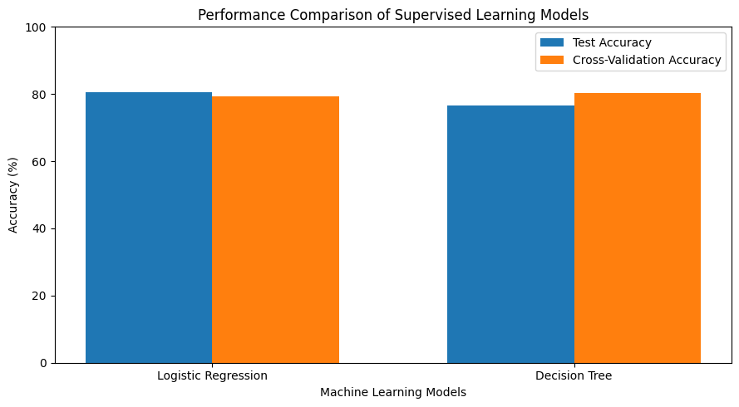
Figure 1. Test accuracy and mean cross-validation accuracy for both models.

13. Strengths and Limitations

Strengths
- Uses a public dataset that is commonly used for learning classification.
- Includes both numerical and categorical feature preprocessing.
- Evaluates two different supervised-learning algorithms.
- Uses precision, recall, F1-score, a confusion matrix, and cross-validation instead of accuracy alone.
- The workflow is reproducible because a fixed random state is used.

Limitations
- The dataset is historical and may not represent modern populations or current real-world conditions.
- Some columns contain substantial missing data; Cabin was excluded due to its high missing-value count.
- The selected features do not capture every factor that may have influenced survival.
- The initial imputation of Age and Embarked was performed before the train-test split, creating a small risk of data leakage.
- A single test split can produce results that vary depending on which samples are selected.
- The Decision Tree and Logistic Regression were not exhaustively tuned.

14. Future Improvements
- Re-run the experiment with imputation fitted only on the training data by passing the original, unfilled feature columns into the preprocessing pipeline.
- Use GridSearchCV or RandomizedSearchCV to tune hyperparameters.
- Evaluate additional algorithms such as Random Forest, Gradient Boosting, or Support Vector Machines.
- Inspect feature importance or Logistic Regression coefficients to understand which features contribute most to predictions.
- Use repeated cross-validation and report confidence intervals for more robust comparison.
- Consider class-wise metrics and the cost of false positives versus false negatives when selecting a final model.

15. Conclusion
This task demonstrated an end-to-end supervised-learning workflow using the Titanic survival dataset. After selecting features and preparing the data, Logistic Regression and Decision Tree classifiers were trained and evaluated. Logistic Regression achieved 80.45% test accuracy and an F1-score of 72.44%, outperforming the Decision Tree on the held-out test-set metrics. The Decision Tree obtained a mean five-fold cross-validation accuracy of 80.34%, compared with 79.35% for Logistic Regression. The experiment highlights the importance of using several evaluation metrics, validating models across folds, and preventing data leakage during preprocessing. Further tuning and a stricter preprocessing workflow could improve the reliability of the comparison.

16. References
1. Titanic dataset (public CSV): https://raw.githubusercontent.com/datasciencedojo/datasets/master/titanic.csv
2. Scikit-learn documentation: https://scikit-learn.org/stable/
3. Pandas documentation: https://pandas.pydata.org/docs/
4. Matplotlib documentation: https://matplotlib.org/stable/

