TEST-2

S.Chandana

192110388

1. print the pattern * ** *** **** *****

Program:

#include <iostream>

using namespace std;

int main() {

int rows;

cout << "Enter the number of rows: ";

cin >> rows;

for (int i = 1; i <= rows; i++) {

for (int j = 1; j <= i; j++) {

cout << "*";

}

cout << endl;

}

    return 0;

}

OUTPUT:

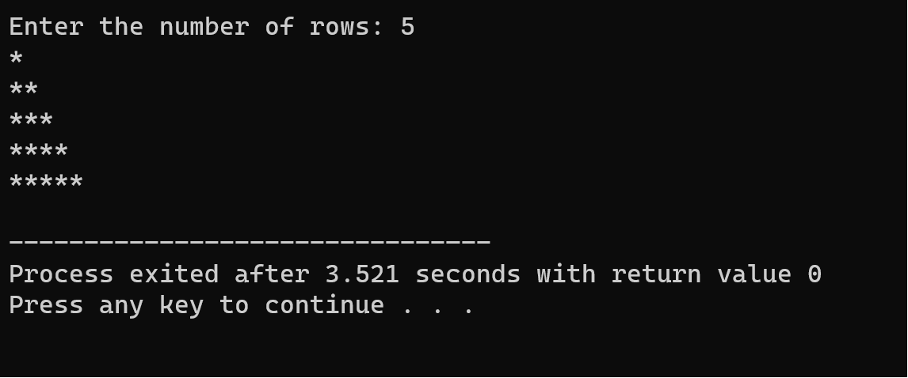

2. Find the second largest element in an array

PROGRAM:

#include <iostream>

#include <climits>

using namespace std;

int main() {

int size;

cout << "Enter the size of the array: ";

cin >> size;

if (size < 2) {

cout << "Array should contain at least two elements." << endl;

return 1;

}

int arr[100]; // Assuming maximum array size is 100

cout << "Enter elements of the array:" << endl;

for (int i = 0; i < size; i++) {

cin >> arr[i];

}

int max1 = INT_MIN;

int max2 = INT_MIN;

for (int i = 0; i < size; i++) {

if (arr[i] > max1) {

max2 = max1;

max1 = arr[i];

} else if (arr[i] > max2 && arr[i] != max1) {

max2 = arr[i];

}

}

if (max2 == INT_MIN) {

cout << "There is no second largest element in the array." << endl;

} else {

cout << "The second largest element in the array is: " << max2 << endl;

}

    return 0;

}

OUTPUT:

