**Topics: Descriptive Statistics and Probability**

1. Look at the data given below. Plot the data, find the outliers and find out $μ, σ, σ^{2}$

|  |  |
| --- | --- |
| **Name of company** | **Measure X** |
| Allied Signal | 24.23% |
| Bankers Trust | 25.53% |
| General Mills | 25.41% |
| ITT Industries | 24.14% |
| J.P.Morgan & Co. | 29.62% |
| Lehman Brothers | 28.25% |
| Marriott | 25.81% |
| MCI | 24.39% |
| Merrill Lynch | 40.26% |
| Microsoft | 32.95% |
| Morgan Stanley | 91.36% |
| Sun Microsystems | 25.99% |
| Travelers | 39.42% |
| US Airways | 26.71% |
| Warner-Lambert | 35.00% |

**Mean**: 33.27133

**Variance**: 287.1466

**Standard deviation**: 16.9454

**Distribution:**

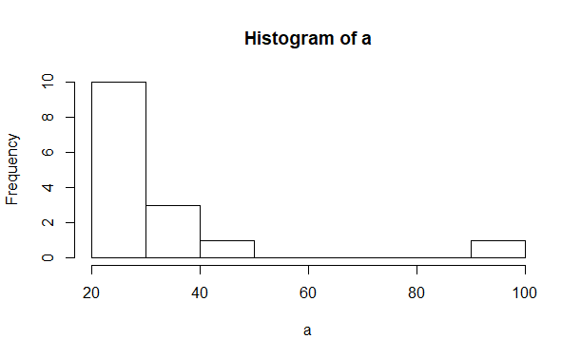

**Outliers:**

There is one outlier at approximately 90.

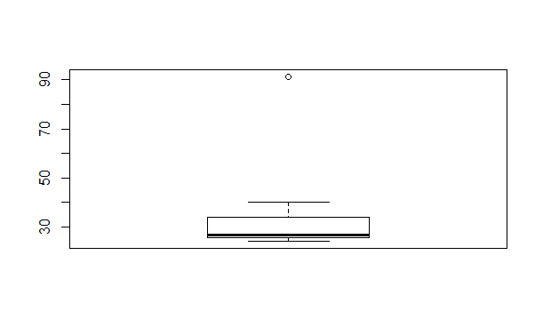



Answer the following three questions based on the box-plot above.

1. What is inter-quartile range of this dataset? (please approximate the numbers) In one line, explain what this value implies.
2. **Inter Quartile region (IQR) is approximately 5.5 . It represents the length of the box. Generally 50% of data will present in the inter quartile region.**
3. What can we say about the skewness of this dataset?
4. **Upper whisker length is longer than the lower whisker and the median is towards the left side of the box we can that it is Right skewed**.

1. If it was found that the data point with the value 25 is actually 2.5, how would the new box-plot be affected?
2. **Position of the median,upper whisker and lower whisker length is going to change**.



Answer the following three questions based on the histogram above.

1. Where would the mode of this dataset lie?
2. **According to the definition the mode will be present at the highest peak of the histogram.**

**The mode will be approximately between 5-6.**

1. Comment on the skewness of the dataset.
2. **Right skewed**
3. Suppose that the above histogram and the box-plot in question 2 are plotted for the

same dataset. Explain how these graphs complement each other in providing information about any dataset.

1. **According to both the plots we can say that the distribution is right skewed.As we know that for a right skewed distribution mean>median>mode the condition is satisfied. From the boxplot the median is almost at 7 and from the histogram the mode is almost at 5. So we can say that the condition is satisfied. And from both the plot there an outlier i.e a data point is present at 25.**
   1. AT&T was running commercials in 1990 aimed at luring back customers who had switched to one of the other long-distance phone service providers. One such commercial shows a businessman trying to reach Phoenix and mistakenly getting Fiji, where a half-naked native on a beach responds incomprehensibly in Polynesian. When asked about this advertisement, AT&T admitted that the portrayed incident did not actually take place but added that this was an enactment of something that “could happen.” Suppose that one in 200 long-distance telephone calls is misdirected. What is the probability that at least one in five attempted telephone calls reaches the wrong number? (Assume independence of attempts.)
      1. **0.024**
2. Returns on a certain business venture, to the nearest $1,000, are known to follow the following probability distribution

|  |  |
| --- | --- |
| X | P(x) |
| -2,000 | 0.1 |
| -1,000 | 0.1 |
| 0 | 0.2 |
| 1000 | 0.2 |
| 2000 | 0.3 |
| 3000 | 0.1 |

1. What is the most likely monetary outcome of the business venture?
2. **2000$**
3. Is the venture likely to be successful? Explain
4. **Yes it is likely to be successful because the probability of getting some returns i.e ‘**

**P(1000)+p(2000)+p(3000) is 0.6 and there is 0.2 of getting ‘0’ returns.**

1. What is the long-term average earning of business ventures of this kind? Explain
2. **3000$.**
3. What is the good measure of the risk involved in a venture of this kind? Compute this measure
4. **There was some risk involved in starting the venture because there was 20% (from the probabilities of -1000 and -2000) probability of getting a loss**.