Step 1: Version Control with Git

Overview
The main repository was forked from the instructor's GitHub account into a personal GitHub account. This allows maintaining an independent copy while being able to sync updates from the upstream repository.

Steps Performed
1. Navigated to the main repository: https://github.com/UnpredictablePrashant/StreamingApp.git
2. Clicked **Fork** to create a personal copy at: https://github.com/chandanbg/HV-Microservices-Task
3. Cloned the forked repository to local machine:
git clone https://github.com/chandanbg/HV-Microservices-Task.git
4. Configured upstream remote to sync with original repository:
git remote add upstream https://github.com/UnpredictablePrashant/StreamingApp.git

Repository Structure
- frontend/ — React.js frontend application
- backend/authService/ — Authentication microservice (Port 3001)
- backend/streamingService/ — Video streaming microservice (Port 3002)
- backend/adminService/ — Admin panel microservice (Port 3003)
- backend/chatService/ — Chat microservice (Port 3004)
- docker-compose.yml — Local development orchestration
- Jenkinsfile — CI/CD pipeline definition

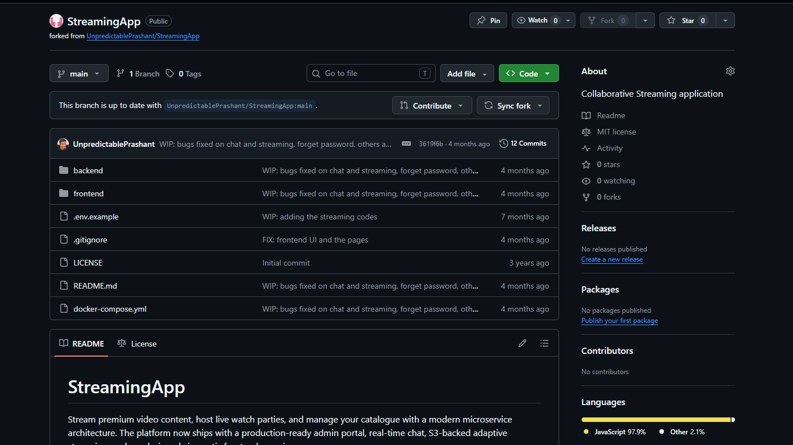

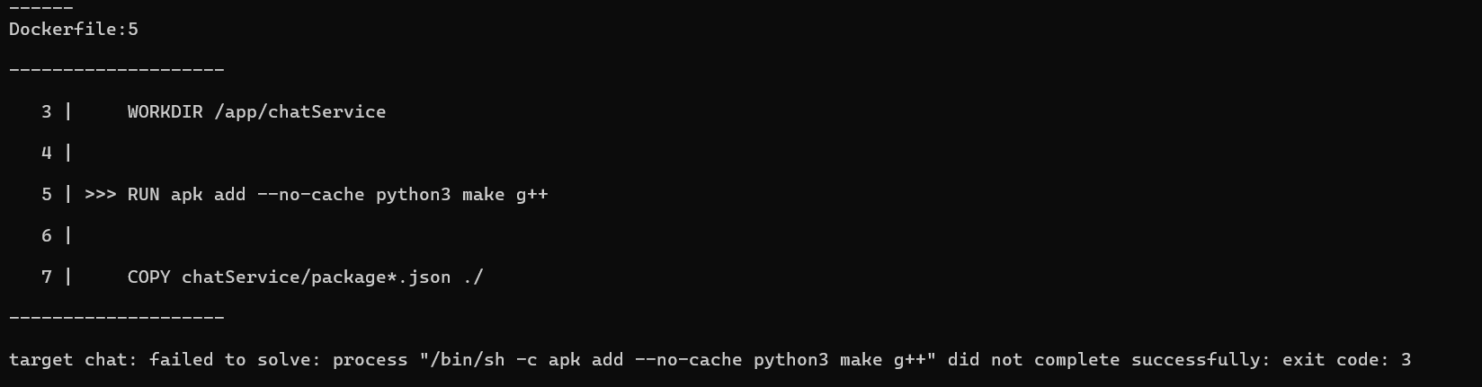

Step 2: Docker Containerization & Local Setup

Overview
Each microservice was containerized using Docker. Individual Dockerfiles were created for the frontend and each backend service. Docker Compose was used for local development and testing.

Dockerfiles Created
- frontend/Dockerfile — Multi-stage build: Node.js build stage + Nginx serve stage
- backend/authService/Dockerfile — Node.js 18 Alpine image
- backend/streamingService/Dockerfile — Node.js 18 Alpine image
- backend/adminService/Dockerfile — Node.js 18 Alpine image
- backend/chatService/Dockerfile — Node.js 18 Alpine image

Local Testing with Docker Compose
1. Built and started all services:
docker-compose up --build
2. Verified all 5 services running on their respective ports:
  - Frontend: http://localhost:3000
  - Auth Service: http://localhost:3001
  - Streaming Service: http://localhost:3002
  - Admin Service: http://localhost:3003
  - Chat Service: http://localhost:3004
3. Committed changes to GitHub:
git add . git commit -m "Completed Docker containerization and local setup" git push origin main

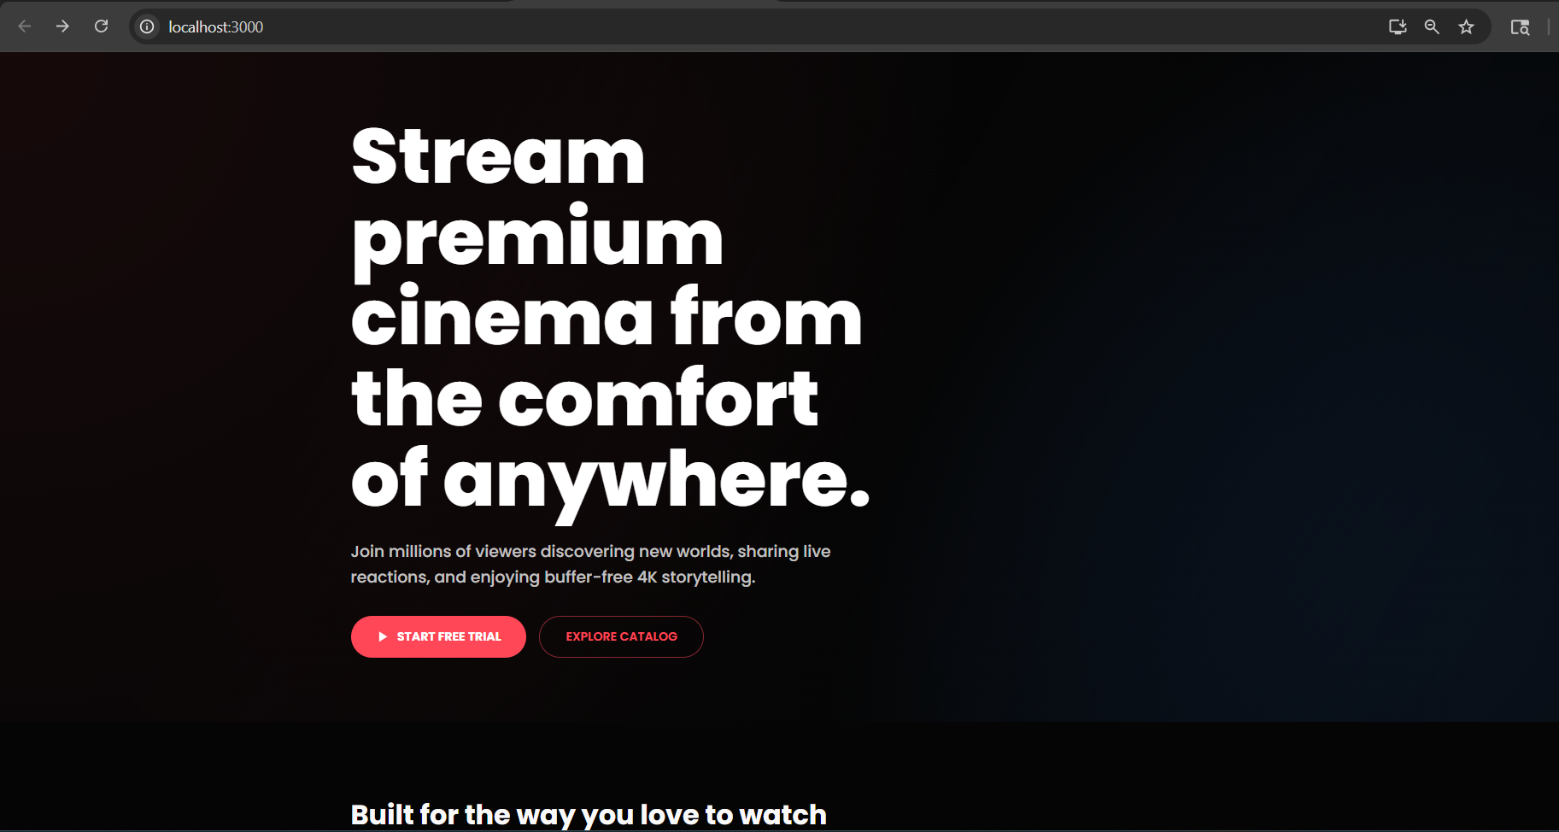

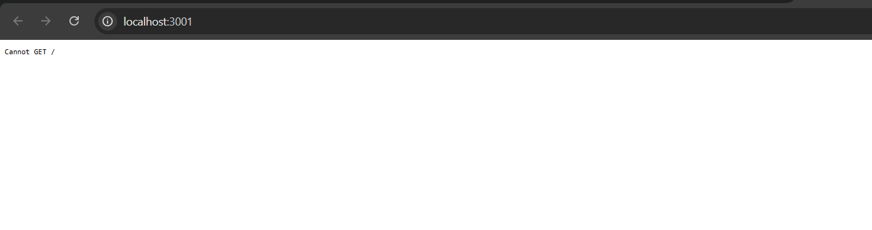
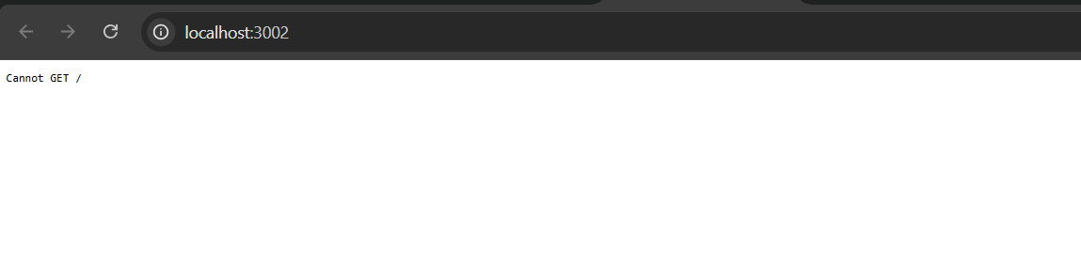
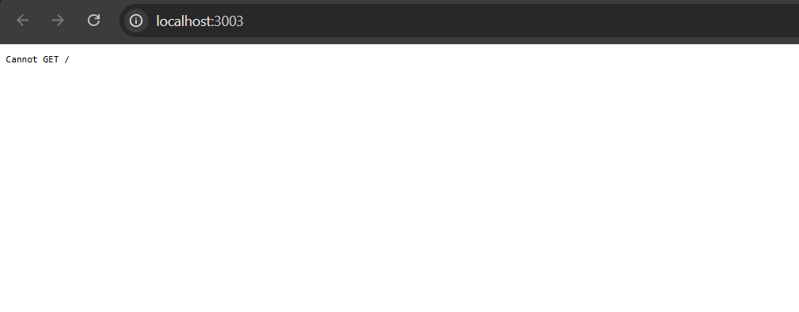
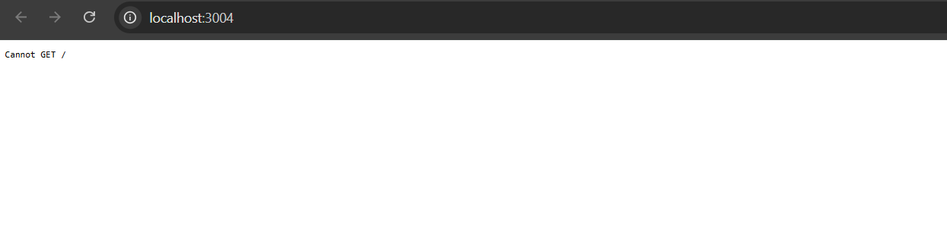

Step 3: AWS ECR — Container Registry

Overview
Amazon Elastic Container Registry (ECR) was used to store and manage Docker images. Five private ECR repositories were created — one for each microservice.

ECR Repositories Created
- 503577850130.dkr.ecr.ap-south-1.amazonaws.com/streaming-frontend
- 503577850130.dkr.ecr.ap-south-1.amazonaws.com/streaming-auth
- 503577850130.dkr.ecr.ap-south-1.amazonaws.com/streaming-service
- 503577850130.dkr.ecr.ap-south-1.amazonaws.com/streaming-admin
- 503577850130.dkr.ecr.ap-south-1.amazonaws.com/streaming-chat

Steps Performed
1. Configured AWS CLI with credentials:
aws configure
2. Created ECR repositories via AWS Console (ap-south-1 region)
3. Authenticated Docker to ECR:
aws ecr get-login-password --region ap-south-1 | docker login --username AWS --password-stdin 503577850130.dkr.ecr.ap-south-1.amazonaws.com
4. Tagged and pushed each image to ECR:
docker tag streaming-frontend:latest 503577850130.dkr.ecr.ap-south-1.amazonaws.com/streaming-frontend:latest docker push 503577850130.dkr.ecr.ap-south-1.amazonaws.com/streaming-frontend:latest

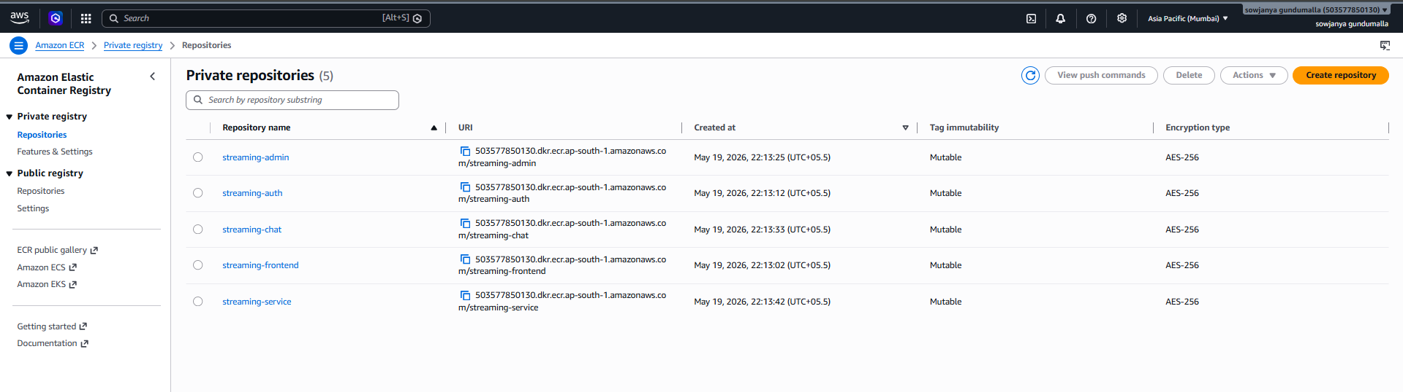

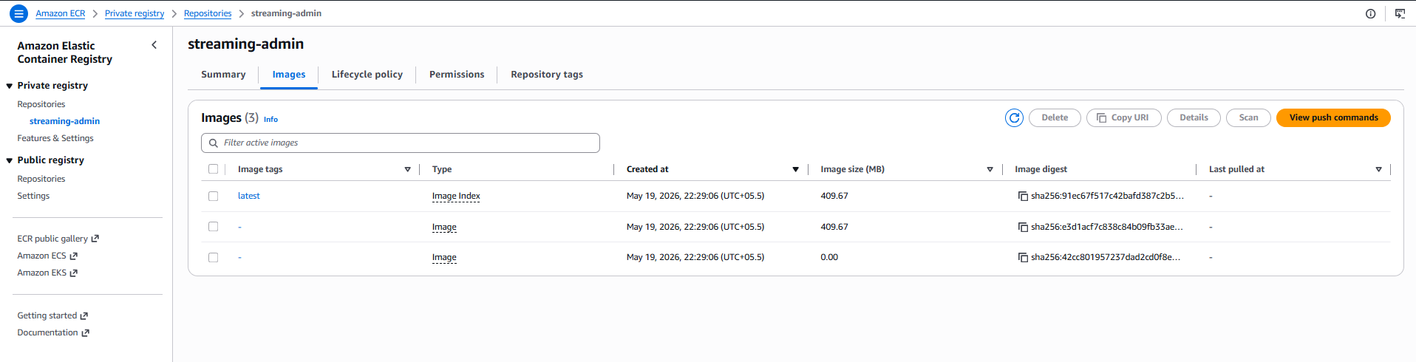

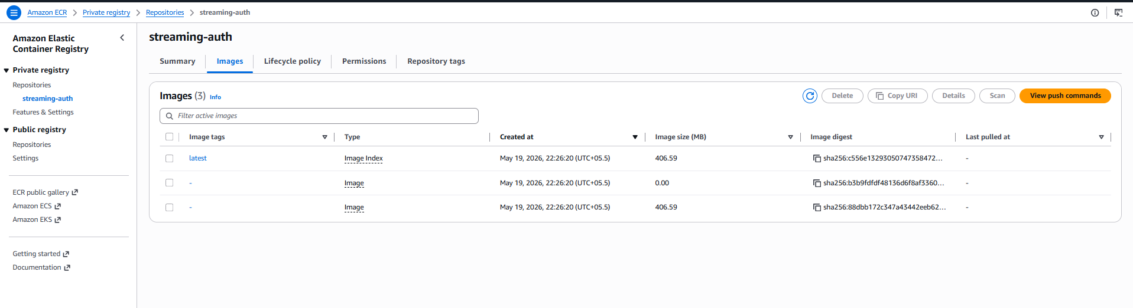
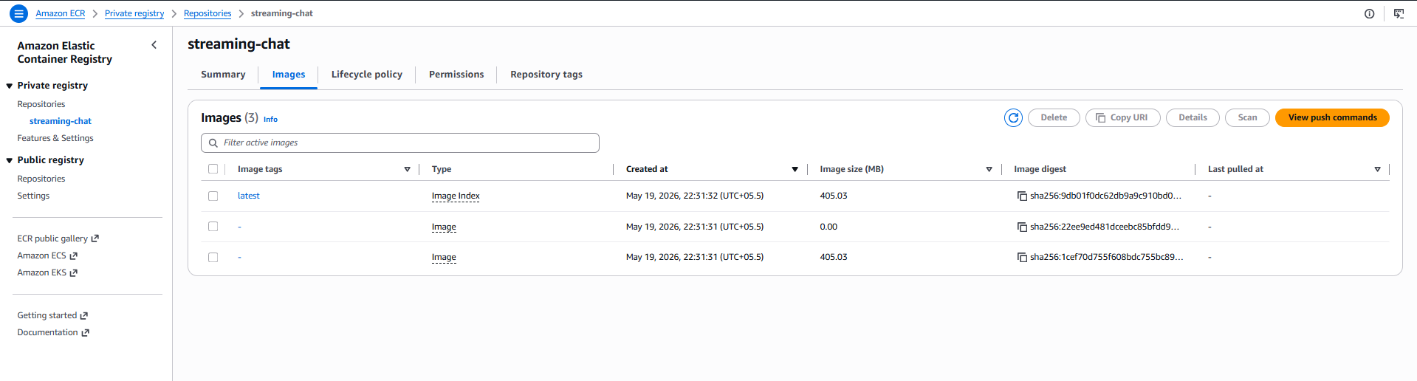
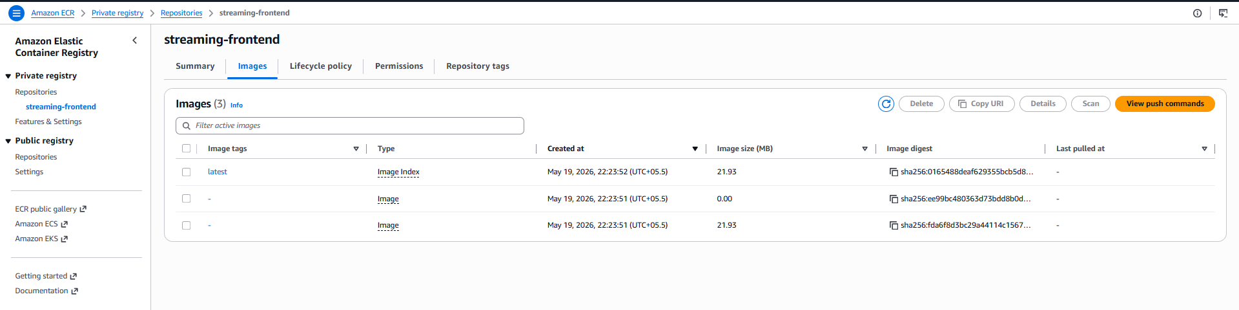
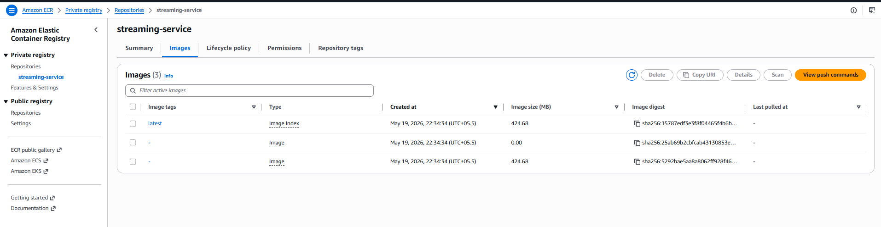

Step 4: CI/CD with Jenkins on AWS EC2

Overview
Jenkins was installed on an AWS EC2 instance (t3.small, Ubuntu 24.04) to automate the build and push process. A pipeline was created to build Docker images and push them to ECR on every GitHub commit.

EC2 Instance Setup
- Instance Type: t3.small (2 vCPU, 2GB RAM)
- OS: Ubuntu 24.04 LTS
- Region: ap-south-1 (Mumbai)
- Security Group: Port 22 (SSH), Port 8080 (Jenkins), Port 80, Port 443

Jenkins Installation Steps
1. Updated system packages:
sudo apt update
2. Installed Java 21 (required by Jenkins):
sudo apt install fontconfig openjdk-21-jre -y
3. Added Jenkins repository and GPG key:
curl -fsSL https://pkg.jenkins.io/debian-stable/jenkins.io-2023.key | sudo gpg --dearmor -o /usr/share/keyrings/jenkins-keyring.gpg echo "deb [signed-by=/usr/share/keyrings/jenkins-keyring.gpg] https://pkg.jenkins.io/debian-stable binary/" | sudo tee /etc/apt/sources.list.d/jenkins.list
4. Installed Jenkins:
sudo apt install jenkins -y sudo systemctl start jenkins sudo systemctl enable jenkins
5. Installed Docker and added Jenkins to Docker group:
sudo apt install docker.io -y sudo usermod -aG docker jenkins sudo systemctl restart jenkins
6. Installed AWS CLI:
curl "https://awscli.amazonaws.com/awscli-exe-linux-x86_64.zip" -o "awscliv2.zip" unzip awscliv2.zip sudo ./aws/install

Jenkins Configuration
1. Accessed Jenkins UI at http://<EC2-IP>:8080 and completed initial setup wizard
2. Installed plugins: Pipeline, Docker Pipeline, GitHub plugin, AWS Credentials
3. Added AWS credentials (Username with password type):
  - Credentials ID: aws-credentials
  - Username: AWS Access Key ID
  - Password: AWS Secret Access Key

Jenkins Pipeline
A declarative pipeline was created with the following stages:
- Checkout — Clones the GitHub repository
- Login to ECR — Authenticates Docker with Amazon ECR
- Build and Push Frontend — Builds and pushes frontend image
- Build and Push Auth — Builds and pushes auth service image
- Build and Push Streaming — Builds and pushes streaming service image
- Build and Push Admin — Builds and pushes admin service image
- Build and Push Chat — Builds and pushes chat service image

The Jenkinsfile was committed to the repository root for pipeline-as-code best practice.

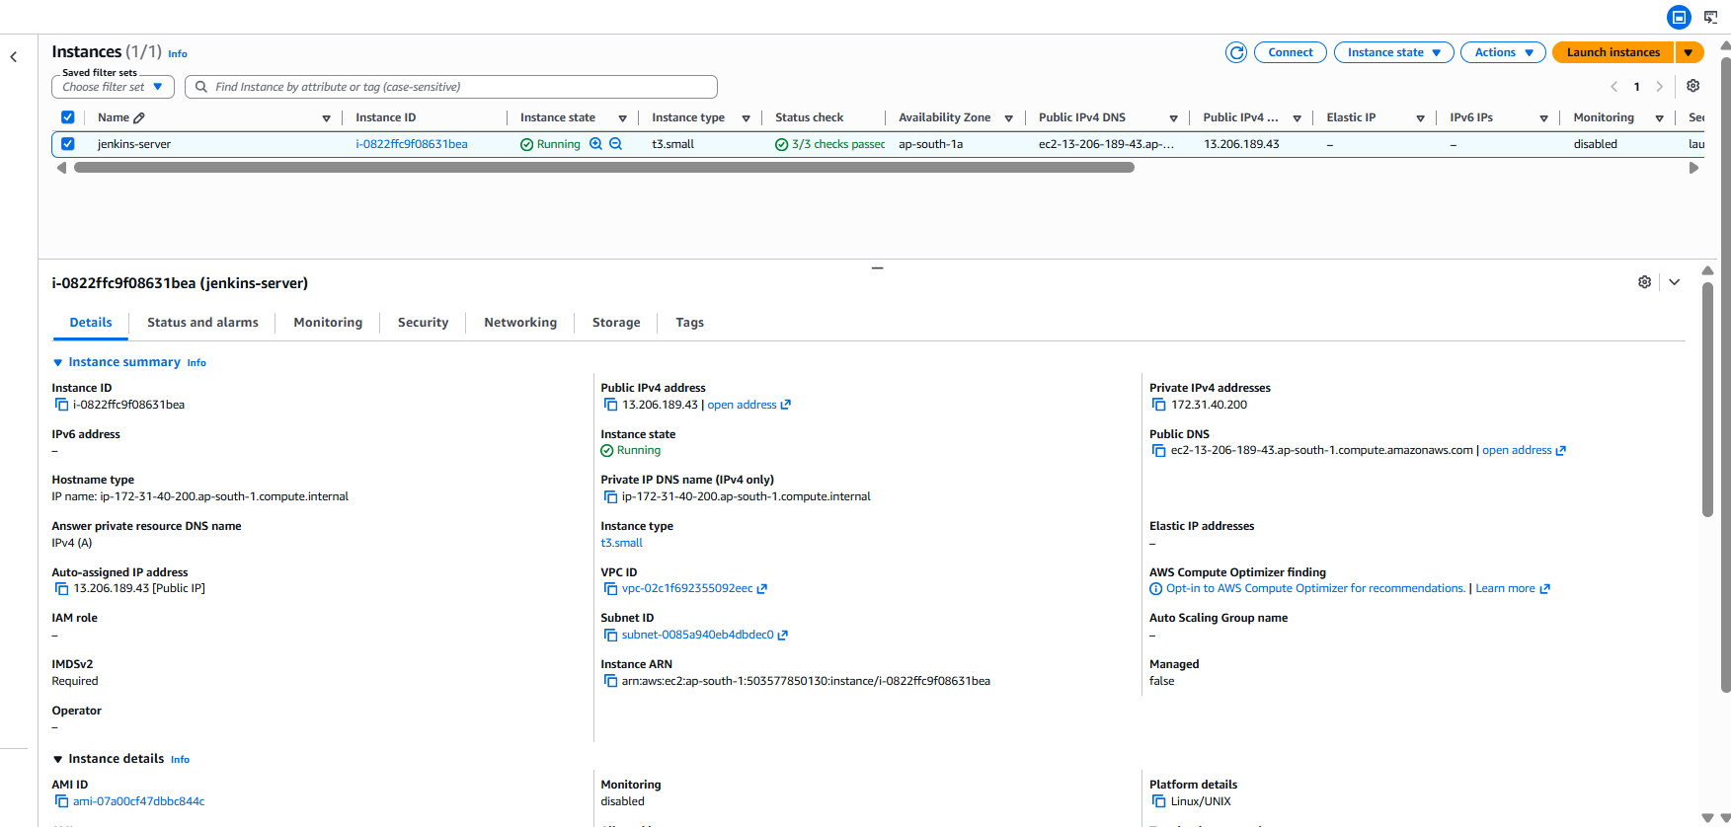

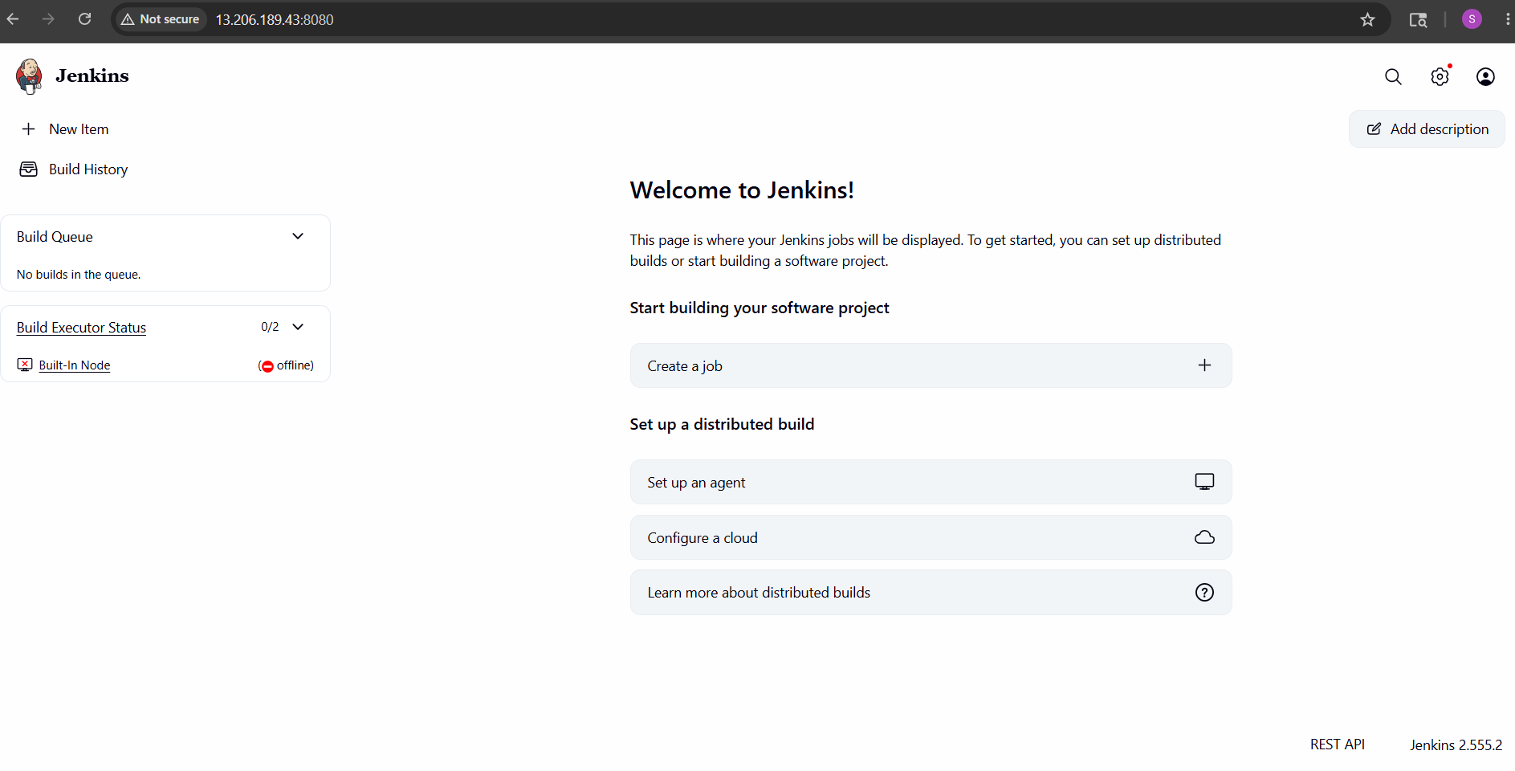

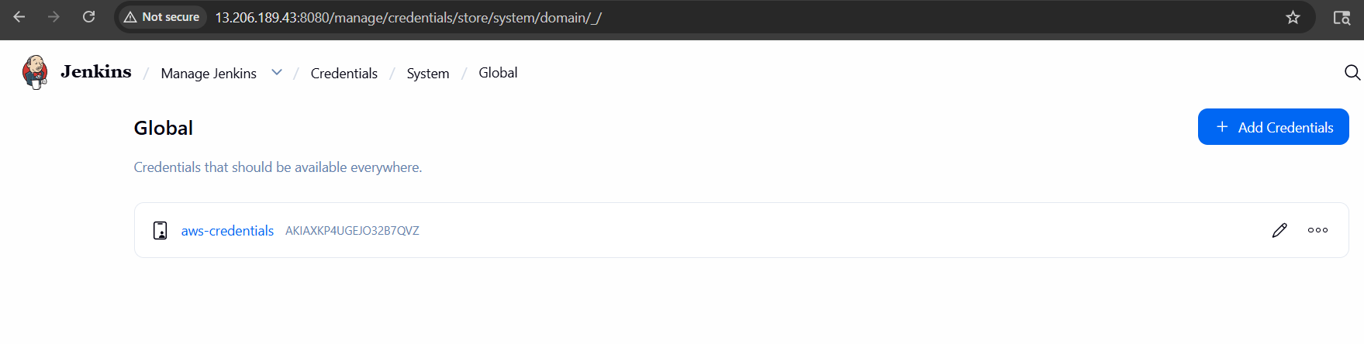

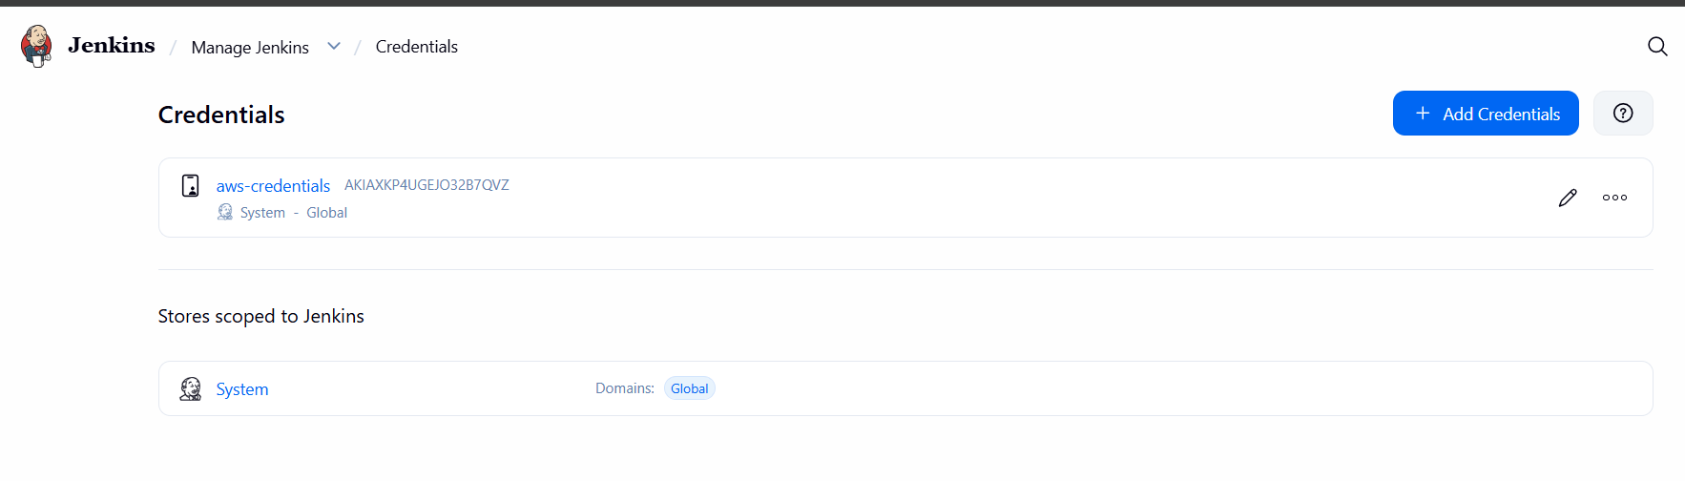

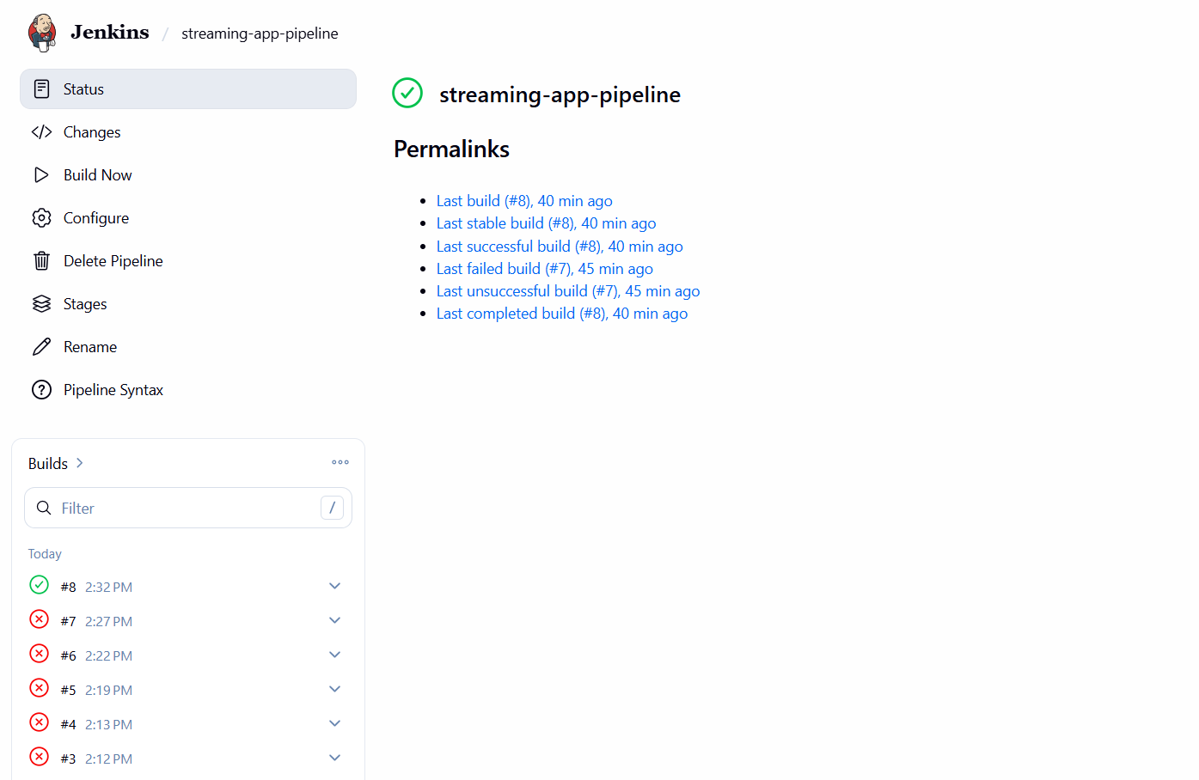

GitHub Webhook — Auto-trigger CI/CD
1. Configured webhook in GitHub repository Settings → Webhooks:
  - Payload URL: http://<EC2-IP>:8080/github-webhook/
  - Content type: application/json
  - Event: Push events
2. Enabled 'GitHub hook trigger for GITScm polling' in Jenkins pipeline configuration
3. Verified: pushing a commit automatically triggers Jenkins pipeline build

✅ Build #9 auto-triggered in 23 seconds after GitHub push

Step 5: Kubernetes Deployment with EKS & Helm

Overview
Amazon EKS (Elastic Kubernetes Service) was used to deploy the containerized application at scale. Helm was used to package and deploy all microservices as a single chart.

Tools Installed on EC2
1. Installed eksctl:
curl --silent --location "https://github.com/weaveworks/eksctl/releases/latest/download/eksctl_$(uname -s)_amd64.tar.gz" | tar xz -C /tmp sudo mv /tmp/eksctl /usr/local/bin
2. Installed kubectl:
curl -LO "https://dl.k8s.io/release/$(curl -L -s https://dl.k8s.io/release/stable.txt)/bin/linux/amd64/kubectl" sudo install -o root -g root -m 0755 kubectl /usr/local/bin/kubectl
3. Installed Helm:
curl https://raw.githubusercontent.com/helm/helm/main/scripts/get-helm-3 | bash

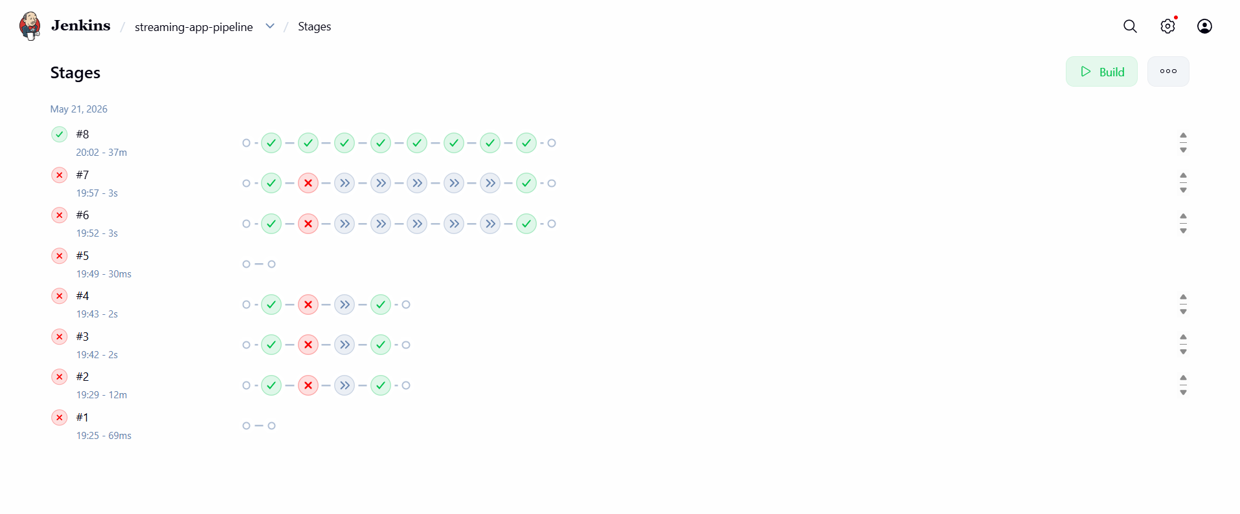

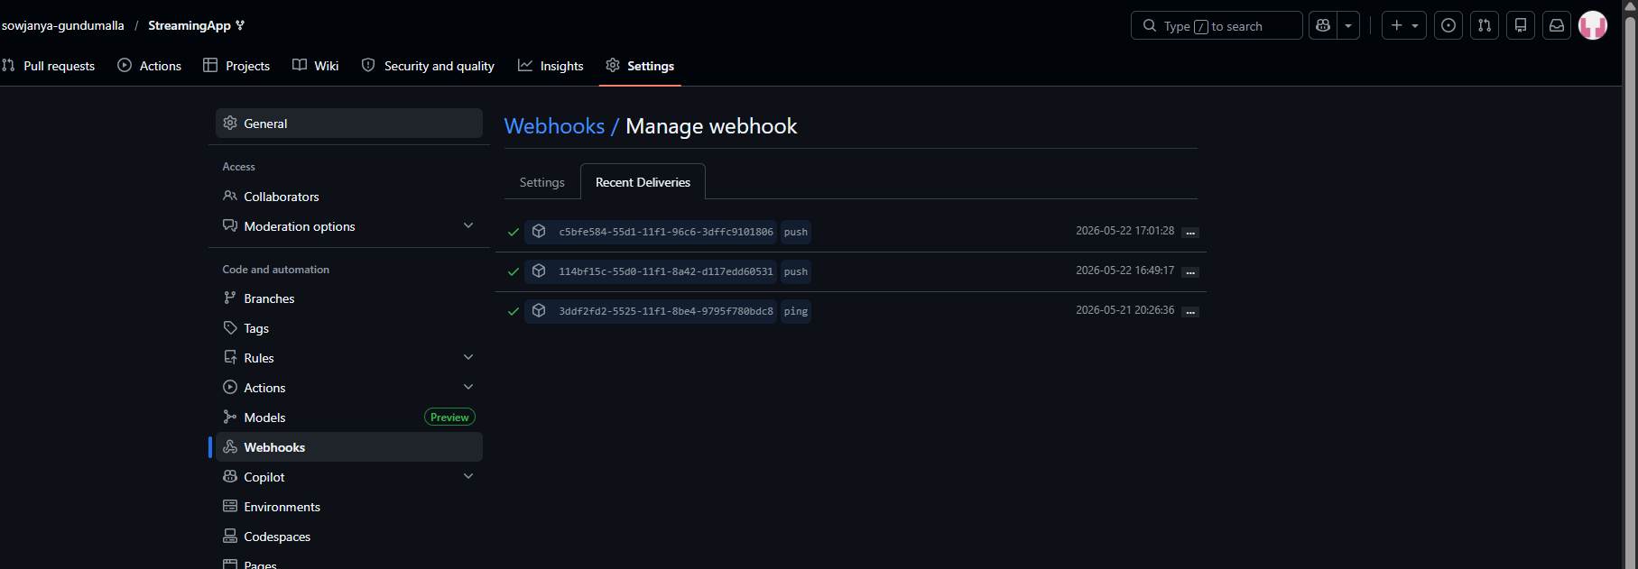

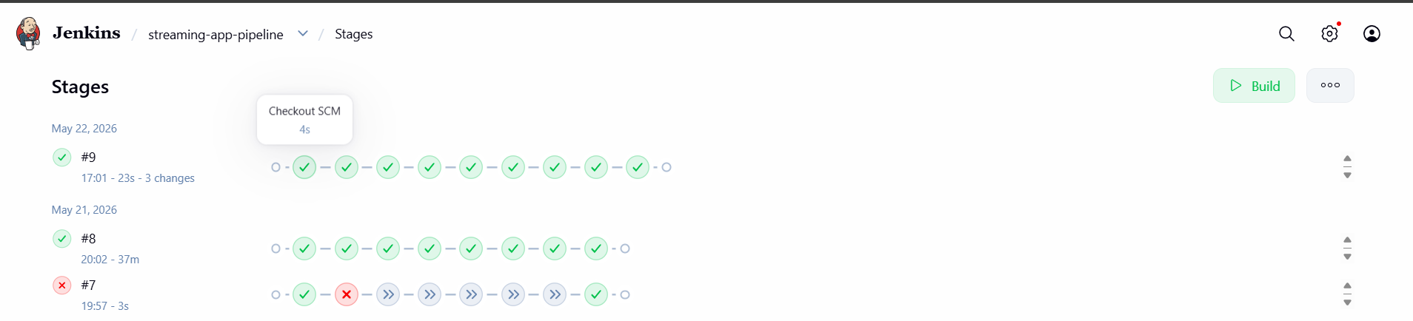

EKS Cluster Creation
1. Created EKS cluster with managed node group:
eksctl create cluster \ --name streaming-cluster \ --region ap-south-1 \ --nodegroup-name streaming-nodes \ --node-type t3.small \ --nodes 2 \ --nodes-min 1 \ --nodes-max 2 \ --managed
2. Cluster details:
  - Cluster name: streaming-cluster
  - Region: ap-south-1
  - Node type: t3.small x 2
  - Kubernetes version: v1.34.7-eks-7fcd7ec
3. Configured kubectl to connect to cluster:
aws eks update-kubeconfig --region ap-south-1 --name streaming-cluster
4. Verified nodes are ready:
kubectl get nodes

Helm Chart Structure
A custom Helm chart was created for the streaming application:
- Chart.yaml — Chart metadata (name, version, description)
- values.yaml — Configurable values (ECR registry, image names, replicas)
- templates/deployment.yaml — Kubernetes Deployments for all 5 services
- templates/service.yaml — Kubernetes Services (Frontend: LoadBalancer, Others: ClusterIP)

Helm Deployment
1. Deployed the application using Helm:
helm install streaming-app ~/streaming-app
2. Verified all pods are running:
kubectl get pods
Output showed all 5 pods in Running state:
- admin-7d5f587d6f-54fmx — Running
- auth-5f975ddfd8-jl98d — Running
- chat-85b59946c9-6f5bx — Running
- frontend-b8b8fd7c4-4jn5k — Running
- streaming-9fb8fdd98-m24mh — Running
3. Verified services and obtained LoadBalancer URL:
kubectl get services
Frontend exposed via AWS LoadBalancer:
- URL: ab3579614225d4964b895795db40c73f-1499092884.ap-south-1.elb.amazonaws.com
- Port: 80

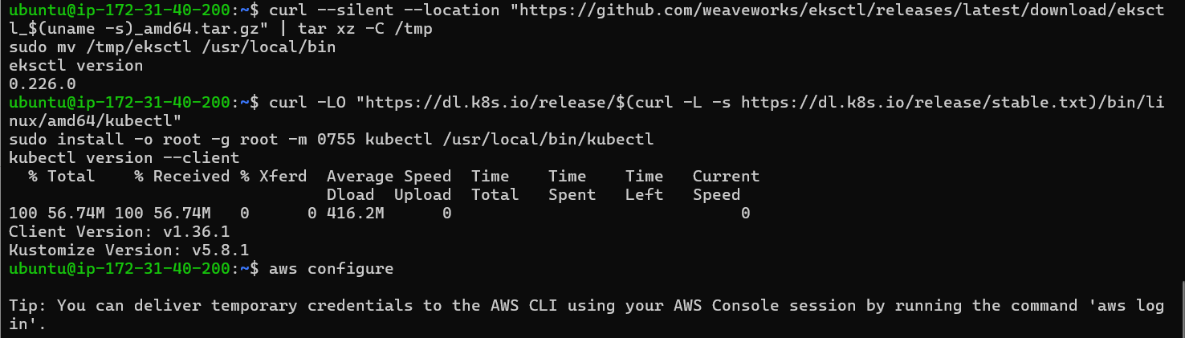

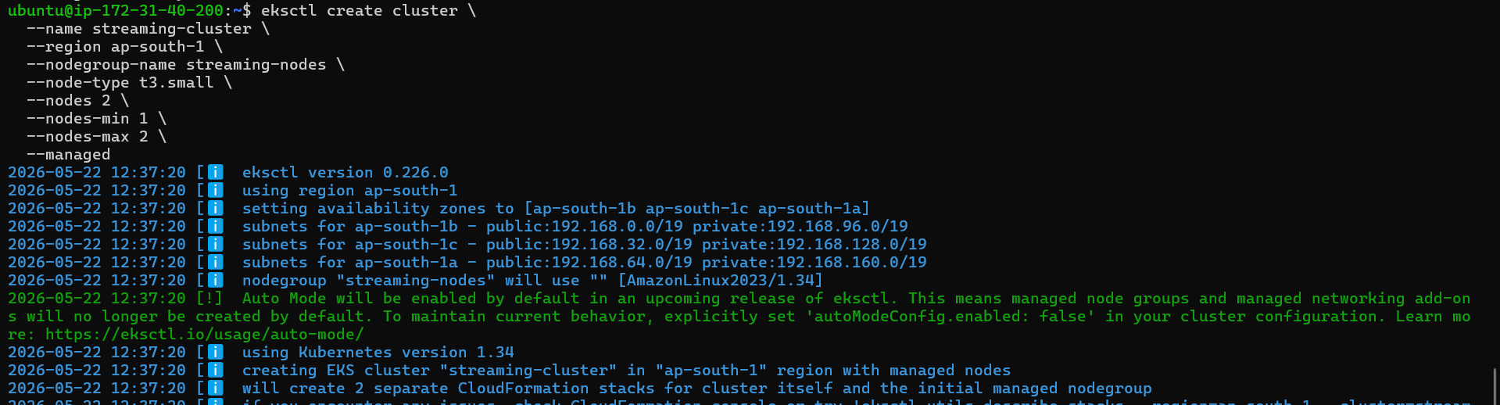

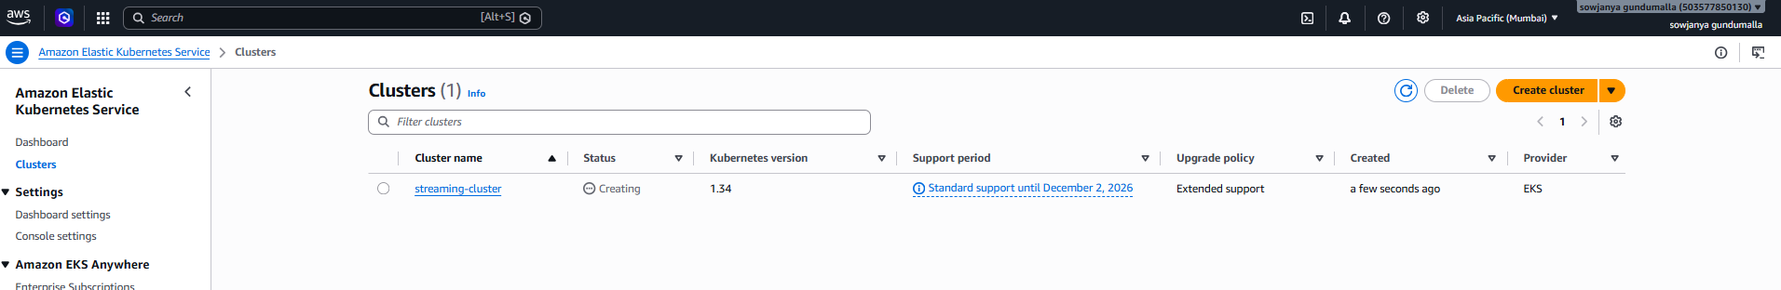

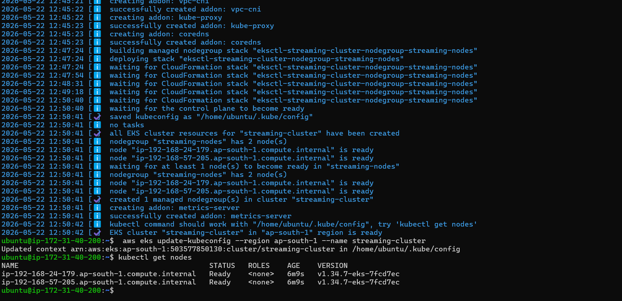

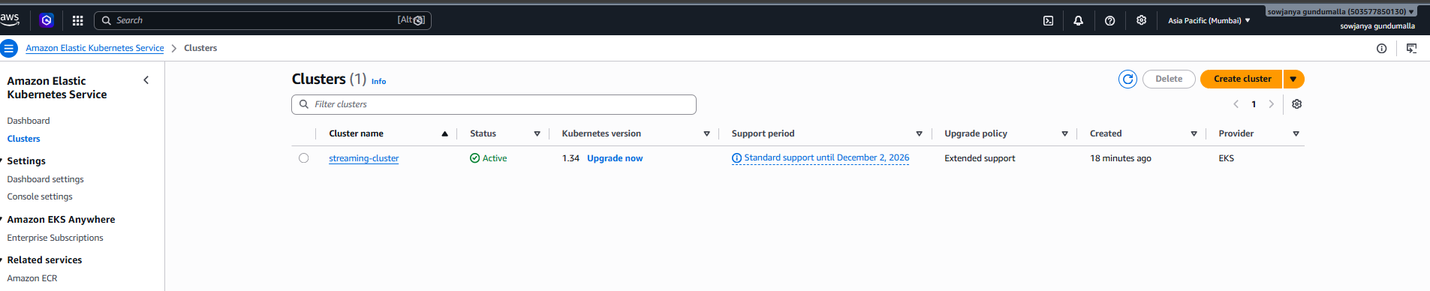
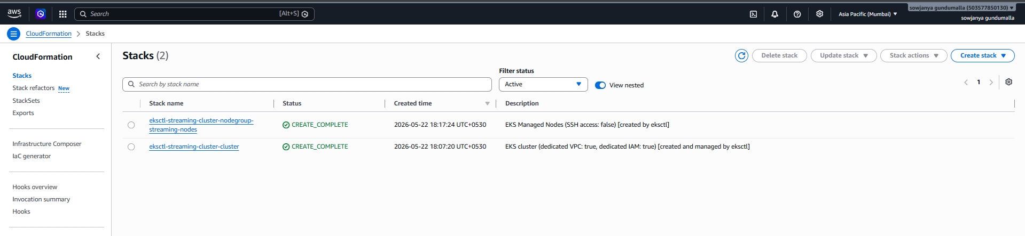

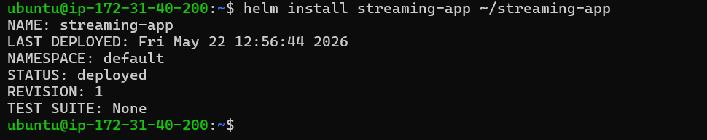

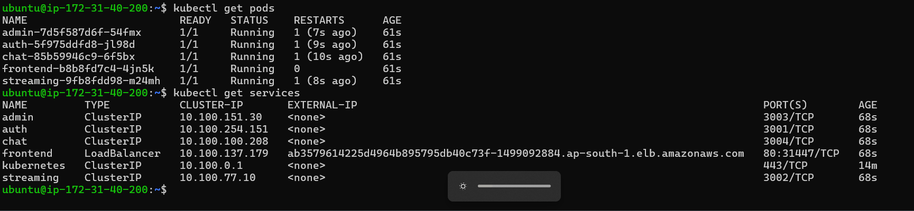

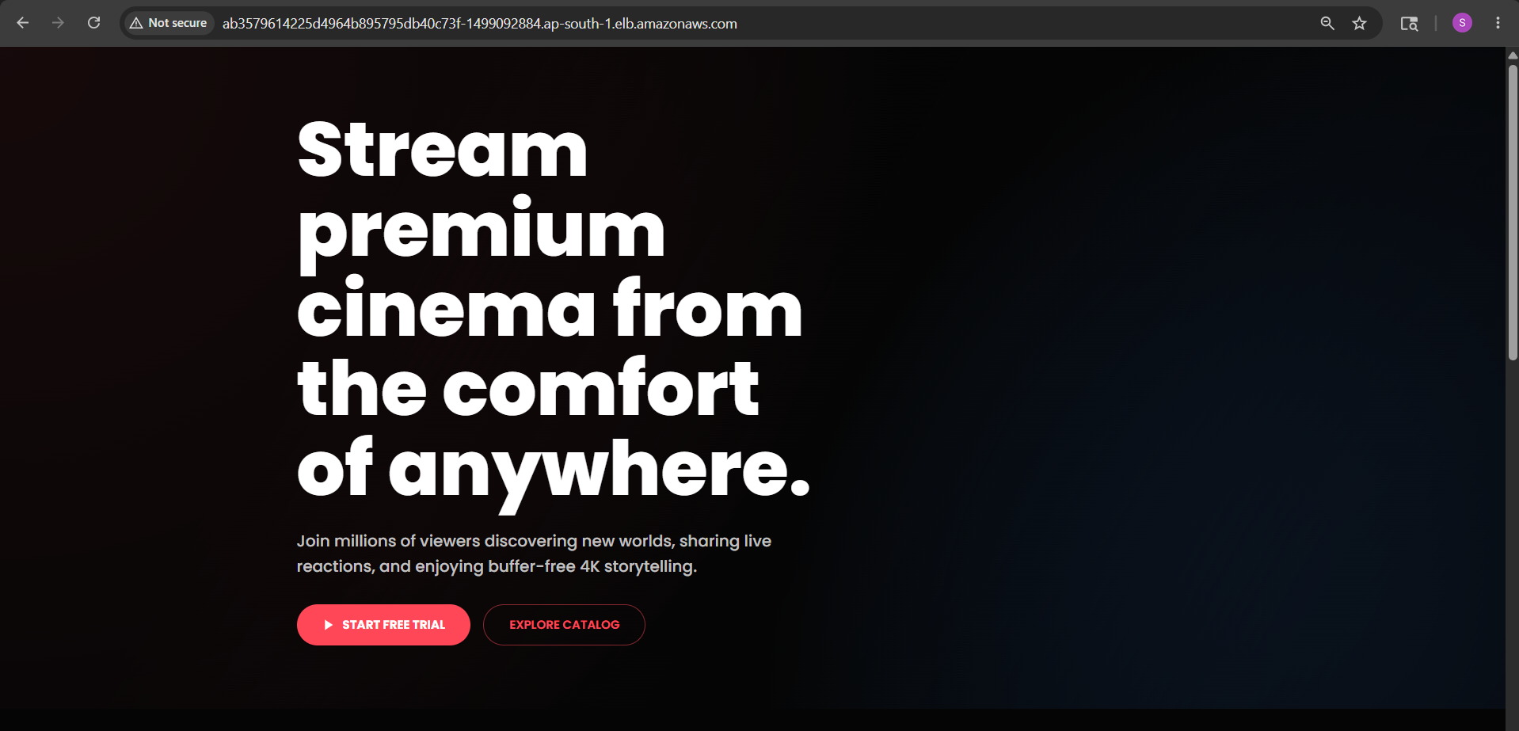

Step 6: Monitoring with Amazon CloudWatch

Overview
Amazon CloudWatch was configured for metrics collection and alerting on the EKS cluster. The CloudWatch Observability addon was installed and a CPU utilization alarm was created.

CloudWatch Observability Addon
1. Installed the CloudWatch Observability addon on the EKS cluster:
aws eks create-addon \ --cluster-name streaming-cluster \ --addon-name amazon-cloudwatch-observability \ --region ap-south-1
2. Addon version installed: v5.4.0-eksbuild.1
3. Namespace: amazon-cloudwatch

CloudWatch Alarm
1. Created CPU utilization alarm:
aws cloudwatch put-metric-alarm \ --alarm-name "EKS-CPU-High" \ --alarm-description "EKS CPU utilization high" \ --metric-name CPUUtilization \ --namespace AWS/EC2 \ --statistic Average \ --period 300 \ --threshold 80 \ --comparison-operator GreaterThanThreshold \ --evaluation-periods 2 \ --region ap-south-1
2. Alarm configuration:
  - Alarm name: EKS-CPU-High
  - Metric: CPUUtilization
  - Threshold: > 80% for 2 consecutive periods
  - Period: 300 seconds (5 minutes)

✅ CloudWatch alarm EKS-CPU-High visible in AWS CloudWatch console

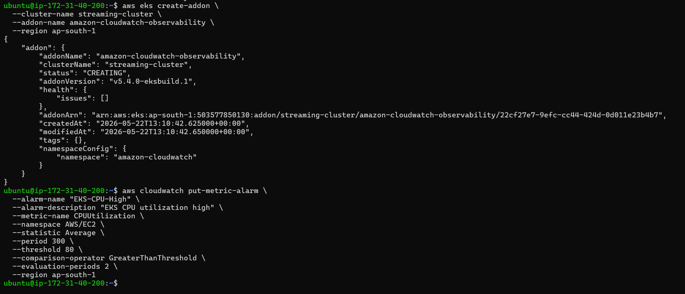

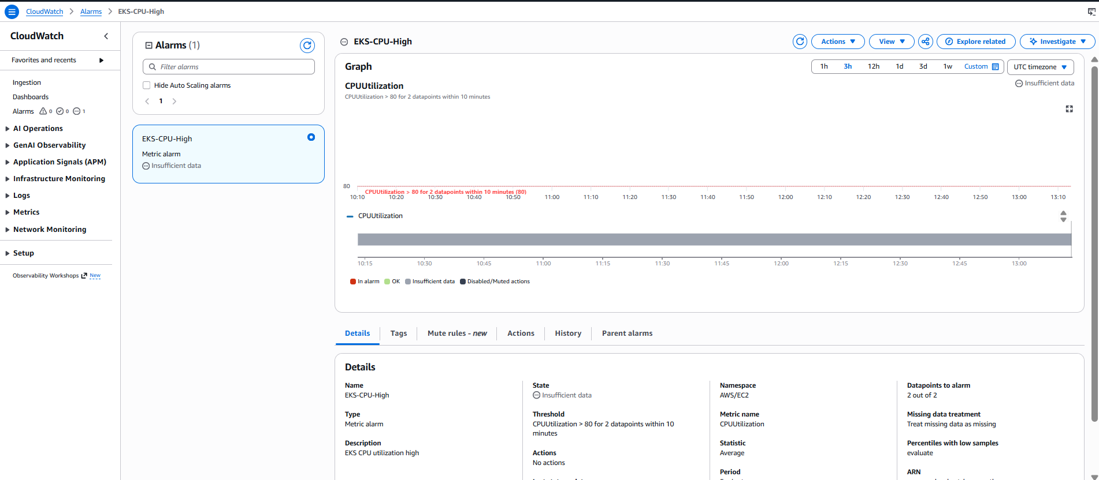

Step 7: Final Validation

Verification Checklist
✅ GitHub repository forked and maintained
✅ Docker images built for all 5 microservices
✅ All 5 ECR repositories created and images pushed
✅ Jenkins installed and configured on EC2
✅ Jenkins pipeline successfully builds and pushes to ECR
✅ GitHub webhook auto-triggers Jenkins on push
✅ EKS cluster created with 2 worker nodes
✅ All 5 pods running on Kubernetes
✅ Frontend accessible via AWS LoadBalancer URL
✅ CloudWatch monitoring configured
✅ Helm charts committed to GitHub repository

System Architecture Summary

Component Overview
- Source Control: GitHub (forked repository with Jenkinsfile)
- CI/CD: Jenkins on EC2 t3.small, triggered via GitHub webhook
- Container Registry: Amazon ECR (5 private repositories, ap-south-1)
- Container Orchestration: Amazon EKS (Kubernetes v1.34, 2x t3.small nodes)
- Deployment: Helm chart (streaming-app v0.1.0)
- Monitoring: Amazon CloudWatch with CPU alarm
- Load Balancing: AWS ELB (auto-provisioned by Kubernetes LoadBalancer service)

CI/CD Flow
1. Developer pushes code to GitHub
2. GitHub webhook notifies Jenkins
3. Jenkins pipeline triggers automatically
4. Jenkins builds Docker images for all 5 services
5. Images tagged and pushed to Amazon ECR
6. Kubernetes pulls updated images from ECR
7. Pods updated with zero downtime rolling deployment

