Area: **Mandate Tab**

Description: Enter an amount into the mandate when the reserve is $0.

Multiple error messages appear.

Error message doesn’t go away upon clicking OK.

Have to click on “x” to get rid of the error messages.

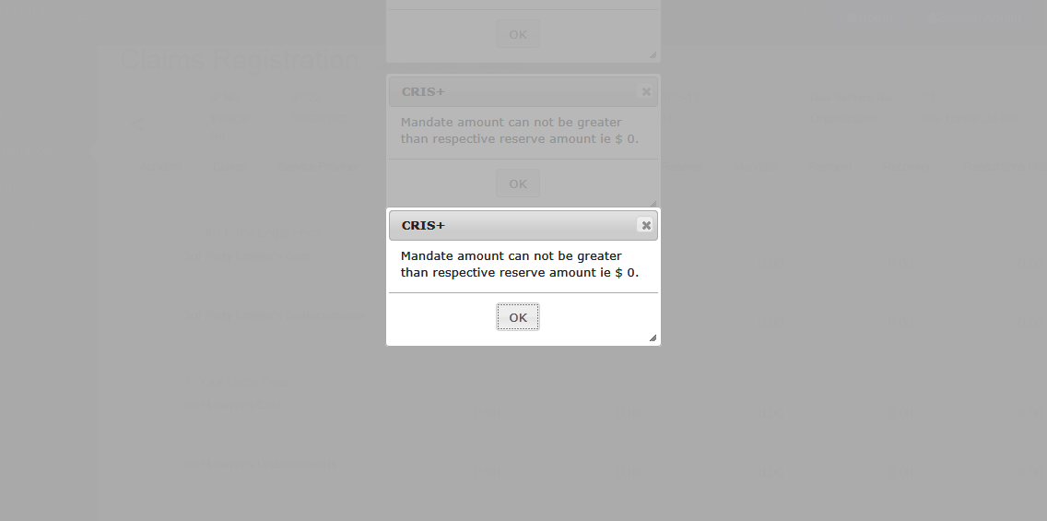

Area**: Mandate Tab**

Description: Reserve amount was entered into LOG Medical Expenses on the Reserve Tab. However this amount appeared in the Future Medical Expenses on the Mandate Tab.

Please ensure all values are mapped correctly across the various tabs.

