Launching an Amazon EC2 instance — A Step By Step Tutorial

Learn How to Launch an EC2 instance from scratch.

In my last article, I went over the Amazon EC2 service in detail. We learned about what is EC2 and its major components. What are AMIs, instances, and their types, storage options in EC2 networking and security features in EC2. This article would be a step by step tutorial for beginners to launch an EC2 instance from their AWS account.

Launching an EC2 instance

Signing up For AWS

To launch an EC2 instance first you’ll need to set up an AWS account. Amazon provides new users with **1 year of free tire access**which comes with free access to various AWS services within

Launching EC2 instance from the Management Console

Although there are various options provided by AWS to launch an EC2 instance (management console, CLI, APIs, and SDKs), **AWS Management Console** provides an interactive and neatly built user interface from which we can access and manage all the available services of AWS. To launch an EC2 instance, log in to your account that will take you to the management console. Your management console looks like this:

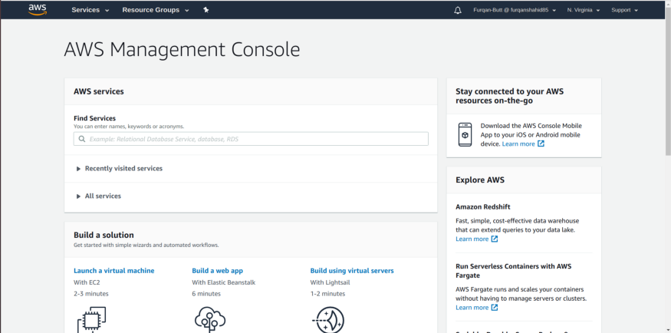

AWS Management Console

You can search for the EC2 service in the search bar or you can select your service from the **Services**option in the navbar at the top. The EC2 service will be under the **compute category**. Upon selecting the EC2 service you’ll be on the following screen.

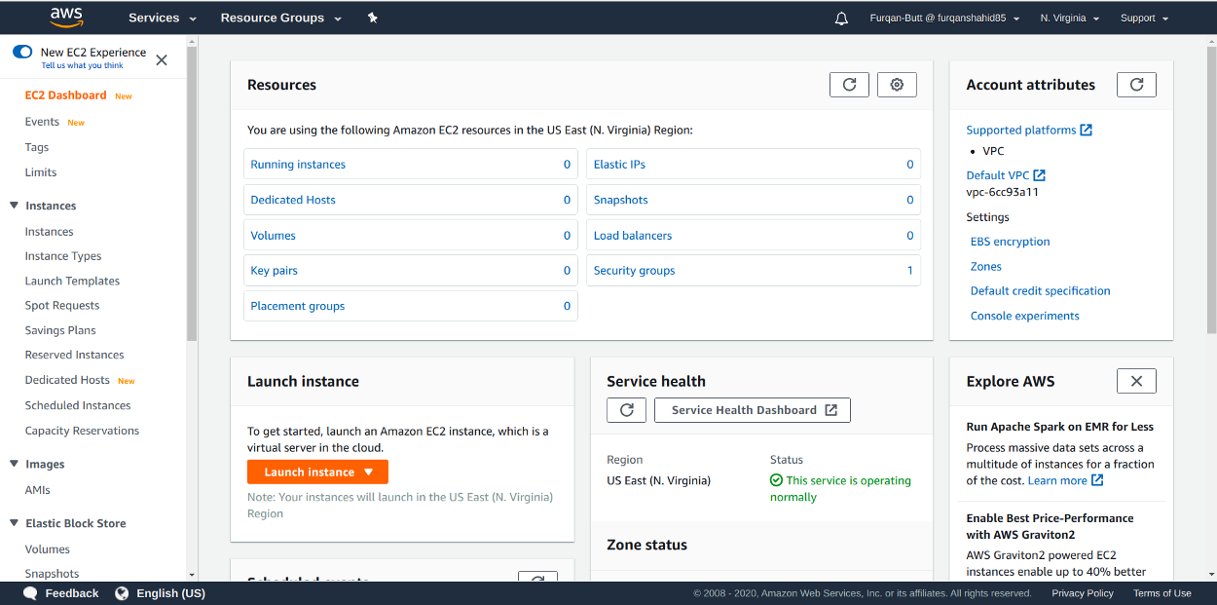

Select **instances** under the instances dropdown and click on **launch instance** option:

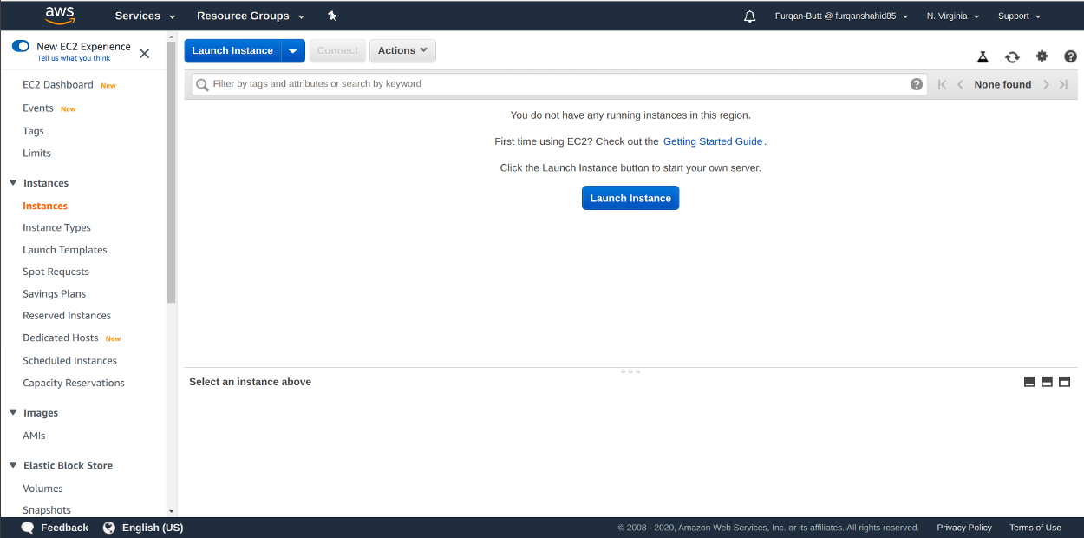

From here we have a bunch of configurations to set for our instance. First, we need to select an AMI that will be used to launch our instance. There are a number of options to select from (Redhat, ubuntu, windows). For this tutorial, we’ll just select the Amazon Linux 2 AMI which is also free tier eligible.

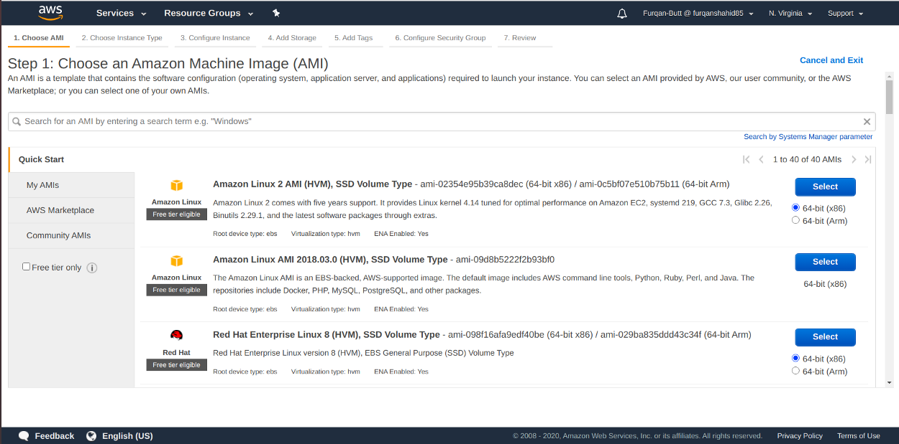

AWS AMIs

After selecting the AMI, the next step is to select the instance type we want to launch. Which instance type to launch is usually based on the type of application we want to run on our EC2 instance. AWS provides us with general-purpose, compute-optimized, memory-optimized, storage optimized, and accelerated graphics instance types and each comes with different computing, memory, storage, and networking capabilities.

For this tutorial, we’ll be selecting the **general-purpose t2.mirco** instance that is also included in the free tier. Selecting any other instance type will incur you some cost.

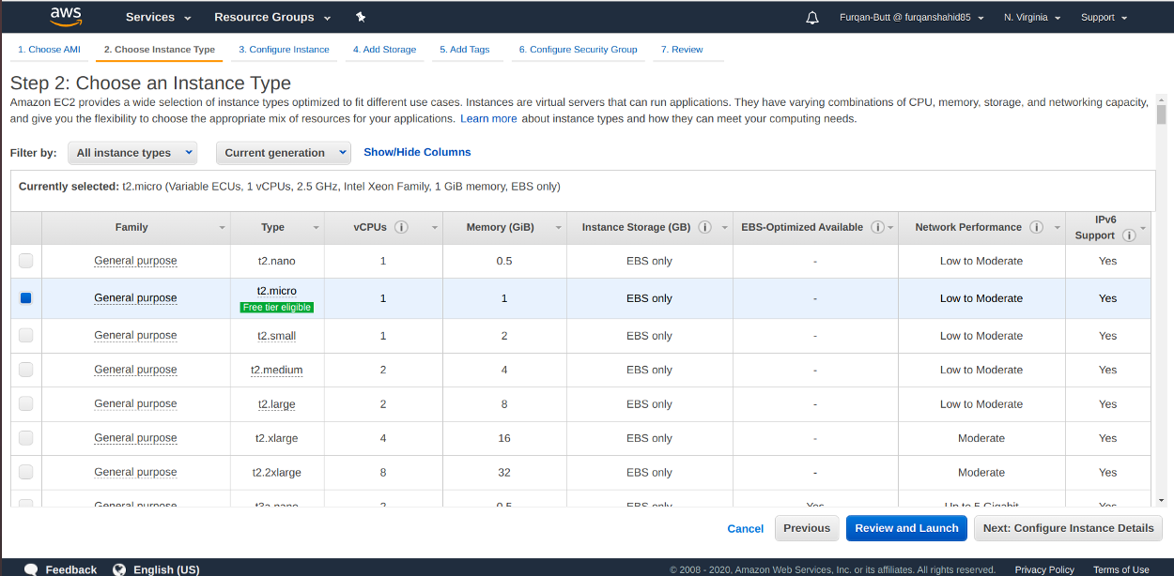

EC2 Instance Types

In the next step, we configure a few options regarding the number of instances we want to launch, selecting a VPC and subnets, IAM role, bootstrap scripts to run at launch time.

We’ll move forward with the default settings.

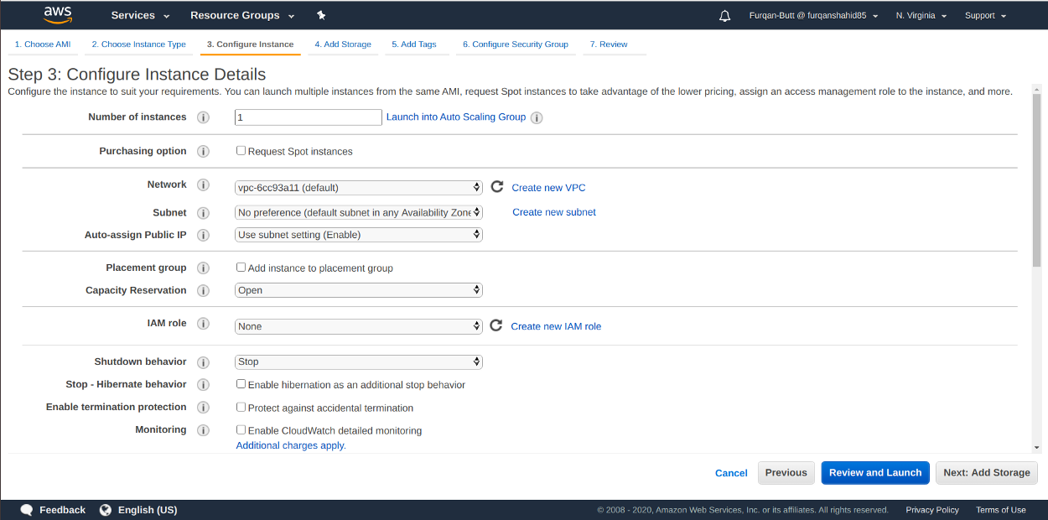

EC2 Configurations

Next, we select the storage. By default, we’ll have one EBS backed root volume attached. We can add additional EBS volumes as well with storage capacity as per our requirements. AWS provides 30GBs of free general-purpose EBS storage in the free tier.

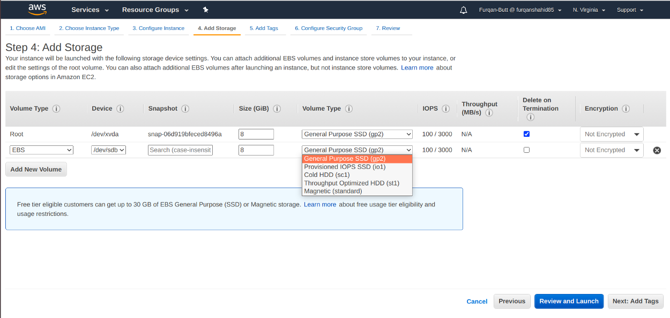

EC2 Storage

Next, we have tags. A tag is basically a case-sensitive key-value pair. For example, you could define a tag with key = Name and value = Webserver. It is best practice to tag your instances to add metadata to them. We can add up to 50 tags.

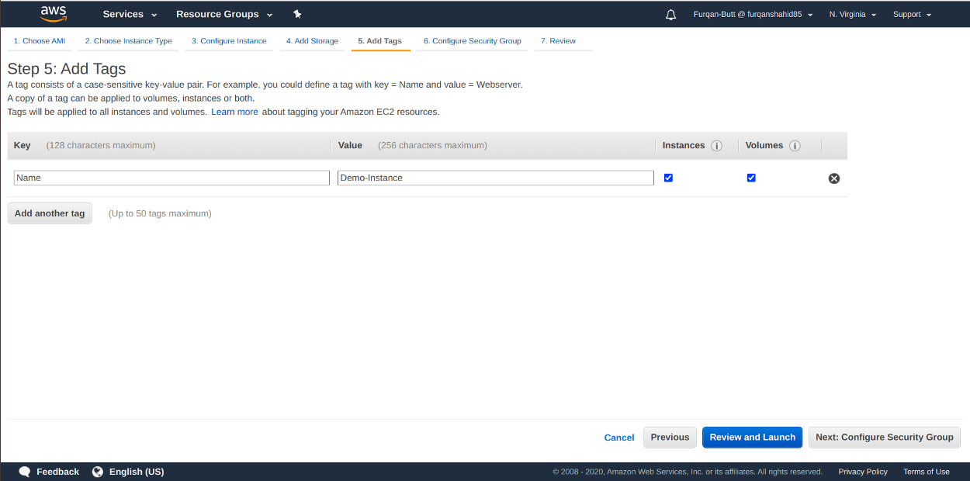

EC2 Tags

In the next step, we add security groups. Security groups act like firewalls controlling what traffic to allow and what to deny access to your instances. We can specify what protocols to accept traffic from or specific port ranges or IP ranges to allow traffic from. **It is important to define appropriate security groups to prevent any unwanted access to your instances**.

For this tutorial, we’ll just move on with the default IP range of 0.0.0.0/0 which allows all traffic to access the instance. The default setting specify we are allowing all SSH traffic on port 22.

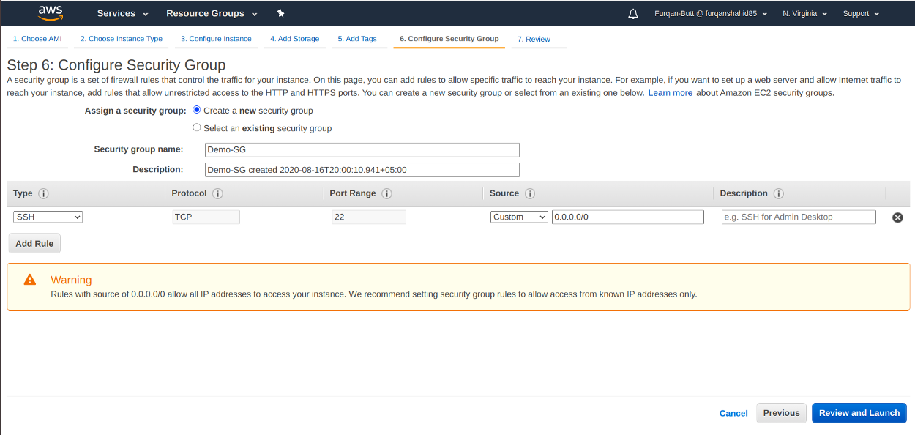

EC2 Security Group Setting.

The last step is to review our settings. After that, we process to launch the instance.

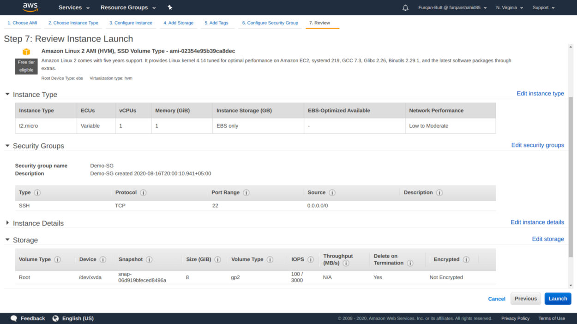

EC2 Setting Review

Upon launching, we are prompted to select the key pair that will be used to connect to the instance.

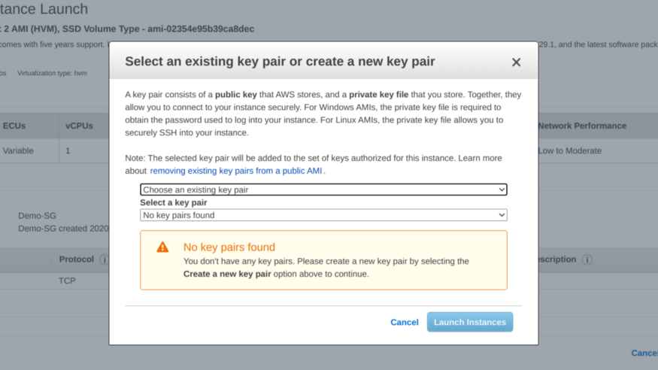

Since we haven’t created a key pair yet, select the **Create a new key pair**option and enter a name for the new key pair. It is important to download the key pair. The public key is stored by AWS while the private by the user.

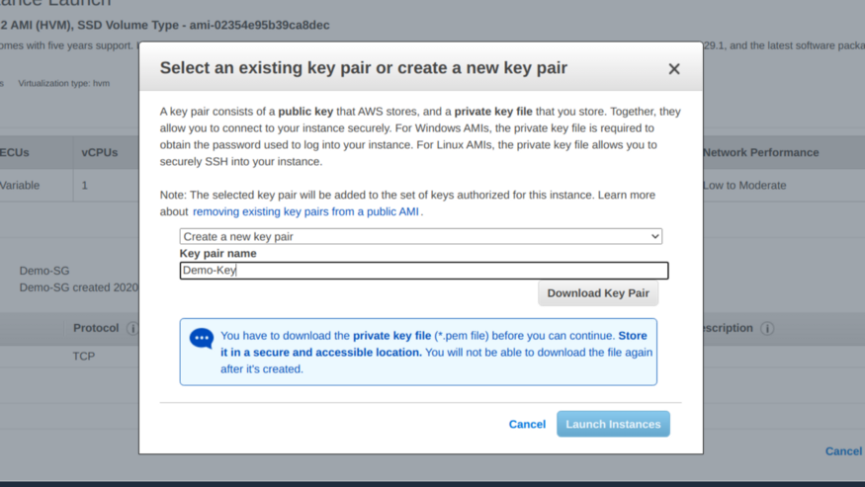

Once you have downloaded the key we can now launch the instance.

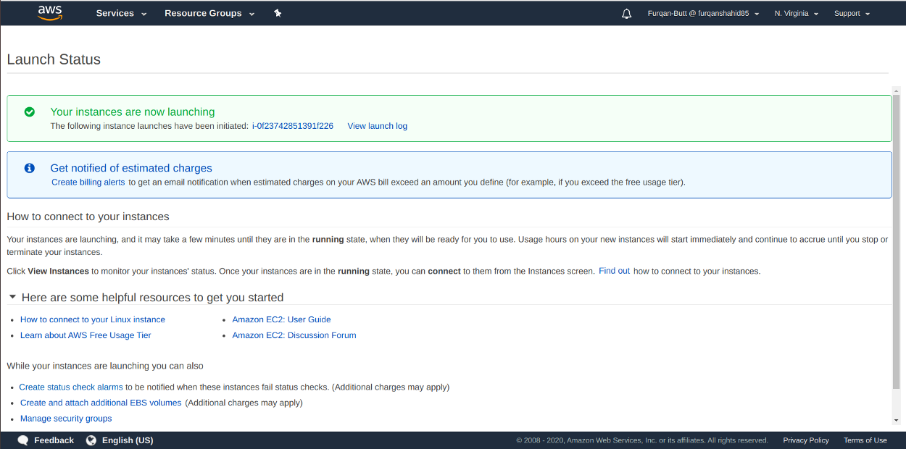

The instance can take a minute or so to launch. Click the **View Instances**button to see the all your instances.

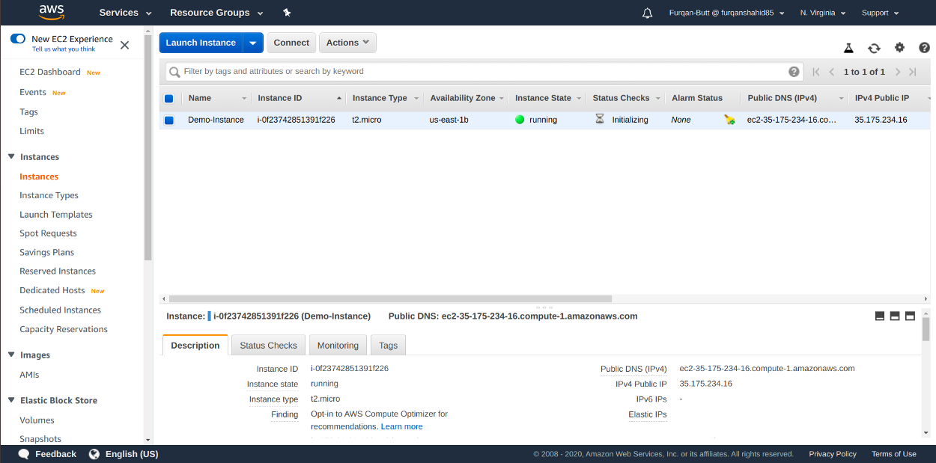

As we can see our instance is properly launched.

**Connecting to EC2 Instance**

Now that our instance is up and running we can now connect to it. On Mac or Linux we can connect to our instance via ssh server. Installing ssh on Mac or Linux.

Open the terminal application for Ubuntu desktop. Type

sudo apt-get install openssh-server

Enable the ssh service by typing

sudo systemctl enable ssh

Start the ssh service by typing

sudo systemctl start ssh

Test it by login into the system using **ssh user@server-name.**

Now that we have ssh installed, locate your private key file (Demo-Key.pem) and do

chmod 400 Demo-Key.pem

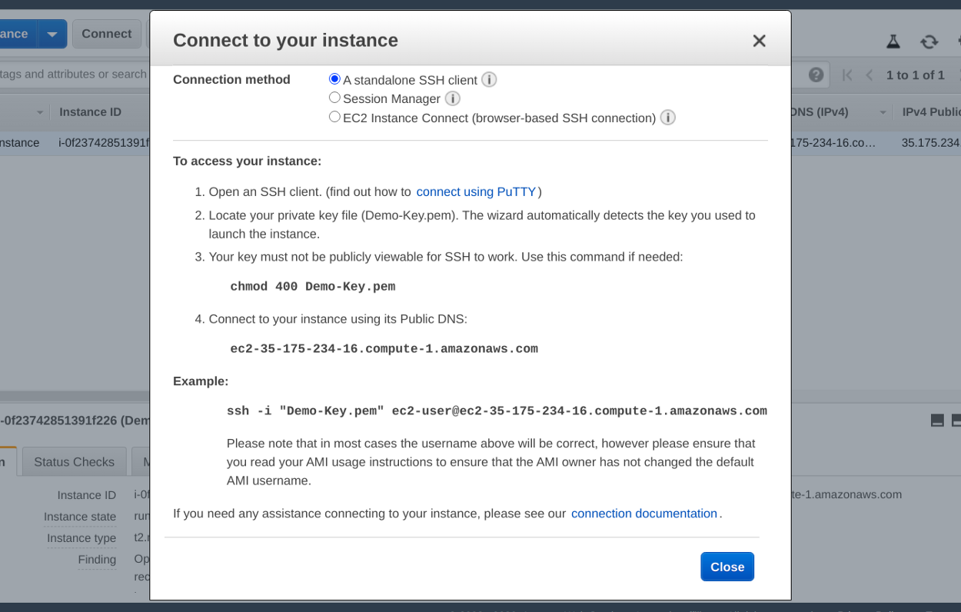

After that, Connect to your instance via that following command:

ssh -i "Demo-Key.pem" ec2-user@ec2-35-175-234-16.compute-1.amazonaws.com

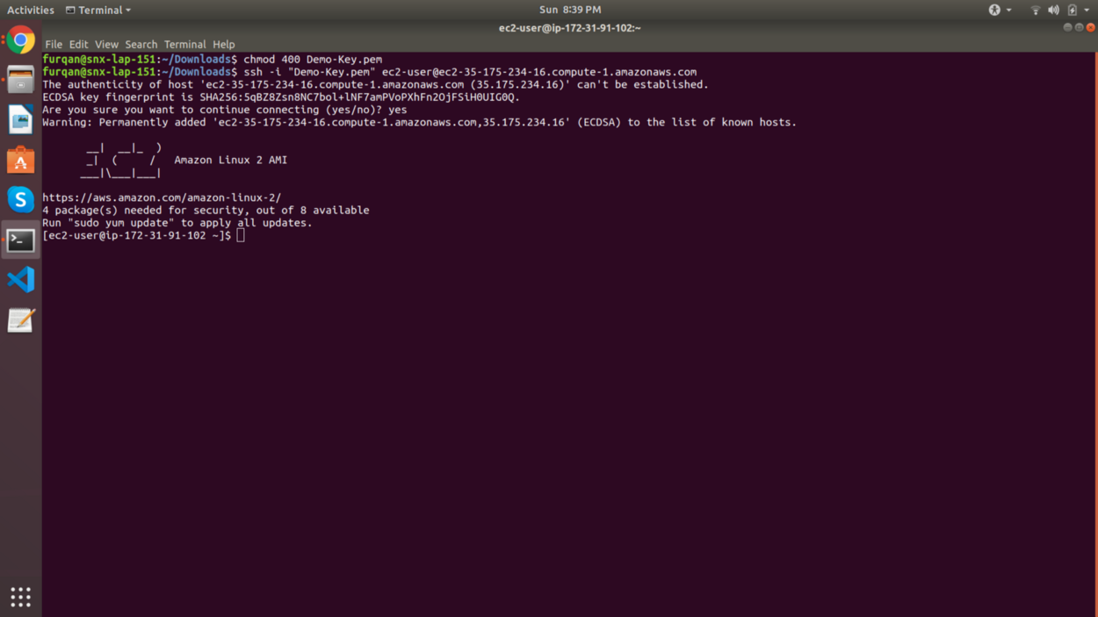

As we can see we are connected to our instance. If you don't want to connect via ssh you can select the **EC2 Instance Connect** Option which will open a connection to your EC2 instance in your browser window.

**Note: Always stop or terminate your instance when not using because all running instances will incur you cost.