Multithreading in Python | Set 1

**Thread**

In computing, a **process** is an instance of a computer program that is being executed. Any process has 3 basic components:

* An executable program.
* The associated data needed by the program (variables, work space, buffers, etc.)
* The execution context of the program (State of process)

A **thread** is an entity within a process that can be scheduled for execution. Also, it is the smallest unit of processing that can be performed in an OS (Operating System).

In simple words, a **thread** is a sequence of such instructions within a program that can be executed independently of other code. For simplicity, you can assume that a thread is simply a subset of a process!

A thread contains all this information in a **Thread Control Block (TCB)**:

* **Thread Identifier:** Unique id (TID) is assigned to every new thread
* **Stack pointer:** Points to thread’s stack in the process. Stack contains the local variables under thread’s scope.
* **Program counter:** a register which stores the address of the instruction currently being executed by thread.
* **Thread state:** can be running, ready, waiting, start or done.
* **Thread’s register set:** registers assigned to thread for computations.
* **Parent process Pointer:** A pointer to the Process control block (PCB) of the process that the thread lives on.

Consider the diagram below to understand the relation between process and its thread:

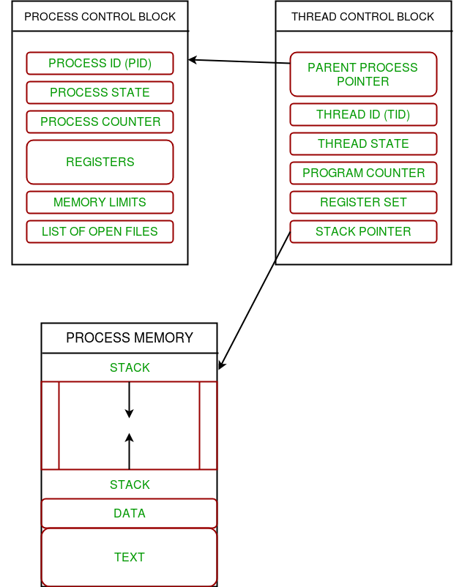

**Multithreading**

Multiple threads can exist within one process where:

* Each thread contains its own **register set** and **local variables (stored in stack)**.
* All thread of a process share **global variables (stored in heap)** and the **program code**.

Consider the diagram below to understand how multiple threads exist in memory:

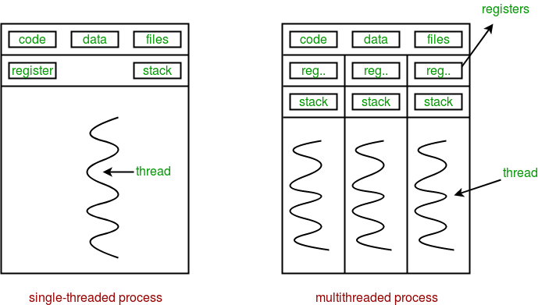

**Multithreading** is defined as the ability of a processor to execute multiple threads concurrently.

*In a simple, single-core CPU, it is achieved using frequent switching between threads.*

*This is termed as****context switching****. In context switching, the state of a thread is saved and state of another thread is loaded whenever any interrupt (due to I/O or manually set) takes place.*

*Context switching takes place so frequently that all the threads appear to be running parallely (this is termed as****multitasking****).*

Consider the diagram below in which a process contains two active threads:

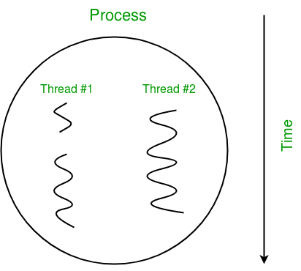

**Multithreading in Python**

In Python, the **threading** module provides a very simple and intuitive API for spawning multiple threads in a program.

Let us consider a simple example using threading module:

|  |
| --- |
| # Python program to illustrate the concept  # of threading  # importing the threading module  import threading    def print_cube(num):      """      function to print cube of given num      """      print("Cube: {}".format(num * num * num))    def print_square(num):      """      function to print square of given num      """      print("Square: {}".format(num * num))    if __name__ == "__main__":      # creating thread      t1 = threading.Thread(target=print_square, args=(10,))      t2 = threading.Thread(target=print_cube, args=(10,))        # starting thread 1      t1.start()      # starting thread 2      t2.start()        # wait until thread 1 is completely executed      t1.join()      # wait until thread 2 is completely executed      t2.join()        # both threads completely executed      print("Done!") |

Square: 100

Cube: 1000

Done!

Let us try to understand the above code:

* To import the threading module, we do:
* import threading
* To create a new thread, we create an object of **Thread** class. It takes following arguments:
  + **target**: the function to be executed by thread
  + **args**: the arguments to be passed to the target function

In above example, we created 2 threads with different target functions:

t1 = threading.Thread(target=print_square, args=(10,))

t2 = threading.Thread(target=print_cube, args=(10,))

* To start a thread, we use **start** method of **Thread** class.
* t1.start()
* t2.start()
* Once the threads start, the current program (you can think of it like a main thread) also keeps on executing. In order to stop execution of current program until a thread is complete, we use **join** method.
* t1.join()
* t2.join()

As a result, the current program will first wait for the completion of **t1** and then **t2**. Once, they are finished, the remaining statements of current program are executed.

Consider the diagram below for a better understanding of how above program works:

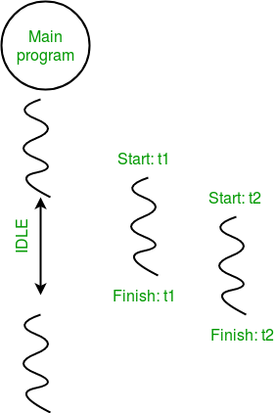

Consider the python program given below in which we print thread name and corresponding process for each task:

|  |
| --- |
| # Python program to illustrate the concept  # of threading  import threading  import os    def task1():      print("Task 1 assigned to thread: {}".format(threading.current_thread().name))      print("ID of process running task 1: {}".format(os.getpid()))    def task2():      print("Task 2 assigned to thread: {}".format(threading.current_thread().name))      print("ID of process running task 2: {}".format(os.getpid()))    if __name__ == "__main__":        # print ID of current process      print("ID of process running main program: {}".format(os.getpid()))        # print name of main thread      print("Main thread name: {}".format(threading.current_thread().name))        # creating threads      t1 = threading.Thread(target=task1, name='t1')      t2 = threading.Thread(target=task2, name='t2')        # starting threads      t1.start()      t2.start()        # wait until all threads finish      t1.join()      t2.join() |

ID of process running main program: 11758

Main thread name: MainThread

Task 1 assigned to thread: t1

ID of process running task 1: 11758

Task 2 assigned to thread: t2

ID of process running task 2: 11758

Let us try to understand the above code:

* We use **os.getpid()** function to get ID of current process.
* print("ID of process running main program: {}".format(os.getpid()))

As it is clear from the output, the process ID remains same for all threads.

* We use **threading.main_thread()** function to get the main thread object. In normal conditions, the main thread is the thread from which the Python interpreter was started. **name** attribute of thread object is used to get the name of thread.
* print("Main thread name: {}".format(threading.main_thread().name))
* We use the **threading.current_thread()** function to get the current thread object.
* print("Task 1 assigned to thread: {}".format(threading.current_thread().name))

The diagram given below clears the above concept:  
