Multiprocessing in Python

**What is multiprocessing?**

Multiprocessing refers to the ability of a system to support more than one processor at the same time. Applications in a multiprocessing system are broken to smaller routines that run independently. The operating system allocates these threads to the processors improving performance of the system.

**Why multiprocessing?**

Consider a computer system with a single processor. If it is assigned several processes at the same time, it will have to interrupt each task and switch briefly to another, to keep all of the processes going.  
This situation is just like a chef working in a kitchen alone. He has to do several tasks like baking, stirring, kneading dough, etc.

So the gist is that: The more tasks you must do at once, the more difficult it gets to keep track of them all, and keeping the timing right becomes more of a challenge.  
This is where the concept of multiprocessing arises!  
**A multiprocessing system can have:**

* multiprocessor, i.e. a computer with more than one central processor.
* multi-core processor, i.e. a single computing component with two or more independent actual processing units (called “cores”).

Here, the CPU can easily executes several tasks at once, with each task using its own processor.

It is just like the chef in last situation being assisted by his assistants. Now, they can divide the tasks among themselves and chef doesn’t need to switch between his tasks.

**Multiprocessing in Python**

In Python, the **multiprocessing** module includes a very simple and intuitive API for dividing work between multiple processes.  
Let us consider a simple example using multiprocessing module:

|  |
| --- |
| # importing the multiprocessing module  import multiprocessing    def print_cube(num):      """      function to print cube of given num      """      print("Cube: {}".format(num * num * num))    def print_square(num):      """      function to print square of given num      """      print("Square: {}".format(num * num))    if __name__ == "__main__":      # creating processes      p1 = multiprocessing.Process(target=print_square, args=(10, ))      p2 = multiprocessing.Process(target=print_cube, args=(10, ))        # starting process 1      p1.start()      # starting process 2      p2.start()        # wait until process 1 is finished      p1.join()      # wait until process 2 is finished      p2.join()        # both processes finished      print("Done!") |

Square: 100

Cube: 1000

Done!

* To import the multiprocessing module, we do:
* import multiprocessing
* To create a process, we create an object of **Process** class. It takes following arguments:
  + **target**: the function to be executed by process
  + **args**: the arguments to be passed to the target function

Note: **Process** constructor takes many other arguments also which will be discussed later. In above example, we created 2 processes with different target functions:

p1 = multiprocessing.Process(target=print_square, args=(10, ))

p2 = multiprocessing.Process(target=print_cube, args=(10, ))

* To start a process, we use **start** method of **Process** class.
* p1.start()
* p2.start()
* Once the processes start, the current program also keeps on executing. In order to stop execution of current program until a process is complete, we use **join** method.
* p1.join()
* p2.join()

As a result, the current program will first wait for the completion of **p1** and then **p2**. Once, they are completed, the next statements of current program are executed.

Let us consider another program to understand the concept of different processes running on same python script. In this example below, we print the ID of the processes running the target functions:

|  |
| --- |
| # importing the multiprocessing module  import multiprocessing  import os    def worker1():      # printing process id      print("ID of process running worker1: {}".format(os.getpid()))    def worker2():      # printing process id      print("ID of process running worker2: {}".format(os.getpid()))    if __name__ == "__main__":      # printing main program process id      print("ID of main process: {}".format(os.getpid()))        # creating processes      p1 = multiprocessing.Process(target=worker1)      p2 = multiprocessing.Process(target=worker2)        # starting processes      p1.start()      p2.start()        # process IDs      print("ID of process p1: {}".format(p1.pid))      print("ID of process p2: {}".format(p2.pid))        # wait until processes are finished      p1.join()      p2.join()        # both processes finished      print("Both processes finished execution!")        # check if processes are alive      print("Process p1 is alive: {}".format(p1.is_alive()))      print("Process p2 is alive: {}".format(p2.is_alive())) |

ID of main process: 28628

ID of process running worker1: 29305

ID of process running worker2: 29306

ID of process p1: 29305

ID of process p2: 29306

Both processes finished execution!

Process p1 is alive: False

Process p2 is alive: False

* The main python script has a different process ID and multiprocessing module spawns new processes with different process IDs as we create **Process** objects **p1** and **p2**. In above program, we use **os.getpid()** function to get ID of process running the current target function.

Notice that it matches with the process IDs of **p1** and **p2** which we obtain using **pid** attribute of **Process** class.

* Each process runs independently and has its own memory space.
* As soon as the execution of target function is finished, the processes get terminated. In above program we used **is_alive** method of **Process** class to check if a process is still active or not.

Consider the diagram below to understand how new processes are different from main Python script:  
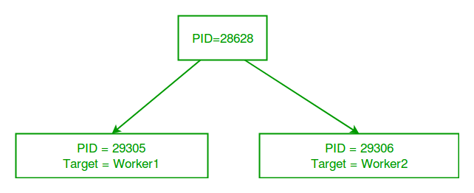  
So, this was a brief introduction to multiprocessing in Python. Next few articles will cover following topics related to multiprocessing:

* Sharing data between processes using Array, value and queues.
* Lock and Pool concepts in multiprocessing