Multiprocessing in Python

In multiprocessing, any newly created process will do following:

* run independently
* have their own memory space.

Consider the program below to understand this concept:

|  |
| --- |
| import multiprocessing    # empty list with global scope  result = []    def square_list(mylist):      """      function to square a given list      """      global result      # append squares of mylist to global list result      for num in mylist:          result.append(num * num)      # print global list result      print("Result(in process p1): {}".format(result))    if __name__ == "__main__":      # input list      mylist = [1,2,3,4]        # creating new process      p1 = multiprocessing.Process(target=square_list, args=(mylist,))      # starting process      p1.start()      # wait until process is finished      p1.join()        # print global result list      print("Result(in main program): {}".format(result)) |

Result(in process p1): [1, 4, 9, 16]

Result(in main program): []

In above example, we try to print contents of global list **result** at two places:

* In **square_list** function. Since, this function is called by process **p1**, **result** list is changed in memory space of process **p1** only.
* After the completion of process **p1** in main program. Since main program is run by a different process, its memory space still contains the empty **result** list.

Diagram shown below clears this concept:  
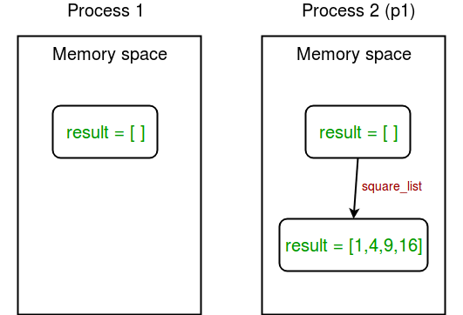

**Sharing data between processes**

1. **Shared memory : multiprocessing** module provides **Array** and **Value** objects to share data between processes.
   * **Array:** a ctypes array allocated from **shared memory**.
   * **Value:** a ctypes object allocated from **shared memory**.

Given below is a simple example showing use of **Array** and **Value** for sharing data between processes.

|  |
| --- |
| import multiprocessing    def square_list(mylist, result, square_sum):      """      function to square a given list      """      # append squares of mylist to result array      for idx, num in enumerate(mylist):          result[idx] = num * num        # square_sum value      square_sum.value = sum(result)        # print result Array      print("Result(in process p1): {}".format(result[:]))        # print square_sum Value      print("Sum of squares(in process p1): {}".format(square_sum.value))    if __name__ == "__main__":      # input list      mylist = [1,2,3,4]        # creating Array of int data type with space for 4 integers      result = multiprocessing.Array('i', 4)        # creating Value of int data type      square_sum = multiprocessing.Value('i')        # creating new process      p1 = multiprocessing.Process(target=square_list, args=(mylist, result, square_sum))        # starting process      p1.start()        # wait until process is finished      p1.join()        # print result array      print("Result(in main program): {}".format(result[:]))        # print square_sum Value      print("Sum of squares(in main program): {}".format(square_sum.value)) |

Result(in process p1): [1, 4, 9, 16]

Sum of squares(in process p1): 30

Result(in main program): [1, 4, 9, 16]

Sum of squares(in main program): 30

Let us try to understand the above code line by line:

* + First of all, we create an Array **result** like this:
  + result = multiprocessing.Array('i', 4)
    - First argument is the **data type**. ‘i’ stands for integer whereas ‘d’ stands for float data type.
    - Second argument is the **size** of array. Here, we create an array of 4 elements.

Similarly, we create a Value **square_sum** like this:

square_sum = multiprocessing.Value('i')

Here, we only need to specify data type. The value can be given an initial value(say 10) like this:

square_sum = multiprocessing.Value('i', 10)

* + Secondly, we pass **result** and **square_sum** as arguments while creating **Process** object.
  + p1 = multiprocessing.Process(target=square_list, args=(mylist, result, square_sum))
  + **result** array elements are given a value by specifying index of array element.
  + for idx, num in enumerate(mylist):
  + result[idx] = num * num

**square_sum** is given a value by using its **value** attribute:

square_sum.value = sum(result)

* + In order to print **result** array elements, we use **result[:]** to print complete array.
  + print("Result(in process p1): {}".format(result[:]))

Value of **square_sum** is simply printed as:

print("Sum of squares(in process p1): {}".format(square_sum.value))

Here is a diagram depicting how processes share **Array** and **Value** object:  
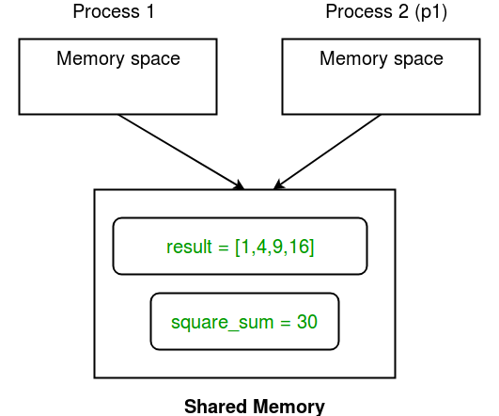

1. **Server process :**Whenever a python program starts, a **server process** is also started. From there on, whenever a new process is needed, the parent process connects to the server and requests it to fork a new process.

A **server process** can hold Python objects and allows other processes to manipulate them using proxies.

**multiprocessing** module provides a **Manager** class which controls a server process. Hence, managers provide a way to create data which can be shared between different processes.

*Server process managers are more flexible than using****shared memory****objects because they can be made to support arbitrary object types like lists, dictionaries, Queue, Value, Array, etc. Also, a single manager can be shared by processes on different computers over a network. They are, however, slower than using shared memory.*

Consider the example given below:

|  |
| --- |
| import multiprocessing    def print_records(records):      """      function to print record(tuples) in records(list)      """      for record in records:          print("Name: {0}\nScore: {1}\n".format(record[0], record[1]))    def insert_record(record, records):      """      function to add a new record to records(list)      """      records.append(record)      print("New record added!\n")    if __name__ == '__main__':      with multiprocessing.Manager() as manager:          # creating a list in server process memory          records = manager.list([('Sam', 10), ('Adam', 9), ('Kevin',9)])          # new record to be inserted in records          new_record = ('Jeff', 8)            # creating new processes          p1 = multiprocessing.Process(target=insert_record, args=(new_record, records))          p2 = multiprocessing.Process(target=print_records, args=(records,))            # running process p1 to insert new record          p1.start()          p1.join()            # running process p2 to print records          p2.start()          p2.join() |

New record added!

Name: Sam

Score: 10

Name: Adam

Score: 9

Name: Kevin

Score: 9

Name: Jeff

Score: 8

Let us try to understand above piece of code:

* + First of all, we create a **manager** object using:
  + with multiprocessing.Manager() as manager:

All the lines under **with** statement block are under the scope of **manager** object.

* + Then, we create a list **records** in **server process** memory using:
  + records = manager.list([('Sam', 10), ('Adam', 9), ('Kevin',9)])

Similarly, you can create a dictionary as **manager.dict** method.

* + Finally, we create to processes **p1** (to insert a new record in **records** list) and **p2** (to print **records**) and run them while passing **records** as one of the arguments.

The concept of **server process** is depicted in the diagram shown below:  
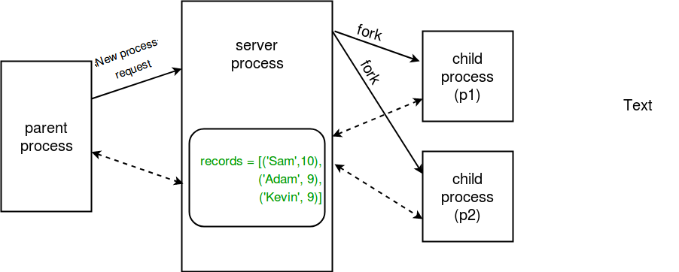

**Communication between processes**

Effective use of multiple processes usually requires some communication between them, so that work can be divided and results can be aggregated.  
**multiprocessing** supports two types of communication channel between processes:

* Queue
* Pipe

1. **Queue :**A simple way to communicate between process with multiprocessing is to use a Queue to pass messages back and forth. Any Python object can pass through a Queue.  
   **Note:** The **multiprocessing.Queue** class is a near clone of **queue.Queue**.  
   Consider the example program given below:

|  |
| --- |
| import multiprocessing    def square_list(mylist, q):      """      function to square a given list      """      # append squares of mylist to queue      for num in mylist:          q.put(num * num)    def print_queue(q):      """      function to print queue elements      """      print("Queue elements:")      while not q.empty():          print(q.get())      print("Queue is now empty!")    if __name__ == "__main__":      # input list      mylist = [1,2,3,4]        # creating multiprocessing Queue      q = multiprocessing.Queue()        # creating new processes      p1 = multiprocessing.Process(target=square_list, args=(mylist, q))      p2 = multiprocessing.Process(target=print_queue, args=(q,))        # running process p1 to square list      p1.start()      p1.join()        # running process p2 to get queue elements      p2.start()      p2.join() |

1. Queue elements:
2. 1
3. 4
4. 9
5. 16
6. Queue is now empty!
7. Let us try to understand the above code step by step:
   * Firstly, we create a **multiprocessing Queue** using:
   * q = multiprocessing.Queue()
   * Then we pass empty queue **q** to **square_list** function through process **p1**. Elements are inserted to queue using **put** method.
   * q.put(num * num)
   * In order to print queue elements, we use **get** method until queue is not empty.
   * while not q.empty():
   * print(q.get())

Given below is a simple diagram depicting the operations on queue:  
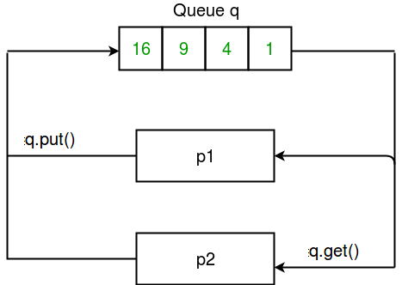

1. **Pipes :**A pipe can have only two endpoints. Hence, it is preferred over queue when only two-way communication is required.

**multiprocessing** module provides **Pipe()** function which returns a pair of connection objects connected by a pipe. The two connection objects returned by **Pipe()** represent the two ends of the pipe. Each connection object has **send()** and **recv()** methods (among others).  
Consider the program given below:

|  |
| --- |
| import multiprocessing    def sender(conn, msgs):      """      function to send messages to other end of pipe      """      for msg in msgs:          conn.send(msg)          print("Sent the message: {}".format(msg))      conn.close()    def receiver(conn):      """      function to print the messages received from other      end of pipe      """      while 1:          msg = conn.recv()          if msg == "END":              break          print("Received the message: {}".format(msg))    if __name__ == "__main__":      # messages to be sent      msgs = ["hello", "hey", "hru?", "END"]        # creating a pipe      parent_conn, child_conn = multiprocessing.Pipe()        # creating new processes      p1 = multiprocessing.Process(target=sender, args=(parent_conn,msgs))      p2 = multiprocessing.Process(target=receiver, args=(child_conn,))        # running processes      p1.start()      p2.start()        # wait until processes finish      p1.join()      p2.join() |

Sent the message: hello

Sent the message: hey

Sent the message: hru?

Received the message: hello

Sent the message: END

Received the message: hey

Received the message: hru?

Let us try to understand above code:

* + A pipe was created simply using:
  + parent_conn, child_conn = multiprocessing.Pipe()

The function returned two connection objects for the two ends of the pipe.

* + Message is sent from one end of pipe to another using **send** method.
  + conn.send(msg)
  + To receive any messages at one end of a pipe, we use **recv** method.
  + msg = conn.recv()
  + In above program, we send a list of messages from one end to another. At the other end, we read messages until we receive “END” message.

Consider the diagram given below which shows the relation b/w pipe and processes:  
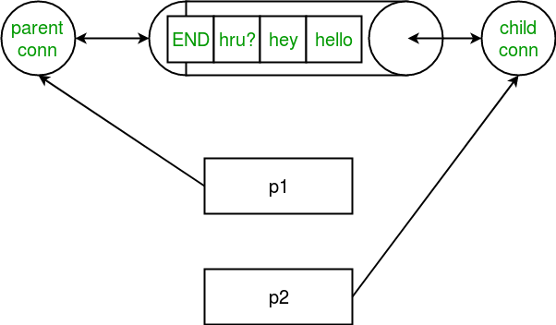

**Note:** Data in a pipe may become corrupted if two processes (or threads) try to read from or write to the same end of the pipe at the same time. Of course there is no risk of corruption from processes using different ends of the pipe at the same time. Also note that, Queues do proper synchronization between processes, at the expense of more complexity. Hence, queues are said to be thread and process safe!