Synchronization and Pooling of processes in Python

* Synchronization between processes
* Pooling of processes

**Synchronization between processes**

Process synchronization is defined as a mechanism which ensures that two or more concurrent processes do not simultaneously execute some particular program segment known as **critical section**.

*Critical section refers to the parts of the program where the shared resource is accessed.*

For example, in the diagram below, 3 processes try to access shared resource or critical section at the same time.  
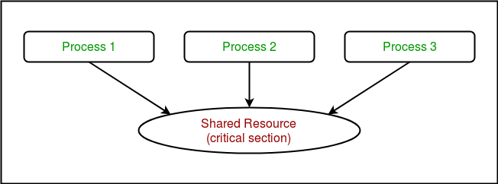

Concurrent accesses to shared resource can lead to **race condition**.

*A race condition occurs when two or more processes can access shared data and they try to change it at the same time. As a result, the values of variables may be unpredictable and vary depending on the timings of context switches of the processes.*

Consider the program below to understand the concept of race condition:

|  |
| --- |
| # Python program to illustrate  # the concept of race condition  # in multiprocessing  import multiprocessing    # function to withdraw from account  def withdraw(balance):      for _ in range(10000):          balance.value = balance.value - 1    # function to deposit to account  def deposit(balance):      for _ in range(10000):          balance.value = balance.value + 1    def perform_transactions():        # initial balance (in shared memory)      balance = multiprocessing.Value('i', 100)        # creating new processes      p1 = multiprocessing.Process(target=withdraw, args=(balance,))      p2 = multiprocessing.Process(target=deposit, args=(balance,))        # starting processes      p1.start()      p2.start()        # wait until processes are finished      p1.join()      p2.join()        # print final balance      print("Final balance = {}".format(balance.value))    if __name__ == "__main__":      for _ in range(10):            # perform same transaction process 10 times          perform_transactions() |

If you run above program, you will get some unexpected values like this:

Final balance = 1311

Final balance = 199

Final balance = 558

Final balance = -2265

Final balance = 1371

Final balance = 1158

Final balance = -577

Final balance = -1300

Final balance = -341

Final balance = 157

In above program, 10000 withdraw and 10000 deposit transactions are carried out with initial balance as 100. The expected final balance is 100 but what we get in 10 iterations of **perform_transactions** function is some different values.

This happens due to concurrent access of processes to the shared data **balance**. This unpredictability in balance value is nothing but **race condition**.

Let us try to understand it better using the sequence diagrams given below. These are the different sequences which can be produced in above example for a single withdraw and deposit action.

* This is a possible sequence which gives wrong answer as both processes read the same value and write it back accordingly.

|  |  |  |
| --- | --- | --- |
| p1 | p2 | balance |
| **read(balance)** current=100 |  | 100 |
|  | **read(balance)** current=100 | 100 |
| balance=current-1=99 **write(balance)** |  | 99 |
|  | balance=current+1=101 **write(balance)** | 101 |

* These are 2 possible sequences which are desired in above scenario.

|  |  |  |
| --- | --- | --- |
| p1 | p2 | balance |
| **read(balance)** current=100 |  | 100 |
| balance=current-1=99 **write(balance)** |  | 99 |
|  | **read(balance)** current=99 | 99 |
|  | balance=current+1=100 **write(balance)** | 100 |

|  |  |  |
| --- | --- | --- |
| p1 | p2 | balance |
|  | **read(balance)** current=100 | 100 |
|  | balance=current+1=101 **write(balance)** | 101 |
| **read(balance)** current=101 |  | 101 |
| balance=current-1=100 **write(balance)** |  | 100 |

**Using Locks**

**multiprocessing** module provides a **Lock** class to deal with the race conditions. **Lock** is implemented using a **Semaphore** object provided by the Operating System.

*A semaphore is a synchronization object that controls access by multiple processes to a common resource in a parallel programming environment. It is simply a value in a designated place in operating system (or kernel) storage that each process can check and then change. Depending on the value that is found, the process can use the resource or will find that it is already in use and must wait for some period before trying again. Semaphores can be binary (0 or 1) or can have additional values. Typically, a process using semaphores checks the value and then, if it using the resource, changes the value to reflect this so that subsequent semaphore users will know to wait.*

**Consider the example given below:**

|  |
| --- |
| # Python program to illustrate  # the concept of locks  # in multiprocessing  import multiprocessing    # function to withdraw from account  def withdraw(balance, lock):      for _ in range(10000):          lock.acquire()          balance.value = balance.value - 1          lock.release()    # function to deposit to account  def deposit(balance, lock):      for _ in range(10000):          lock.acquire()          balance.value = balance.value + 1          lock.release()    def perform_transactions():        # initial balance (in shared memory)      balance = multiprocessing.Value('i', 100)        # creating a lock object      lock = multiprocessing.Lock()        # creating new processes      p1 = multiprocessing.Process(target=withdraw, args=(balance,lock))      p2 = multiprocessing.Process(target=deposit, args=(balance,lock))        # starting processes      p1.start()      p2.start()        # wait until processes are finished      p1.join()      p2.join()        # print final balance      print("Final balance = {}".format(balance.value))    if __name__ == "__main__":      for _ in range(10):            # perform same transaction process 10 times          perform_transactions() |

Output:

Final balance = 100

Final balance = 100

Final balance = 100

Final balance = 100

Final balance = 100

Final balance = 100

Final balance = 100

Final balance = 100

Final balance = 100

Final balance = 100

Let us try to understand the above code step by step:

* Firstly, a **Lock** object is created using:
* lock = multiprocessing.Lock()
* Then, **lock** is passed as target function argument:
* p1 = multiprocessing.Process(target=withdraw, args=(balance,lock))
* p2 = multiprocessing.Process(target=deposit, args=(balance,lock))
* In the critical section of target function, we apply lock using **lock.acquire()** method. As soon as a lock is acquired, no other process can access its critical section until the lock is released using **lock.release()** method.
* lock.acquire()
* balance.value = balance.value - 1
* lock.release()

As you can see in the results, the final balance comes out to be 100 every time (which is the expected final result).

**Pooling between processes**

Let us consider a simple program to find squares of numbers in a given list.

|  |
| --- |
| # Python program to find  # squares of numbers in a given list  def square(n):      return (n*n)    if __name__ == "__main__":        # input list      mylist = [1,2,3,4,5]        # empty list to store result      result = []        for num in mylist:          result.append(square(num))        print(result) |

Output:

[1, 4, 9, 16, 25]

It is a simple program to calculate squares of elements of a given list. In a multi-core/multi-processor system, consider the diagram below to understand how above program will work:

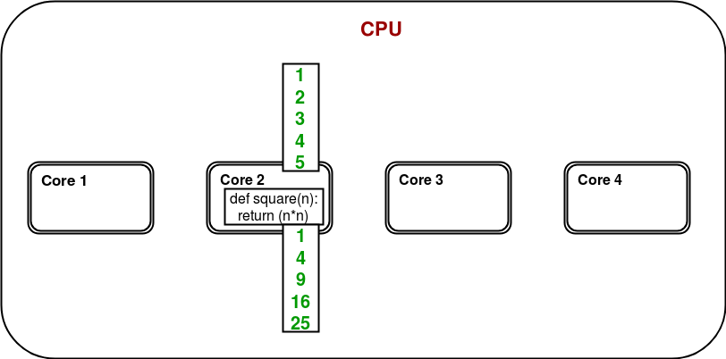

Only one of the cores is used for program execution and it’s quite possible that other cores remain idle.

In order to utilize all the cores, **multiprocessing** module provides a **Pool** class. The **Pool** class represents a pool of worker processes. It has methods which allows tasks to be offloaded to the worker processes in a few different ways. Consider the diagram below:

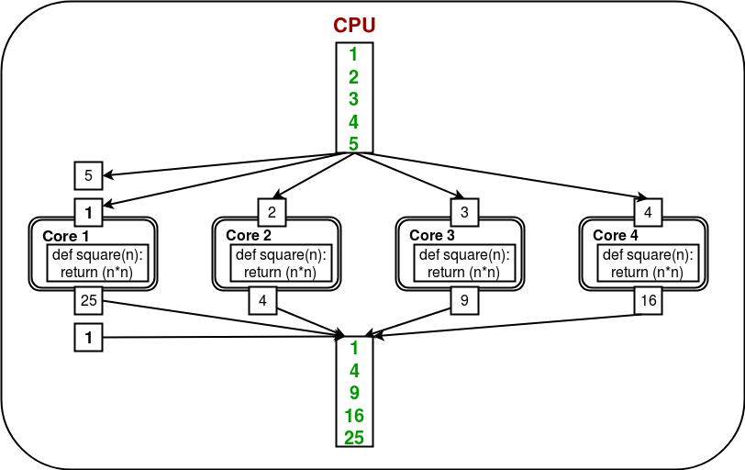

Here, the task is offloaded/distributed among the cores/processes automatically by **Pool** object. User doesn’t need to worry about creating processes explicitly.

Consider the program given below:

|  |
| --- |
| # Python program to understand  # the concept of pool  import multiprocessing  import os    def square(n):      print("Worker process id for {0}: {1}".format(n, os.getpid()))      return (n*n)    if __name__ == "__main__":      # input list      mylist = [1,2,3,4,5]        # creating a pool object      p = multiprocessing.Pool()        # map list to target function      result = p.map(square, mylist)        print(result) |

Output:

Worker process id for 2: 4152

Worker process id for 1: 4151

Worker process id for 4: 4151

Worker process id for 3: 4153

Worker process id for 5: 4152

[1, 4, 9, 16, 25]

Let us try to understand above code step by step:

* We create a **Pool** object using:
* p = multiprocessing.Pool()

There are a few arguments for gaining more control over offloading of task. These are:

* + **processes:** specify the number of worker processes.
  + **maxtasksperchild:** specify the maximum number of task to be assigned per child.

All the processes in a pool can be made to perform some initialization using these arguments:

* + **initializer:** specify an initialization function for worker processes.
  + **initargs:** arguments to be passed to initializer.
* Now, in order to perform some task, we have to map it to some function. In the example above, we map **mylist** to **square** function. As a result, the contents of **mylist** and definition of **square** will be distributed among the cores.

result = p.map(square, mylist)