Spring Boot basics

**Get started using Spring Boot to write Spring applications that just run**

[Save Like](https://developer.ibm.com/sso/login?d=https%3A%2F%2Fdeveloper.ibm.com%2Ftutorials%2Fj-spring-boot-basics-perry%2F&lang=us_EN)

Spring Boot is a lightweight framework that takes most of the work out of configuring Spring-based applications. In this tutorial, you’ll learn how to use Spring Boot’s starters, opinions, and executable JAR file structure to quickly create Spring-based applications that “just run.”

After briefly introducing Spring Boot, I’ll guide you through setting up and running two Spring Boot applications: a simple “Hello, World” app, and a slightly more complex Spring MVC RESTful web services application. Note that I use Spring Boot version 1.5.2 for my application examples. I recommend you use 1.5.2 or higher, but the examples should work for any release after 1.5.

Prerequisites

To get the most out of the tutorial, you should be comfortable using the Java™ Development Kit, version 8 (JDK 8). You’ll also need to be familiar with Eclipse IDE, Maven, and Git.

To follow along with the tutorial, be sure this software is installed:

* [JDK 8 for Windows, Mac, and Linux.](http://www.oracle.com/technetwork/java/javase/downloads/jdk8-downloads-2133151.html)
* [Eclipse IDE for Windows, Mac, and Linux.](https://www.eclipse.org/downloads/eclipse-packages/)
* [Apache Maven for Windows, Mac, and Linux.](https://maven.apache.org/download.cgi)
* [Git for Windows, Mac, and Linux.](https://git-scm.com/downloads)

Before we dive into the tutorial, I want to talk a little about Spring Boot.

What is Spring Boot

The goal of Spring Boot is to provide a set of tools for quickly building Spring applications that are easy to configure.

The problem: Configuring Spring is hard

If you’ve ever written a Spring-based application, you know that a lot of work goes into configuring it just to get to “Hello, World.” This isn’t a bad thing: Spring is an elegant set of frameworks that require carefully coordinated configuration to work correctly. But that elegance comes at the cost of configuration complexity (and don’t even get me started on all that XML).

The solution: Spring Boot

Enter Spring Boot. The [Spring Boot website](https://projects.spring.io/spring-boot/) says it much more succinctly than I can: “Spring Boot makes it easy to create stand-alone, production-grade Spring based Applications that you can “just run.” We take an opinionated view of the Spring platform and third-party libraries so you can get started with minimum fuss.”

Basically, this means you can quickly get a Spring application up and running with very little configuration. What little configuration there is comes in the form of annotations, so no XML.

All of that sounds great, right? But how exactly does Spring Boot work?

First, it’s opinionated

Spring Boot has *opinions*. This is just another way of saying that Spring Boot has *reasonable defaults*, so you can build an application quickly using these commonly used values.

As an example, Tomcat is a very popular web container. By default, a Spring Boot web application uses an embedded Tomcat container.

Second, it’s customizable

An opinionated framework isn’t much good if you can’t change its mind. You can easily customize a Spring Boot application to your liking, either in the initial configuration or later in the development cycle.

For example, if you prefer Maven, then you can easily make change(s) in your POM file to replace the Spring Boot default value. You’ll do this later in the tutorial.

Get started using Spring Boot

Starters

Starters are a big part of the magic of Spring Boot, used to limit the amount of manual dependency configuration that you have to do. If you’re going to use Spring Boot effectively, you should know about starters.

A *starter* is essentially a set of dependencies (such as a Maven POM) that are specific to the type of application the starter represents.

All starters use the naming convention: spring-boot-starter-XYZ, where XYZ is the type of application you want to build. Here are some popular Spring Boot starters:

* spring-boot-starter-web is used to build RESTful web services using Spring MVC and Tomcat as the embedded application container.
* spring-boot-starter-**jersey**spring-boot-starter-jersey is an alternative to spring-boot-starter-web that uses Apache Jersey rather than Spring MVC.
* spring-boot-starter-**jdbc**spring-boot-starter-jdbc is used for JDBC connection pooling. It’s based on Tomcat’s JDBC connection-pool implementation.

The [Spring Boot starter reference page](https://docs.spring.io/spring-boot/docs/current/reference/htmlsingle/#using-boot-starter) lists **lots** more starters. Check it out to see the POM and dependencies for each starter.

Auto-configuration

If you let it, Spring Boot will use its @EnableAutoConfiguration annotation to automatically configure your application. Auto-configuration is based on the JARS in your classpath and how you’ve defined your beans:

**Take a look**: Fire up your Spring Boot application with the --debug option and an auto-configuration report will be generated to the console.

* Spring Boot uses the JARs you have specified to be present in the CLASSPATH to form an opinion about how to configure certain automatic behavior. For example, if you have the H2 database JAR in your classpath and have configured no other DataSource beans, then your application will be automatically configured with an in-memory database.
* Spring Boot uses the way you define beans to determine how to automatically configure itself. For example, if you annotate your JPA beans with @Entity, then Spring Boot will automatically configure JPA such that you do not need a persistence.xml file.

The Spring Boot über jar

Spring Boot aims to help developers create applications that “just run.” To that end, it packages your application and its dependencies into a single, executable JAR. To run your application, you start Java like this:

$ java ‑jar PATH_TO_EXECUTABLE_JAR/executableJar.jar

Show more

The Spring Boot über JAR isn’t a new concept. Because Java doesn’t provide a standard way to load nested JARs, developers have been using tools like the [Apache Maven Shade plugin](https://maven.apache.org/plugins/maven-shade-plugin/) to build “shaded” JARs for years. A shaded JAR simply contains the .class files from all of the application’s dependent JARs. But as the complexity of your application grows and dependencies increase, shaded JARs can suffer from two issues:

1. Name collisions, where two classes in different JARs have the same name.
2. Dependency version issues, where two JARs use different versions of the same dependency.

Spring Boot resolves these issues by defining a [special JAR file layout](https://docs.spring.io/spring-boot/docs/current/reference/htmlsingle/#executable-jar) where the JARs themselves are nested within the über JAR. Spring tool support (for example, the spring-boot-maven plugin) then builds the executable über JAR to follow that layout (not just unpacking and repackaging .class files, as with a shaded JAR). When you run the executable JAR, Spring Boot uses a special class loader to handle loading the classes within the nested JARs.

Say Hello, World

Now you’re ready to start working directly with Spring Boot. Examples in this section are based on a simple application called HelloSpringBoot. I encourage you to work through the application development example with me, but if you want to jump right in you can [download](https://github.com/makotogo/HelloSpringBoot) the application code from Github.

Let’s dive right in and create a new Maven project!

Create the Maven project

In Eclipse, go to **File > New Project** and select **Maven > Maven Project**, as shown in Figure 1.

Figure 1. Selecting a Maven project

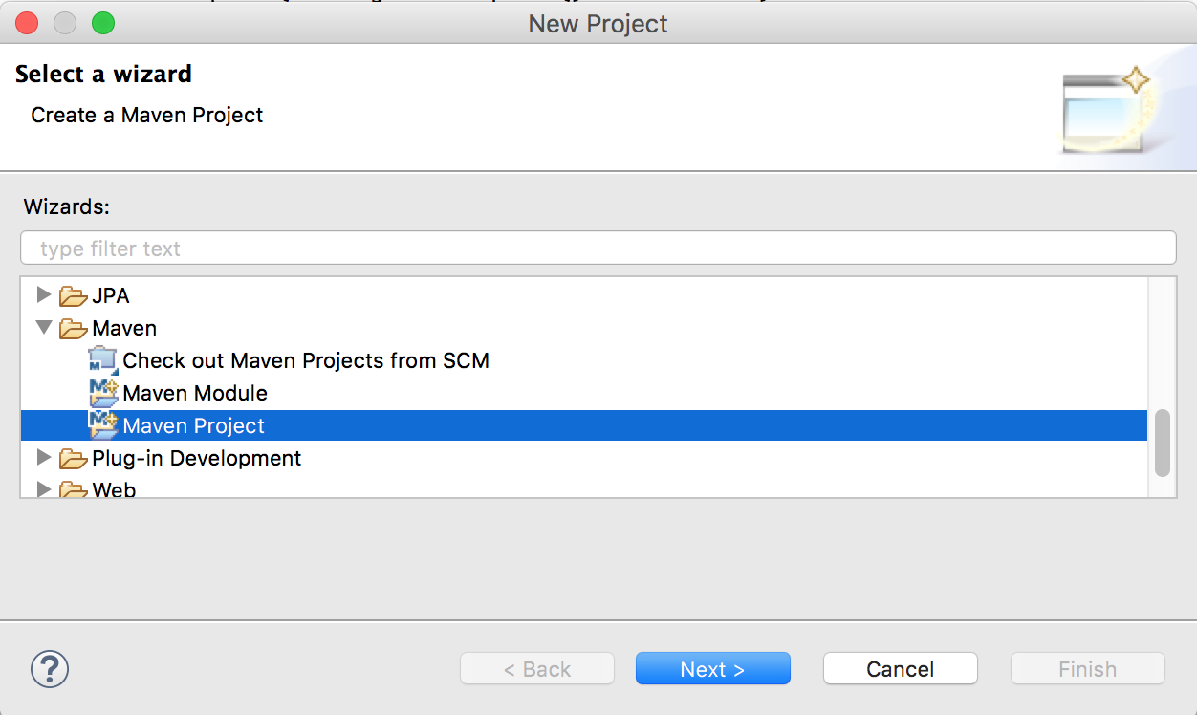

Click Next, then click Next again on the dialog that follows (not shown).

You’ll be asked to choose the archetype of your new Maven project. Select **maven-archetype-quickstart**, as shown in Figure 2.

Figure 2. Selecting the Maven quickstart archetype

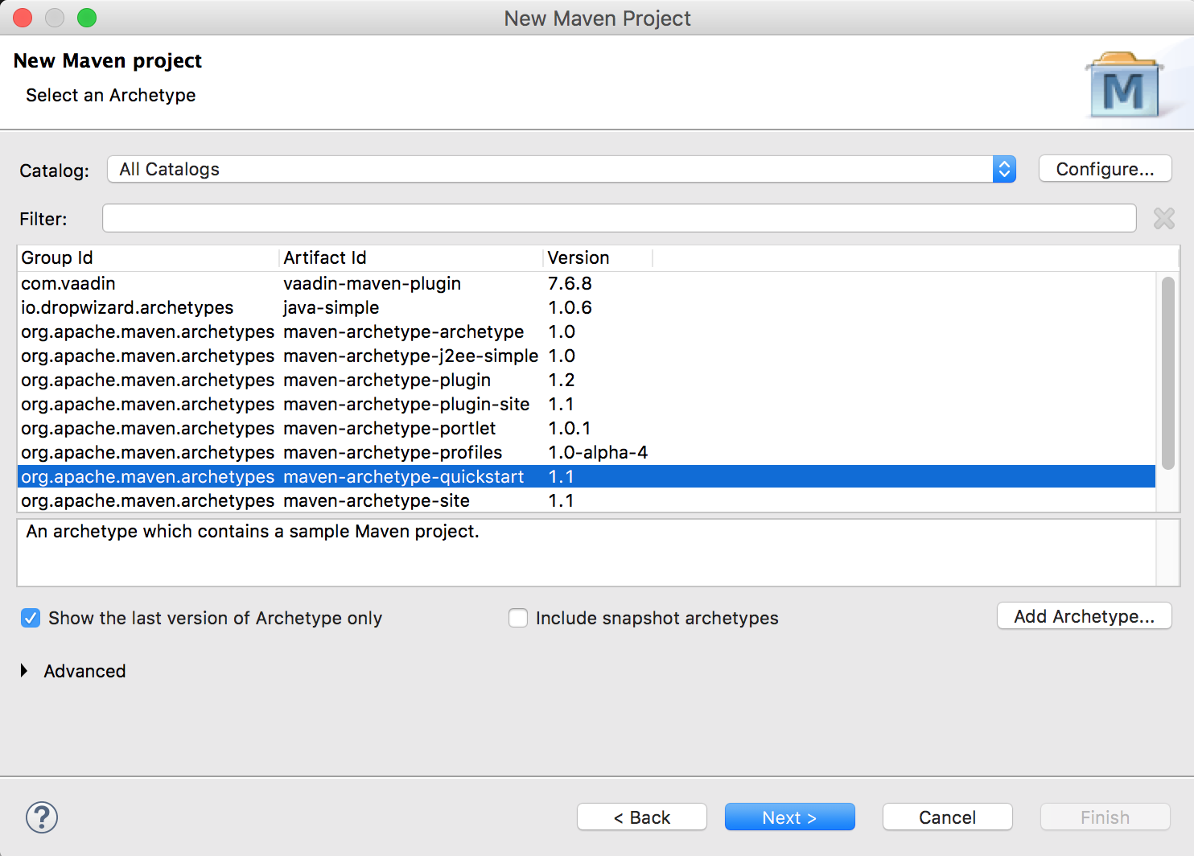

Click Next.

Finally, enter the artifact settings as shown in Figure 3.

Figure 3. Selecting the Maven artifact settings

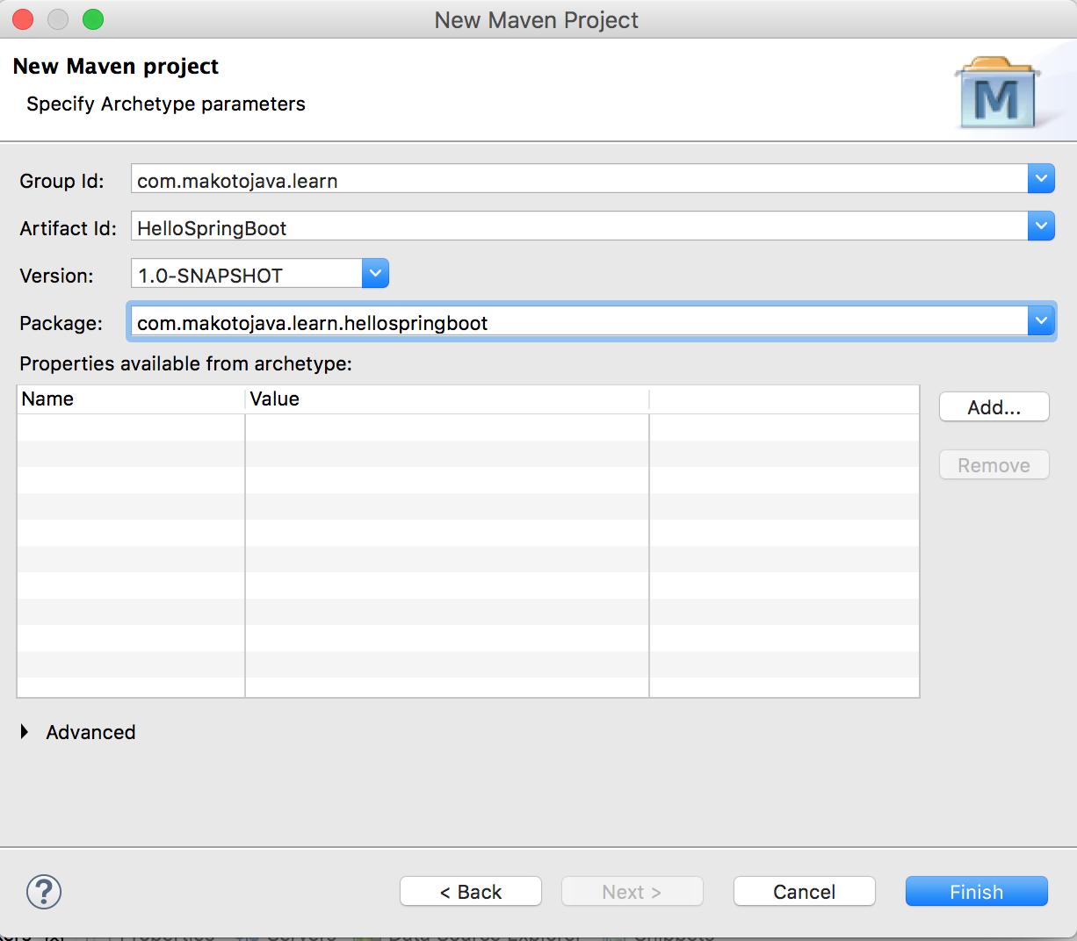

I’m using the following settings for the HelloSpringBoot application:

* Group Id: com.makotojava.learn
* Artifact Id: HelloSpringBoot
* Version: 1.0-SNAPSHOT
* Package: com.makotojava.learn.hellospringboot

Click Finish to create the project.

Now open App.java in Eclipse and replace its **entire contents** with the following:

package com.makotojava.learn.hellospringboot;

import java.util.Arrays;

import org.slf4j.Logger;

import org.slf4j.LoggerFactory;

import org.springframework.boot.CommandLineRunner;

import org.springframework.boot.SpringApplication;

import org.springframework.boot.autoconfigure.SpringBootApplication;

import org.springframework.context.ApplicationContext;

import org.springframework.context.annotation.Bean;

@SpringBootApplication

public class App {

private static final Logger log = LoggerFactory.getLogger(App.class);

public static void main(String[] args) {

SpringApplication.run(App.class, args);

}

@Bean

public CommandLineRunner commandLineRunner(ApplicationContext ctx) {

return args ‑> {

log.debug("Let's inspect the beans provided by Spring Boot:");

String[] beanNames = ctx.getBeanDefinitionNames();

Arrays.sort(beanNames);

for (String beanName : beanNames) {

log.debug(beanName);

}

};

}

}

Show more

Then create a new class called HelloRestController in the same package as App that looks like this:

package com.makotojava.learn.hellospringboot;

import org.springframework.web.bind.annotation.RequestMapping;

import org.springframework.web.bind.annotation.RestController;

@RestController

public class HelloRestController {

@RequestMapping("/hello")

public String hello() {

return "Hello. All your base are belong to us.";

}

}

Show more

Create the POM

Modify the POM created by the New Project wizard so it looks like Listing 1.

Listing 1. The POM file for HelloSpringBoot

<project xmlns="http://maven.apache.org/POM/4.0.0" xmlns:xsi="http://www.w3.org/2001/XMLSchema‑instance"

xsi:schemaLocation="http://maven.apache.org/POM/4.0.0 http://maven.apache.org/xsd/maven‑4.0.0.xsd">

<modelVersion>4.0.0</modelVersion>

<groupId>com.makotojava.learn</groupId>

<artifactId>HelloSpringBoot</artifactId>

<version>1.0‑SNAPSHOT</version>

<packaging>jar</packaging>

<name>HelloSpringBoot</name>

<url>http://maven.apache.org</url>

<parent>

<groupId>org.springframework.boot</groupId>

<artifactId>spring‑boot‑starter‑parent</artifactId>

<version>1.5.2.RELEASE</version>

</parent>

<dependencies>

<dependency>

<groupId>org.springframework.boot</groupId>

<artifactId>spring‑boot‑starter‑web</artifactId>

</dependency>

</dependencies>

<properties>

<java.version>1.8</java.version>

</properties>

<build>

<plugins>

<plugin>

<groupId>org.springframework.boot</groupId>

<artifactId>spring‑boot‑maven‑plugin</artifactId>

</plugin>

</plugins>

</build>

</project>

Show more

Note the highlighted lines in Listing 1:

**Lines 10 through 14** show the <parent> element, which specifies the Spring Boot parent POM and contains definitions for common components. You don’t have to manually configure these.

**Lines 16 through 19** show the <dependency> on the spring-boot-starter-web Spring Boot starter. This tells Spring Boot that the application is a web application. Spring Boot will form its opinions accordingly.

**Lines 25 through 30** tell Maven to use the spring-boot-maven-plugin plugin to generate the Spring Boot application.

That’s not a lot of configuration, is it? Notice there is no XML. We’ll use Java annotations for the remaining configuration.

More about Spring Boot’s opinions

Before we go further, I want to talk a little more about Spring Boot’s *opinions*. Namely, I think it’s important to explain how Spring Boot uses a starter like spring-boot-starter-web to form its configuration opinions.

The example application, HelloSpringBoot, uses Spring Boot’s web application starter, spring-boot-starter-web. Based on this starter, Spring Boot has formed the following opinions about the application:

* Tomcat embedded web server container
* Hibernate for Object-Relational Mapping (ORM)
* Apache Jackson for JSON binding
* Spring MVC for the REST framework

Talk about opinionated! But in Spring Boot’s defense, these are the most popular web application defaults—at least I know I use them all the time.

But remember how I said Spring Boot is customizable? If you want to use a different technology stack, you can easily override Spring Boot’s defaults.

We’ll walk through a simple customization next.

Lose the <parent>

What if if you already have a <parent> element in your POM, or what if just don’t want to use it? Will Spring Boot still work?

Yes it will, but you have to do two things:

1. Manually add the dependencies (including the versions)
2. Add a configuration snippet to your spring-boot-maven-plugin, as shown in Listing 2:

Listing 2. Specifying the repackage goal when not using the <parent> POM element

<build>

<plugins>

<plugin>

<groupId>org.springframework.boot</groupId>

<artifactId>spring‑boot‑maven‑plugin</artifactId>

<version>1.5.2.RELEASE</version>

<executions>

<execution>

<goals>

<goal>repackage</goal>

</goals>

</execution>

</executions>

</plugin>

</plugins>

</build>

Show more

**Check the dependencies**: If you ever need to see exactly what dependencies are being pulled in by the Spring Boot starter you’re using, visit the [Spring Boot starter reference page](https://docs.spring.io/spring-boot/docs/current/reference/htmlsingle/#using-boot-starter).

It’s important to note that the element does a lot of cool Maven magic, so if you have a good reason for not using it, proceed with caution. Make sure to add a repackage goal execution to the spring-boot-maven-plugin [as explained here](https://docs.spring.io/spring-boot/docs/current/maven-plugin/reference/html/#using).

The project is configured and customized. Now it’s time to build the executable.

Build the executable JAR

You have two options for building the executable JAR using Maven: run the Maven build in Eclipse or run it from the command line.

I’ll show you how to do both.

Build in Eclipse

To run the Maven build in Eclipse, right-click the POM file and choose **Run As > Maven Build**. In the Goals text field, enter clean and package, then click the Run button.

Figure 4. Edit configuration

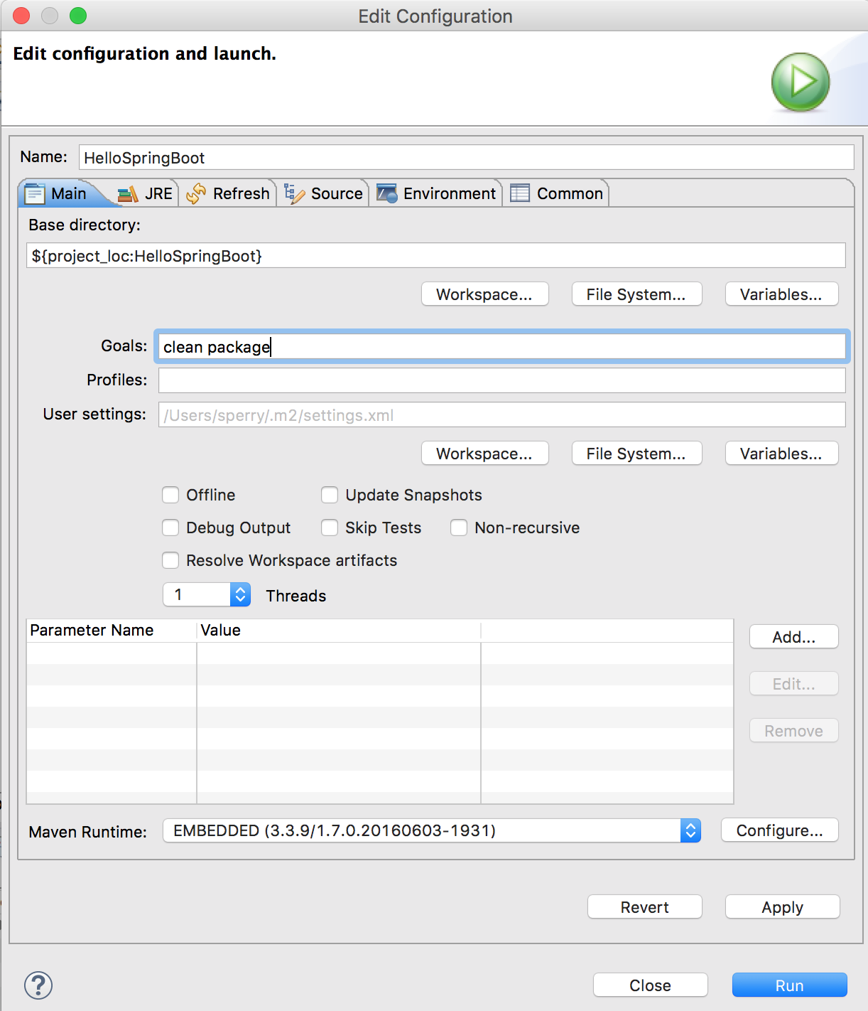

You should see a message in the console view indicating a successful build:

.

.

[INFO] ‑‑‑‑‑‑‑‑‑‑‑‑‑‑‑‑‑‑‑‑‑‑‑‑‑‑‑‑‑‑‑‑‑‑‑‑‑‑‑‑‑‑‑‑‑‑‑‑‑‑‑‑‑‑‑‑‑‑‑‑‑‑‑‑‑‑‑‑‑‑‑‑

[INFO] BUILD SUCCESS

[INFO] ‑‑‑‑‑‑‑‑‑‑‑‑‑‑‑‑‑‑‑‑‑‑‑‑‑‑‑‑‑‑‑‑‑‑‑‑‑‑‑‑‑‑‑‑‑‑‑‑‑‑‑‑‑‑‑‑‑‑‑‑‑‑‑‑‑‑‑‑‑‑‑‑

[INFO] Total time: 2.440 s

[INFO] Finished at: 2017‑04‑16T10:17:21‑05:00

[INFO] Final Memory: 30M/331M

[INFO] ‑‑‑‑‑‑‑‑‑‑‑‑‑‑‑‑‑‑‑‑‑‑‑‑‑‑‑‑‑‑‑‑‑‑‑‑‑‑‑‑‑‑‑‑‑‑‑‑‑‑‑‑‑‑‑‑‑‑‑‑‑‑‑‑‑‑‑‑‑‑‑‑

Show more

Build from the command line

To run the Maven build from the command line, open a Mac terminal window or a Windows command prompt, navigate to the HelloSpringBoot project directory, and execute the command:

mvn clean package

Show more

You should see a message in the terminal window or command prompt indicating a successful build.

$ cd HelloSpringBoot

$ pwd

/Users/sperry/home/HelloSpringBoot

$ mvn clean package

.

.

[INFO] ‑‑‑‑‑‑‑‑‑‑‑‑‑‑‑‑‑‑‑‑‑‑‑‑‑‑‑‑‑‑‑‑‑‑‑‑‑‑‑‑‑‑‑‑‑‑‑‑‑‑‑‑‑‑‑‑‑‑‑‑‑‑‑‑‑‑‑‑‑‑‑‑

[INFO] BUILD SUCCESS

[INFO] ‑‑‑‑‑‑‑‑‑‑‑‑‑‑‑‑‑‑‑‑‑‑‑‑‑‑‑‑‑‑‑‑‑‑‑‑‑‑‑‑‑‑‑‑‑‑‑‑‑‑‑‑‑‑‑‑‑‑‑‑‑‑‑‑‑‑‑‑‑‑‑‑

[INFO] Total time: 2.440 s

[INFO] Finished at: 2017‑04‑16T10:17:21‑05:00

[INFO] Final Memory: 30M/331M

[INFO] ‑‑‑‑‑‑‑‑‑‑‑‑‑‑‑‑‑‑‑‑‑‑‑‑‑‑‑‑‑‑‑‑‑‑‑‑‑‑‑‑‑‑‑‑‑‑‑‑‑‑‑‑‑‑‑‑‑‑‑‑‑‑‑‑‑‑‑‑‑‑‑‑

$

Show more

Now you’re ready to run the executable JAR.

Run the executable JAR

To run the executable JAR you’ve just created, open a Mac terminal window or a Windows command prompt, navigate to the HelloSpringBoot project folder, and execute:

java ‑jar target/HelloSpringBoot‑1.0‑SNAPSHOT.jar

Show more

where target is the default output directory of the build. If you have configured it differently, please make the appropriate substitution in the command above.

The output from Spring Boot contains a text-based “Splash Screen” (lines 2 to 7) along with other output, similar to the listing below. I’ve showed just a few lines, to give you an idea of what you should see when you run the app:

$ java ‑jar target/HelloSpringBoot‑1.0‑SNAPSHOT.jar

. _

/\ / ' () \ \ \

( ( )__ | ' | '| | ' \/ ` | \ \ \

\/ )| |)| | | | | || (| | ) ) ) )

' |_| .|| ||| |\, | / / / /

=========||==============|__/=///_/

:: Spring Boot :: (v1.5.2.RELEASE)

2017‑04‑15 17:46:12.919 INFO 20096 ‑‑‑ [ main] c.makotojava.learn.hellospringboot.App : Starting App v1.0‑SNAPSHOT on Ix.local with PID 20096 (/Users/sperry/home/projects/learn/HelloSpringBoot/target/HelloSpringBoot‑1.0‑SNAPSHOT.jar started by sperry in /Users/sperry/home/projects/learn/HelloSpringBoot)

2017‑04‑15 17:46:12.924 DEBUG 20096 ‑‑‑ [ main] c.makotojava.learn.hellospringboot.App : Running with Spring Boot v1.5.2.RELEASE, Spring v4.3.7.RELEASE

.

.

2017‑04‑15 17:46:15.221 INFO 20096 ‑‑‑ [ main] c.makotojava.learn.hellospringboot.App : Started App in 17.677 seconds (JVM running for 18.555)

Show more

If the application starts successfully, the last line of output from Spring Boot will contain the words “Started App” (line 13). Now you’re ready to exercise your application, which you’ll do next.

Exercise the app

You can execute HelloSpringBoot’s single REST method by opening a browser and hitting the following URL:

http://localhost:8080/hello

Show more

Figure 5. Hello, Spring Boot!

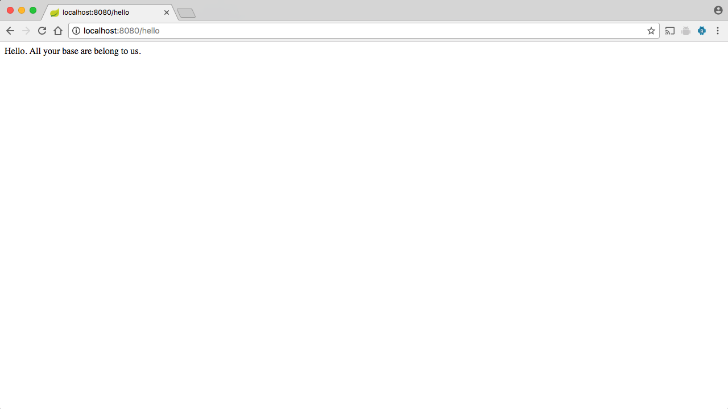

If you see the text “Hello, All your base are belong to us” (an homage to the video game [Zero Wing](https://en.wikipedia.org/wiki/All_your_base_are_belong_to_us)), then you know the application works!

Changing Spring Boot’s opinions

Spring Boot’s opinions are based on the contents of the POM, including the Spring Boot starter you specify when you initially configure your application. After forming an opinion about the type of application you intend to build, Spring Boot delivers a set of Maven dependencies. Figure 4 shows some of the Maven dependencies Spring Boot has set up in Eclipse, based on the POM contents and starter specified for the HelloSpringBoot application:

Figure 6. Initial dependencies for HelloSpringBoot

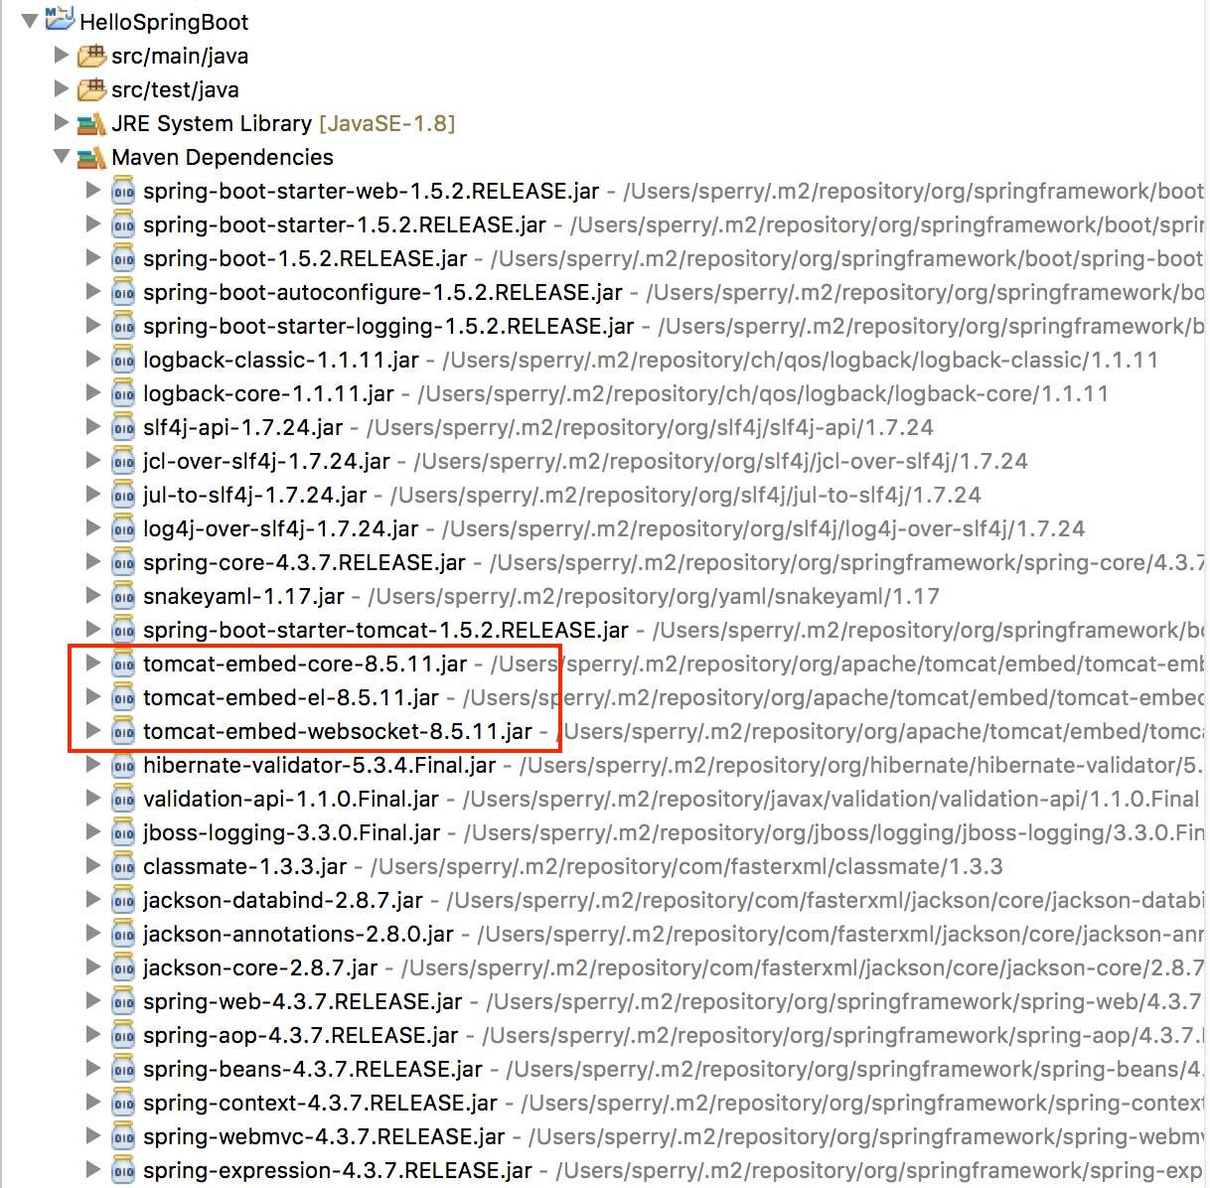

Note that Tomcat is the default embedded web server container. Now let’s suppose that instead of Tomcat you want to use Jetty. All you need to do is change the <dependencies> section in the POM (just paste lines 5 through 15 from Listing 3 over line 19 from ):

Listing 3. POM change to use Jetty instead of Tomcat

<dependencies>

<dependency>

<groupId>org.springframework.boot</groupId>

<artifactId>spring‑boot‑starter‑web</artifactId>

<exclusions>

<exclusion>

<groupId>org.springframework.boot</groupId>

<artifactId>spring‑boot‑starter‑tomcat</artifactId>

</exclusion>

</exclusions>

</dependency>

<dependency>

<groupId>org.springframework.boot</groupId>

<artifactId>spring‑boot‑starter‑jetty</artifactId>

</dependency>

</dependencies>

Show more

Notice below that the Maven dependencies for Tomcat are gone (thanks to lines 5 through 10 in Listing 3), replaced with dependencies for Jetty (lines 12 through 15).

Figure 7. Customized dependencies for HelloSpringBoot

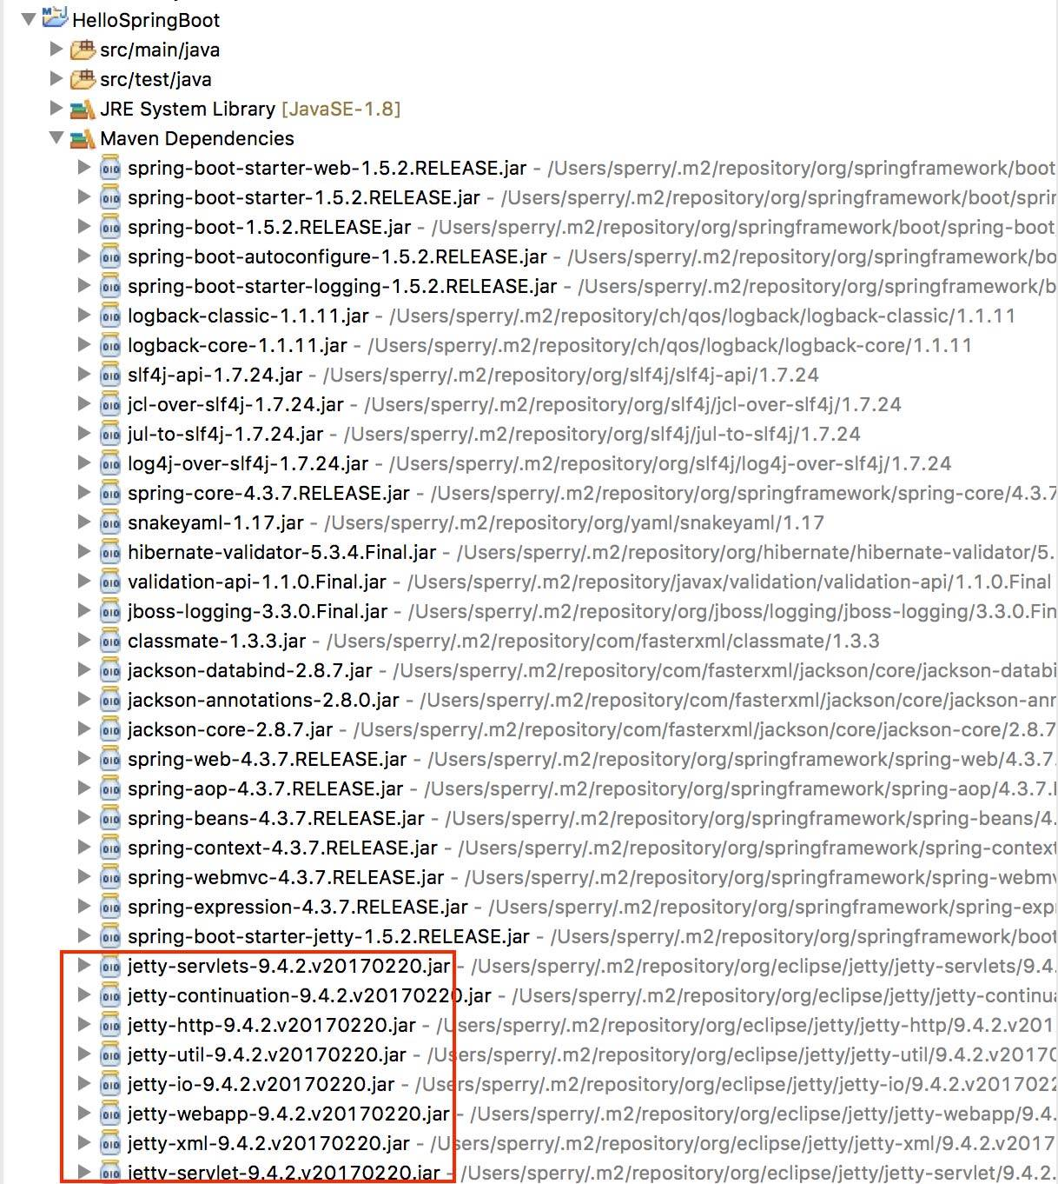

Actually, there are more Jetty dependencies than would fit in a single screenshot, but they are all there, and the Tomcat dependencies are gone. Try it and see for yourself!

Say Hello, Galaxy

Simple examples are great, but Spring Boot is capable of so much more! In this section, I’ll show you how to put Spring Boot through its paces with a Spring MVC RESTful web application. The first thing to do is set up the new example application, SpringBootDemo.

SpringBootDemo

SpringBootDemo is a Spring Boot wrapper around a simple Spring-based POJO application called oDoT. (For ToDo backwards … get it?) The idea is to walk through the process of developing an application that is more complex than a simple Hello, World. You’ll also learn how to wrap an existing application with Spring Boot.

You’ll do three things to setup and run SpringBootDemo:

1. Get the code from GitHub.
2. Build and run the executable JAR.
3. Access the application through SoapUI.

Get the code

To start, you will need to clone two projects from their GitHub repositories. The first, called odotCore, contains the application’s business logic, which is written as a Spring-based POJO application. The other, called SpringBootDemo, is a Spring Boot application wrapper around odotCore.

To clone the odotCore repo, open a Mac terminal window or a Windows command prompt, navigate to the root directory under which you want the code to reside, and execute the command:

git clone https://github.com/makotogo/odotCore

Show more

To clone the SpringBootDemo repo, execute the command:

git clone https://github.com/makotogo/SpringBootDemo

Show more

Note that the two projects are immediately subordinate to the application’s root directory. Next you’ll import the code to your workspace.

Import the code into Eclipse

Go to **File > Import…** and choose **Maven > Existing Maven Projects**.

In the next dialog, use the Browse button to navigate to the root directory. Both of the projects cloned in the previous step should appear in the dialog, as shown here:

Figure 8. Import Maven Projects

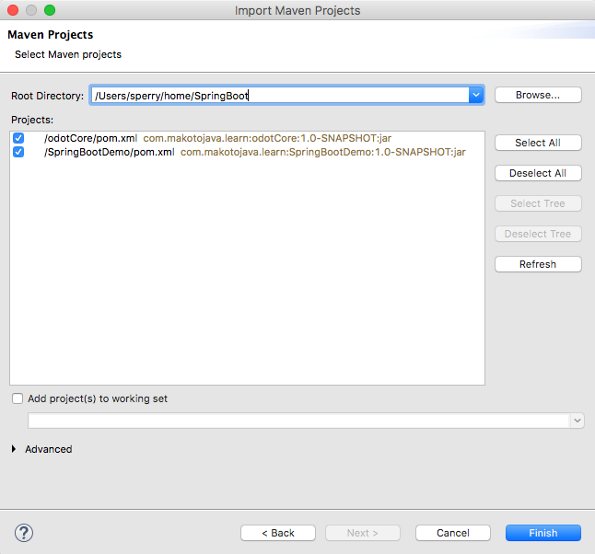

Click Finish to import the projects into your Eclipse workspace. Next you’ll build the executable JAR.

Build SpringBootDemo

Building SpringBootDemo requires you to build both the odotCore and SpringBootDemo projects. It is possible to build the projects from the command line, as you saw with the HelloSpringBoot application. In this case, I’ll walk you through using Eclipse.

In Eclipse, right-click on the odotCore project. Choose **Run As > Maven Build** and specify the clean and install goals. The install goal will install the odotCore-1.0-SNAPSHOT.jar JAR file into your local Maven repository. From here, it will be available to pull in as a dependency when you run the SpringBootDemo Maven build.

After the odotCore Maven build runs successfully, right-click on the SpringBootDemo project, choose **Run As > Maven Build** and specify the clean and package goals.

**Note**: The odotCore project contains several unit tests. While I recommend never (ever) skipping unit tests, you can setup the Run Configuration that builds the odotCore project in Eclipse to skip the tests (there’s a check box for that on the Run Configuration dialog).

After the SpringBootDemo build has run successfully, you can run the SpringBootDemo über JAR from the command line.

Run the SpringBootDemo über JAR

From a Mac terminal window or Windows command prompt, navigate to the SpringBootDemo directory. Assuming the build’s output directory is called target (which is the default), execute the following command:

java ‑jar target/SpringBootDemo‑1.0‑SNAPSHOT.jar

Show more

Now stand back in awe as Spring Boot runs the application. When you see the text “App Started” you’re ready to exercise the application.

Test the app

As a quick smoke test, to make sure your application is working correctly, open a browser window and enter the following URL:

http://localhost:8080/CategoryRestService/FindAll

Show more

This accesses the FindAll method of the CategoryRestService and returns all of the Category objects in the database in JSON format.

Figure 9. Accessing SpringBootDemo through a browser

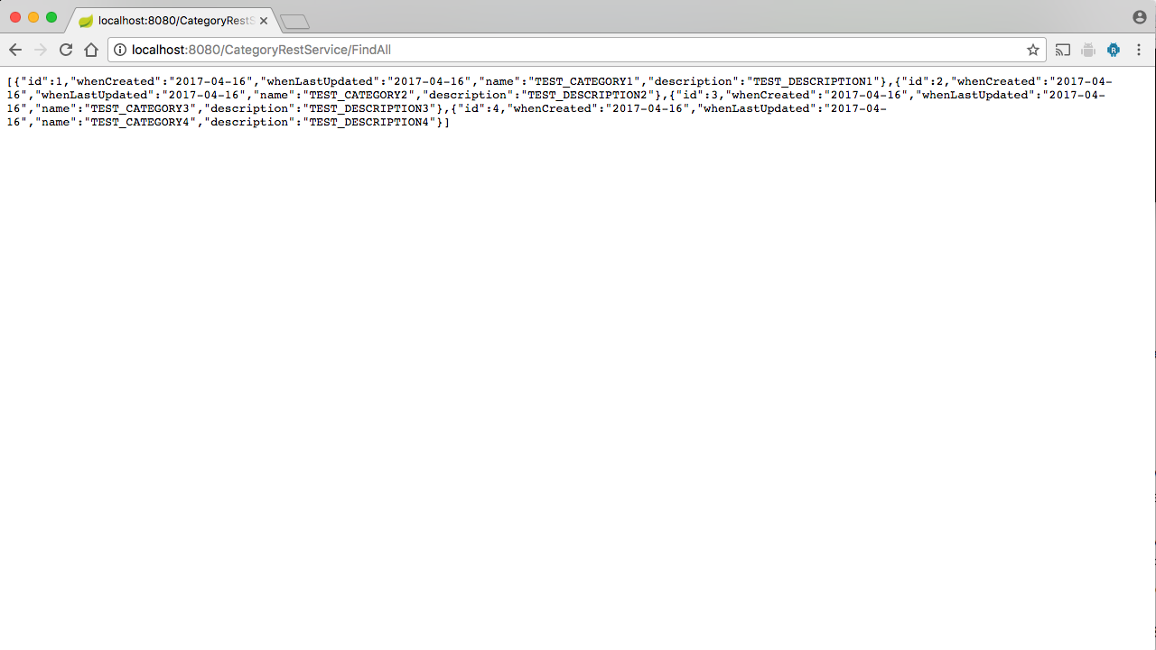

You can also exercise the app through SoapUI. I won’t demonstrate how to do that here, but I do guide you through the process in the video for this tutorial.

Table 1 shows the services and methods within each service for the SpringBootDemo.

Table 1. oDoT (SpringBootDemo) services and methods

| **Service** | **Method** | **HTTP method** | **Example URL @ http://localhost:8080** |  |
| --- | --- | --- | --- | --- |
| Category | FindAll | GET | /CategoryRestService/FindAll | Finds all Category objects in the DB. |
| Category | FindById | GET | /CategoryRestService/FindbyId/1 | Finds Category by ID value 1. |
| Category | FindById | GET | /CategoryRestService/FindbyName/MY_CATEGORY | Finds Category by name value “MY_CATEGORY”. |
| Category | Add | PUT | /CategoryRestService/Add | Adds the specified Category (as JSON payload in request body) to the DB. Returns: Category object that was added (as JSON in response body). |
| Category | Update | POST | /CategoryRestService/Update | Updates the specified Category (as JSON payload in request body) to the DB. Returns: String message indicating status of the update. |
| Category | Delete | DELETE | /CategoryRestService/Delete | Deletes the specified Category (as JSON payload in request body) to the DB. Returns: String message indicating status of the delete. |
| Item | FindAll | GET | /ItemRestService/FindAll | Finds all Category objects in the DB. |
| Item | FindById | GET | /ItemRestService/FindbyId/1 | Finds Category by ID value 1. |
| Item | FindById | GET | /ItemRestService/FindbyName/TODO_ITEM_1 | Finds Item by name value “TODO_ITEM_1”. |
| Item | Add | PUT | /ItemRestService/Add | Adds the specified Item (as JSON payload in request body) to the DB. Returns: Item object that was added (as JSON in response body). |
| Item | Update | POST | /ItemRestService/Update | Updates the specified Item (as JSON payload in request body) to the DB. Returns: String message indicating status of the update. |
| Item | Delete | DELETE | /ItemRestService/Delete | Deletes the specified Item (as JSON payload in request body) to the DB. Returns: String message indicating status of the delete. |

I recommend you study the code, play around with it, and get a better feeling for how Spring Boot works.