What is RCP Workbench application?

RCP (Rich Client Platform): As a platform it based on SWT, SWT which is a programming library for desktop applications. RCP provides a platform to help you write applications like Eclipse IDE.

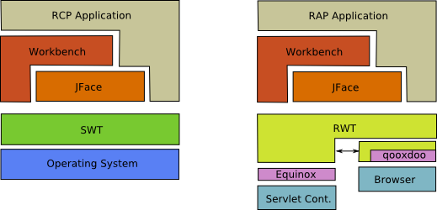

RCP allows Workbench application programming interface similar to the interface of the Eclipse IDE. Programming the Eclipse Plugin integrates into the IDE.

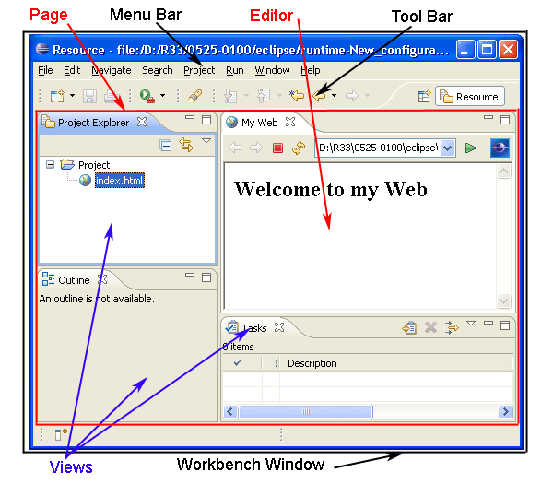

To create a desktop application using SWT. On the Eclipse, we will create an RCP Plugin Project. You have 2 options.  
  
     Only use the features of the SWT  
     Using the platform provided by the RCP to RCP Application Workbench programming.

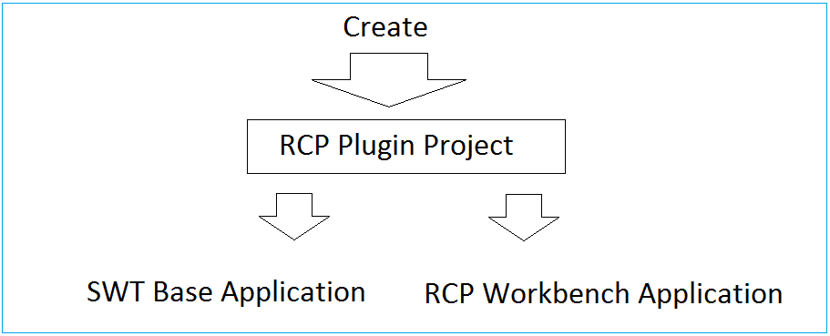

4- Create Project

First of all you have to create a new workspace to get started:  
On Eclipse select: File/Switch Workspace/Other ...

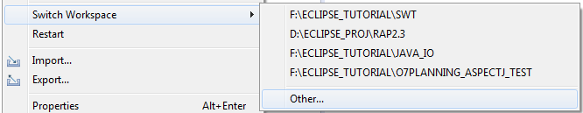

Enter your workspace directory:

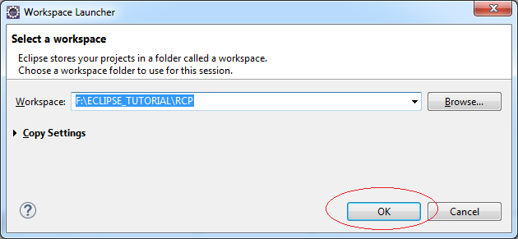

In Eclipse select: File/New/Other...

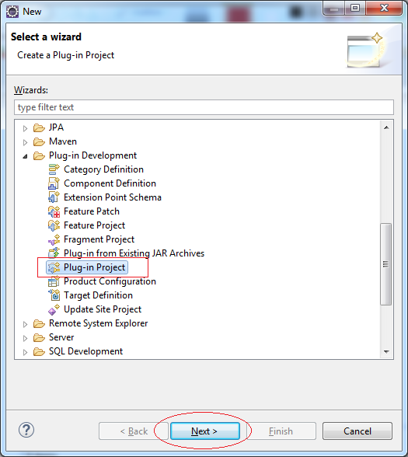

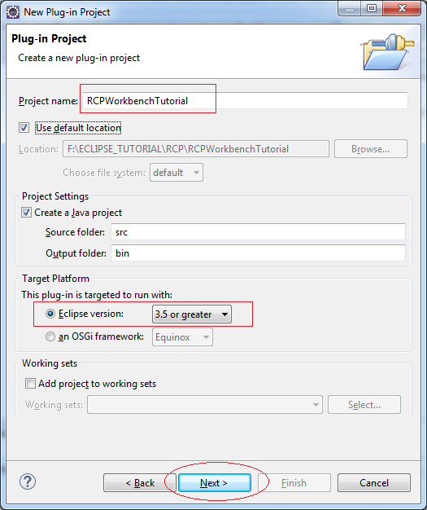

1. Check selected on (1)
2. On the (2) select *"Yes"* to create Eclipse RCP Project (Running on Desktop), otherwise it will create RAP Project (Running on the Web).

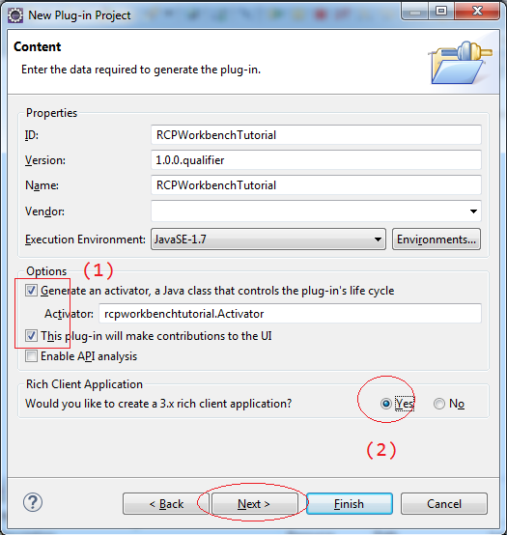

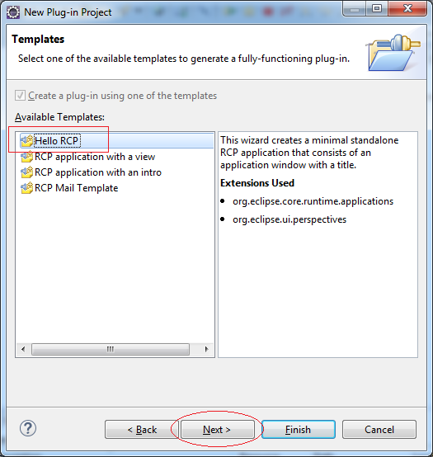

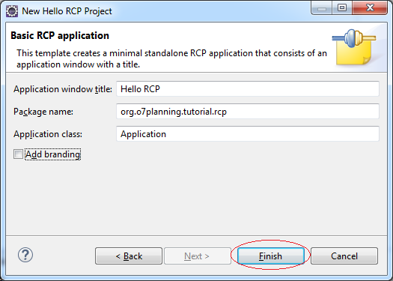

Project was created:

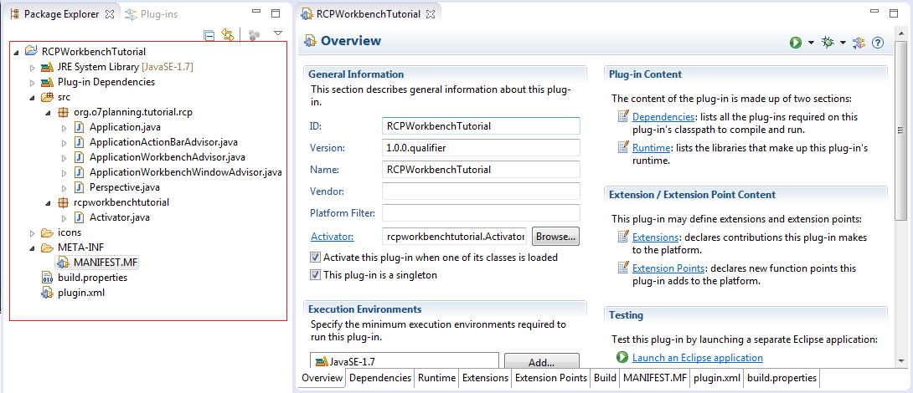

5- Run Project

We will test this Project Hello RCP immediately after it has been created.

Right-click on the Project: RCPWorkbenchTutorial choose RunAs/Eclipse Application

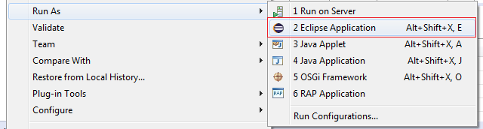

Result:

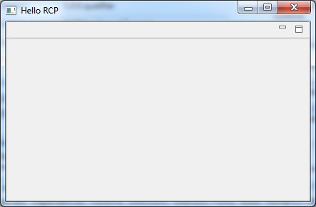

6- Structure RCP applications, and configure RCP

This is an image of the class is created by default when you create RCP Project from template "Hello RCP":

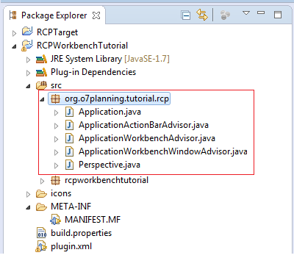

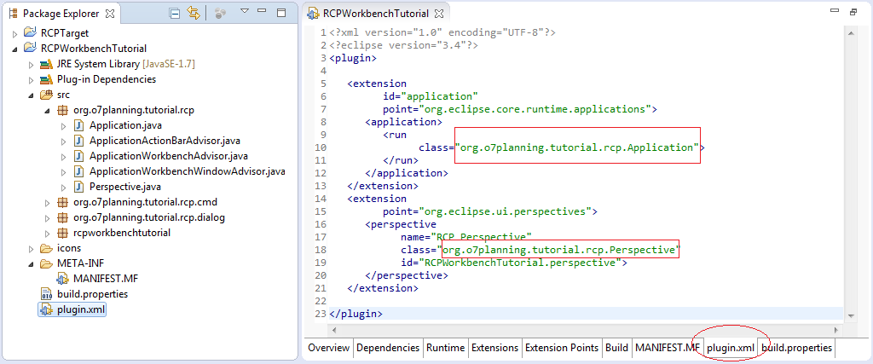

Application Configuration:

Change the code in the class ApplicationWorkbenchWindowAdvisor, to ensure Coolbar bar, PerspectiveBar, .. will be displayed on the Workbench:

ApplicationWorkbenchWindowAdvisor.java

**package** org.o7planning.tutorial.rcp;

**import** org.eclipse.swt.graphics.Point;

**import** org.eclipse.ui.application.ActionBarAdvisor;

**import** org.eclipse.ui.application.IActionBarConfigurer;

**import** org.eclipse.ui.application.IWorkbenchWindowConfigurer;

**import** org.eclipse.ui.application.WorkbenchWindowAdvisor;

**public** **class** **ApplicationWorkbenchWindowAdvisor** **extends** **WorkbenchWindowAdvisor** {

**public** **ApplicationWorkbenchWindowAdvisor**(IWorkbenchWindowConfigurer configurer) {

super(configurer);

}

**public** ActionBarAdvisor **createActionBarAdvisor**(IActionBarConfigurer configurer) {

**return** **new** **ApplicationActionBarAdvisor**(configurer);

}

**public** **void** **preWindowOpen**() {

IWorkbenchWindowConfigurer configurer = getWindowConfigurer();

configurer.setInitialSize(**new** **Point**(400, 300));

// Show MenuBar

configurer.setShowMenuBar(true);

// Show CoolBar.

configurer.setShowCoolBar(true);

// Show Status Line.

configurer.setShowStatusLine(true);

// Show PerspectiveBar

configurer.setShowPerspectiveBar(true);

// Show FastViewBars

configurer.setShowFastViewBars(true);

// Show ProgressIndicator

configurer.setShowProgressIndicator(true);

configurer.setTitle("Hello RCP"); //$NON-NLS-1$

}

}

Rerun Application:

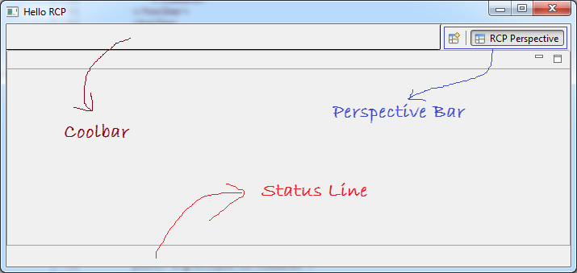

7- Project Target Component

RCP is Platform based on:

* SWT
* JFace
* RCP Component.

Creating a file "Define Target" is necessary to actively declare the components needed, and runtime environment for RCP applications. You can also use other additional component such as Nebula for your RCP application, just declare in the file "Define Target".

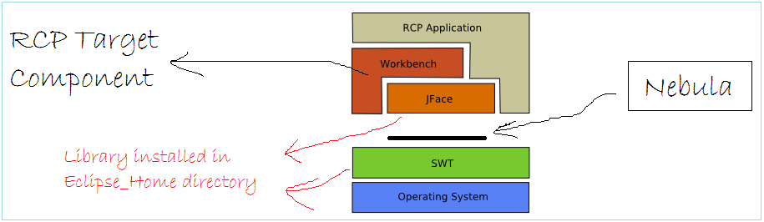

Create a Java Project, to declare the file "Define Target" in it..

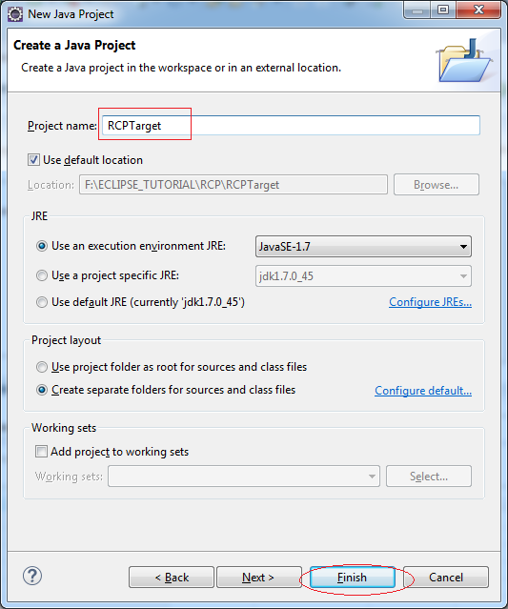

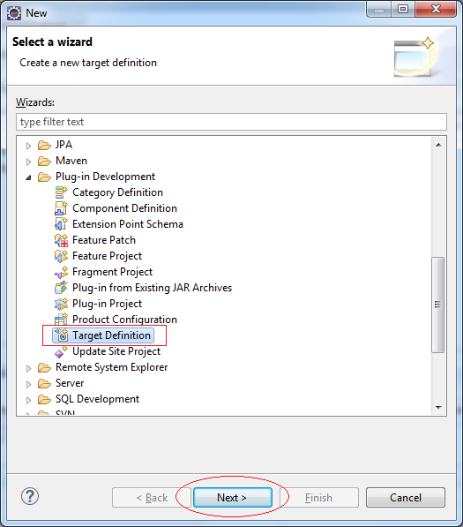

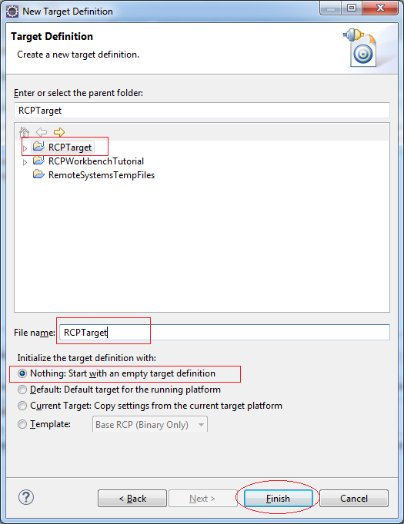

First of all, declare  SWT libraries, it available on the Eclipse folder.

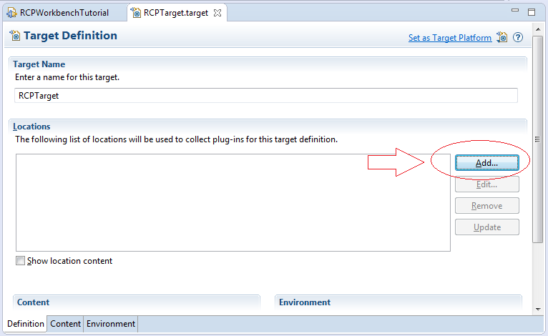

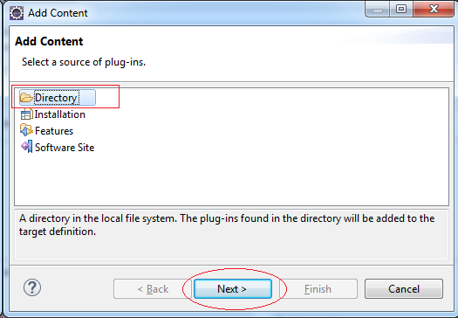

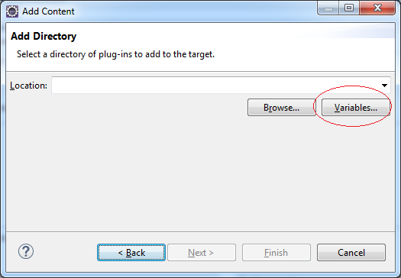

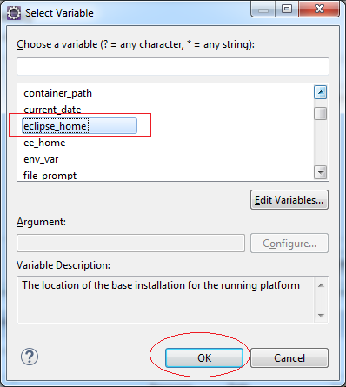

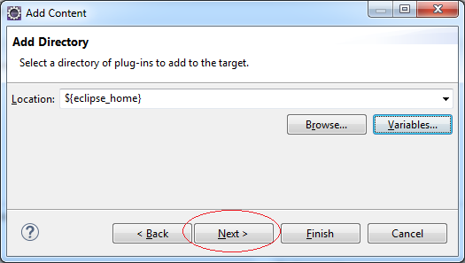

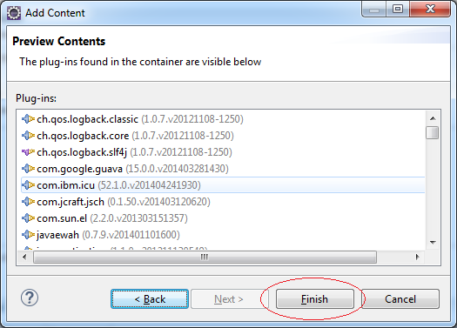

Next declare "RCP Target Component". It is the library component of the RCP.

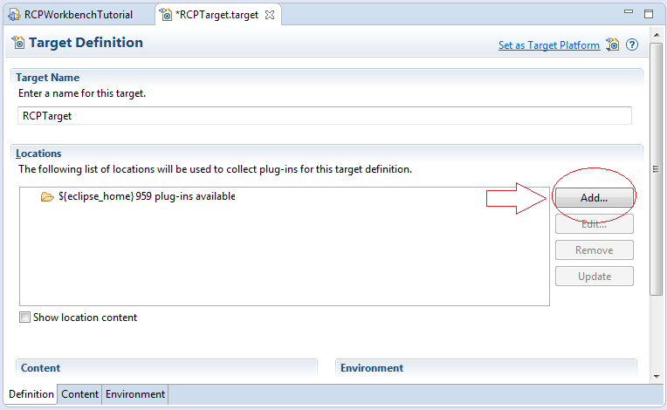

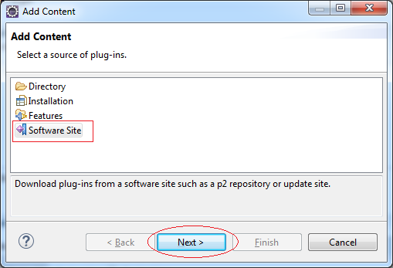

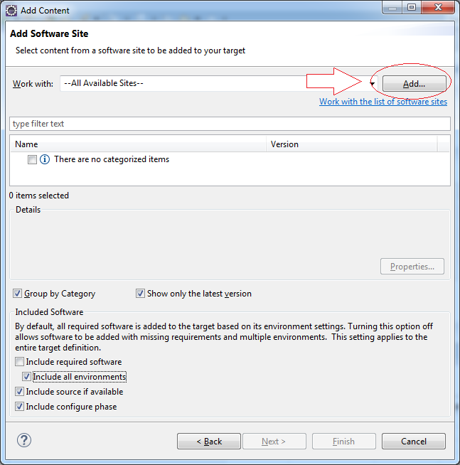

Enter:

* Name: RCP Target Component
* Location: http://download.eclipse.org/eclipse/updates/4.4/

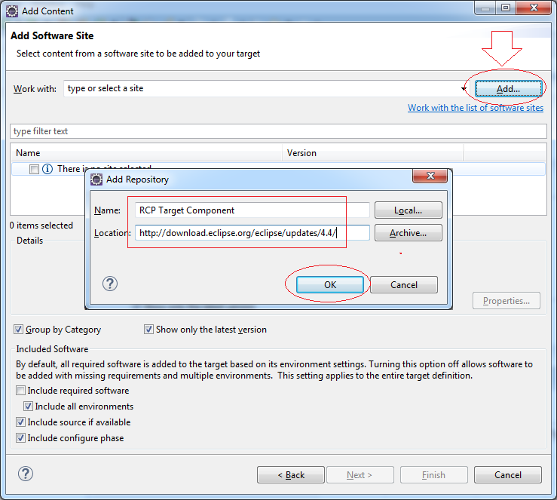

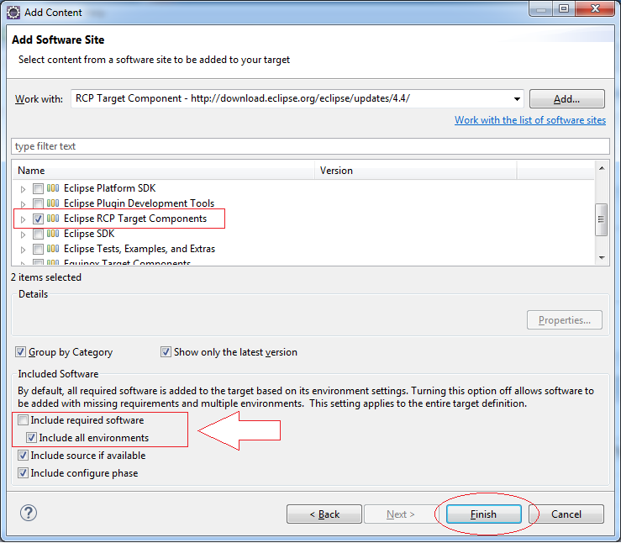

Click on "Set As Target Component", the library will be running environment for RCP applications.

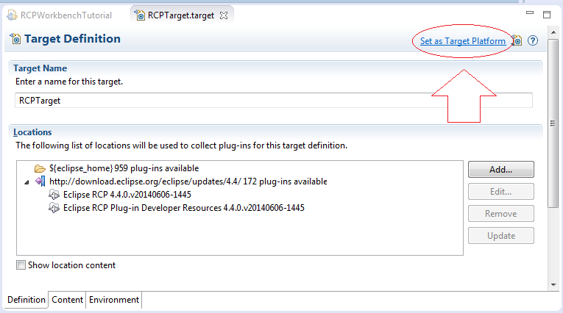

8- Create a few Command used in applications

You can create the class command to control a certain event, such as:

* Open the file
* Exit the application
* Open AboutDialog
* ....

Each command will be registered with a certain ID. And MenuItem, or ToolItem will call command via the Command ID.

AboutDialog.java

**import** org.eclipse.swt.SWT;

**public** **class** **AboutDialog** **extends** **Dialog** {

**protected** Object result;

**protected** Shell shlAbout;

/**

* Create the dialog.

* **@param** parent

* **@param** style

*/

**public** **AboutDialog**(Shell parent, int style) {

super(parent, style);

setText("SWT Dialog");

}

/**

* Open the dialog.

* **@return** the result

*/

**public** Object **open**() {

createContents();

shlAbout.open();

shlAbout.layout();

Display display = getParent().getDisplay();

**while** (!shlAbout.isDisposed()) {

**if** (!display.readAndDispatch()) {

display.sleep();

}

}

**return** result;

}

/**

* Create contents of the dialog.

*/

**private** **void** **createContents**() {

shlAbout = **new** **Shell**(getParent(), getStyle());

shlAbout.setSize(418, 145);

shlAbout.setText("About");

shlAbout.setLayout(**new** **GridLayout**(1, false));

Label lblNewLabel = **new** **Label**(shlAbout, SWT.NONE);

lblNewLabel.setLayoutData(**new** **GridData**(SWT.CENTER, SWT.CENTER, true, true, 1, 1));

lblNewLabel.setText("RCP Tutorial");

}

}

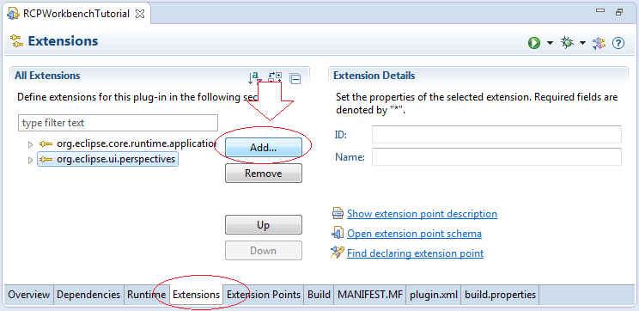

Create Extension Point:

* org.eclipse.ui.commands

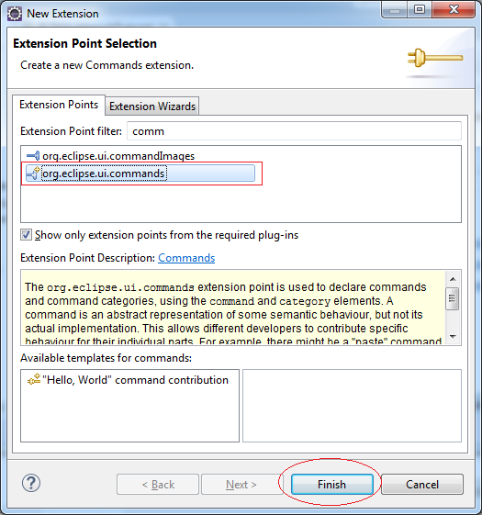

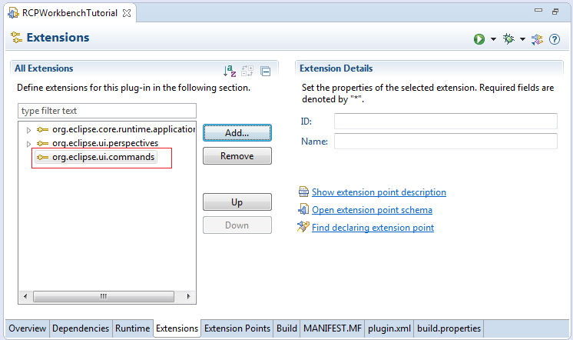

Next we will create a Command class with ID:

* *org.o7planning.tutorial.rcp.cmd.about*

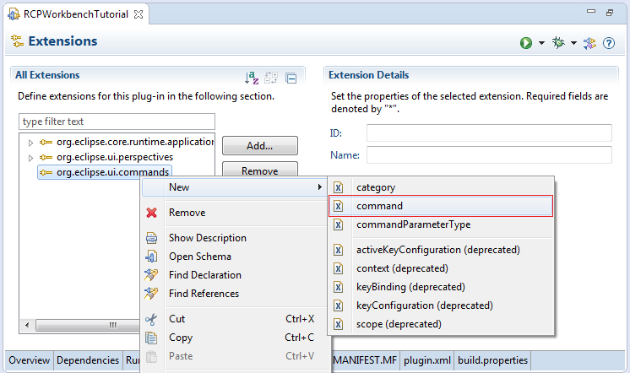

Enter:

* id: org.o7planning.tutorial.rcp.cmd.about
* defaultHandler: org.o7planning.tutorial.rcp.cmd.AboutCommand

Click to link *"defaultHandler"* to create class.

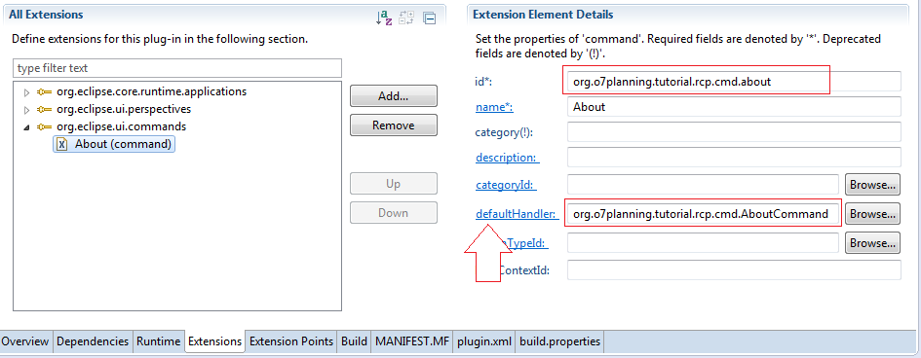

You should write AboutCommand extends from the class:

* org.eclipse.core.commands.AbstractHandler.

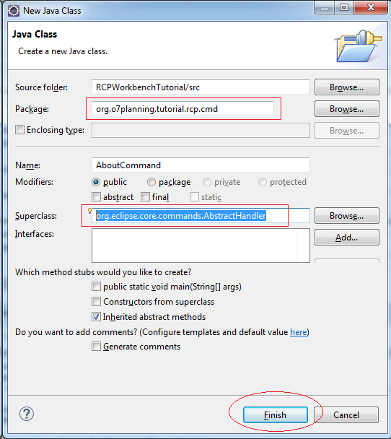

AboutCommand.java

**import** org.eclipse.core.commands.AbstractHandler;

**import** org.eclipse.core.commands.ExecutionEvent;

**import** org.eclipse.core.commands.ExecutionException;

**import** org.eclipse.swt.SWT;

**import** org.eclipse.swt.widgets.Shell;

**import** org.eclipse.ui.handlers.HandlerUtil;

**import** org.o7planning.tutorial.rcp.dialog.AboutDialog;

**public** **class** **AboutCommand** **extends** **AbstractHandler** {

@Override

**public** Object **execute**(ExecutionEvent event) **throws** ExecutionException {

Shell shell = HandlerUtil.getActiveWorkbenchWindow(event).getShell();

AboutDialog dialog = **new** **AboutDialog**(shell, SWT.DIALOG_TRIM

| SWT.APPLICATION_MODAL);

dialog.open();

**return** null;

}

}

9- Design Interface

9.1- Interface

Below is a Workbench picture that we would design.

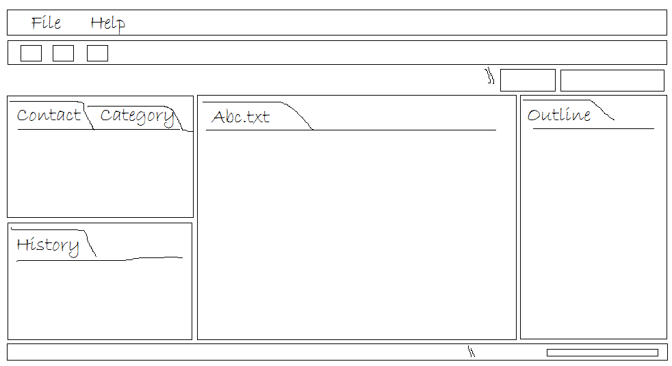

9.2- Menu

We will design the menu as shown below:

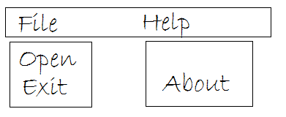

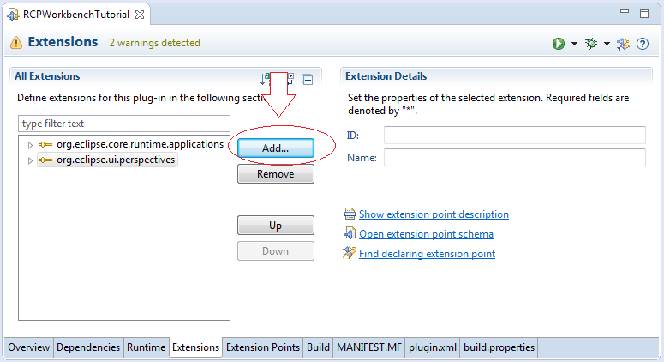

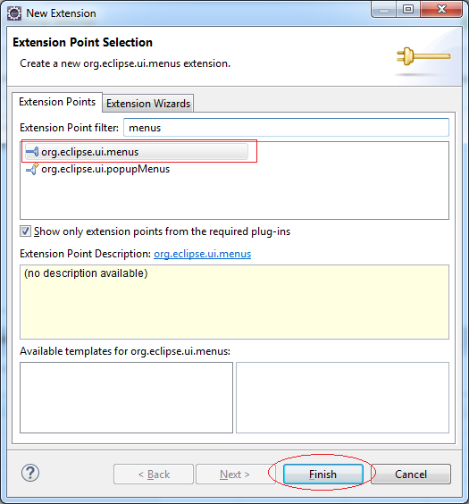

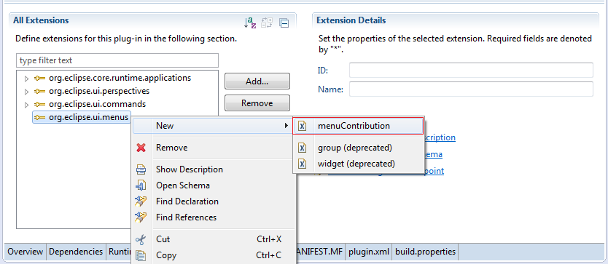

Enter:

* locationURI:  menu:org.eclipse.ui.main.menu

*menu:org.eclipse.ui.main.menu ==> ID to Locate of the menu, it is a constant of the RCP workbench available. You can also create locationURI to define the position display MENU.*

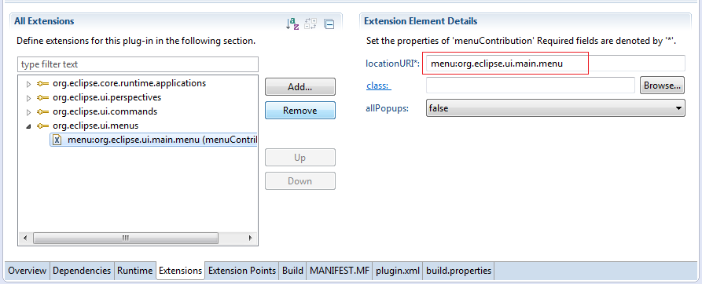

Next create Menu *"File"*.

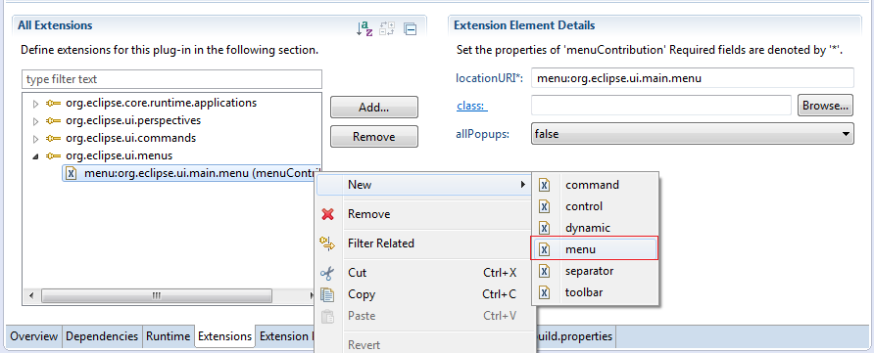

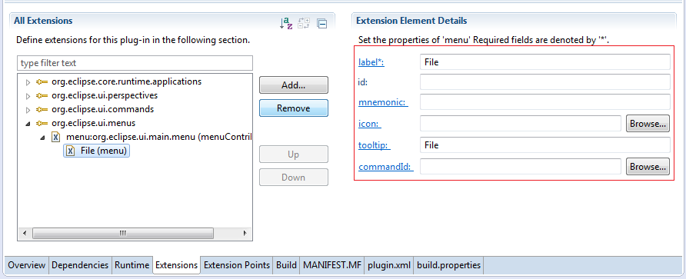

And add Command "Exit" in the menu "File".

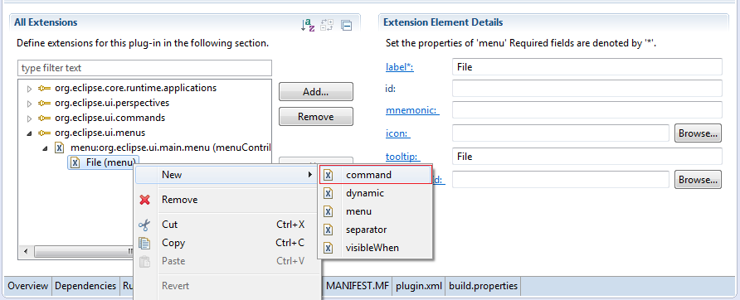

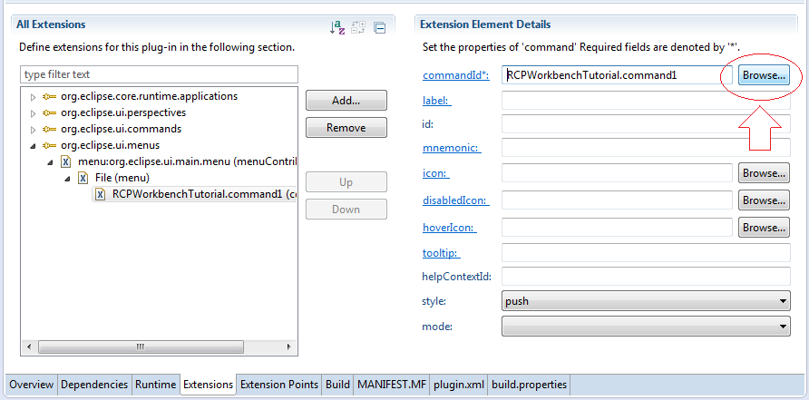

Enter Command ID:

* org.eclipse.ui.file.exit

This is a pre-defined command in RCP Platform, it exit the application.

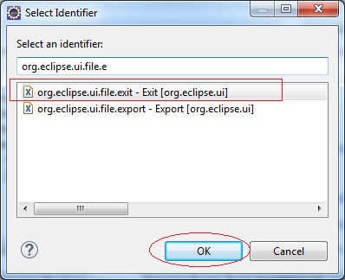

Similarly we create menu "Help".

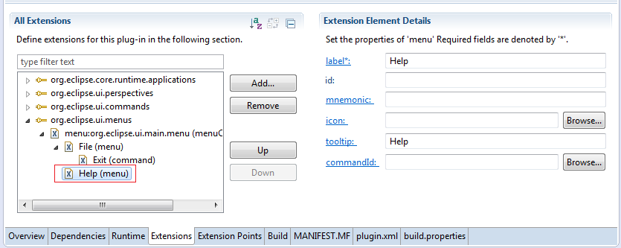

And create Command *"About"* child of Menu *"Help"*.

Enter ID of command will call to:

* org.o7planning.tutorial.rcp.cmd.about

*Class AboutCommand with ID: .rcp.cmd.about was created above.*

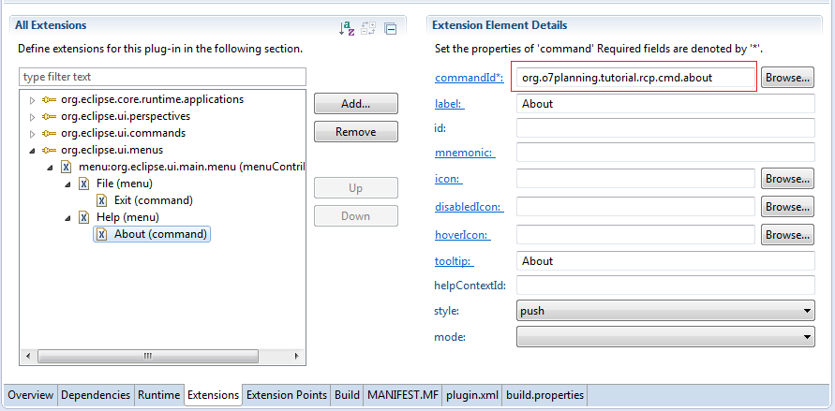

Rerun:

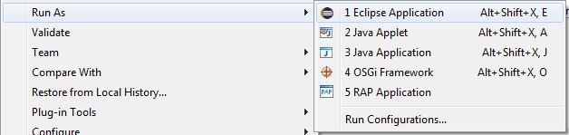

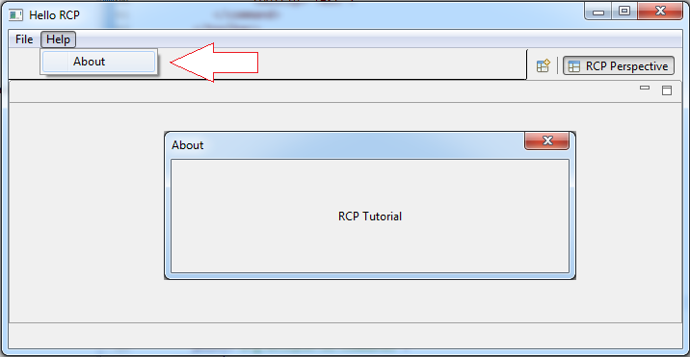

9.3- Toolbar

This is the toolbar structure seen on the Eclipse IDE.

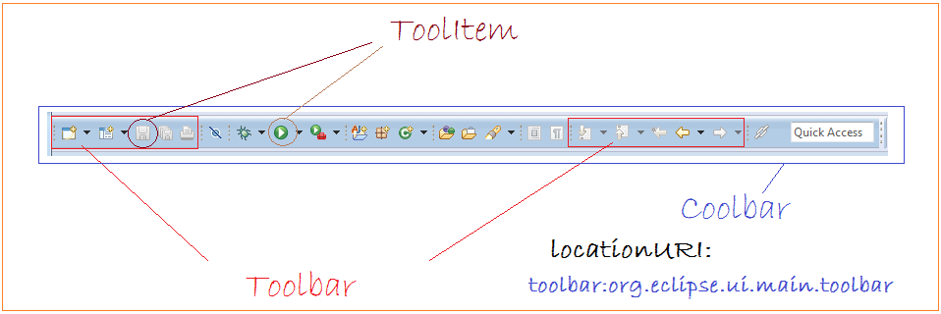

Create Coolbar:

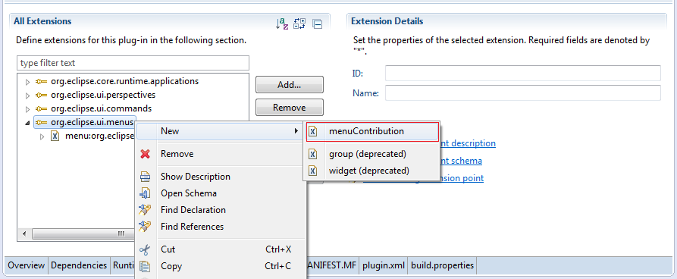

Enter

* locationURI: toolbar:org.eclipse.ui.main.toolbar

*locationURI: ID- defines the position of the Coolbar.  
toolbar:org.eclipse.ui.main.toolbar an ID has been declared available by RCP Platform. You can also create locationURI to define certain location..*

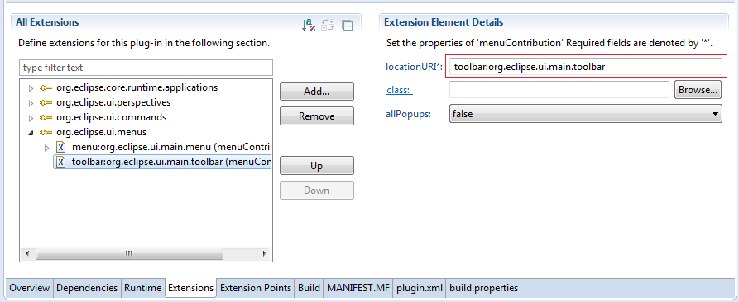

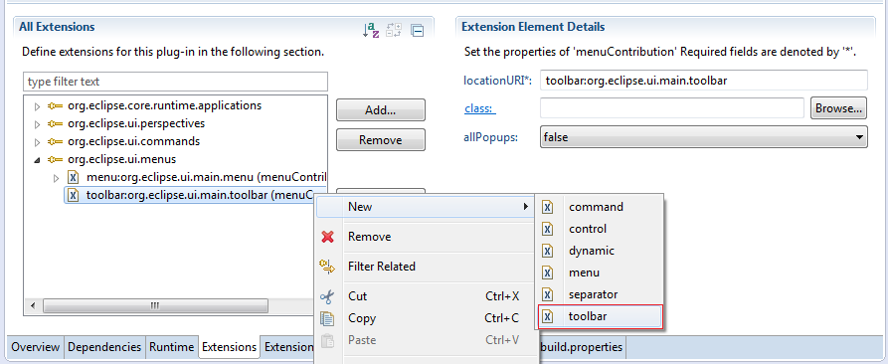

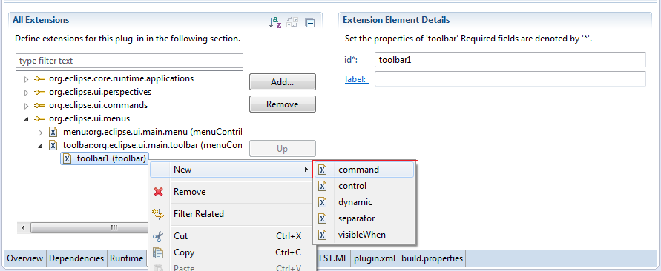

Enter commandID:

* org.eclipse.ui.file.exit

This is a predefined ID Platform RCP, it executes the command exit workbench applications..

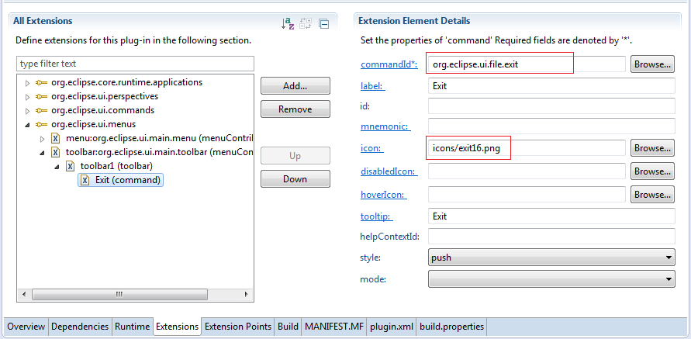

Similarly to create ToolItem (Type Command) to call Command ID:

* org.o7planning.tutorial.rcp.cmd.about

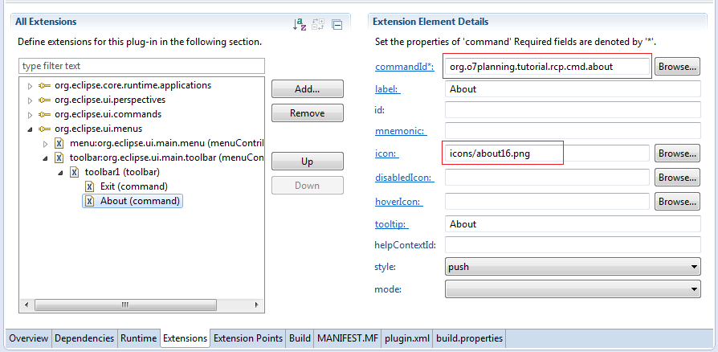

Similar create Toolbar with id: toolbar0

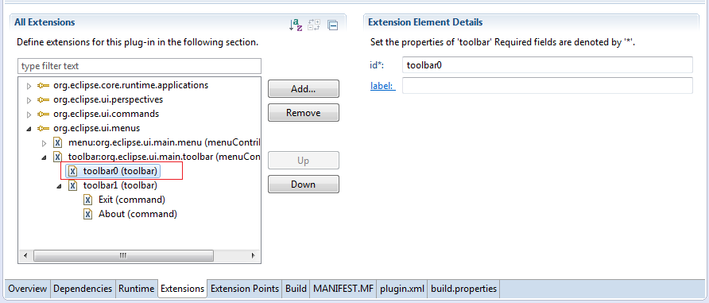

9.4- View

Add *"Extension Point"*

* org.eclipse.ui.views

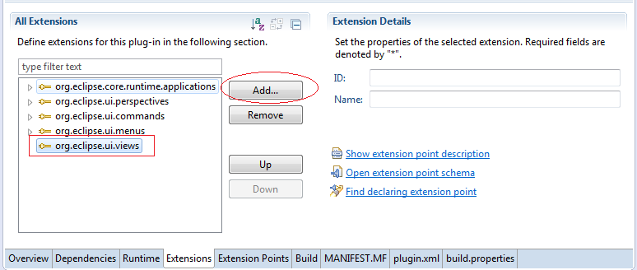

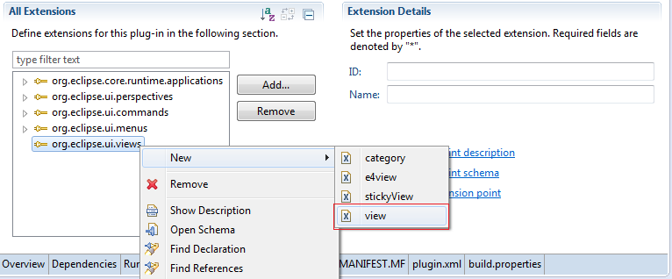

Enter:

* id: org.o7planning.tutorial.rcp.view.contact
* class: org.o7planning.tutorial.rcp.view.ContactView

Click to link *"class"* Eclipse will create class if it not exists.

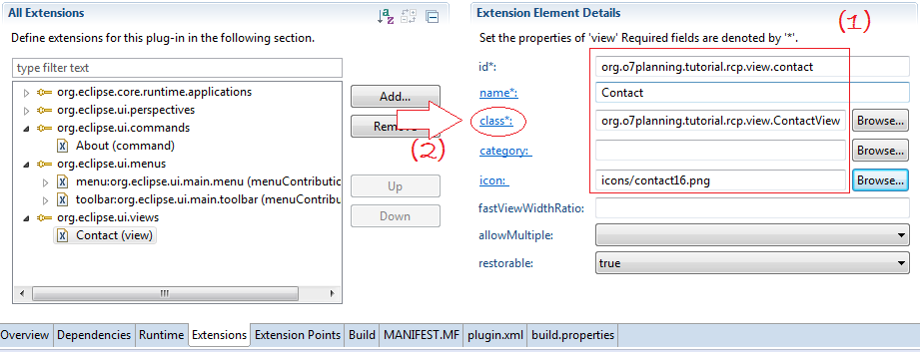

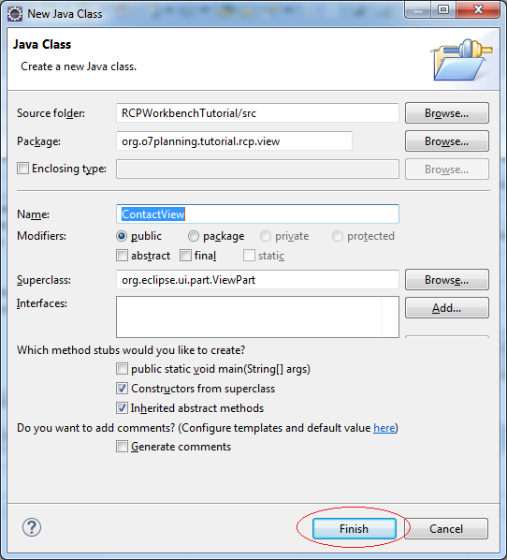

Class ContactView is created you can easily design it with WindowBuilder. Click on the class and open with WindowBuilder.

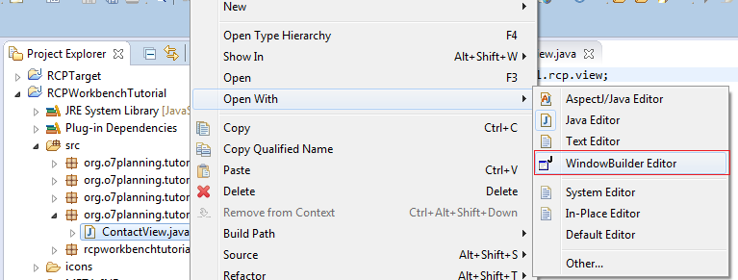

Similarly create another view.

CategoryView

* name: Category
* id: org.o7planning.tutorial.rcp.view.category
* class: org.o7planning.tutorial.rcp.view.CategoryView
* icon: icons/category16.png

HistoryView

* name: History
* id: org.o7planning.tutorial.rcp.view.history
* class: org.o7planning.tutorial.rcp.view.HistoryView
* icon: icons/history16.png

TaskView

* name: Task
* id: org.o7planning.tutorial.rcp.view.task
* class: org.o7planning.tutorial.rcp.view.TaskView
* icon: icons/task16.png

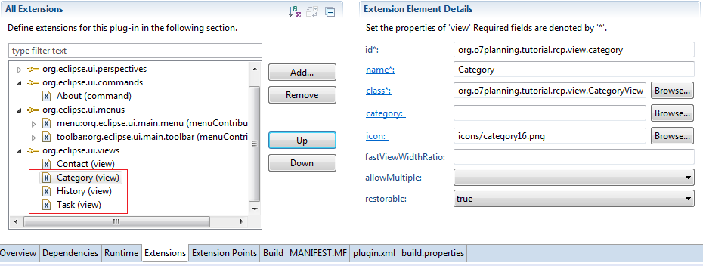

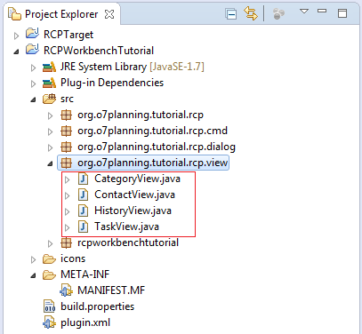

Registry Views to the Perspective

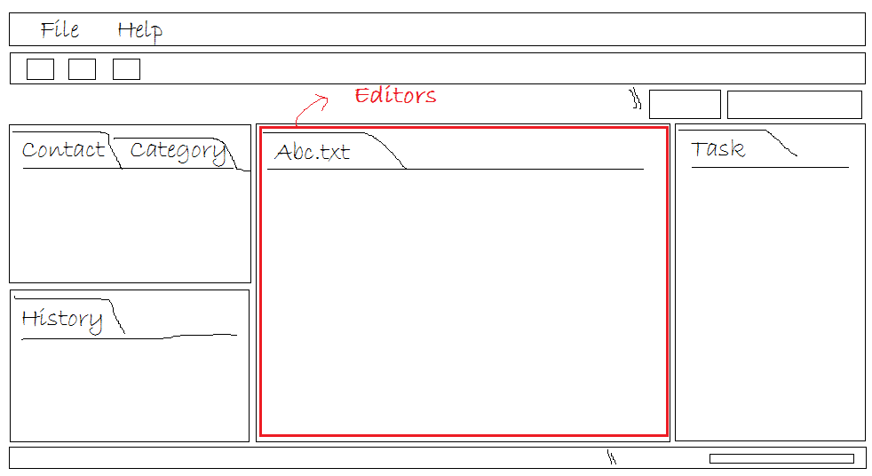

Add *"Extension Point"*:

* org.eclipse.ui.perspectiveExtensions

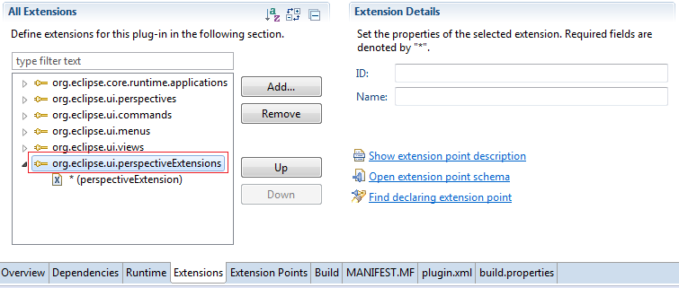

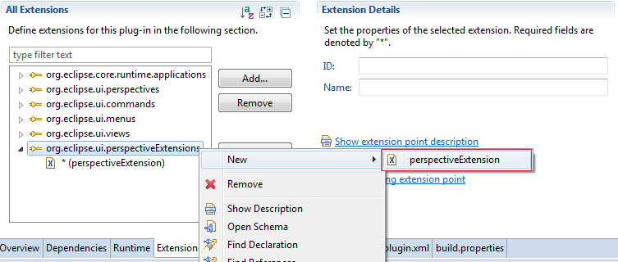

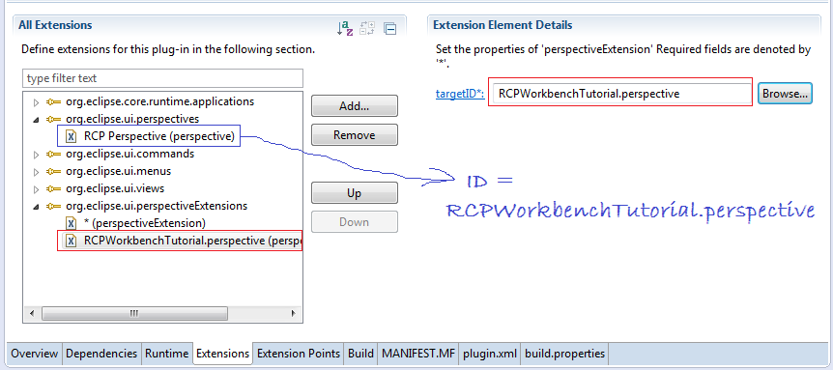

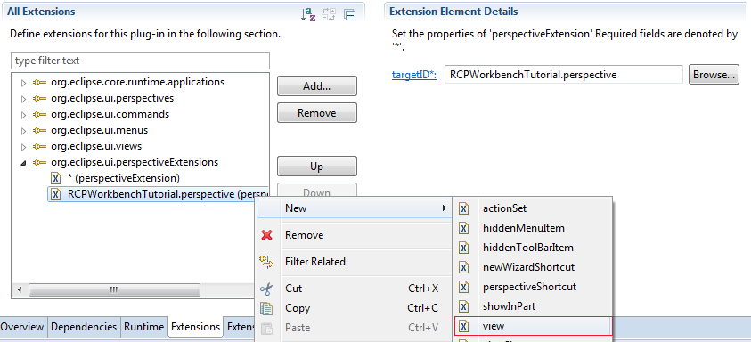

We define View: ContactView on the left compared with Editor.

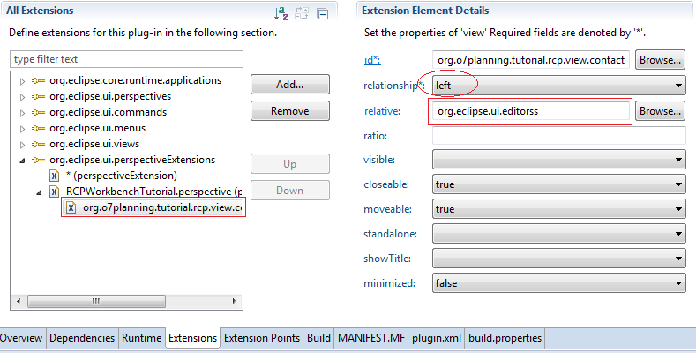

Next CategoryView stack up compared to ContactView.

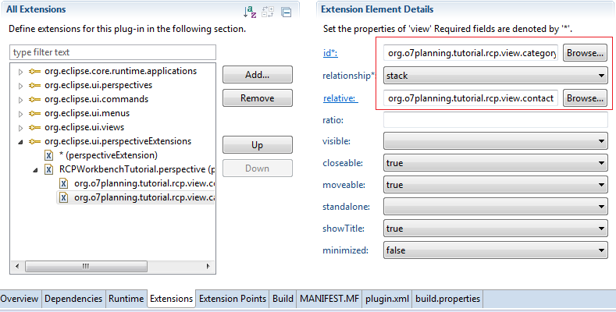

Next HistoryView below than ContactView

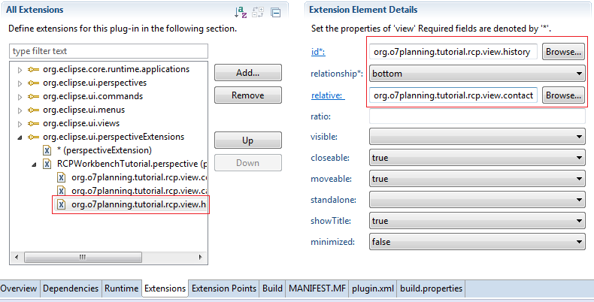

Finally TaskView declared displayed on the Perspective id is *, which means it will show up on any Perspective. Right position compared with the Editors.

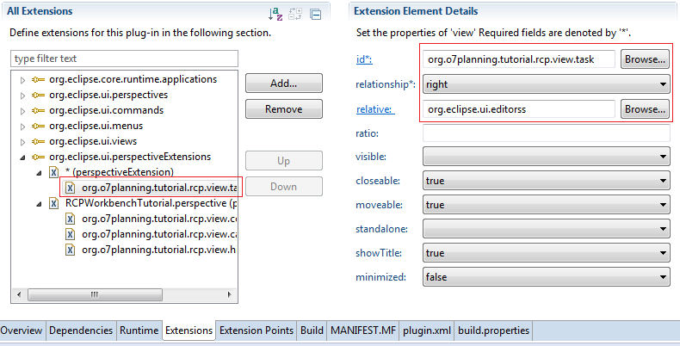

Rerun Application:

If Workbench does not display the View, right-click on the "RCP Perspective" and select reset.

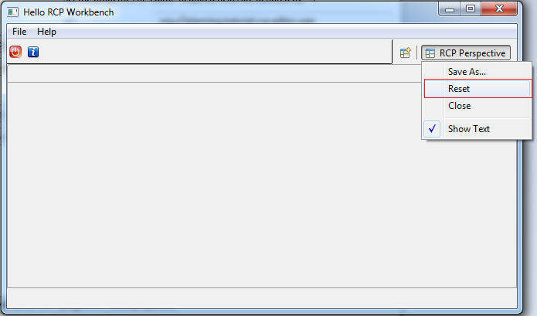

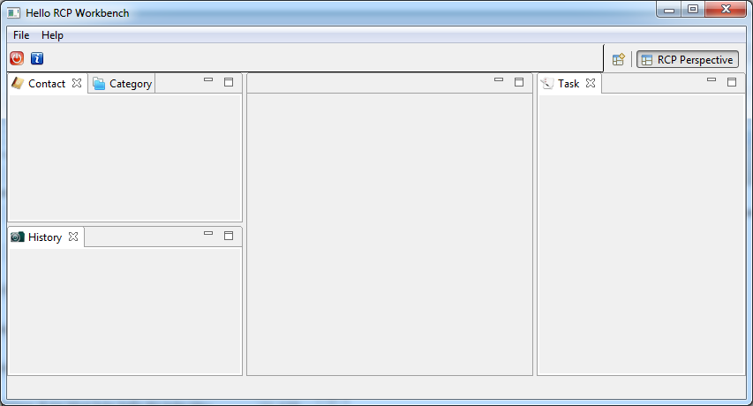

9.5- Perspective

A workbench application has one or more Perspective.

9.6- Editor

Add Extension Point:

* org.eclipse.ui.editors

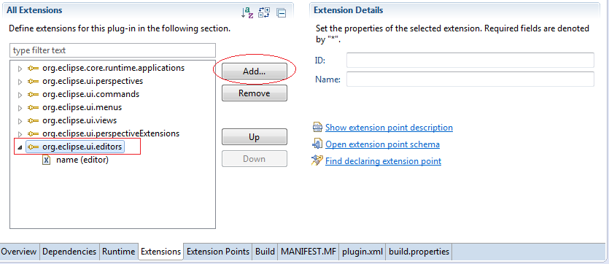

Enter:

* id: org.rcp.editor.user
* name: UserEditor
* icon: icons/user16.png
* class: org. rcp.editor.UserEditor

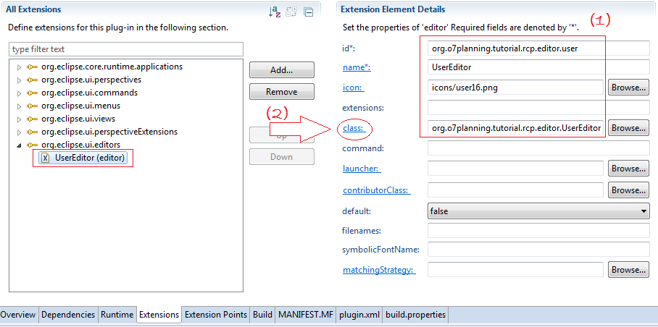

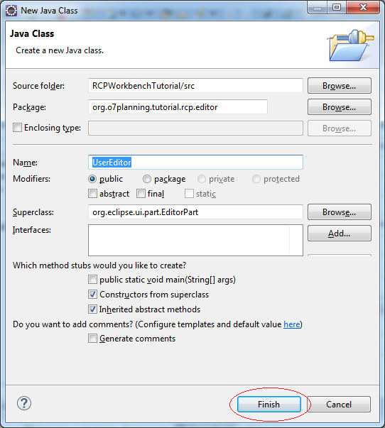

Class UserEditor was created. Next we create a class UserEditorInput

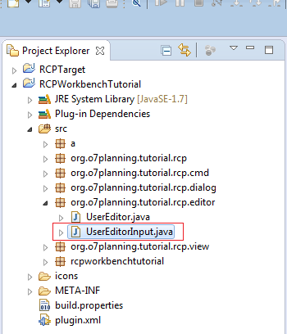

UserEditorInput.java

**import** org.eclipse.jface.resource.ImageDescriptor;

**import** org.eclipse.ui.IEditorInput;

**import** org.eclipse.ui.IPersistableElement;

**public** **class** **UserEditorInput** **implements** **IEditorInput** {

@Override

**public** Object **getAdapter**(Class adapter) {

**return** null;

}

@Override

**public** boolean **exists**() {

**return** false;

}

@Override

**public** ImageDescriptor **getImageDescriptor**() {

**return** null;

}

@Override

**public** String **getName**() {

**return** "User Editor";

}

@Override

**public** IPersistableElement **getPersistable**() {

**return** null;

}

@Override

**public** String **getToolTipText**() {

**return** "User Editor";

}

}

And edit UserEditor

UserEditorInput.java

**package** org.o7planning.tutorial.rcp.editor;

**import** org.eclipse.core.runtime.IProgressMonitor;

**import** org.eclipse.swt.SWT;

**import** org.eclipse.swt.layout.FillLayout;

**import** org.eclipse.swt.widgets.Composite;

**import** org.eclipse.ui.IEditorInput;

**import** org.eclipse.ui.IEditorSite;

**import** org.eclipse.ui.PartInitException;

**import** org.eclipse.ui.part.EditorPart;

**public** **class** **UserEditor** **extends** **EditorPart** {

**public** **static** **final** String ID = "org.o7planning.tutorial.rcp.editor.user";

**public** **UserEditor**() {

}

@Override

**public** **void** **doSave**(IProgressMonitor monitor) {

}

@Override

**public** **void** **doSaveAs**() {

}

/**

* Important!!!

*/

@Override

**public** **void** **init**(IEditorSite site, IEditorInput input)

**throws** PartInitException {

**if** (!(input **instanceof** UserEditorInput)) {

**throw** **new** **PartInitException**("Invalid Input: Must be "

+ UserEditorInput.class.getName());

}

setSite(site);

setInput(input);

}

@Override

**public** boolean **isDirty**() {

**return** false;

}

@Override

**public** boolean **isSaveAsAllowed**() {

**return** false;

}

@Override

**public** **void** **createPartControl**(Composite parent) {

// Add Code.

// If you want to design with WindowBuilder Designer

// Change code like: (Important!!!)

parent.setLayout(**new** **FillLayout**());

Composite body = **new** **Composite**(parent, SWT.NONE);

}

@Override

**public** **void** **setFocus**() {

}

}

You can open UserEditor with WindowBuilder to design.

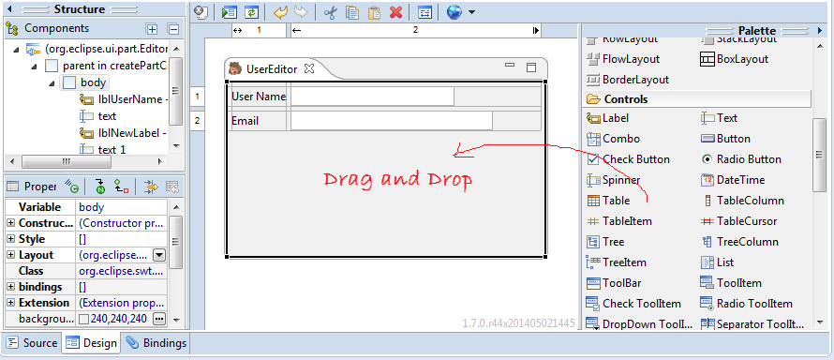

Next we create a Command to call UserEditor.

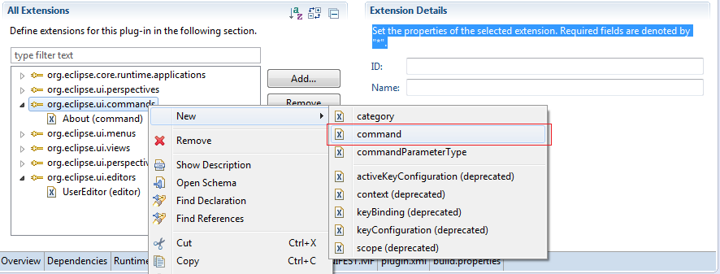

Enter:

* id: org.rcp.cmd.user
* name: Call UserEditor
* defaultHandler: org.rcp.cmd.UserCommand

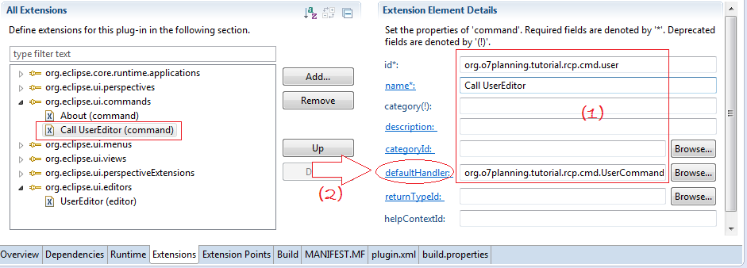

UserCommand.java

**import** org.eclipse.core.commands.AbstractHandler;

**import** org.eclipse.core.commands.ExecutionEvent;

**import** org.eclipse.core.commands.ExecutionException;

**import** org.eclipse.ui.IWorkbenchPage;

**import** org.eclipse.ui.IWorkbenchWindow;

**import** org.eclipse.ui.PartInitException;

**import** org.eclipse.ui.handlers.HandlerUtil;

**import** org.o7planning.tutorial.rcp.editor.UserEditor;

**import** org.o7planning.tutorial.rcp.editor.UserEditorInput;

**public** **class** **UserCommand** **extends** **AbstractHandler** {

**public** **static** **final** String ID = "org.o7planning.tutorial.rcp.cmd.user";

@Override

**public** Object **execute**(ExecutionEvent event) **throws** ExecutionException {

IWorkbenchWindow window = HandlerUtil.getActiveWorkbenchWindow(event);

IWorkbenchPage page = window.getActivePage();

UserEditorInput input = **new** **UserEditorInput**();

**try** {

page.openEditor(input, UserEditor.ID);

} **catch** (PartInitException e) {

System.out.println("Error:" + this.getClass().getName() + ":" + e);

e.printStackTrace();

**throw** **new** **ExecutionException**("Error open UserEditor");

}

**return** null;

}

}

Next you to make a MenuItem (Command):

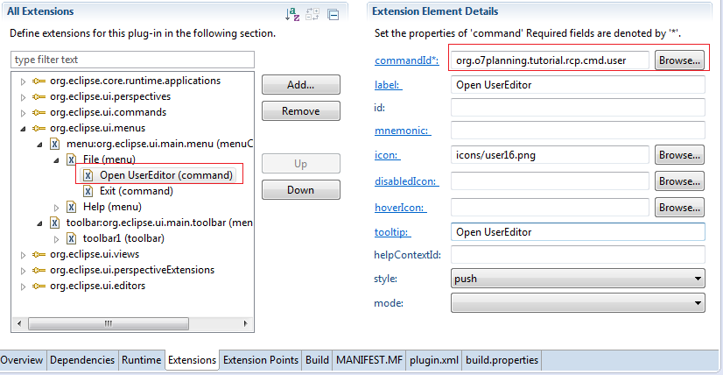

Rerun Application:

