RCP (Rich Client Platform)

RCP (Rich Client Platform) - As a platform based on SWT, used for programming Desktop applications, so far it has built a platform that allows you to develop desktop-style applications Workbench, like Eclipse IDE, or programmers can integrate the plugin to Eclipse IDE.  
  
But even if you want to use SWT to programming, and do not need to use those provided by the RCP you should also create an RCP application.

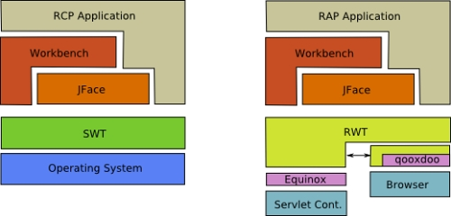

SWT:

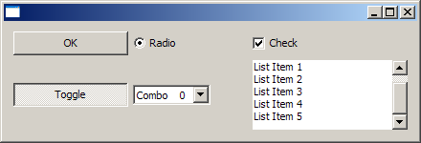

Workbench Application:

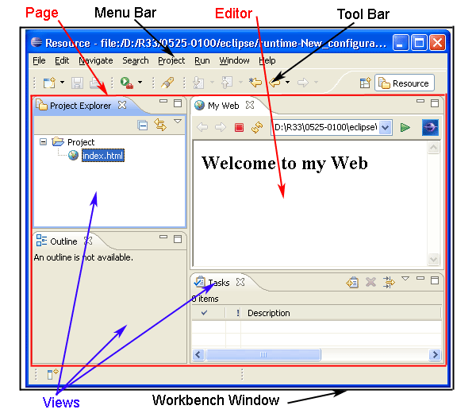

To create a desktop application using SWT. On the Eclipse, we will create an RCP Plugin Project. You have 2 options.

* Only use the features of the SWT
* Using the platform provided by the RCP to RCP Application Workbench programming

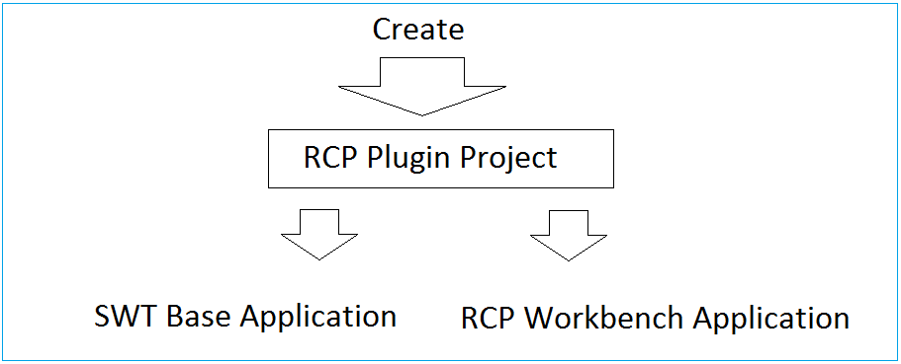

In this document, I will guide you to become familiar with basic programming SWT, using WindowBuilder to drag and drop components into the interface.

3- The settings required before starting

Some required settings before you start:  
  
You need the latest version of Eclipse. There currently is Eclipse 4.7 (Codes OXYGEN).

* <http://eclipse.org/downloads/>

In my opinion you to download package: "Eclipse IDE for Java EE Developers". The only different is number of Plugins, for the purpose of different programming. You can install additional plugins for other purposes if desired.

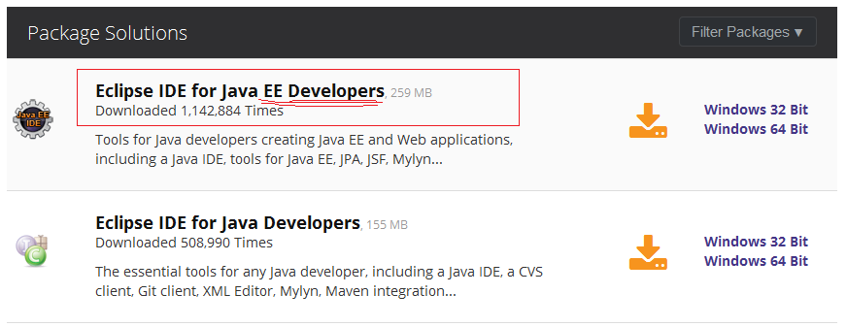

WindowBuilder, this is a plugin that allows you to design SWT GUI applications using drag and drop convenience.  
See installation instructions at:

* Install WindowBuilder for Eclipse



4- Some concepts of SWT.

4.1- Display & Shell

The Display and Shell classes are key components of SWT applications.  
  
- org.eclipse.swt.widgets.Shell class represents a window.  
  
- org.eclipse.swt.widgets.Display class is responsible for managing event loops, fonts, colors and for controlling the communication between the UI thread and other threads. Display is the base for all SWT capabilities.  
  
Every SWT application requires at least one Display and one or more Shell instances. The main Shell gets, as a default parameter, a Display as a constructor argument. Each Shell is constructed with a Display and if none is provided during construction it will use either the Display which is currently used or a default one.

Example:

Display display = **new** **Display**();

Shell shell = **new** **Shell**(display);

shell.open();

// run the event loop as long as the window is open

**while** (!shell.isDisposed()) {

// read the next OS event queue and transfer it to a SWT event

**if** (!display.readAndDispatch())

{

// if there are currently no other OS event to process

// sleep until the next OS event is available

display.sleep();

}

}

// disposes all associated windows and their components

display.dispose();

4.2- SWT Widgets

SWT widgets are located in the packages org.eclipse.swt.widgets and org.eclipse.swt.custom. Widgets extend either the Widget or the Control class. Several of these widgets are depicted in the following graphic.

This graphic is a screenshot of the [SWT widget homepage](http://www.eclipse.org/swt/widgets/).

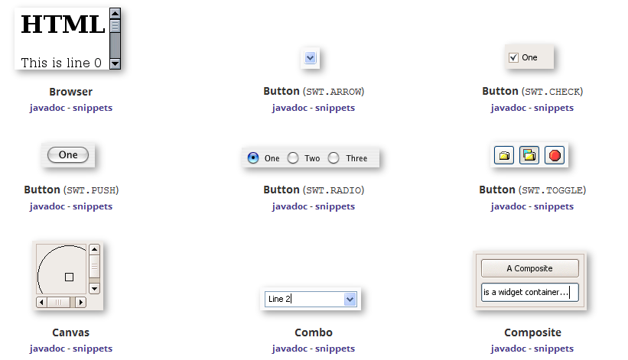

5- Create RCP Plugin Project

In Eclipse select:

* File/New/Other...

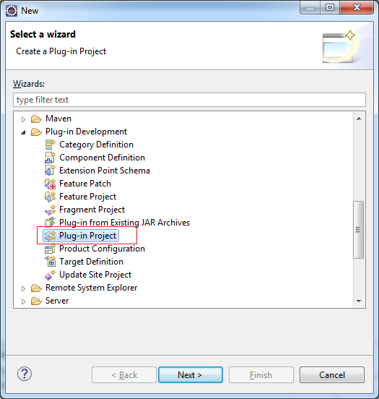

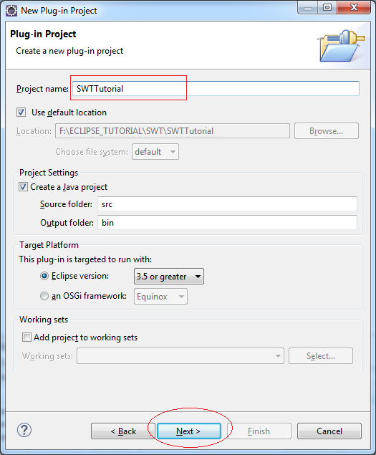

* So there is no need to create a Workbench application so we can not check in (1) as shown below.
* Select 'Yes' in the region (2) to Eclipse RCP Application created (Run on the Desktop), otherwise it will create RAP Application (Running on Web).

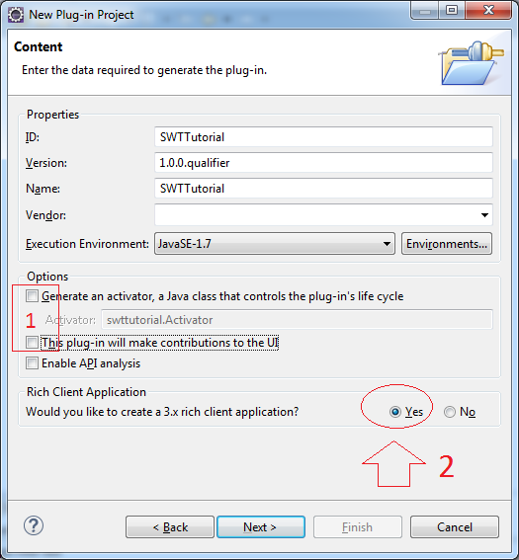

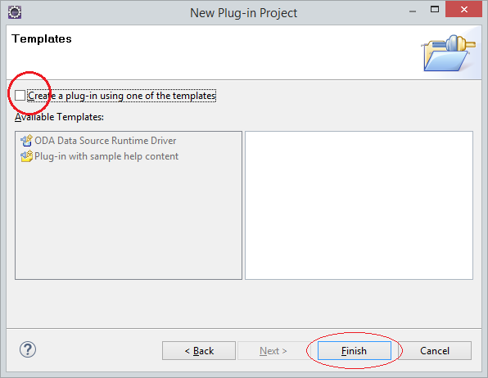

Created Project:

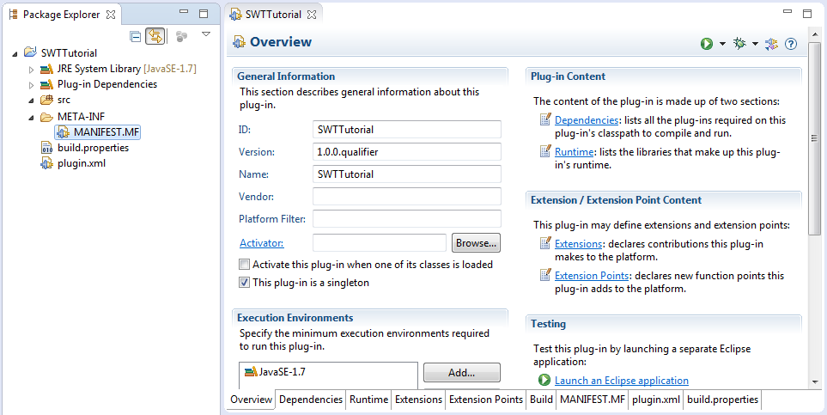

Add swt libary:  org.eclipse.swt

*If you develop RAP, using org.eclipse.rap.rwt*

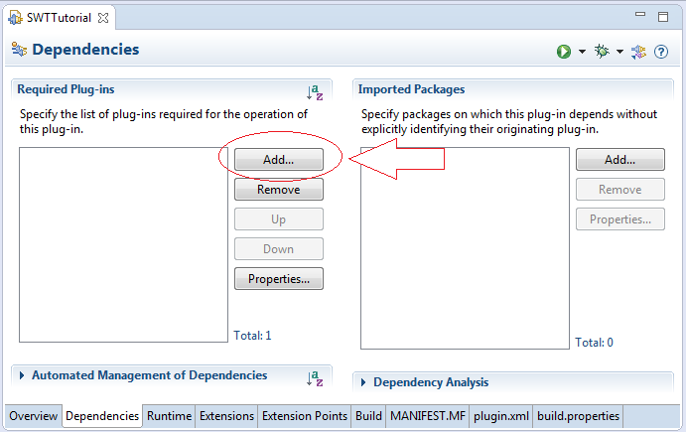

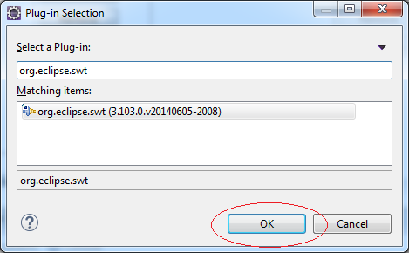

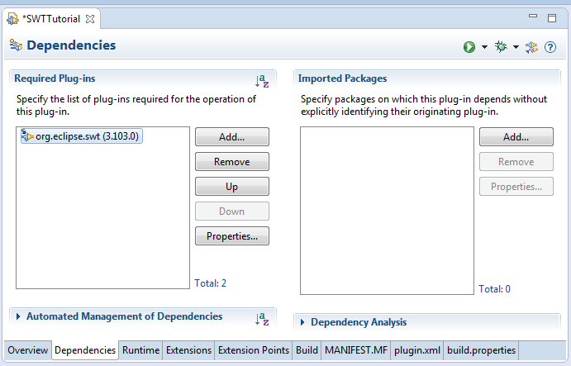

6- First Example

This is a simple example, not using the drag and drop tools WindowBuilder.

HelloSWT.java

**import** org.eclipse.swt.widgets.Display;

**import** org.eclipse.swt.widgets.Shell;

**public** **class** **HelloSWT** {

**public** **static** **void** **main**(String[] args) {

// Create Display

Display display = **new** **Display**();

// Create Shell (Window) from diplay

Shell shell = **new** **Shell**(display);

shell.open();

**while** (!shell.isDisposed()) {

**if** (!display.readAndDispatch())

display.sleep();

}

display.dispose();

}

}

Right-click on the class HelloSWT, and select Run As/Java Application.

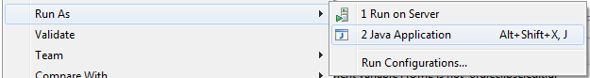

Result:

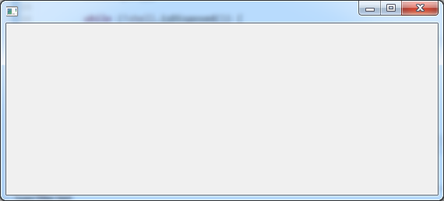

7- Using WindowBuilder

Next we will create an example for drag and drop with WindowBuilder.

* File/New/Other ..

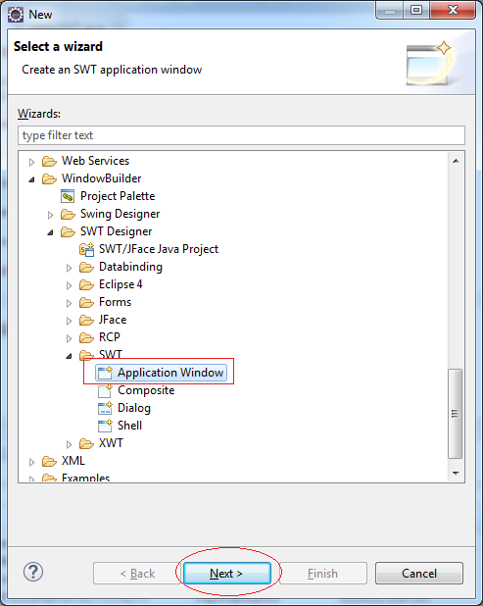

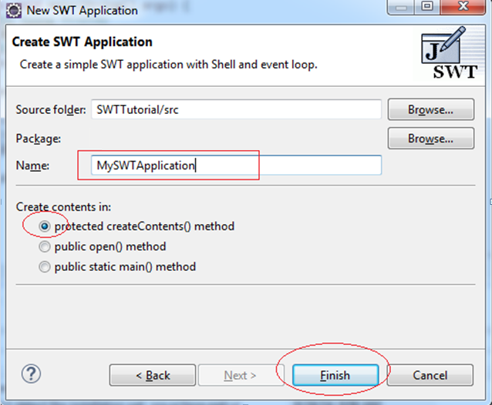

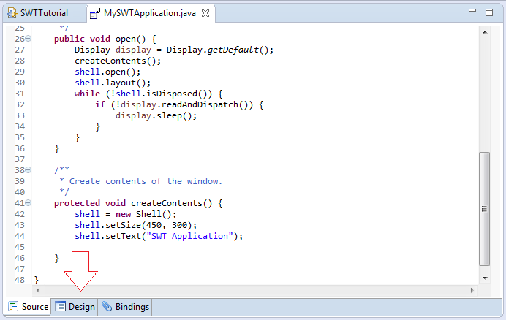

This is the window of WindowBuilder design. It allows you to drag and drop the widgets easily.

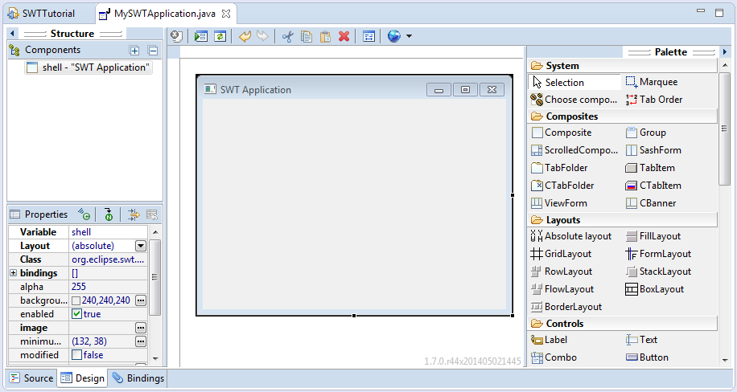

You can watch the video below:

8- SWT Widget

8.1- Overview

This is the hierarchy of widgets in SWT.

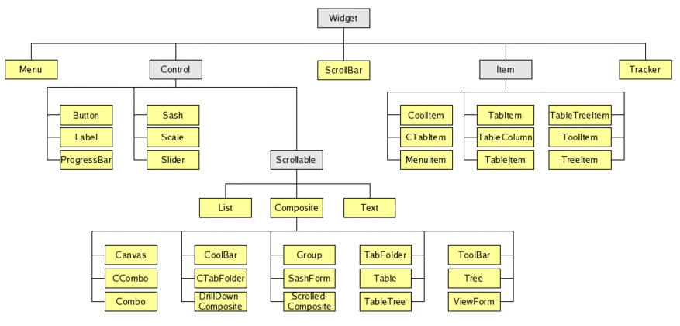

You can view the demo of the Control at the link below, it's RWT Control, but they are essentially the same as SWT control.

Demo:

* <http://rap.eclipsesource.com/demo/release/controls/>

8.2- Widgets can contain other widgets (Container)



8.3- Controls

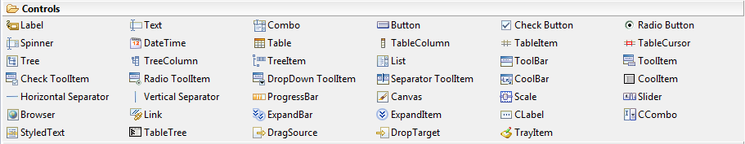

9- SWT Layout

9.1- What is Layout?

Put simply, Layout is how to arrange the components on the interface.

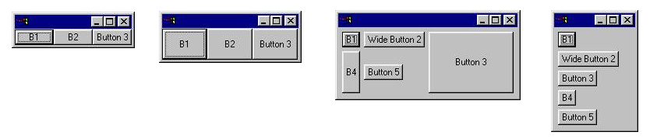

The standard layout classes in the SWT library are:

* FillLayout – lays out equal-sized widgets in a single row or column
* RowLayout – lays out widgets in a row or rows, with fill, wrap, and spacing options
* GridLayout – lays out widgets in a grid

9.2- Online Example

This is an example online, allowing you to see how the exercise of the Layout.

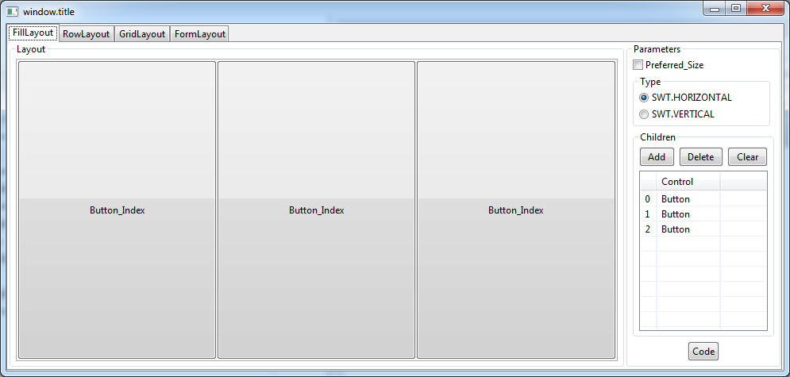

* TODO Link?

9.3- FillLayout

FillLayout is the simplest layout class. It lays out widgets in a single row or column, forcing them to be the same size. Initially, the widgets will all be as tall as the tallest widget, and as wide as the widest. FillLayout does not wrap, and you cannot specify margins or spacing.

FillLayout fillLayout = **new** **FillLayout**();

fillLayout.type = SWT.VERTICAL;

shell.setLayout(fillLayout);

|  |  |  |
| --- | --- | --- |
|  | Initial | After resize |
| fillLayout.type = SWT.HORIZONTAL (default) | http://www.eclipse.org/articles/Article-Understanding-Layouts/files/image008.jpg | http://www.eclipse.org/articles/Article-Understanding-Layouts/files/image010.jpg |
| fillLayout.type = SWT.VERTICAL | http://www.eclipse.org/articles/Article-Understanding-Layouts/files/image012.jpg | http://www.eclipse.org/articles/Article-Understanding-Layouts/files/image014.jpg |

Video:

FillLayoutExample.java

**import** org.eclipse.swt.SWT;

**import** org.eclipse.swt.layout.FillLayout;

**import** org.eclipse.swt.layout.RowLayout;

**import** org.eclipse.swt.widgets.Button;

**import** org.eclipse.swt.widgets.Composite;

**import** org.eclipse.swt.widgets.Display;

**import** org.eclipse.swt.widgets.Shell;

**public** **class** **FillLayoutExample** {

**public** **static** **void** **main**(String[] args) {

Display display = **new** **Display**();

**final** Shell shell = **new** **Shell**(display);

shell.setLayout(**new** **FillLayout**());

//

Composite parent = **new** **Composite**(shell, SWT.NONE);

FillLayout fillLayout= **new** **FillLayout**();

fillLayout.type= SWT.VERTICAL;

parent.setLayout(fillLayout);

Button b1 = **new** **Button**(parent, SWT.NONE);

b1.setText("B1");

Button b2 = **new** **Button**(parent, SWT.NONE);

b2.setText("B2");

Button button3 = **new** **Button**(parent, SWT.NONE);

button3.setText("Button 3");

// Windows back to natural size.

shell.pack();

//

shell.open();

**while** (!shell.isDisposed()) {

**if** (!display.readAndDispatch())

display.sleep();

}

// tear down the SWT window

display.dispose();

}

}

Run result:

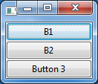

9.4- RowLayout

RowLayout is more commonly used than FillLayout because of its ability to wrap, and because it provides configurable margins and spacing. RowLayout has a number of configuration fields. In addition, the height and width of each widget in a RowLayout can be specified by setting a RowData object into the widget using setLayoutData.

The field configuration:

Wrap, Pack, Justify:

|  |  |  |
| --- | --- | --- |
|  | Initial | After resize |
| wrap = true pack = true justify = false   (defaults) | http://www.eclipse.org/articles/Article-Understanding-Layouts/files/image018.jpg | http://www.eclipse.org/articles/Article-Understanding-Layouts/files/image020.jpg |
| wrap = false   (clips if not enough space) | http://www.eclipse.org/articles/Article-Understanding-Layouts/files/image021.jpg | http://www.eclipse.org/articles/Article-Understanding-Layouts/files/image023.jpg |
| pack = false   (all widgets are the same size) | http://www.eclipse.org/articles/Article-Understanding-Layouts/files/image025.jpg | http://www.eclipse.org/articles/Article-Understanding-Layouts/files/image027.jpg |
| justify = true   (widgets are spread across the available space) | http://www.eclipse.org/articles/Article-Understanding-Layouts/files/image029.jpg | http://www.eclipse.org/articles/Article-Understanding-Layouts/files/image031.jpg |

MarginLeft, MarginTop, MarginRight, MarginBottom, Spacing:

These fields control the number of pixels between widgets (spacing) and the number of pixels between a widget and the side of the parent Composite (margin). By default, RowLayouts leave 3 pixels for margin and spacing. The margin and spacing fields are shown in the following diagram.

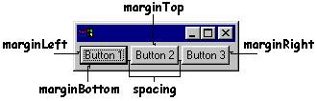

Video:

9.5- GridLayout

GridLayout is the most useful and powerful of the standard layouts, but it is also the most complicated. With a GridLayout, the widget children of a Composite are laid out in a grid. GridLayout has a number of configuration fields, and, like RowLayout, the widgets it lays out can have an associated layout data object, called GridData. The power of GridLayout lies in the ability to configure GridData for each widget controlled by the GridLayout.

The configuration of the GridLayout:

* NumColumns

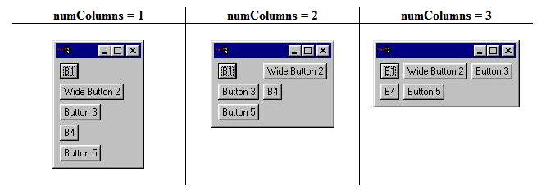

* MakeColumnsEqualWidth

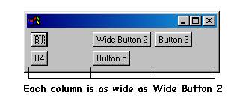

Video GridLayout:

9.6- StackLayout

This Layout stacks all the controls one on top of the other and resizes all controls to have the same size and location. The control specified in topControl is visible and all other controls are not visible. Users must set the topControl value to flip between the visible items and then call layout() method on the composite which has the StackLayout.

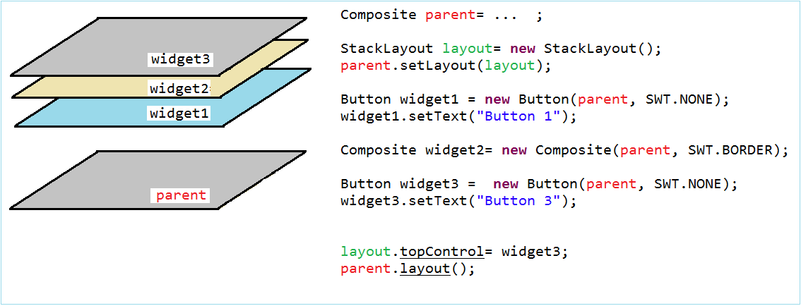

Video StackLayout:

9.7- Combine Layout

Above, we have become familiar with the standard layout. Combining different layout, and the other container (Composite, TabFolder, SashForm, ..) will create the desired interface.

* TODO

10- Write the class extending from the SWT widget

Sometimes you need to write a class extending from available widget class of SWT. It is perfectly normal, but there is a small note, you need to override the method checkSubclass() without having to do anything in that method.

MyButton.java

**import** org.eclipse.swt.widgets.Button;

**import** org.eclipse.swt.widgets.Composite;

**public** **class** **MyButton** **extends** **Button** {

**public** **MyButton**(Composite parent, int style) {

super(parent, style);

}

// You have to override this method.

@Override

**protected** **void** **checkSubclass**() {

// No need to do anything.

}

}

11- Modular component interfaces

In case you have designed a complex interface. The splitting of designs is necessary and then put together, this will be easier if designing on Window Builder.  
  
Please see the following interface, and we will try to split it up.

Suppose that you want to design an interface like the illustration below. (It is not complicated to split the design, but this is an example to illustrate how to split interface design)

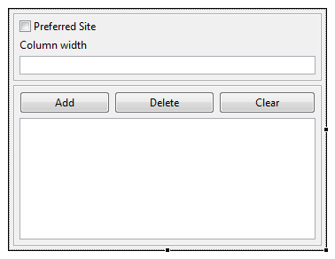

We can design two separate Composite and graft it on MainComposite.

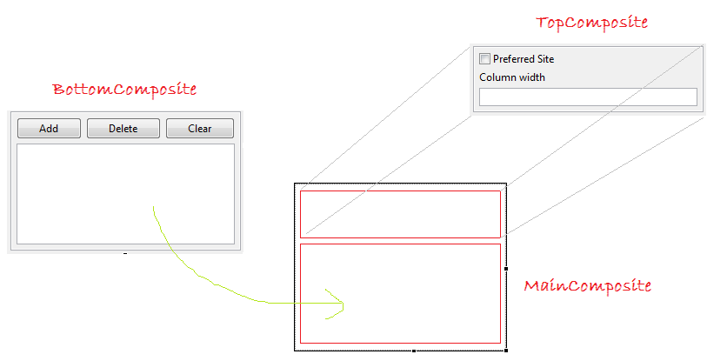

TopComposite

* File/New/Other...

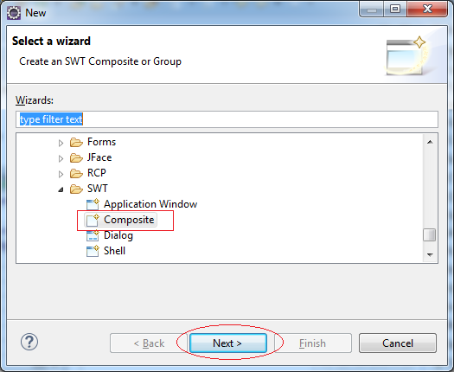

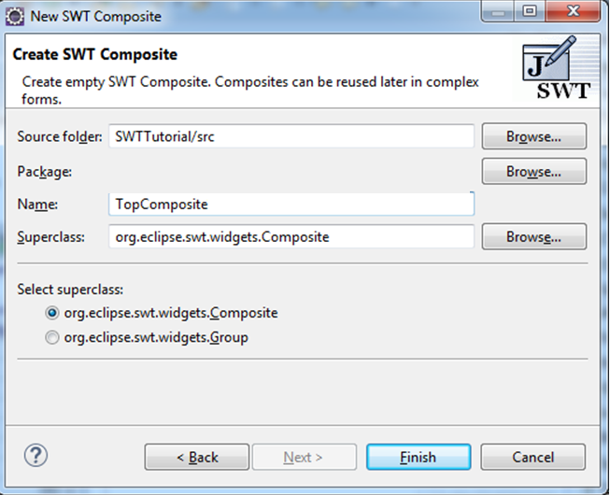

Interface Design for TopComposite.

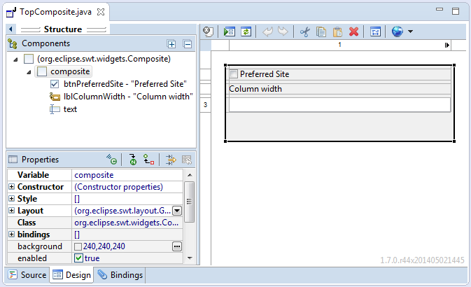

TopComposite.java

**import** org.eclipse.swt.widgets.Composite;

**public** **class** **TopComposite** **extends** **Composite** {

**private** Text text;

/**

* Create the composite.

* **@param** parent

* **@param** style

*/

**public** **TopComposite**(Composite parent, int style) {

super(parent, style);

setLayout(**new** **FillLayout**(SWT.HORIZONTAL));

Composite composite = **new** **Composite**(this, SWT.NONE);

composite.setLayout(**new** **GridLayout**(1, false));

Button btnPreferredSite = **new** **Button**(composite, SWT.CHECK);

btnPreferredSite.setText("Preferred Site");

Label lblColumnWidth = **new** **Label**(composite, SWT.NONE);

lblColumnWidth.setText("Column width");

text = **new** **Text**(composite, SWT.BORDER);

text.setLayoutData(**new** **GridData**(SWT.FILL, SWT.CENTER, true, false, 1, 1));

}

@Override

**protected** **void** **checkSubclass**() {

}

}

BottomComposite

Similarly, create class BottomComposite

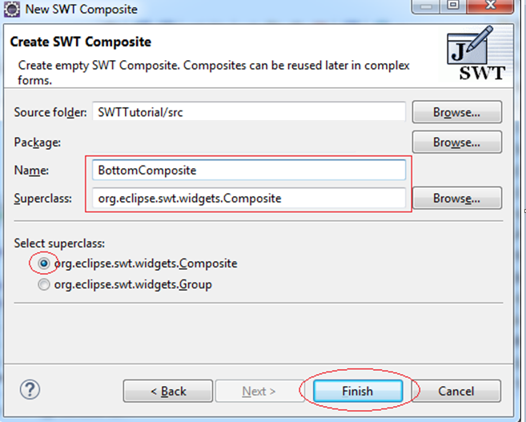

Interface Design for BottomComposite:

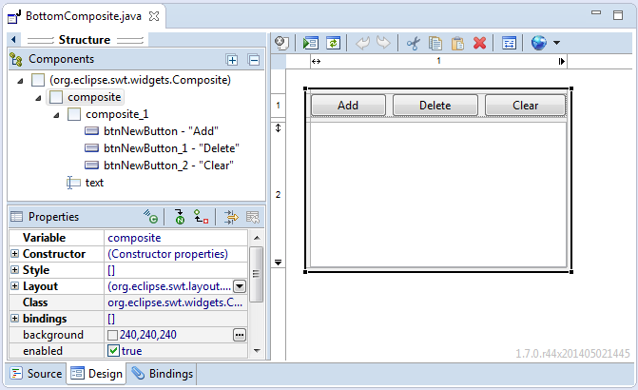

BottomComposite.java

**import** org.eclipse.swt.SWT;

**public** **class** **BottomComposite** **extends** **Composite** {

**private** Text text;

/**

* Create the composite.

* **@param** parent

* **@param** style

*/

**public** **BottomComposite**(Composite parent, int style) {

super(parent, style);

setLayout(**new** **FillLayout**(SWT.HORIZONTAL));

Composite composite = **new** **Composite**(this, SWT.NONE);

composite.setLayout(**new** **GridLayout**(1, false));

Composite composite_1 = **new** **Composite**(composite, SWT.NONE);

GridLayout gl_composite_1 = **new** **GridLayout**(3, false);

gl_composite_1.marginHeight = 0;

gl_composite_1.marginWidth = 0;

composite_1.setLayout(gl_composite_1);

composite_1.setLayoutData(**new** **GridData**(SWT.FILL, SWT.CENTER, true, false, 1, 1));

Button btnNewButton = **new** **Button**(composite_1, SWT.NONE);

btnNewButton.setLayoutData(**new** **GridData**(SWT.FILL, SWT.CENTER, true, false, 1, 1));

btnNewButton.setText("Add");

Button btnNewButton_1 = **new** **Button**(composite_1, SWT.NONE);

btnNewButton_1.setLayoutData(**new** **GridData**(SWT.FILL, SWT.CENTER, true, false, 1, 1));

btnNewButton_1.setText("Delete");

Button btnNewButton_2 = **new** **Button**(composite_1, SWT.NONE);

btnNewButton_2.setLayoutData(**new** **GridData**(SWT.FILL, SWT.CENTER, true, false, 1, 1));

btnNewButton_2.setText("Clear");

text = **new** **Text**(composite, SWT.BORDER | SWT.MULTI);

text.setLayoutData(**new** **GridData**(SWT.FILL, SWT.FILL, true, true, 1, 1));

}

@Override

**protected** **void** **checkSubclass**() {

// Disable the check that prevents subclassing of SWT components

}

}

MainComposite

Similarly create class MainComposite:

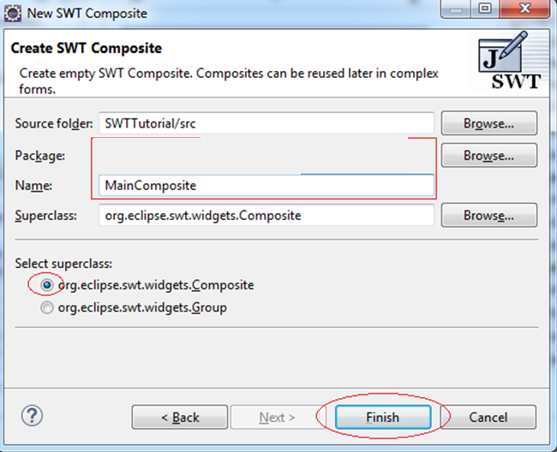

Register TopComposite & BottomComposite into Palette

Right-click the Palette and choose Add category ...

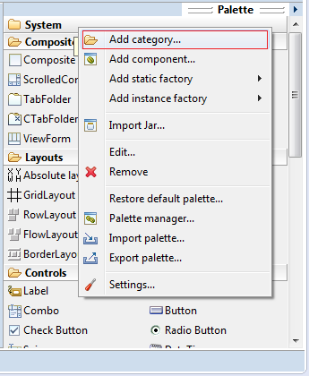

Named Pallete Category:

* My Composite

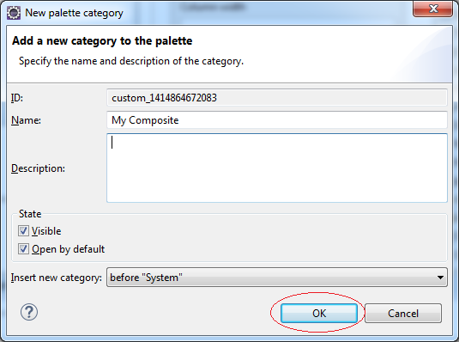

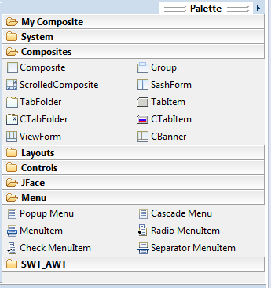

Right-click on the Category Pallette "My Composite" to add TopComposite & BottomComposite.

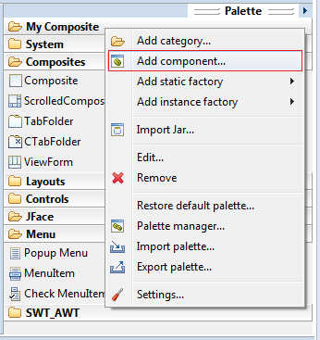

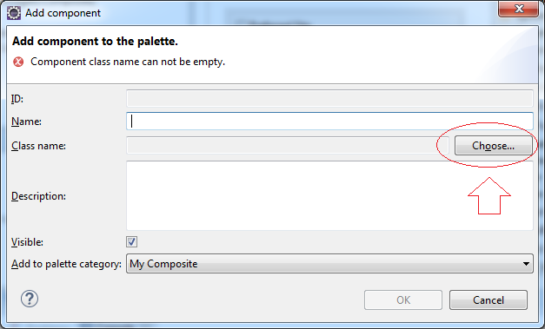

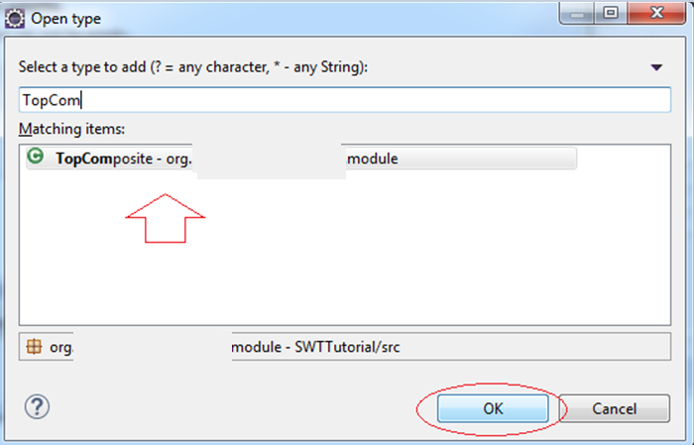

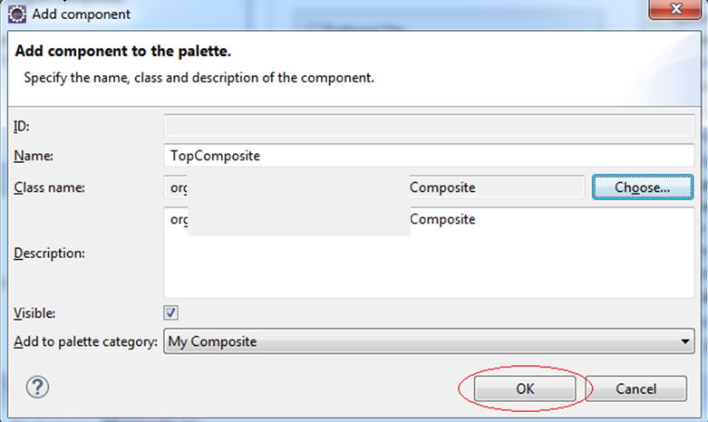

Similarly add BottomComposite to *"My Composite"* catalog.

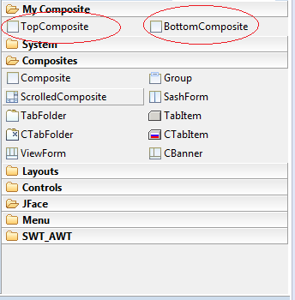

Now TopComposite & BottomComposite are easily drag and drop on the other Composite.

MainComposite.java

**import** org.eclipse.swt.SWT;

**import** org.eclipse.swt.layout.FillLayout;

**import** org.eclipse.swt.layout.GridData;

**import** org.eclipse.swt.layout.GridLayout;

**import** org.eclipse.swt.widgets.Composite;

**public** **class** **MainComposite** **extends** **Composite** {

/**

* Create the composite.

* **@param** parent

* **@param** style

*/

**public** **MainComposite**(Composite parent, int style) {

super(parent, style);

setLayout(**new** **FillLayout**(SWT.HORIZONTAL));

Composite composite = **new** **Composite**(this, SWT.NONE);

composite.setLayout(**new** **GridLayout**(1, false));

TopComposite topComposite = **new** **TopComposite**(composite, SWT.BORDER);

topComposite.setLayoutData(**new** **GridData**(SWT.FILL, SWT.CENTER, true, false, 1, 1));

BottomComposite bottomComposite = **new** **BottomComposite**(composite, SWT.BORDER);

bottomComposite.setLayoutData(**new** **GridData**(SWT.FILL, SWT.FILL, true, true, 1, 1));

}

@Override

**protected** **void** **checkSubclass**() {

}

}

12- Using event handlers

SWT event handling is very simple with the support of WindowBuilder.

Examples:

* File/New/Other...

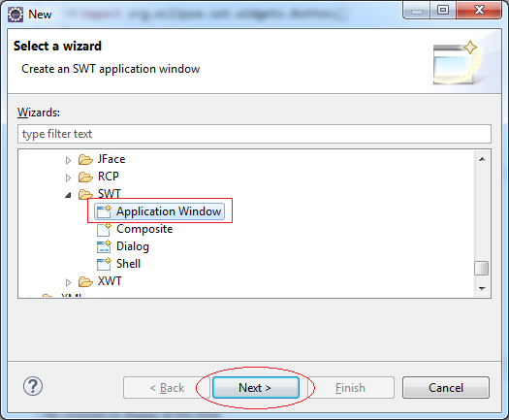

* Package: org.swt.event1
* Name: ButtonEventDemo

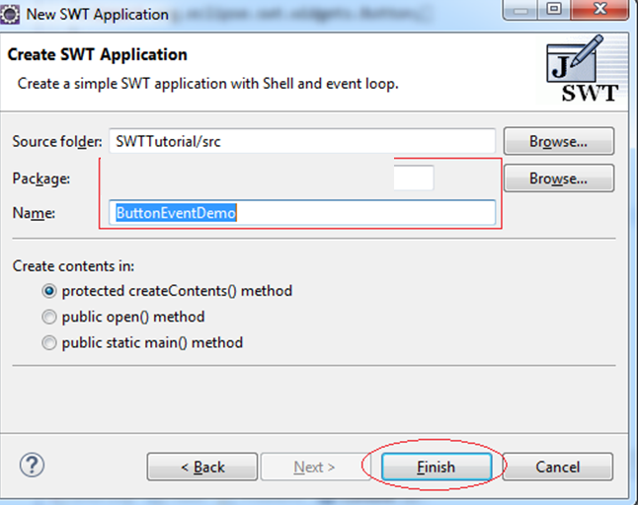

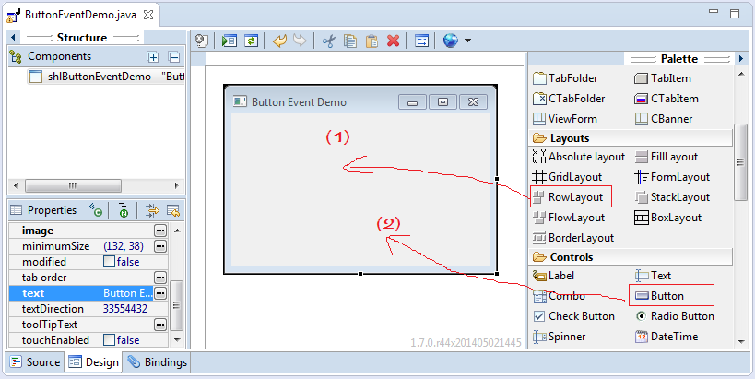

Right-click the Button, select *Add event handler*, a series of events for Button displayed.

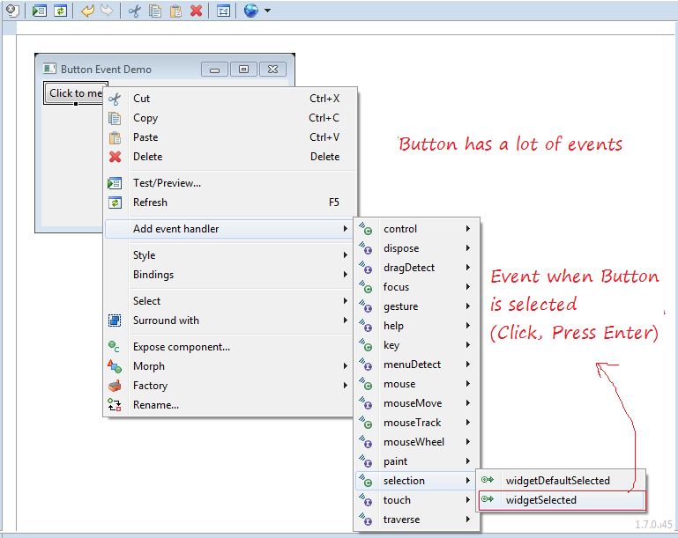

WindowBuilder will automatically generate code for you:

btnClickToMe.addSelectionListener(**new** **SelectionAdapter**() {

@Override

**public** **void** **widgetSelected**(SelectionEvent e) {

// Sử lý sự kiện Button được chọn tại đây.

System.out.println("Button selected!");

}

});

ButtonEventDemo.java

**import** org.eclipse.swt.SWT;

**import** org.eclipse.swt.events.SelectionAdapter;

**import** org.eclipse.swt.events.SelectionEvent;

**import** org.eclipse.swt.layout.RowLayout;

**import** org.eclipse.swt.widgets.Button;

**import** org.eclipse.swt.widgets.Display;

**import** org.eclipse.swt.widgets.Shell;

**public** **class** **ButtonEventDemo** {

**protected** Shell shlButtonEventDemo;

**public** **static** **void** **main**(String[] args) {

**try** {

ButtonEventDemo window = **new** **ButtonEventDemo**();

window.open();

} **catch** (Exception e) {

e.printStackTrace();

}

}

**public** **void** **open**() {

Display display = Display.getDefault();

createContents();

shlButtonEventDemo.open();

shlButtonEventDemo.layout();

**while** (!shlButtonEventDemo.isDisposed()) {

**if** (!display.readAndDispatch()) {

display.sleep();

}

}

}

**protected** **void** **createContents**() {

shlButtonEventDemo = **new** **Shell**();

shlButtonEventDemo.setSize(296, 205);

shlButtonEventDemo.setText("Button Event Demo");

shlButtonEventDemo.setLayout(**new** **RowLayout**(SWT.HORIZONTAL));

Button btnClickToMe = **new** **Button**(shlButtonEventDemo, SWT.NONE);

btnClickToMe.addSelectionListener(**new** **SelectionAdapter**() {

@Override

**public** **void** **widgetSelected**(SelectionEvent e) {

// Handle Button selected here!

System.out.println("Button selected!");

}

});

btnClickToMe.setText("Click to me");

}

}

13- JFace

