* Loading data into the database
* Running SQL statements on the database

Create the BANK_CUSTOMERS table

1. Log into the web console for your Db2 Warehouse on Cloud instance.  
   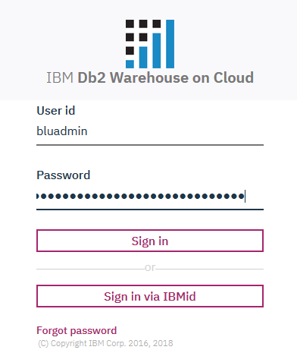
2. In the Db2 Warehouse on Cloud web console, click the hamburger menu.  Select **RUN SQL**to access the SQL editor.  
   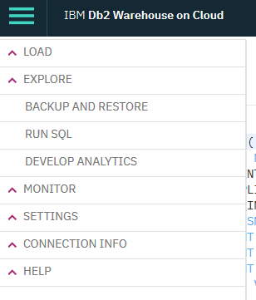
3. You can use the SQL editor to run SQL statements on your Db2 Warehouse on Cloud instance. You can create a SQL statement from scratch, by using a template or opening a saved script from a file. For this tutorial, let’s start from scratch by clicking **Blank**.  
   ​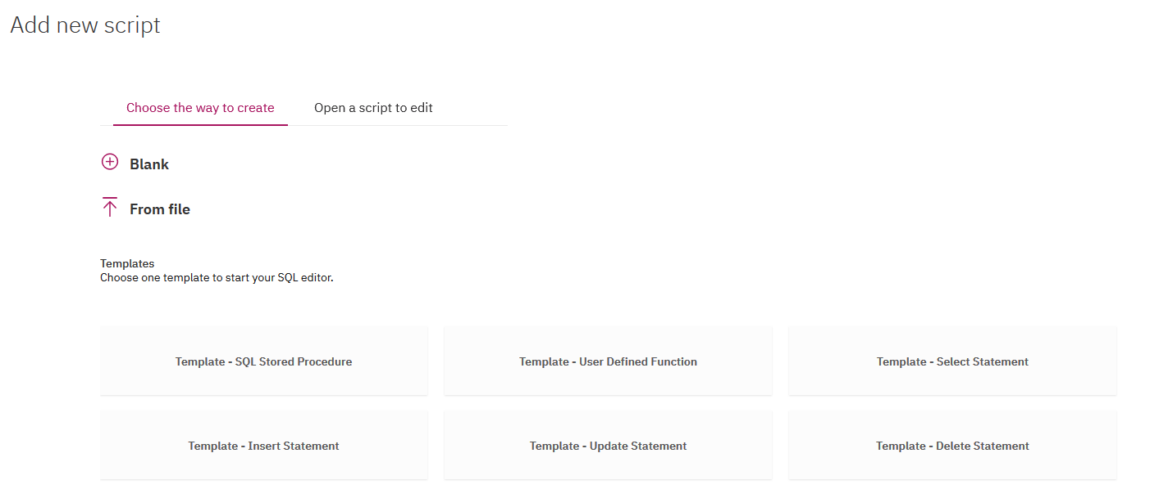​
4. Copy and paste the following DDL statements into the SQL editor and click **Run all** to create a table named **BANK_CUSTOMERS**.

CREATE TABLE BANK_CUSTOMERS (  
        CUSTOMER VARCHAR(10) NOT NULL,  
        NUMBER_OF_LATE_PAYMENTS SMALLINT,  
        NUMBER_OF_CREDIT_APPLICATIONS SMALLINT,  
        DECLARED_BANKRUPTCY_IN_PAST_7_YRS VARCHAR(3),  
        AVERAGE_MONTHLY_FEE SMALLINT,  
        CREDIT_SCORE SMALLINT,  
        SATISFACTION SMALLINT,  
        DEFAULT_DATA SMALLINT,  
        AVERAGE_CASH_BALANCE VARCHAR(3),  
        AGE SMALLINT,  
        AGE_RANGE VARCHAR(5),  
        GENDER VARCHAR(6),  
        NUMBER_OF_PRODUCTS SMALLINT,  
        CUST_ACQUISITION_YEAR SMALLINT,  
        NO_OF_UNIQUE_PRODUCTS SMALLINT,  
        NO_OF_UNIQUE_PRODUCTS_GROUPED VARCHAR(9),  
        EQUITIES_BALANCE INTEGER,  
        INITIAL_MORTGAGE_AMT VARCHAR(14),  
        ADDRESS_CHANGES SMALLINT,  
        HOUSEHOLD SMALLINT,  
        CLIENTS_IN_HOUSEHOLD SMALLINT,  
        AVERAGE_CREDIT_CARD_BALANCE INTEGER,  
        CUSTOMER_TYPE VARCHAR(14),  
        HOME_BRANCH_CITY VARCHAR(27),  
        HOME_BRANCH_STATE VARCHAR(14),  
        SALESPERSON VARCHAR(4),  
        CHURN VARCHAR(3),  
        COUNT SMALLINT,  
        BANKID VARCHAR(1)  
    )  
;  
ALTER TABLE BANK_CUSTOMERS  
      ADD CONSTRAINT CUSTOMER_PK  
      PRIMARY KEY (CUSTOMER)  
;

1. Review the results.

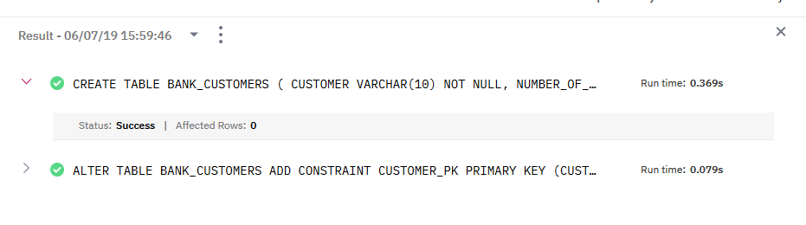

1. By default, the new table was created in the **BLUADMIN**schema. Click **Explore** in the hamburger menu to view your newly created table.  
   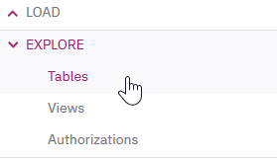
2. Select the **BLUADMIN**schema from the list of schemas.  
   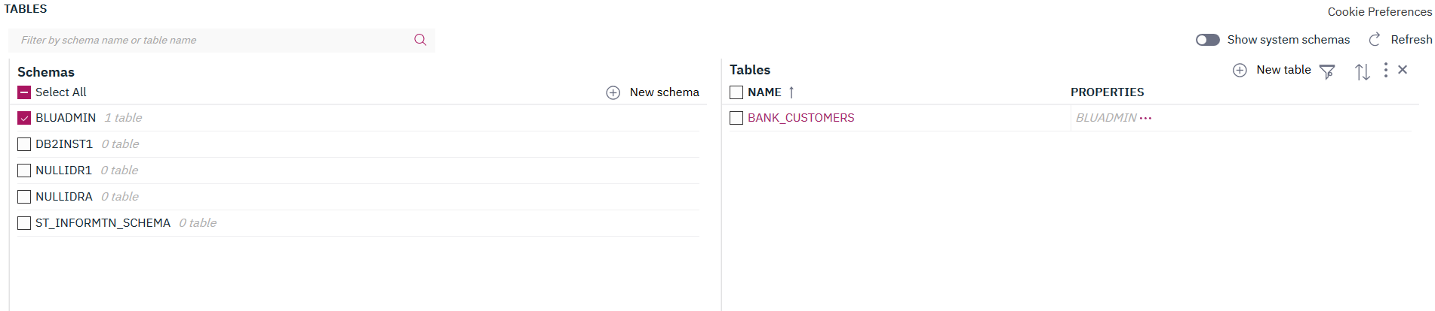
3. Click the **BANK_CUSTOMERS** table from the list of tables and you'll see the table definitions pane open.

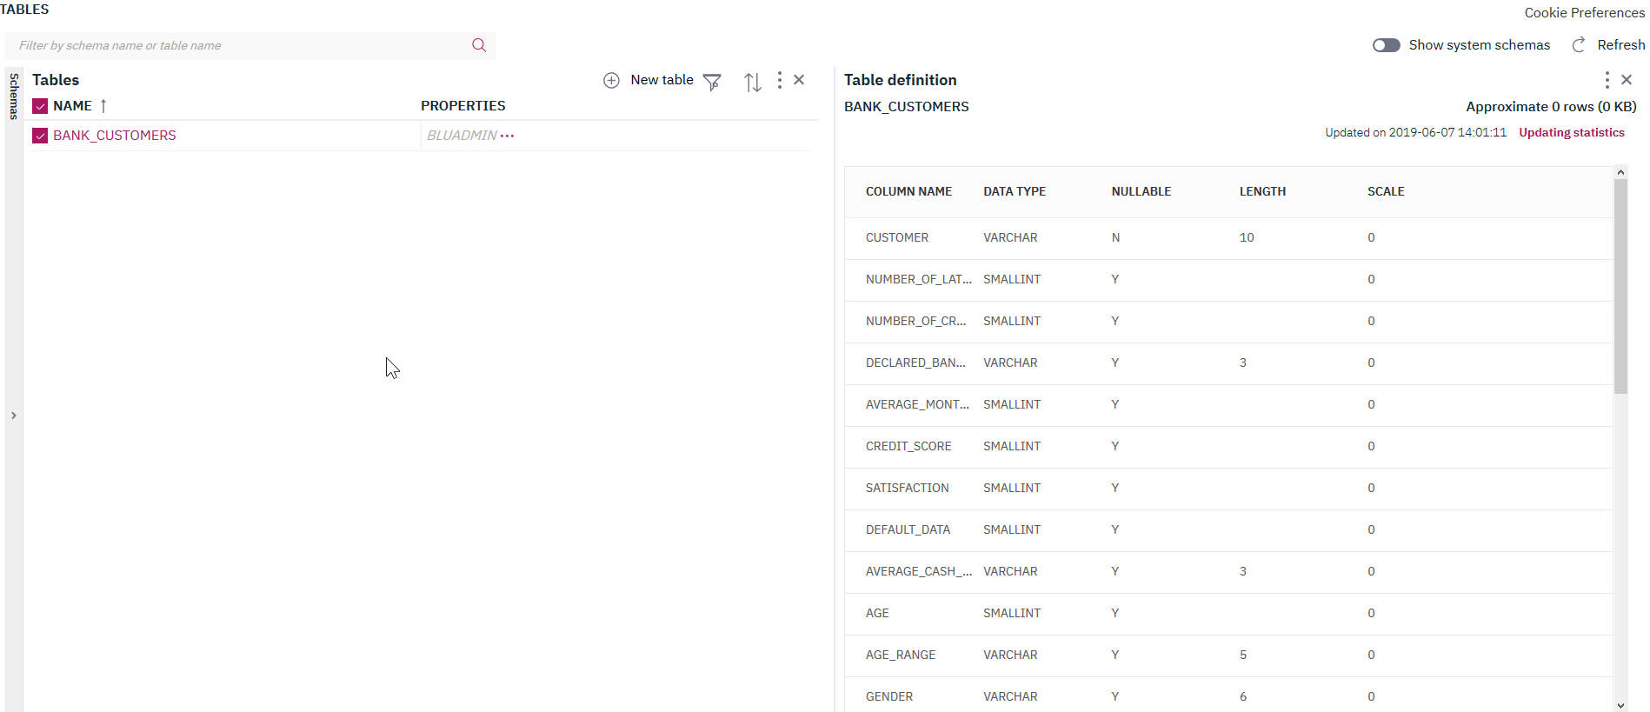

1. Click **View Data**. A new screen is displayed. You’ve just created this table, so the table should be empty. In the next task, we’ll load data into this table so you can query it.

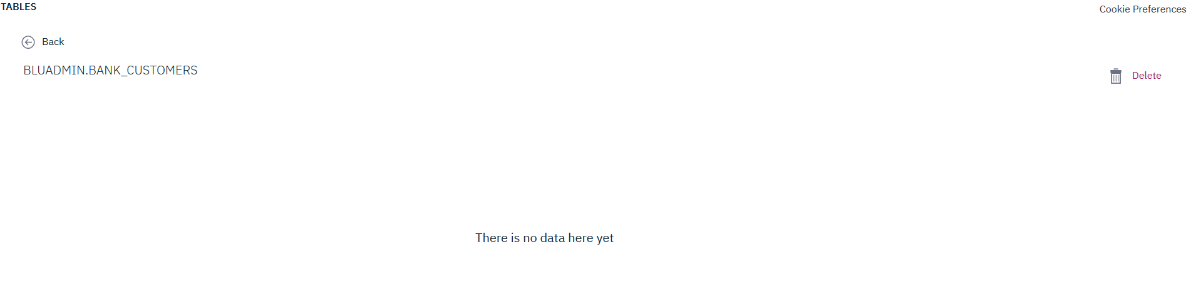

Loading Data

In this task, you’ll learn how to load data into your Db2 Warehouse on Cloud instance. You’ll load data into the **BANK_CUSTOMERS** table that you just created.

1. Click the **LOAD > Load Data**option in the hamburger menu.

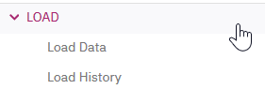

1. You can load data into your Db2 Warehouse on Cloud instance from a variety of sources through the **LOAD DATA** page. Download the **zbank_customers.csv** file [here](https://ibm.box.com/s/tp7ysl4yplh4850jr8kjt4m7605locde) (the file is stored on an external site, hosted by Box) and save it to your local computer. You’ll use this CSV file to populate the **BANK_CUSTOMERS** table.

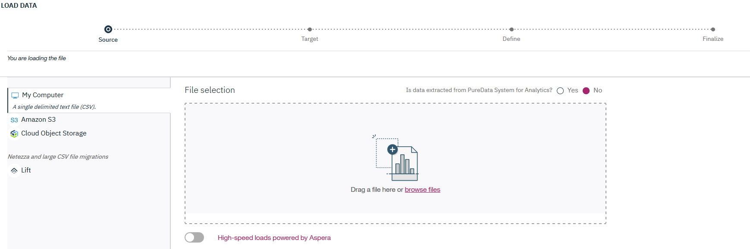

1. You can drag and drop the file into the area specified on the page, or click **browse files** to search for the **zbank_customers.csv** file that you just downloaded.  
   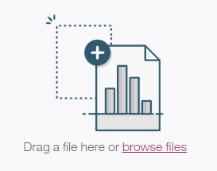Your selected file is shown in the pane on the right.

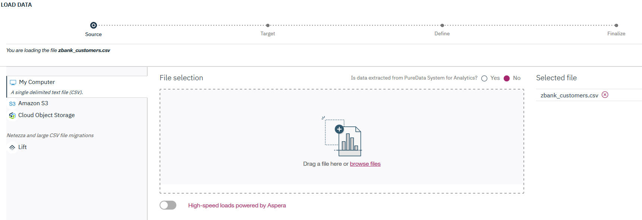

By default, normal web protocols are used to upload data into the Db2 Warehouse on Cloud database. You can also leverage [IBM Aspera](https://www.ibm.com/cloud/high-speed-data-transfer) to increase data transfer speed, especially useful for larger files. You can enable it by clicking the toggle and installing the Aspera browser plug-in.

Click Next. Provide the target table for the data load by selecting your BLUADMIN schema and then selecting the BANK_CUSTOMERS table. With the table being empty, you can select Overwrite table with new data.

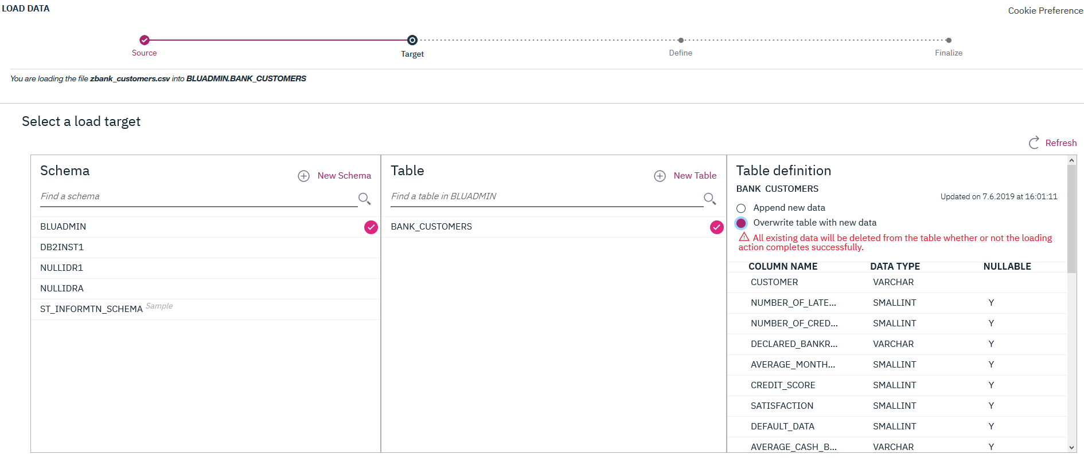

5.Click **Next**. On this page, you can define further load options, such as date/time formats, or the separator that is used in the CSV data file. For this tutorial, leave all of the automatically preselected options as they are.

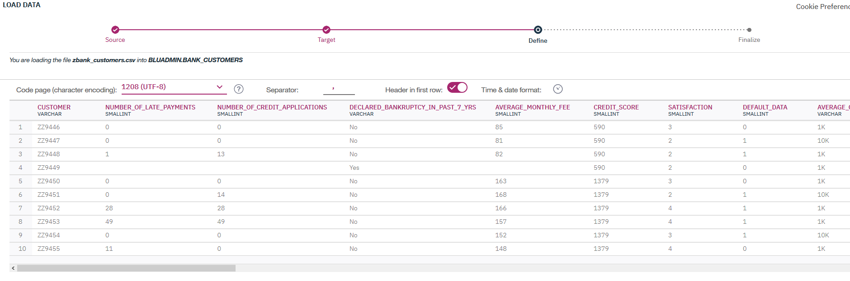

1. Click **Next**. On this page, you can review the settings to be used for the load. Click **Begin Load**.

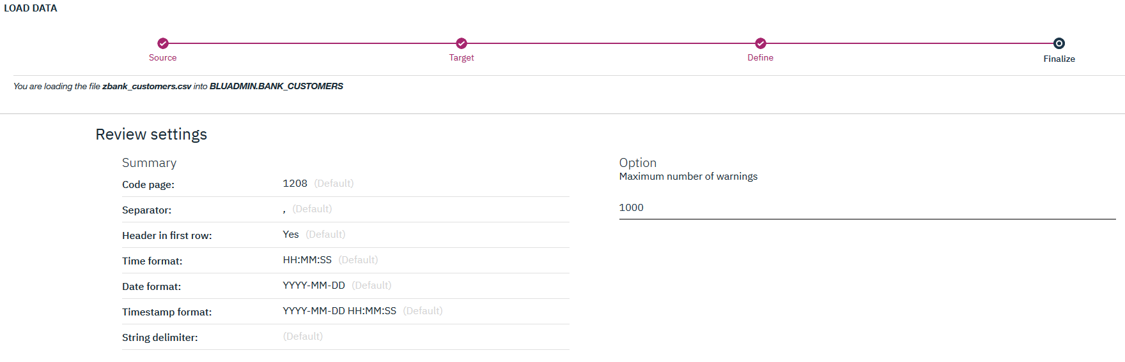

The load operation completes without any errors or warnings.The CSV file contains 3000 records. You can verify that 3000 rows were loaded into the BANK_CUSTOMERS table.

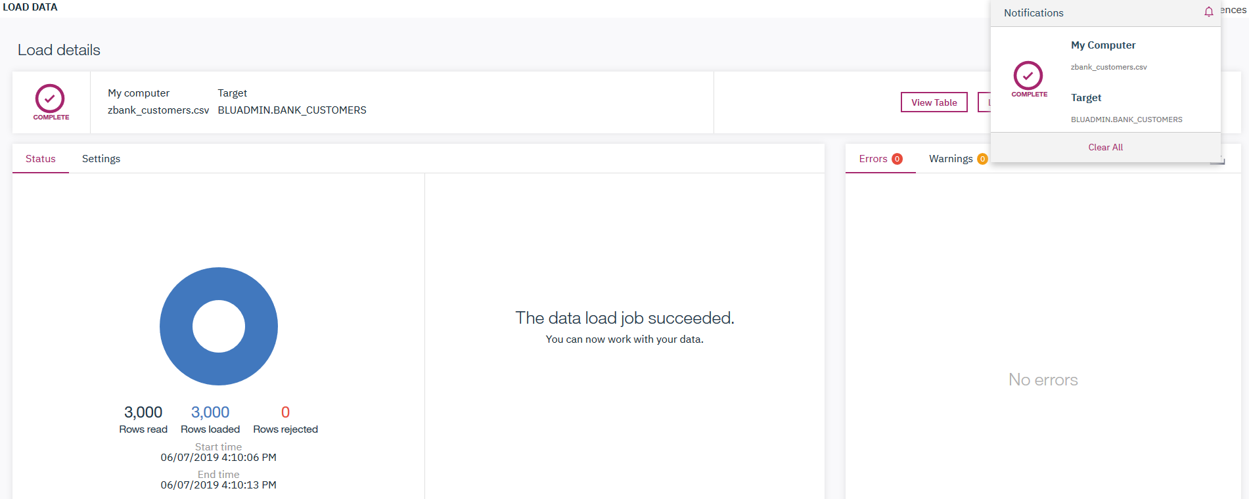

1. Click **View Table**to see the table contents. In the next task, you’ll learn how to query this data through the web console. 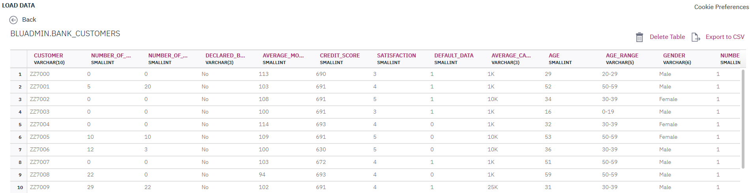

Querying the BANK_CUSTOMERS table

In this task, you’ll learn how to use the Db2 Warehouse on Cloud web console to query data in your Db2 Warehouse on Cloud instance.

1. In the web console for your Db2 Warehouse on Cloud instance, click the hamburger menu and select **RUN SQL**. This opens the SQL editor as seen earlier.  
   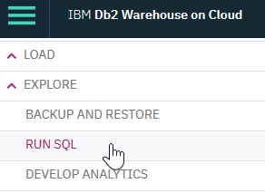
2. Let’s explore the **BANK_CUSTOMERS**data by running a simple SQL statement.  First, create a new script from **blank**, as done previously in this tutorial. Then, copy the following statement into the SQL editor. This query will retrieve only the first five rows of the **BANK_CUSTOMERS**table.

SELECT * FROM BLUADMIN.BANK_CUSTOMERS FETCH FIRST 5 ROWS ONLY;

1. After pasting the SQL statement into the SQL editor, click **Run All**to run the statement.

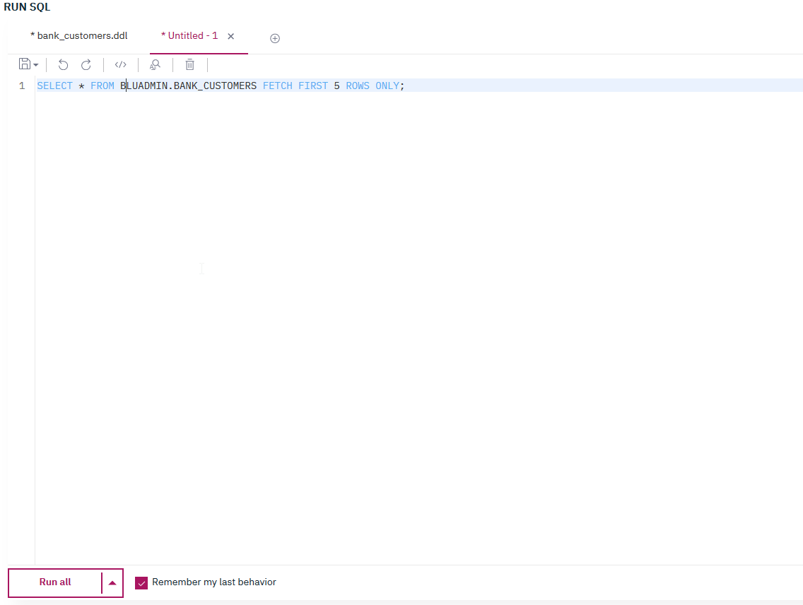

1. You can see the result of the SQL statement. The first five rows of the **BANK_CUSTOMERS**table were retrieved for you to view.  
   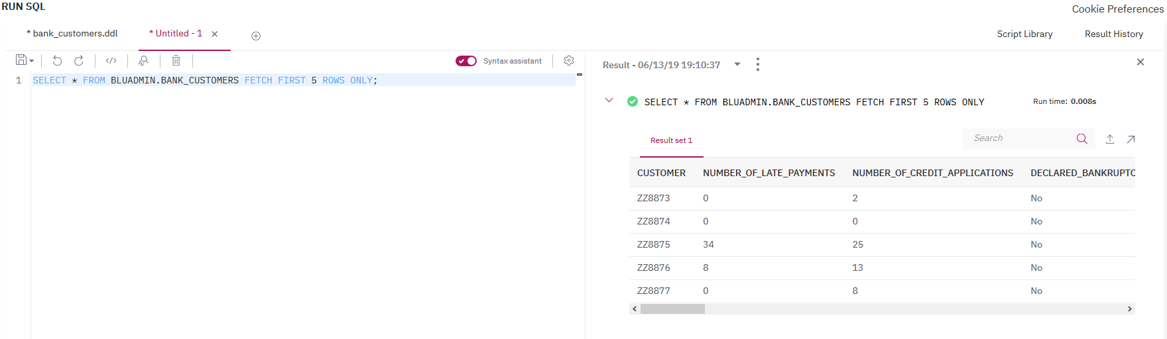
2. Now, let’s do a quick analysis of the dataset. Copy the following SQL statement into the SQL editor.

SELECT AGE_RANGE, AVG(AVERAGE_CREDIT_CARD_BALANCE) as BALANCE FROM BLUADMIN.BANK_CUSTOMERS GROUP BY AGE_RANGE;

This query shows us the average credit card balance for each age group in the dataset. You can paste the second SQL statement into the editor on a new line, without replacing the first statement.

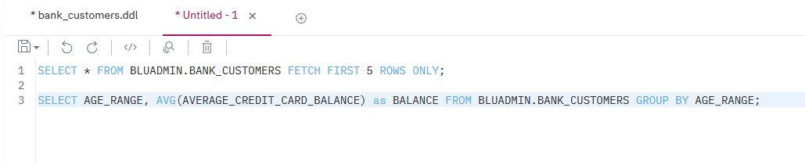

1. Position the cursor in the line containing the second SQL statement. With two SQL statements in the editor, click **Run selected** to run only the second SQL statement.  
   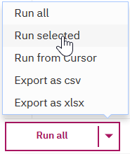
2. You can see the result of running the second SQL statement.  
   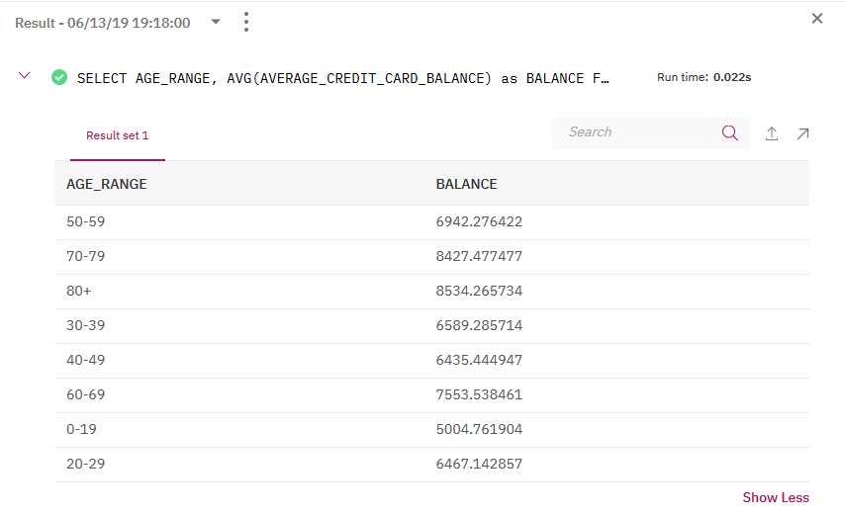
3. You can continue to work with the SQL statements directly in the editor. For example, add the text **ORDER BY AGE_RANGE** to the end of the second query. This will option will run the same analysis as the previous step, but neatly orders the entire result set by according to the **AGE_RANGE** table column.

SELECT AGE_RANGE, AVG(AVERAGE_CREDIT_CARD_BALANCE) as BALANCE FROM BLUADMIN.BANK_CUSTOMERS GROUP BY AGE_RANGE ORDER BY AGE_RANGE;

This option will run the same analysis as the previous step, but neatly order the entire result set according to the **AGE_RANGE** table column.

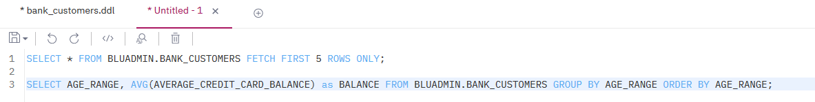  
You can **save**the new SQL statement - either to the Db2 Warehouse on Cloud instance or locally to your client - by clicking the **Save**image-20190613192512-12icon.

Finally, you can also export the result set to your local client, either as a CSV file or in the Microsoft Excel (xlsx) format:

