Optim™ High Performance Unload can achieve substantially higher performance than other applications by directly accessing the database files, bypassing the Db2® database manager.

In [Figure 1](https://www.ibm.com/support/knowledgecenter/SSC6UE_6.1.0/inmucon_conceptual.html?view=kc#inmucon_conceptual__hpudirectaccess), two Optim High Performance Unload requests and the Db2 database manager are running. Each instance of Optim High Performance Unload directly accesses the Db2 files that are owned by the Db2 database manager. In the example, Optim High Performance Unload unloads from two different tables simultaneously.

*Figure 1. Optim High Performance Unload directly accessing Db2 files*

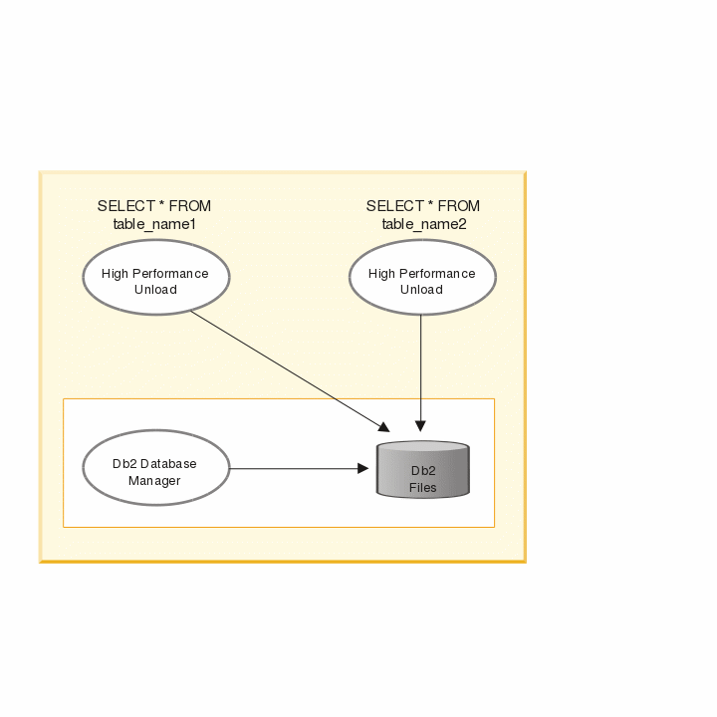

[Figure 2](https://www.ibm.com/support/knowledgecenter/SSC6UE_6.1.0/inmucon_conceptual.html?view=kc#inmucon_conceptual__hpuindirectaccess) shows how a typical database application accesses the database by issuing SQL commands to the Db2 database manager. When an SQL statement is received from a typical database application, the Db2 database manager translates the SQL statement into the appropriate access plan to access the Db2 physical files.

*Figure 2. Typical application indirectly accessing Db2 files*

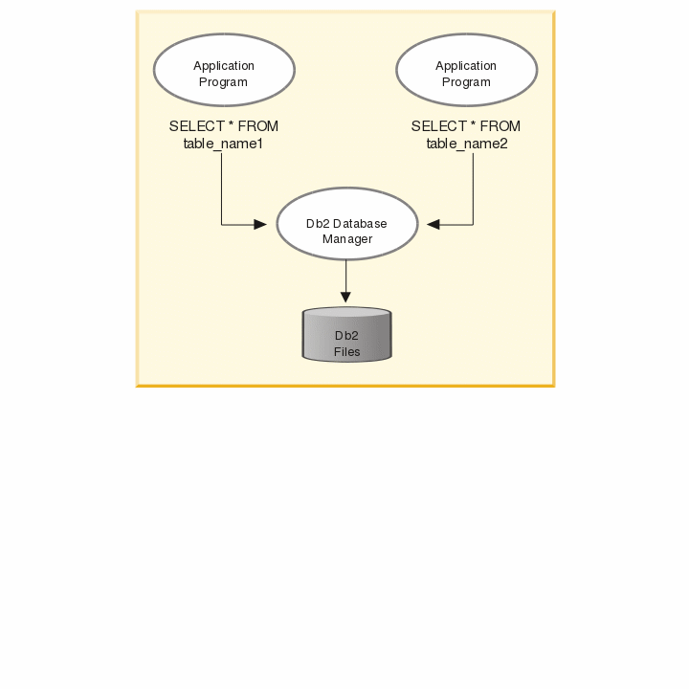

In contrast, Optim High Performance Unload translates the SQL-like SELECT statement in the control file. By directly accessing the database files, Optim High Performance Unload can achieve substantially higher performance than a typical SQL application that simply passes SQL statements to the Db2 database manager.

[Figure 3](https://www.ibm.com/support/knowledgecenter/SSC6UE_6.1.0/inmucon_conceptual.html?view=kc#inmucon_conceptual__ctr_fl_transl) shows the contrast between how a typical database application accesses a database, and how Optim High Performance Unload accesses the database.

*Figure 3. Optim High Performance Unload control file translation*

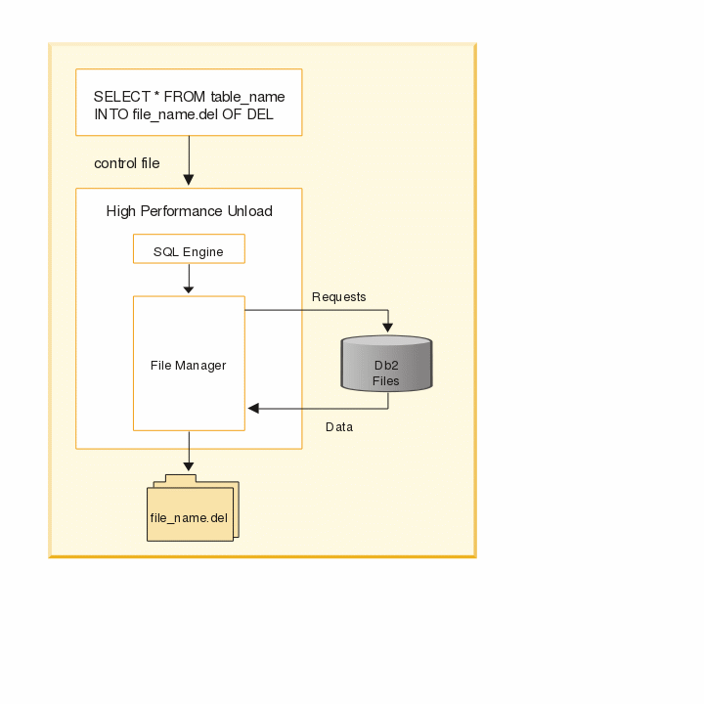

Ways to unload data

In a partitioned database environment, Optim High Performance Unload can directly unload data in two main ways:

1. Optim High Performance Unload can unload data from multiple nodes to a single file, as shown in

*Figure 4. Unload data from multiple nodes to a single file*

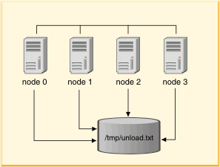

1. Optim High Performance Unload can unload data from multiple nodes to different files on each node, as shown in [Figure 5](https://www.ibm.com/support/knowledgecenter/SSC6UE_6.1.0/inmucon_conceptual.html?view=kc#inmucon_conceptual__unldmultf).

*Figure 5. Unload data from multiple nodes to multiple files*

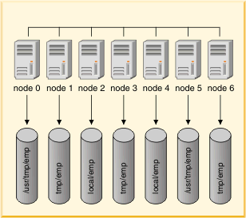

The second option gives you the best performance since the data never has to leave the node it physically resides on. On the other hand, in the first case, much of the data must travel from one node to another.