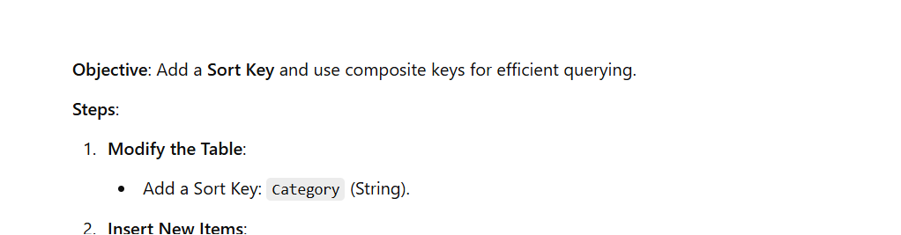

{

"ProductID": "P003",

"Category": "Books",

"ProductName": "AWS Handbook",

"Price": 30

}

{

"ProductID": "P004",

"Category": "Books",

"ProductName": "Python Guide",

"Price": 20

}

