Promises in Node JS

In JavaScript, Promises are a popular and powerful tool for handling asynchronous operations. They provide a clean and structured way to handle operations that take time to complete, such as network requests or database queries. Promises also make it easy to handle errors and ensure that code executes in the correct order.

Promises are now a standard part of the language and are widely used in Node.js development. They can be created using the Promise constructor, and then chained together using the then() method. Promises can also be used in conjunction with other language features, such as async/await and try/catch blocks.

The beauty of Promises lies in their ability to simplify code and make it more readable. They allow developers to write asynchronous code that looks and behaves like synchronous code, making it easier to reason about and debug.

Overall, Promises are an important concept for any JavaScript developer to understand, particularly those working with Node.js. They provide a powerful tool for handling asynchronous operations and can make development faster and more efficient.

Creating promises in Node.js

In Node.js, you can create a Promise using the Promise constructor. The Promise constructor takes a function as its argument, which is called the executor function. The executor function is passed two functions as arguments: resolve and reject. These functions are used to signal that the Promise has either been fulfilled or rejected.

Here's an example of creating a Promise in Node.js:

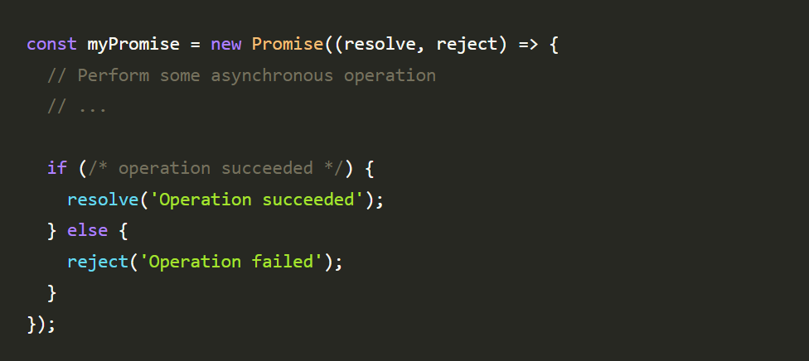

In this example, the Promise is created with an executor function that performs some asynchronous operation. If the operation succeeds, the resolve() function is called with a value that represents the result of the operation. If the operation fails, the reject() function is called with an error message.

Chaining promises in Node.js

Once the Promise is created, it can be chained together with other Promises using the then() method. The then() method takes two arguments: a function to handle the resolved value of the Promise, and a function to handle any errors that occur during the Promise chain.

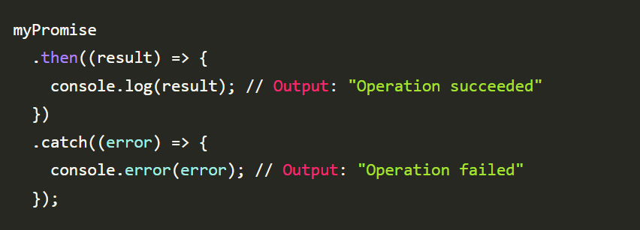In this example, the then() method is used to handle the resolved value of the Promise. If the Promise is rejected, the catch() method is used to handle the error.

One of the key benefits of Promises in Node.js is the ability to chain them together. This allows developers to create a series of asynchronous operations that depend on one another, without creating callback hell. To chain Promises in Node.js, the then() method is used.

Overall, creating Promises in Node.js provides a clean and structured way to handle asynchronous operations. They make it easy to handle errors and ensure that code executes in the correct order, making development faster and more efficient.

Working with Promises in Node.js can be a bit tricky at first, but once you get the hang of it, they can make your code much cleaner and easier to maintain. By using Promises to handle asynchronous operations, you can avoid callback hell and create code that is easier to read and debug.

Conclusion

Promises are a powerful tool for handling asynchronous operations in Node.js. By providing a clean and efficient way to handle asynchronous code, Promises can help you avoid callback hell and make your code easier to read and maintain.

While working with Promises may take some time to get used to, they are definitely worth learning if you plan on building complex Node.js applications that rely heavily on asynchronous operations. With practice and experience, you'll be able to leverage the power of Promises to build scalable, performant, and maintainable Node.js applications.