**We are going to discuess about below concept:**

**View column store storage details**

To view column store storage details, perform the following steps

1. Run the following query to create the vColumnStoreRowGroupStats:

SQLCopy

create view [wwi_perf].[vColumnStoreRowGroupStats]

as

with cte

as

(

select tb.[name] AS [logical_table_name]

, rg.[row_group_id] AS [row_group_id]

, rg.[state] AS [state]

, rg.[state_desc] AS [state_desc]

, rg.[total_rows] AS [total_rows]

, rg.[trim_reason_desc] AS trim_reason_desc

, mp.[physical_name] AS physical_name

FROM sys.[schemas] sm

JOIN sys.[tables] tb ON sm.[schema_id] = tb.[schema_id]

JOIN sys.[pdw_table_mappings] mp ON tb.[object_id] = mp.[object_id]

JOIN sys.[pdw_nodes_tables] nt ON nt.[name] = mp.[physical_name]

JOIN sys.[dm_pdw_nodes_db_column_store_row_group_physical_stats] rg ON rg.[object_id] = nt.[object_id]

AND rg.[pdw_node_id] = nt.[pdw_node_id]

AND rg.[distribution_id] = nt.[distribution_id]

)

select *

from cte;

In this query we are using the sys.dm_pdw_nodes_db_column_store_row_group_physical_stats DMV which provides current rowgroup-level information about all of the columnstore indexes in the current database.

1. Explore the statistics of the columnstore for the Sale_Partition01 table using the following query:

SELECT

*

FROM

[wwi_perf].[vColumnStoreRowGroupStats]

WHERE

Logical_Table_Name = 'Sale_Partition01'

1. Explore the results of the query:

Browse through the results and get an overview of the rowgroup states. Notice the COMPRESSED and OPEN states of some of the row groups.

1. Explore the statistics of the columnstore for the Sale_Hash_Ordered table using the same query:

SELECT

*

FROM

[wwi_perf].[vColumnStoreRowGroupStats]

WHERE

Logical_Table_Name = 'Sale_Hash_Ordered'

1. Explore the results of the query:

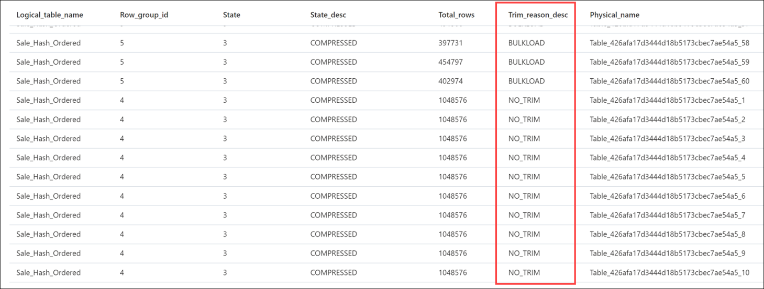

There is a significant difference in the rowgroup states from the previous one. This highlights one of the potential advantages of ordered CCIs.