**We are going to discuess about below concept:**

**Compare storage requirements between optimal and sub-optimal column data types**

Perform the following steps to compare storage requirements between optimal and suboptimal column data types

1. Use the following query to create two tables (Sale_Hash_Projection and Sale_Hash_Projection2) which contain a subset of the columns from Sale_Heap:

CREATE TABLE [wwi_perf].[Sale_Hash_Projection]

WITH

(

DISTRIBUTION = HASH ( [CustomerId] ),

HEAP

)

AS

SELECT

[CustomerId]

,[ProductId]

,[Quantity]

FROM

[wwi_perf].[Sale_Heap]

CREATE TABLE [wwi_perf].[Sale_Hash_Projection2]

WITH

(

DISTRIBUTION = HASH ( [CustomerId] ),

CLUSTERED COLUMNSTORE INDEX

)

AS

SELECT

[CustomerId]

,[ProductId]

,[Quantity]

FROM

[wwi_perf].[Sale_Heap]

The query should finish execution in a few minutes.

1. Use the following query to create two additional tables (Sale_Hash_Projection_Big and Sale_Hash_Projection_Big2) that have the same columns, but with different (sub_optimal) data types:

CREATE TABLE [wwi_perf].[Sale_Hash_Projection_Big]

WITH

(

DISTRIBUTION = HASH ( [CustomerId] ),

HEAP

)

AS

SELECT

[CustomerId]

,CAST([ProductId] as bigint) as [ProductId]

,CAST([Quantity] as bigint) as [Quantity]

FROM

[wwi_perf].[Sale_Heap]

CREATE TABLE [wwi_perf].[Sale_Hash_Projection_Big2]

WITH

(

DISTRIBUTION = HASH ( [CustomerId] ),

CLUSTERED COLUMNSTORE INDEX

)

AS

SELECT

[CustomerId]

,CAST([ProductId] as bigint) as [ProductId]

,CAST([Quantity] as bigint) as [Quantity]

FROM

[wwi_perf].[Sale_Heap]

1. Verify that the four tables have the same number of rows (there should be 339,507,246 rows in each):

SELECT 'Sale_Hash_Projection', COUNT_BIG(*) FROM [wwi_perf].[Sale_Hash_Projection]

UNION

SELECT 'Sale_Hash_Projection2', COUNT_BIG(*) FROM [wwi_perf].[Sale_Hash_Projection2]

UNION

SELECT 'Sale_Hash_Projection_Big', COUNT_BIG(*) FROM [wwi_perf].[Sale_Hash_Projection_Big]

UNION

SELECT 'Sale_Hash_Projection_Big2', COUNT_BIG(*) FROM [wwi_perf].[Sale_Hash_Projection_Big2]

1. Run the following query to compare the storage requirements for the three tables:

SELECT

database_name

, schema_name

, table_name

, distribution_policy_name

, distribution_column

, index_type_desc

, COUNT(distinct partition_nmbr) as nbr_partitions

, SUM(row_count) as table_row_count

, SUM(reserved_space_GB) as table_reserved_space_GB

, SUM(data_space_GB) as table_data_space_GB

, SUM(index_space_GB) as table_index_space_GB

, SUM(unused_space_GB) as table_unused_space_GB

FROM

[wwi_perf].[vTableSizes]

WHERE

schema_name = 'wwi_perf'

and table_name in ('Sale_Hash_Projection', 'Sale_Hash_Projection2',

'Sale_Hash_Projection_Big', 'Sale_Hash_Projection_Big2')

GROUP BY

database_name

, schema_name

, table_name

, distribution_policy_name

, distribution_column

, index_type_desc

ORDER BY

table_reserved_space_GB desc

1. Analyze the results:

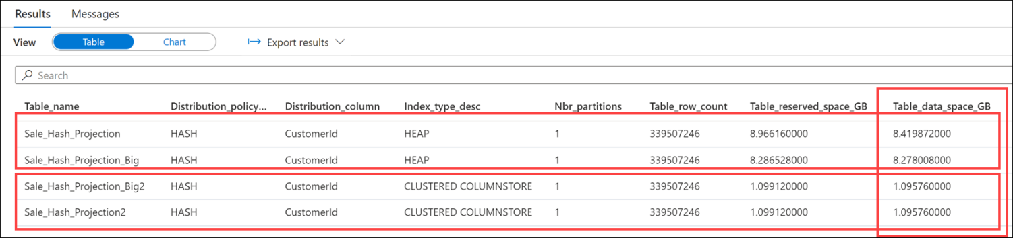

There are two important conclusions to draw here:

* + In the case of HEAP tables, the storage impact of using BIGINT instead of SMALLINT(for ProductId) and TINYINT (for QUANTITY) is 0.141864 GB. We're talking here about only two columns and a moderate number of rows (2.9 billion).
  + Even in the case of CLUSTERED COLUMNSTORE tables, where compression will offset some of the differences, there is still a difference of 12.7 MB.