**Prerequisites**

1. Jenkins Master Running
2. EC2 RHEL 7.x Instance - *for Slave Node*
   * With Internet Access
   * Security Group with Port 8080 open for internet
   * Java v1.8.x

**Install Java**

We will be using open java for our demo, Get latest version from http://openjdk.java.net/install/. Also configure the default JAVA_HOME path

yum install java-1.8*

#yum -y install java-1.8.0-openjdk

**Setup Jenkins Slave**

# Create user and add the user to wheel group

useradd jenkins-slave-01

# Create SSH Keys

sudo su - jenkins-slave-01

ssh-keygen -t rsa -N "" -f /home/jenkins-slave-01/.ssh/id_rsa

# The private and public keys will be created at these locations `/home/jenkins-slave-01/.ssh/id_rsa` and `/home/jenkins-slave-01/.ssh/id_rsa.pub`

cd .ssh

cat id_rsa.pub > authorized_keys

chmod 700 authorized_keys

**Configuration on Master**

Copy the slave node's public key[id_rsa.pub] to Master Node's known_hosts file

mkdir -p /var/lib/jenkins/.ssh

cd /var/lib/jenkins/.ssh

ssh-keyscan -H SLAVE-NODE-IP-OR-HOSTNAME >>/var/lib/jenkins/.ssh/known_hosts

# ssh-keyscan -H 172.31.38.42 >>/var/lib/jenkins/.ssh/known_hosts

chown jenkins:jenkins known_hosts

chmod 700 known_hosts

**Configure the Slave using Manage Jenkins**

Configure the node as shown here Manage Jenkins > Manage Nodes > New Node 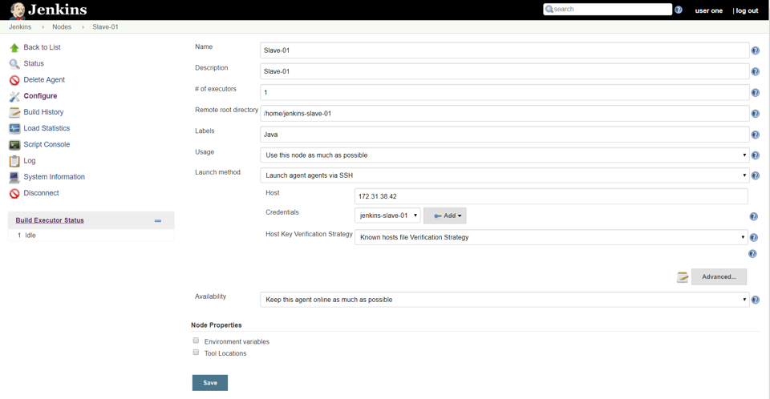

**Test Jenkins Jobs**

1. Create “new item”
2. Enter an item name – My-First-Project
   * Chose Freestyle project
3. Under General Section
   * Choose Restrict where this project can be run
     + Update your *jenkins slave label* Java
4. Under Build section Execute shell
5. #!/bin/bash
6. echo "_______________________________"
7. echo "| |"
8. echo "| Welcome to chandan Demo |"
9. echo "| _nnnn_ |"
10. echo "| dGGGGMMb |"
11. echo "| @p~qp~~qMb |"
12. echo "| M|@||@) M| |"
13. echo "| @,----.JM| |"
14. echo "| JS^\__/ qKL |"
15. echo "| dZP qKRb |"
16. echo "| dZP qKKb |"
17. echo "| fZP SMMb |"
18. echo "| HZM MMMM |"
19. echo "| FqM MMMM |"
20. echo "| __| '. |\dS'qML |"
21. echo "| | '. | ' \Zq |"
22. echo "| _) \.___.,| .' |"
23. echo "| \____ )MMMMMP| .' |"
24. echo "| '-' '--' hjm |"

echo "_______________________________"

1. Save your job
2. Build job
3. Check "console output"