**Java List**

we will learn about the List interface in Java and its methods.

In Java, the List interface is an ordered collection that allows us to store and access elements sequentially. It extends the Collection interface.

**Classes that Implement List**

Since List is an interface, we cannot create objects from it.

In order to use functionalities of the List interface, we can use these classes:

* ArrayList
* LinkedList
* Vector
* Stack

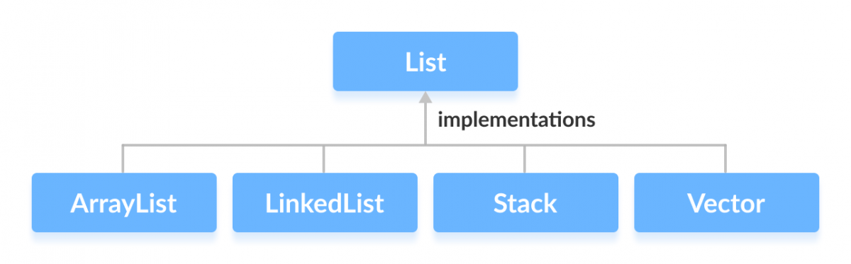

These classes are defined in the Collections framework and implement the List interface.

**How to use List?**

In Java, we must import java.util.List package in order to use List.

// ArrayList implementation of List

List<String> list1 = new ArrayList<>();

// LinkedList implementation of List

List<String> list2 = new LinkedList<>();

Here, we have created objects list1 and list2 of classes ArrayList and LinkedList. These objects can use the functionalities of the List interface.

**Methods of List**

The List interface includes all the methods of the Collection interface. Its because Collection is a super interface of List.

Some of the commonly used methods of the Collection interface that's also available in the List interface are:

* add() - adds an element to a list
* addAll() - adds all elements of one list to another
* get() - helps to randomly access elements from lists
* iterator() - returns iterator object that can be used to sequentially access elements of lists
* set() - changes elements of lists
* remove() - removes an element from the list
* removeAll() - removes all the elements from the list
* clear() - removes all the elements from the list (more efficient than removeAll())
* size() - returns the length of lists
* toArray() - converts a list into an array
* contains() - returns true if a list contains specified element

**Implementation of the List Interface**

**1. Implementing the ArrayList Class**

import java.util.List;

import java.util.ArrayList;

class Main {

public static void main(String[] args) {

// Creating list using the ArrayList class

List<Integer> numbers = new ArrayList<>();

// Add elements to the list

numbers.add(1);

numbers.add(2);

numbers.add(3);

System.out.println("List: " + numbers);

// Access element from the list

int number = numbers.get(2);

System.out.println("Accessed Element: " + number);

// Remove element from the list

int removedNumber = numbers.remove(1);

System.out.println("Removed Element: " + removedNumber);

}

}

**Output**

List: [1, 2, 3]

Accessed Element: 3

Removed Element: 2

To learn more about ArrayList, visit Java ArrayList.

**2. Implementing the LinkedList Class**

import java.util.List;

import java.util.LinkedList;

class Main {

public static void main(String[] args) {

// Creating list using the LinkedList class

List<Integer> numbers = new LinkedList<>();

// Add elements to the list

numbers.add(1);

numbers.add(2);

numbers.add(3);

System.out.println("List: " + numbers);

// Access element from the list

int number = numbers.get(2);

System.out.println("Accessed Element: " + number);

// Using the indexOf() method

int index = numbers.indexOf(2);

System.out.println("Position of 3 is " + index);

// Remove element from the list

int removedNumber = numbers.remove(1);

System.out.println("Removed Element: " + removedNumber);

}

}

**Output**

List: [1, 2, 3]

Accessed Element: 3

Position of 3 is 1

Removed Element: 2

To learn more about LinkedList, visit Java LinkedList.

**Java List vs. Set**

Both the List interface and the Set interface inherits the Collection interface. However, there exists some difference between them.

* Lists can include duplicate elements. However, sets cannot have duplicate elements.
* Elements in lists are stored in some order. However, elements in sets are stored in groups like sets in mathematics.