**Java Stack Class**

In this tutorial, we will learn about the Java Stack class and its methods with the help of examples.

The Java collections framework has a class named Stack that provides the functionality of the stack data structure.

The Stack class extends the Vector class.

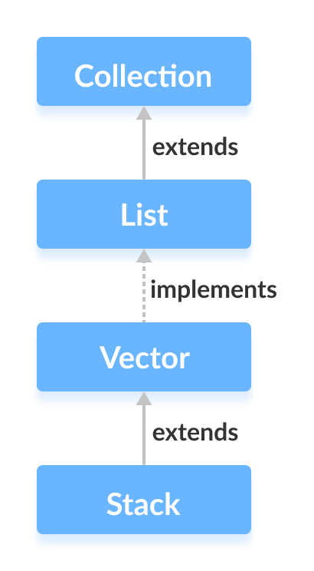

**Stack Implementation**

In stack, elements are stored and accessed in **Last In First Out** manner. That is, elements are added to the top of the stack and removed from the top of the stack.

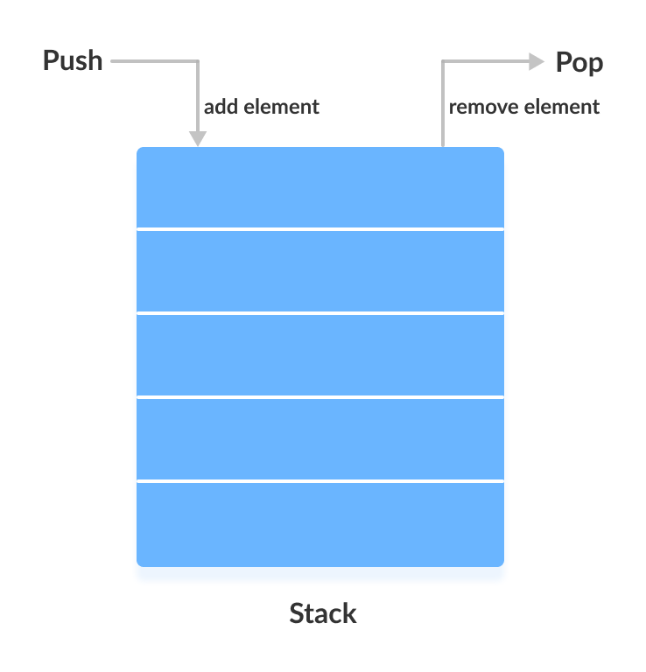

**Creating a Stack**

In order to create a stack, we must import the java.util.Stack package first. Once we import the package, here is how we can create a stack in Java.

Stack<Type> stacks = new Stack<>();

Here, Type indicates the stack's type. For example,

// Create Integer type stack

Stack<Integer> stacks = new Stack<>();

// Create String type stack

Stack<String> stacks = new Stack<>();

**Stack Methods**

Since Stack extends the Vector class, it inherits all the methods Vector.

Besides these methods, the Stack class includes 5 more methods that distinguish it from Vector.

**push() Method**

To add an element to the top of the stack, we use the push() method. For example,

import java.util.Stack;

class Main {

public static void main(String[] args) {

Stack<String> animals= new Stack<>();

// Add elements to Stack

animals.push("Dog");

animals.push("Horse");

animals.push("Cat");

System.out.println("Stack: " + animals);

}

}

Run Code

**Output**

Stack: [Dog, Horse, Cat]

**pop() Method**

To remove an element from the top of the stack, we use the pop() method. For example,

import java.util.Stack;

class Main {

public static void main(String[] args) {

Stack<String> animals= new Stack<>();

// Add elements to Stack

animals.push("Dog");

animals.push("Horse");

animals.push("Cat");

System.out.println("Initial Stack: " + animals);

// Remove element stacks

String element = animals.pop();

System.out.println("Removed Element: " + element);

}

}

Run Code

**Output**

Initial Stack: [Dog, Horse, Cat]

Removed Element: Cat

**peek() Method**

The peek() method returns an object from the top of the stack. For example,

import java.util.Stack;

class Main {

public static void main(String[] args) {

Stack<String> animals= new Stack<>();

// Add elements to Stack

animals.push("Dog");

animals.push("Horse");

animals.push("Cat");

System.out.println("Stack: " + animals);

// Access element from the top

String element = animals.peek();

System.out.println("Element at top: " + element);

}

}

Run Code

**Output**

Stack: [Dog, Horse, Cat]

Element at top: Cat

**search() Method**

To search an element in the stack, we use the search() method. It returns the position of the element from the top of the stack. For example,

import java.util.Stack;

class Main {

public static void main(String[] args) {

Stack<String> animals= new Stack<>();

// Add elements to Stack

animals.push("Dog");

animals.push("Horse");

animals.push("Cat");

System.out.println("Stack: " + animals);

// Search an element

int position = animals.search("Horse");

System.out.println("Position of Horse: " + position);

}

}

Run Code

**Output**

Stack: [Dog, Horse, Cat]

Position of Horse: 2

**empty() Method**

To check whether a stack is empty or not, we use the empty() method. For example,

import java.util.Stack;

class Main {

public static void main(String[] args) {

Stack<String> animals= new Stack<>();

// Add elements to Stack

animals.push("Dog");

animals.push("Horse");

animals.push("Cat");

System.out.println("Stack: " + animals);

// Check if stack is empty

boolean result = animals.empty();

System.out.println("Is the stack empty? " + result);

}

}

Run Code

**Output**

Stack: [Dog, Horse, Cat]

Is the stack empty? false

**Use ArrayDeque Instead of Stack**

The Stack class provides the direct implementation of the stack data structure. However, it is recommended not to use it. Instead, use the ArrayDeque class (implements the Deque interface) to implement the stack data structure in Java.