
Git & GitHub
DEVOPS | Assignment
SUBMISSION GUIDELINES
• Complete all tasks and document your work in a doc (Google Doc or Microsoft Word) with screenshots/commands and explanations.
• Create one folder named Git_and_GitHub_YourName.
• Put your complete project source code and all files inside this folder.
• Add your documentation file (with screenshots and explanations) inside the same folder.
• Compress the folder into a .zip file (Git_and_GitHub_YourName.zip).
• Upload the .zip file on the submission portal.
Zip File Must Contain
• Your complete project source code and all files
• Document with screenshots/commands and explanation for every task
• GitHub repository link
⚠ Your full project code MUST be submitted inside this .zip file. Screenshots (terminal / commands / output) are mandatory. Also share your GitHub repository link.
Do NOT upload separate files.
Do NOT submit without compressing into a .zip file.

Objective: Practise the full Git workflow — SSH setup, branching, merging, conflict resolution, sequential commits, git reset, and rebasing — using a Flask project.

Task 1: Repository Setup & First Branch
- Create a new GitHub repository.
Ans:-
  - Login to Github.
  - Check New repo.
  - Enter repo name. (Flask-Project)
  - Select Public or Private
  - Click create repo.

- Clone the repository to your local machine using SSH (generate an SSH key if needed, and add the public key to your GitHub account).
Ans:-
  - Check existing ssh Key.
    - Open powershell/ git bash
Ls ~/.ssh
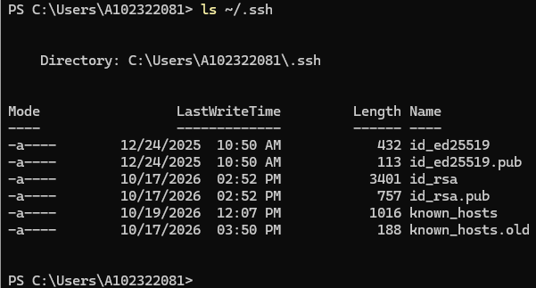

  - Generate New SSH Key if not exist.
    - Paste this command to powershell/GitBash
ssh-keygen -t rsa -b 4096 -C "chandan.singhdec1989@gmail.com"
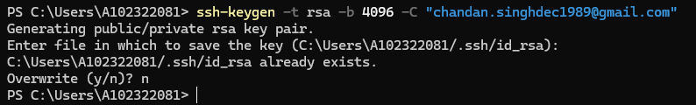
    - Start SSH Agent on powershell
Start-Service ssh-agent
ssh-add ~/.ssh/id_rsa

  - Copy Public key.
    - copy public key using below command.
cat ~/.ssh/id_rsa.pub
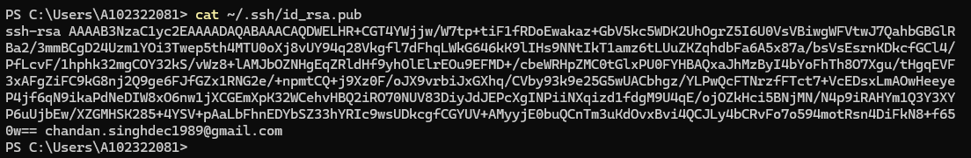

  - Add SSH Key to GithHub.
    - Goto GitHub Setting.
    - Click on Access SSH and GPG Key
    - Click new SSH Key
    - Give SSH Key Name.
    - Paste Public Key.
    - Click ADD SSH Key.
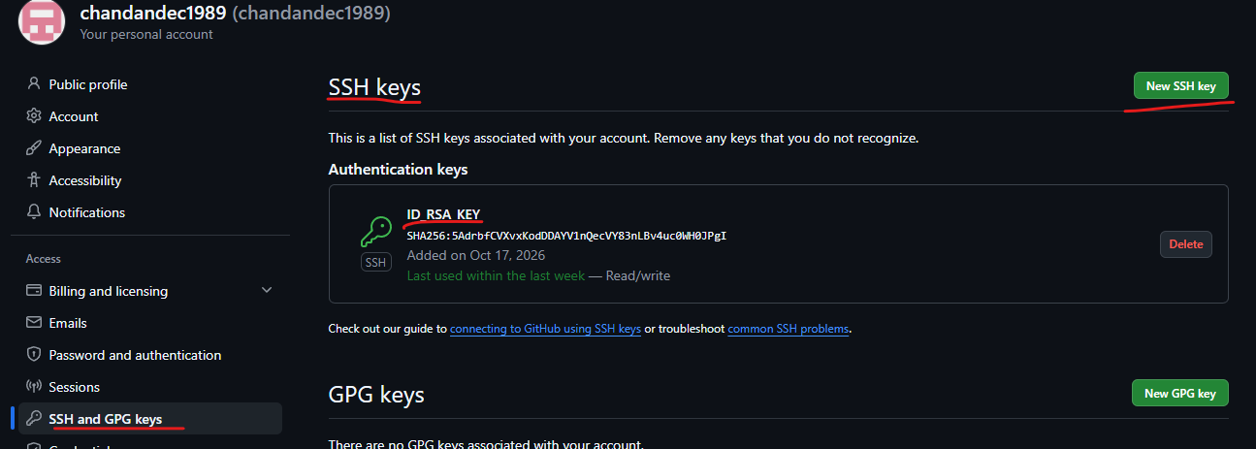

  - Test Connection.
    - Now we have to test the connection.
ssh -T git@github.com
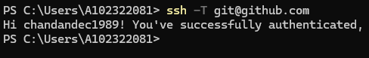

  - Clone Repo using SSH.
    - From GitHub copy SSH URL.
git@github.com:chandandec1989/chandan_git.git
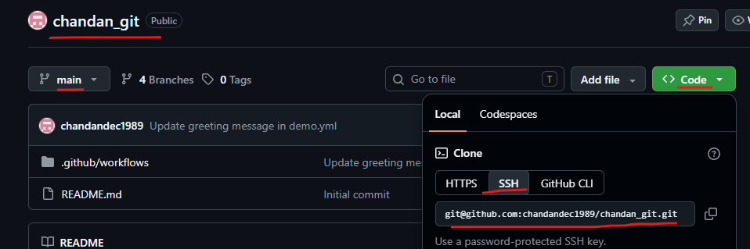
    - Now we have to clone this repo in our local.
Git clone git@github.com:chandandec1989/chandan_git.git

    - Then Move to repo.
cd chandan_git
- Create a new branch named after your username (e.g., Tutedude).
  - Create new branch.
git checkout -b chandandec1989
git branch
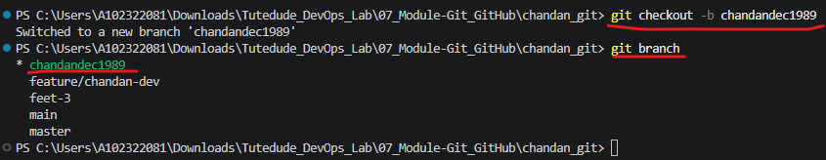
- Add your Flask project files to this branch.

- Commit the changes and merge the branch into the main branch.
Task 2: Update JSON & Resolve Conflicts
- Create a new branch named _new (e.g., Tutedude_new).
- Update the content of the JSON file used for the /api route in this branch.
- Merge the _new branch into the main branch.
- If there are conflicts during the merge, resolve them by accepting the changes from the _new branch.
- Add the resolved changes to the staging area, commit them, and push the updates to the remote repository.
Task 3: Parallel Feature Development
- Branch Creation: Create two branches, master_1 and master_2, from the main branch.
- Feature Development in master_1: Create a To-Do Page in the frontend with a form containing the fields Item Name and Item Description.
- Backend API in master_2: Create a backend route named /submittodoitem that accepts itemName and itemDescription via a POST request and stores these details in a MongoDB database.
- Merging Changes: Merge the changes from both master_1 and master_2 into the main branch.
Task 4: Sequential Commits, Reset & Rebase
- Enhancing the To-Do Form in master_1: Add the following fields to the To-Do form: Item ID, Item UUID, Item Hash.
- Committing in Sequence: Add and commit each field separately — first commit: Item ID; second commit: Item UUID; third commit: Item Hash.
- Merging to main: Merge the master_1 branch into the main branch.
- Git Reset: In the main branch, roll back to the commit where only the Item ID field was added. Use git reset --soft to ensure changes remain staged, then re-commit this state and merge it to main.
- Rebasing: Rebase the updated main branch changes onto master_1 using git rebase main master_1. Preserve individual commits (do NOT squash) to maintain commit history.

If you have any doubt, you can directly contact the Tutedude mentor.

