**SQL Lab Assignment**

*Question 1)*

mysql> use anudip;

Database changed

mysql> create table parents(p_id int,p_name varchar(40),city varchar(50),age int,income int,occuption varchar(60),email varchar(60));

Query OK, 0 rows affected (24.93 sec)

mysql> insert into parents values(1,"om","ahmedbad","40",5000000,"engineer","om@gmail.com");

Query OK, 1 row affected (0.35 sec)

mysql> insert into parents values(2,"shree","delhi","45",6000000,"teacher","shree@gmail.com");

Query OK, 1 row affected (0.05 sec)

mysql> insert into parents values(3,"sony","mumbai","30",6009000,"teacher","sony@gmail.com");

Query OK, 1 row affected (0.00 sec)

mysql> insert into parents values(4,"riya","chennai","36",7008000,"service","riya@gmail.com");

Query OK, 1 row affected (0.06 sec)

mysql> insert into parents values(5,"priya","banglore","33",8008000,"architer","priya@gmail.com");

Query OK, 1 row affected (0.03 sec)

mysql> insert into parents values(6,"ganesh","pune","31",900000,"engineer","ganesh@gmail.com");

Query OK, 1 row affected (0.07 sec)

mysql> insert into parents values(7,"jay","chennai","39",7002000,"service","jay@gmail.com");

Query OK, 1 row affected (0.00 sec)

mysql> insert into parents values(8,"john","chennai","31",700000,"techaer","john@gmail.com");

Query OK, 1 row affected (0.04 sec)

mysql> insert into parents values(9,"mitali","mumbai","33",600000,"teacher","mitali@gmail.com");

Query OK, 1 row affected (0.03 sec)

mysql> insert into parents values(10,"soham","banglore","39",8000000,"architer","soham@gmail.com");

Query OK, 1 row affected (0.00 sec)

mysql> insert into parents values(11,"shreejit","delhi","45",9000000,"teacher","shreejit@gmail.com");

Query OK, 1 row affected (0.03 sec)

mysql> insert into parents values(12,"omii","ahmedbad","40",9000000,"engineer","omii@gmail.com");

Query OK, 1 row affected (0.22 sec)

mysql> insert into parents values(13,"jeveen","chennai","31",700000,"techaer","jeveen@gmail.com");

Query OK, 1 row affected (0.02 sec)

mysql> insert into parents values(14,"moti","banglore","33",8009000,"architer","moti@gmail.com");

Query OK, 1 row affected (0.02 sec)

mysql> insert into parents values(15,"shreya","chennai","36",7008000,"service","shreya@gmail.com");

Query OK, 1 row affected (0.04 sec)

mysql> insert into parents values(16,"ajay","chennai","39",700000,"service","ajay@gmail.com");

Query OK, 1 row affected (0.00 sec)

mysql> insert into parents values(17,"rutuja","chennai","36",700670,"service","rutuja@gmail.com");

Query OK, 1 row affected (0.00 sec)

mysql> insert into parents values(18,"mahesh","mumbai","30",600000,"teacher","maesh@gmail.com");

Query OK, 1 row affected (0.00 sec)

mysql> insert into parents values(19,"maduri","mumbai","30",1000000,"teacher","maduri@gmail.com");

Query OK, 1 row affected (0.00 sec)

mysql> insert into parents values(20,"nikita","mumbai","30",1000045,"teacher","nikita@gmail.com");

Query OK, 1 row affected (0.00 sec)

mysql> select * from parents;

+------+----------+----------+------+---------+-----------+--------------------+

| p_id | p_name | city | age | income | occuption | email |

+------+----------+----------+------+---------+-----------+--------------------+

| 1 | om | ahmedbad | 40 | 5000000 | engineer | om@gmail.com |

| 2 | shree | delhi | 45 | 6000000 | teacher | shree@gmail.com |

| 3 | sony | mumbai | 30 | 6009000 | teacher | sony@gmail.com |

| 4 | riya | chennai | 36 | 7008000 | service | riya@gmail.com |

| 5 | priya | banglore | 33 | 8008000 | architer | priya@gmail.com |

| 6 | ganesh | pune | 31 | 900000 | engineer | ganesh@gmail.com |

| 7 | jay | chennai | 39 | 7002000 | service | jay@gmail.com |

| 8 | john | chennai | 31 | 700000 | techaer | john@gmail.com |

| 9 | mitali | mumbai | 33 | 600000 | teacher | mitali@gmail.com |

| 10 | soham | banglore | 39 | 8000000 | architer | soham@gmail.com |

| 11 | shreejit | delhi | 45 | 9000000 | teacher | shreejit@gmail.com |

| 12 | omii | ahmedbad | 40 | 9000000 | engineer | omii@gmail.com |

| 13 | jeveen | chennai | 31 | 700000 | techaer | jeveen@gmail.com |

| 14 | moti | banglore | 33 | 8009000 | architer | moti@gmail.com |

| 15 | shreya | chennai | 36 | 7008000 | service | shreya@gmail.com |

| 16 | ajay | chennai | 39 | 700000 | service | ajay@gmail.com |

| 17 | rutuja | chennai | 36 | 700670 | service | rutuja@gmail.com |

| 18 | mahesh | mumbai | 30 | 600000 | teacher | maesh@gmail.com |

| 19 | maduri | mumbai | 30 | 1000000 | teacher | maduri@gmail.com |

| 20 | nikita | mumbai | 30 | 1000045 | teacher | nikita@gmail.com |

| 20 | nikita | mumbai | 30 | 1000045 | teacher | nikita@gmail.com |

+------+----------+----------+------+---------+-----------+--------------------+

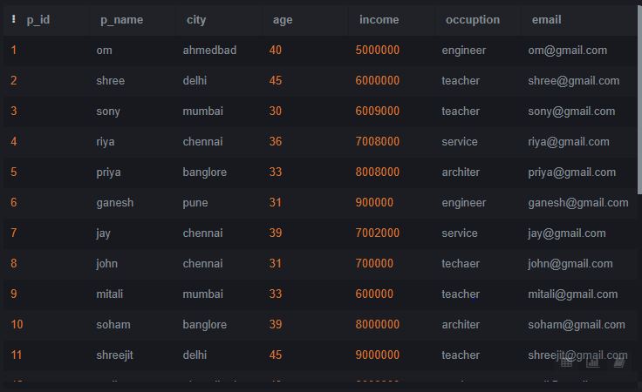

mysql> update parents set email="NA" where p_id=1;

Query OK, 0 rows affected (0.04 sec)

Rows matched: 1 Changed: 0 Warnings: 0

mysql> select * from parents;

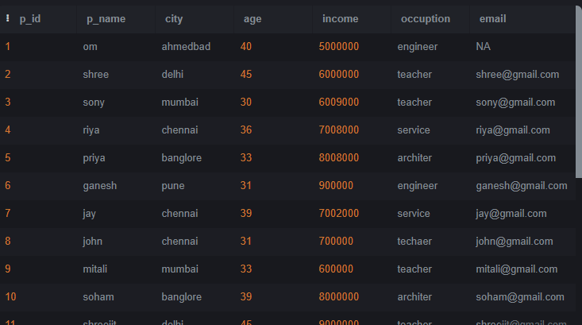

mysql> select * from parents where city in("ahmedbad","delhi","mumbai","chennai","banglore");

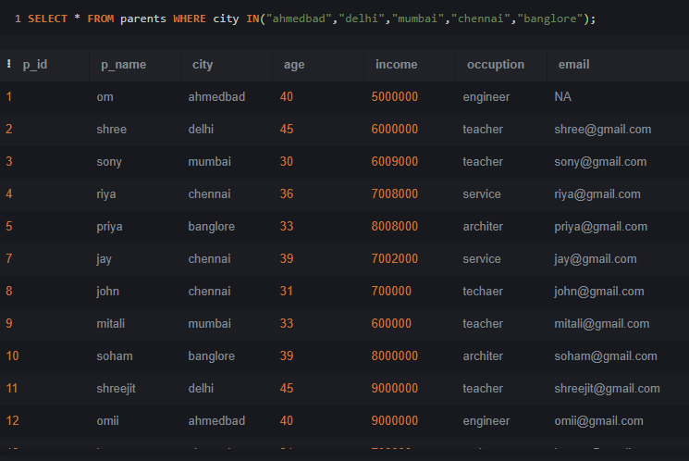

mysql> select count(p_id) from parents where income>600000;

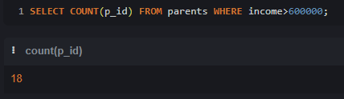

mysql> select * from parents where income<700000 and age>20;

