**SQL Lab Assignment**

*Question 2)*

mysql> create table company(c_id int primary key Auto_increment,c_name varchar(30),c_city varchar(30));

Query OK, 0 rows affected (3.16 sec)

mysql> insert into company values(1,"Dominos","los Angeles");

Query OK, 1 row affected (0.10 sec)

mysql> insert into company values(2,"Pizza Hunt","san Francisco");

Query OK, 1 row affected (0.09 sec)

mysql> insert into company values(3,"papa johns","san Diego");

Query OK, 1 row affected (0.07 sec)

mysql> insert into company values(4,"Ah Pizz","Fremont");

Query OK, 1 row affected (0.09 sec)

mysql> insert into company values(5,"Nino Pizza","Las Vegas");

Query OK, 1 row affected (0.04 sec)

mysql> insert into company values(6,"Pizzeria","Boston");

Query OK, 1 row affected (0.04 sec)

mysql> insert into company values(7,"chunk e cheese","Chicago");

Query OK, 1 row affected (0.04 sec)

mysql> select * from company;

+------+----------------+---------------+

| c_id | c_name | c_city |

+------+----------------+---------------+

| 1 | Dominos | los Angeles |

| 2 | Pizza Hunt | san Francisco |

| 3 | papa johns | san Diego |

| 4 | Ah Pizz | Fremont |

| 5 | Nino Pizza | Las Vegas |

| 6 | Pizzeria | Boston |

| 7 | chuck e cheese | Chicago |

+------+----------------+---------------+

7 rows in set (0.00 sec)



mysql> create table foods(i_id int primary key, i_name varchar(30), unitsold int, c_id int,foreign key(c_id) references company(c_id));

Query OK, 0 rows affected (1.40 sec)

mysql> insert into foods values(1,"Large pizza",5,2);

Query OK, 1 row affected (0.09 sec)

mysql> insert into foods values(2,"Garlic Knots",6,3);

Query OK, 1 row affected (0.06 sec)

mysql> insert into foods values(3,"Large Pizza",3,3);

Query OK, 1 row affected (0.06 sec)

mysql> insert into foods values(4,"Medium pizza",8,4);

Query OK, 1 row affected (0.04 sec)

mysql> insert into foods values(5,"Breadsticks",7,1);

Query OK, 1 row affected (0.05 sec)

mysql> insert into foods values(6,"Medium pizza",11,1);

Query OK, 1 row affected (0.09 sec)

mysql> insert into foods values(7,"Small pizza",9,6);

Query OK, 1 row affected (0.04 sec)

mysql> insert into foods values(8,"Small pizza",6,7);

Query OK, 1 row affected (0.04 sec)

mysql> select * from foods;

+------+--------------+----------+------+

| i_id | i_name | unitsold | c_id |

+------+--------------+----------+------+

| 1 | Large pizza | 5 | 2 |

| 2 | Garlic Knots | 6 | 3 |

| 3 | Large Pizza | 3 | 3 |

| 4 | Medium pizza | 8 | 4 |

| 5 | Breadsticks | 7 | 1 |

| 6 | Medium pizza | 11 | 1 |

| 7 | Small pizza | 9 | 6 |

| 8 | Small pizza | 6 | 7 |

+------+--------------+----------+------+

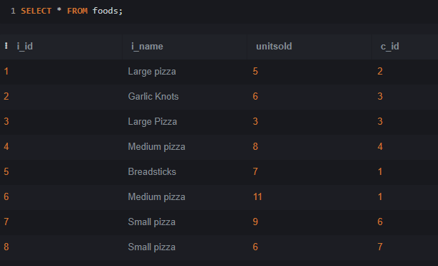

mysql> select * from company as C inner join foods as F on C.c_id = F.c_id;

