# Tutorial: Create a Windows Machine Learning UWP application (C#)

In this tutorial, we'll build a simple Universal Windows Platform application that uses a trained machine learning model to recognize a numeric digit drawn by the user. This tutorial primarily focuses on how to load and use Windows ML in your UWP application.

If you'd prefer to simply look at the code of the finished tutorial, you can find it on the [WinML GitHub repository](https://github.com/Microsoft/Windows-Machine-Learning/tree/master/Samples/MNIST/UWP/cs). It's also available in [C++/CX](https://github.com/Microsoft/Windows-Machine-Learning/tree/master/Samples/MNIST/UWP/cppcx). The sample should also already be downloaded on your machine at **<insert path to sample here>**, but the latest version will always be on GitHub.

## Prerequisites

* Windows 10 (Version 1809 or higher)
* [Windows 10 SDK](https://developer.microsoft.com/windows/downloads/windows-10-sdk) (Build 17763 or higher)
* [Visual Studio 2017](https://developer.microsoft.com/windows/downloads)
* [Windows Machine Learning Code Generator VS 2017 extension](https://marketplace.visualstudio.com/items?itemName=WinML.mlgen)
* Some basic UWP and C# knowledge

## 1. Open the project in Visual Studio

Once you've downloaded the project from GitHub or located it on your machine, launch Visual Studio and open the **MNIST_Demo.sln** file (it should be located at **<Path to repo>-Machine-Learning*). If the solution is shown as unavailable, you'll need to right-click the project in the **Solution Explorer** and select **Reload Project**.

We've provided a template with implemented XAML controls and events, including:

* An [InkCanvas](https://docs.microsoft.com/uwp/api/windows.ui.xaml.controls.inkcanvas) to draw the digit.
* [Buttons](https://docs.microsoft.com/uwp/api/windows.ui.xaml.controls.button) to interpret the digit and clear the canvas.
* Helper routines to convert the **InkCanvas** output to a [VideoFrame](https://docs.microsoft.com/uwp/api/windows.media.videoframe).

Inside the **Solution Explorer**, the project has three main code files:

* **MainPage.xaml** - All of our XAML code to create the UI for the **InkCanvas**, buttons, and labels.
* **MainPage.xaml.cs** - Where our application code lives.
* **Helper.cs** - Helper routines to crop and convert image formats.

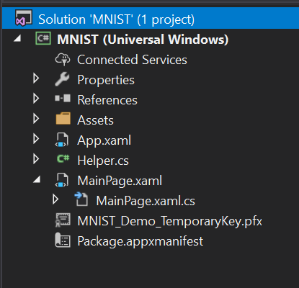

Visual Studio solution explorer with project files

## 2. Build and run the project

In the Visual Studio toolbar, change the **Solution Platform** to **x64** to run the project on your local machine if your device is 64-bit, or **x86** if it's 32-bit. (You can check in the Windows Settings app: **System > About > Device specifications > System type**.)

To run the project, click the **Start Debugging** button on the toolbar, or press **F5**. The application should show an **InkCanvas** where users can write a digit, a **Recognize** button to interpret the number, an empty label field where the interpreted digit will be displayed as text, and a **Clear Digit** button to clear the **InkCanvas**.

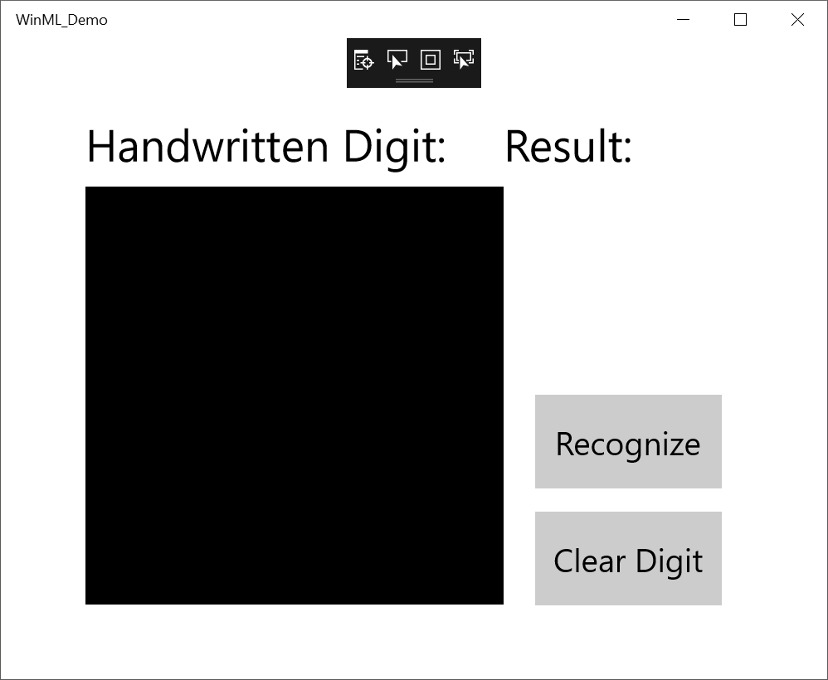

Application screenshot

**Note**: If the project won't build, you might need to change the project's deployment target version. Right-click the project in the **Solution Explorer** and select **Properties**. In the **Application** tab, set the **Target version** and **Min version** to match your OS and SDK.

**Note**: If you get a warning that the application is already installed, just select **Yes** to continue with deployment. You may need to close Visual Studio and re-open if it still doesn't work.

## 3. Download a model

Next, let's get a machine learning model to add to our application. For this tutorial, we'll use a pre-trained MNIST model that was trained with the [Microsoft Cognitive Toolkit (CNTK)](https://docs.microsoft.com/cognitive-toolkit/) and [exported to ONNX format](https://github.com/onnx/tutorials/blob/master/tutorials/CntkOnnxExport.ipynb).

The MNIST model has already been included in your **Assets** folder, and you will need to add it to your application as an existing item. You can also download the pre-trained model from the [ONNX Model Zoo](https://github.com/onnx/models) on GitHub.

## 4. Add the model

Right click on the **Assets** folder in the **Solution Explorer**, and select **Add** > **Existing Item**. Point the file picker to the location of your ONNX model, and click **Add**.

The project should now have two new files:

* **mnist.onnx** - Your trained model.
* **mnist.cs** - The Windows ML-generated code.

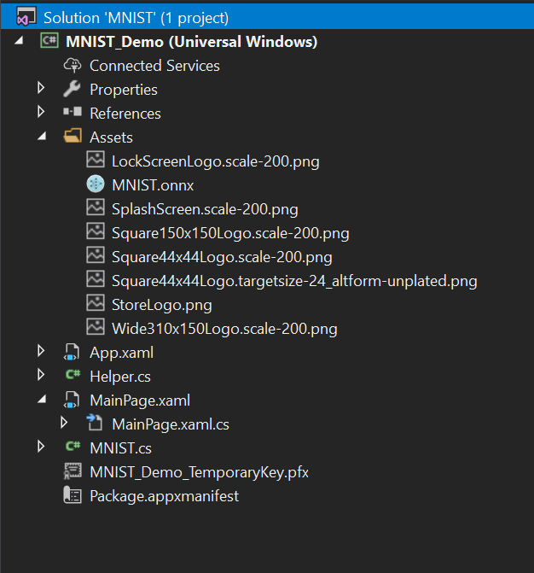

Solution explorer with new files

To make sure the model builds when we compile our application, right click on the **mnist.onnx** file, and select **Properties**. For **Build Action**, select **Content**.

Now, let's take a look at the newly generated code in the **mnist.cs** file. We have three classes:

* **mnistModel** creates the machine learning model representation, creates a session on the system default device, binds the specific inputs and outputs to the model, and evaluates the model asynchronously.
* **mnistInput** initializes the input types that the model expects. In this case, the input expects an [ImageFeatureValue](https://docs.microsoft.com/uwp/api/windows.ai.machinelearning.imagefeaturevalue).
* **mnistOutput** initializes the types that the model will output. In this case, the output will be a list called **Plus214_Output_0** of type [TensorFloat](https://docs.microsoft.com/uwp/api/windows.ai.machinelearning.tensorfloat).

We'll now use these classes to load, bind, and evaluate the model in our project.

## 5. Load, bind, and evaluate the model

For Windows ML applications, the pattern we want to follow is: Load > Bind > Evaluate.

1. Load the machine learning model.
2. Bind inputs and outputs to the model.
3. Evaluate the model and view results.

We'll use the interface code generated in **mnist.cs** to load, bind, and evaluate the model in our application.

First, in **MainPage.xaml.cs**, let's instantiate the model, inputs, and outputs. Add the following member variables to the **MainPage** class:

private mnistModel ModelGen;  
private mnistInput ModelInput = new mnistInput();  
private mnistOutput ModelOutput;

Then, in **LoadModelAsync**, we'll load the model. This method should be called before we use any of the model's methods (that is, on **MainPage**'s [Loaded](https://docs.microsoft.com/uwp/api/windows.ui.xaml.frameworkelement.loaded) event, at an [OnNavigatedTo](https://docs.microsoft.com/uwp/api/windows.ui.xaml.controls.page.onnavigatedto) override, or anywhere before **recognizeButton_Click** is called). The **mnistModel** class represents the MNIST model and creates the session on the system default device. To load the model, we call the **CreateFromStreamAsync** method, passing in the ONNX file as the parameter.

private async Task LoadModelAsync()  
{  
 // Load a machine learning model  
 StorageFile modelFile = await StorageFile.GetFileFromApplicationUriAsync(new Uri($"ms-appx:///Assets/mnist.onnx"));  
 ModelGen = await mnistModel.CreateFromStreamAsync(modelFile as IRandomAccessStreamReference);  
}

**Note**: If you get red underlines under **IRandomAccessStreamReference**, you need to include its namespace. Put your cursor over it, press **Ctrl + .** and select **using Windows.Storage.Streams** from the drop-down menu.

Next, we want to bind our inputs and outputs to the model. The generated code also includes **mnistInput** and **mnistOutput** wrapper classes. The **mnistInput** class represents the model's expected inputs, and the **mnistOutput** class represents the model's expected outputs.

To initialize the model's input object, call the **mnistInput** class constructor, passing in your application data, and make sure that your input data matches the input type that your model expects. The **mnistInput** class expects an **ImageFeatureValue**, so we use a helper method to get an **ImageFeatureValue** for the input.

Using our included helper functions in **helper.cs**, we will copy the contents of the **InkCanvas**, convert it to type **ImageFeatureValue**, and bind it to our model.

private async void recognizeButton_Click(object sender, RoutedEventArgs e)  
{  
 // Bind model input with contents from InkCanvas  
 VideoFrame vf = await helper.GetHandWrittenImage(inkGrid);  
 ModelInput.Input3 = ImageFeatureValue.CreateFromVideoFrame(vf);  
}

For output, we simply call **EvaluateAsync** with the specified input. Once your inputs are initialized, call the model's **EvaluateAsync** method to evaluate your model on the input data. **EvaluateAsync** binds your inputs and outputs to the model object and evaluates the model on the inputs.

Since the model returns an output tensor, we'll first want to convert it to a friendly datatype, and then parse the returned list to determine which digit had the highest probability and display that one.

private async void recognizeButton_Click(object sender, RoutedEventArgs e)  
{  
 // Bind model input with contents from InkCanvas  
 VideoFrame vf = await helper.GetHandWrittenImage(inkGrid);  
 ModelInput.Input3 = ImageFeatureValue.CreateFromVideoFrame(vf);  
  
 // Evaluate the model  
 ModelOutput = await ModelGen.EvaluateAsync(ModelInput);  
  
 // Convert output to datatype  
 IReadOnlyList<float> vectorImage = ModelOutput.Plus214_Output_0.GetAsVectorView();  
 IList<float> imageList = vectorImage.ToList();  
  
 // Query to check for highest probability digit  
 var maxIndex = imageList.IndexOf(imageList.Max());  
  
 // Display the results  
 numberLabel.Text = maxIndex.ToString();  
}

Finally, we'll want to clear out the **InkCanvas** to allow users to draw another number.

private void clearButton_Click(object sender, RoutedEventArgs e)  
{  
 inkCanvas.InkPresenter.StrokeContainer.Clear();  
 numberLabel.Text = "";  
}

## 6. Launch the application

Once we build and launch the application (press **F5**), we'll be able to recognize a number drawn on the **InkCanvas**.

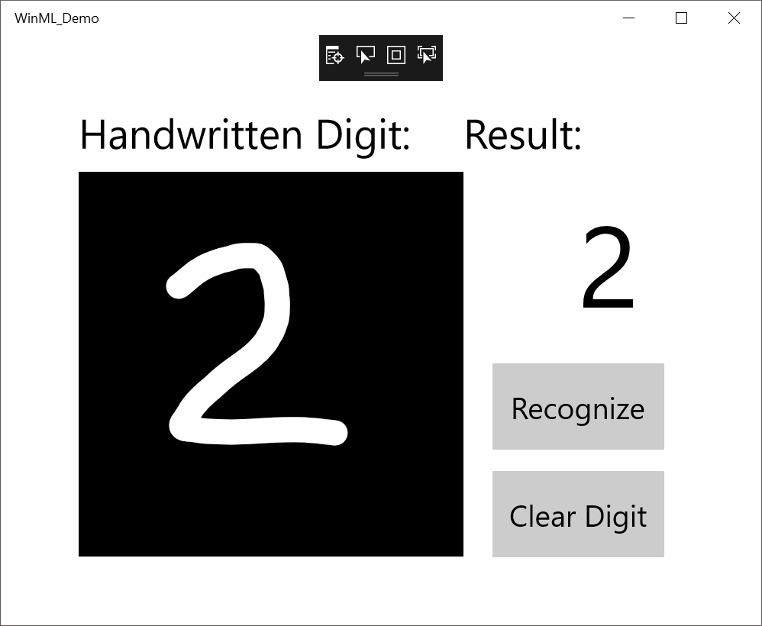

complete application

That's it - you've made your first Windows ML application! For more samples that demonstrate how to use Windows ML, check out our [Windows-Machine-Learning](https://github.com/Microsoft/Windows-Machine-Learning) repo on GitHub.

[!INCLUDE [help](includes/get-help.md)]