Assignment
- Check a number even or odd.
Program:
#include <stdio.h>
int main()
{
int num;
printf("Enter a number: ");
scanf("%d", &num);
if (num % 2 == 0)
{
printf("Even number\n");
}
else
{
printf("Odd number\n");
}
}
Output: 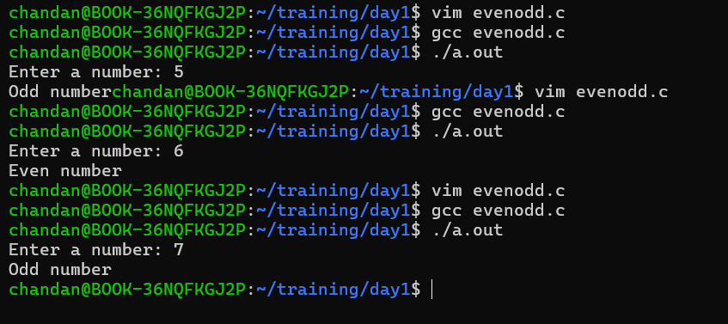
- Find the factorial of the number
Program:
#include<stdio.h>
int main()
{
int num;
int count;
int fact=1;
printf("enter number: ");
scanf("%d",&num);
for(count=1; count<=num; count++)
{
fact=fact*count;
}
printf("Factorial=%d\n",fact);
}
Output:
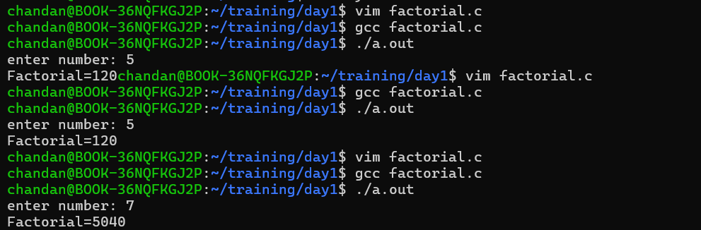

- Swap two numbers using temporary variable
Program:
#include <stdio.h>
int main()
{
int a;
int b;
int temp;
printf("enter number a: ");
scanf("%d", &a);
printf("enter number b: ");
scanf("%d",&b);
temp = a;
a = b;
b = temp;
printf("After swapping: a = %d, b = %d", a, b);
}
Output:
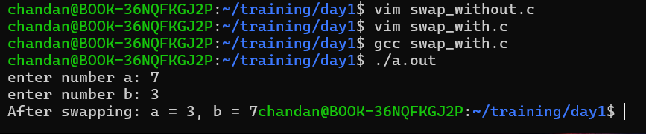

- Swap two numbers without using temporary variable
Program:

#include <stdio.h>
int main()
{
int a;
int b;
printf("a:");
scanf("%d",&a);
printf("b:");
scanf("%d",&b);
printf("a:%d\n",b);
printf("b:%d\n",a);
}
Output:
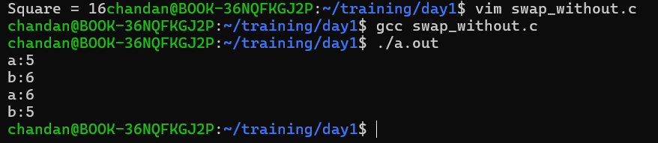

- Find the square of numbers
Program: #include <stdio.h>

int main()
{
int n, square;
printf("Enter a number: ");
scanf("%d", &n);
square = n * n;
printf("Square = %d", square);
}
Output:
