NAME:-BAJARIYA VRUSHTI ASHOKBHAI
CLASS:-SY_IT_C
ENROLL:-SR24BSIT011

ASSIGNMENT-3[EVEN]
TASK-1
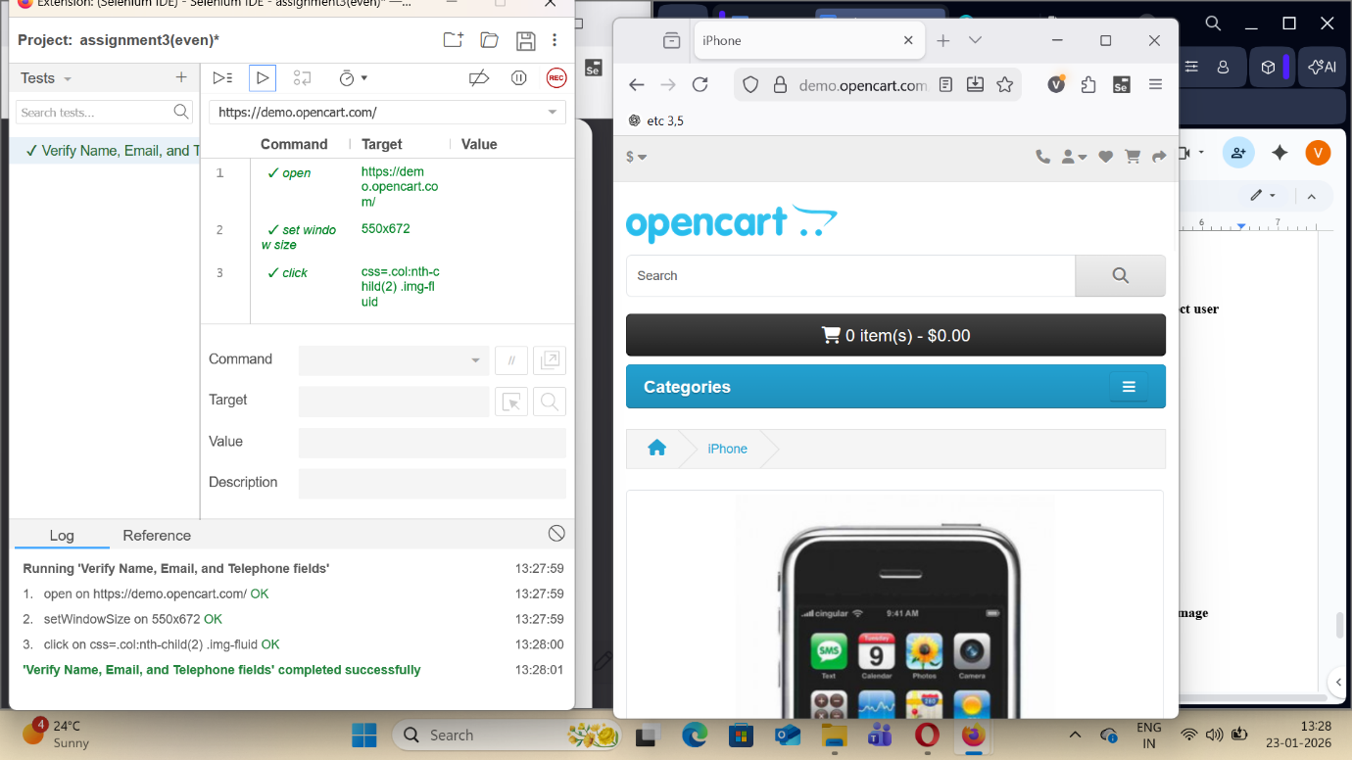

TASK-2
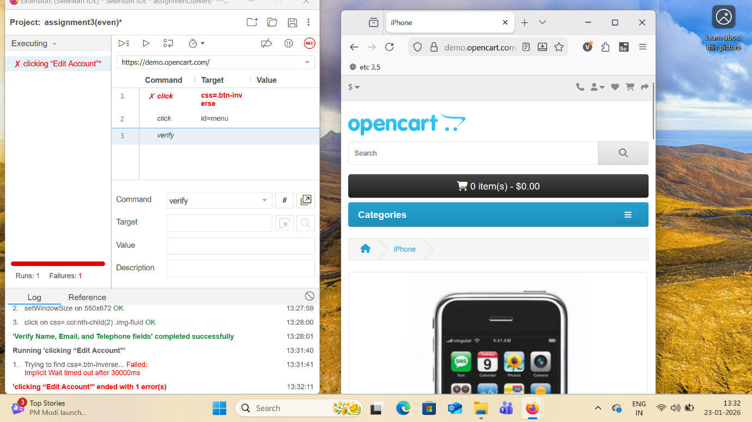
TASK-3
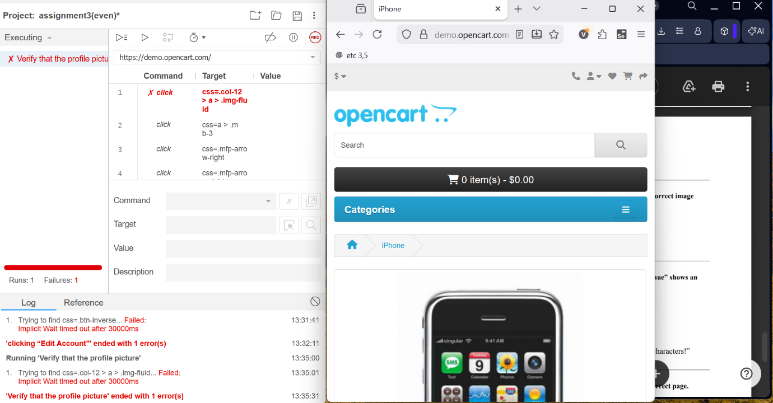

TASK-4
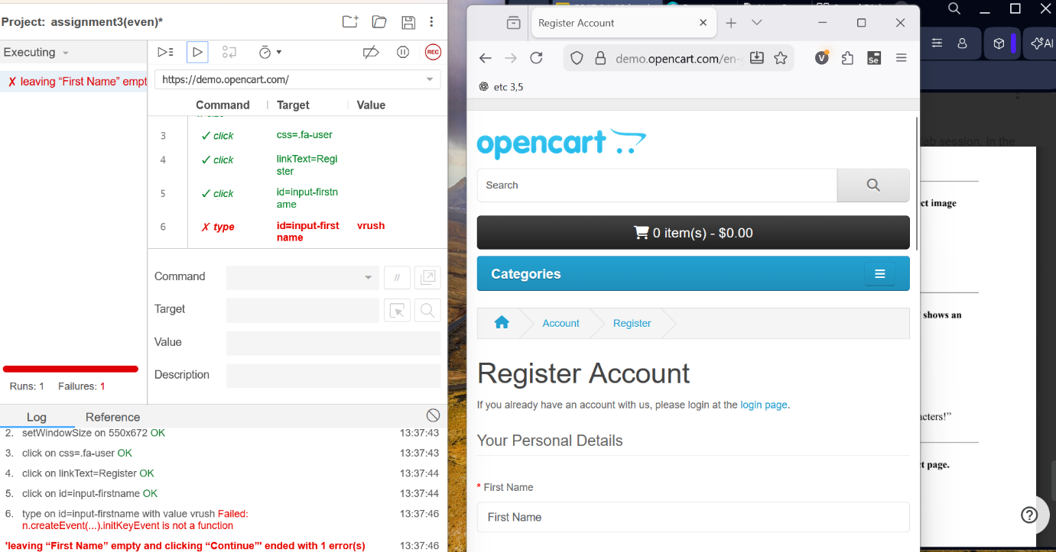

TASK-5

TASK-6
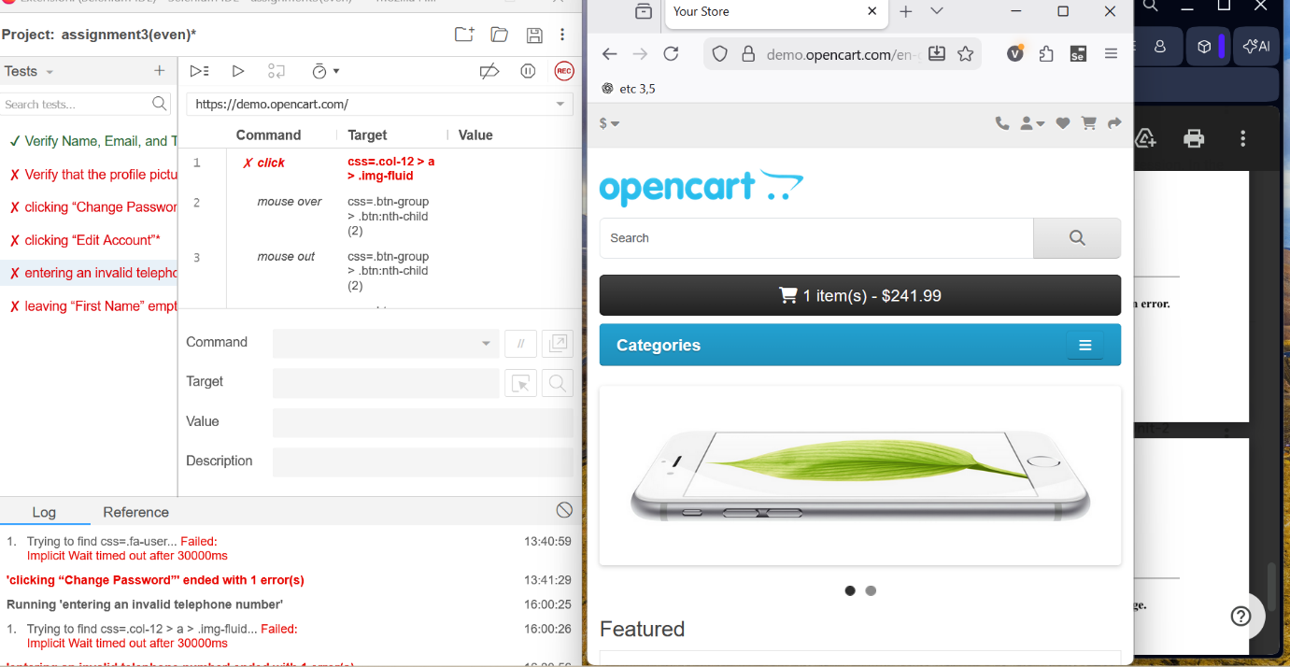

TASK-7
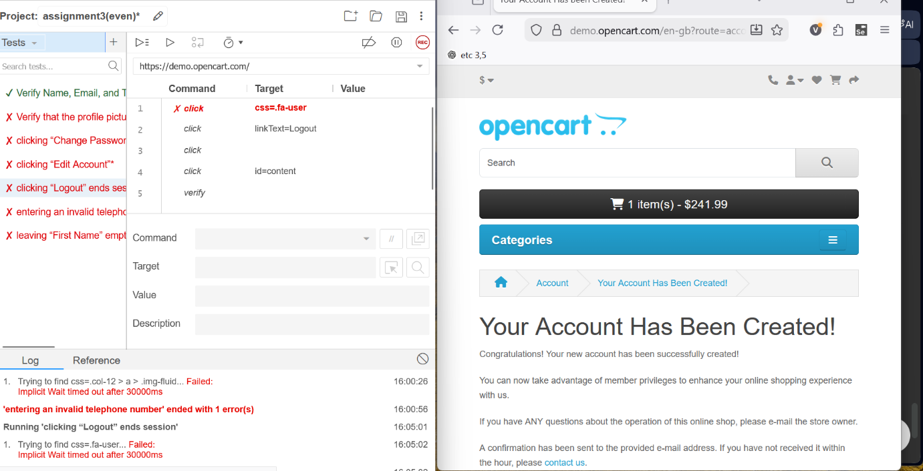

TASK-8
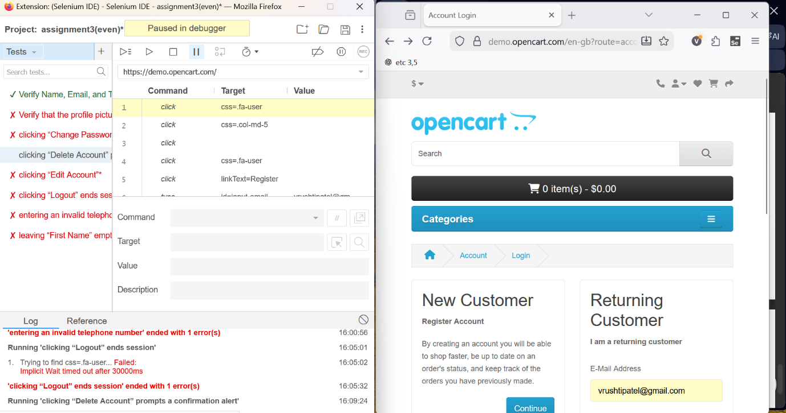

TASK-9
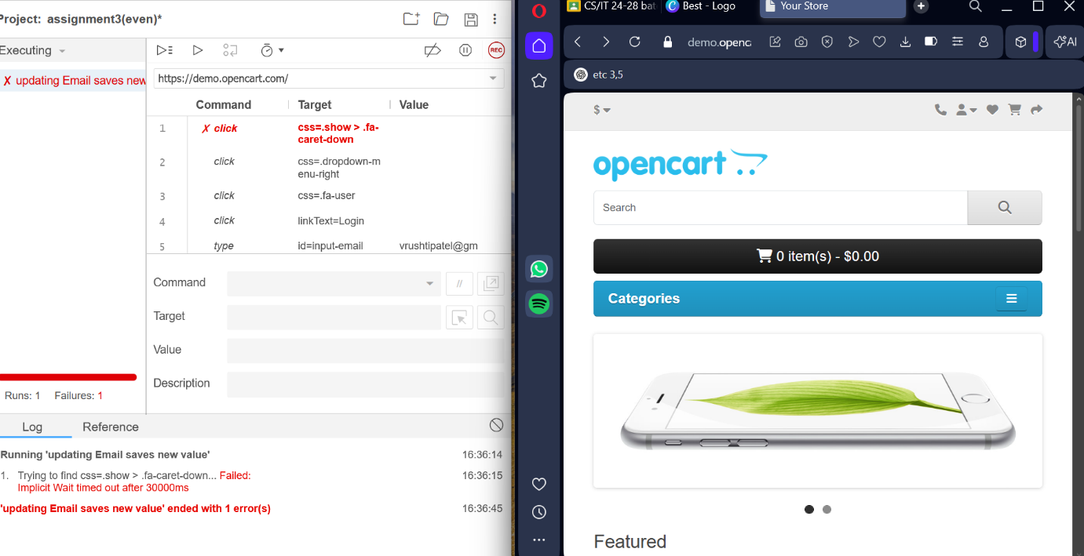

TASK-10
