**Introduction to Combinational Circuit Simulation Lab: 3**

***Full Subtractor***

***Student : Chandani Lapasia***

***User id : fpga0522-chan50***

**Code snippet for Full Subtractor DATA flow modelling.**

**Design:**

module full_sub_data(sub,borrow,in1,in2,in3);

input in1, in2,in3;

output sub,borrow;

assign sub= in1^in2^in3;

assign borrow= (~in1 && in2) || (~in1 && in3) || (in2 && in3);

endmodule

**Testbench:**

module full_sub_data_tb();

wire sub,borrow;

reg in1,in2,in3;

full_sub_data u0(sub,borrow,in1,in2,in3);

initial begin

in1=0; in2=0; in3=0;

#5 in1=0; in2=0; in3=1;

#5 in1=0; in2=1; in3=0;

#5 in1=0; in2=1; in3=1;

#5 in1=1; in2=0; in3=0;

#5 in1=1; in2=0; in3=1;

#5 in1=1; in2=1; in3=0;

#5 in1=1; in2=1; in3=1;

#5 $finish;

end

initial begin

$monitor ($time, "\t" , "in1=%d in2=%d in3=%d borrow=%d sub=%d", in1,in2,in3,borrow,sub);

end

endmodule

**Output waveform:**

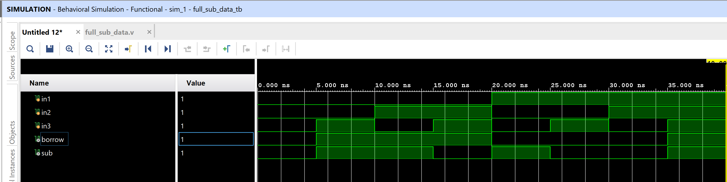

**Output console :**

0 in1=0 in2=0 in3=0 borrow=0 sub=0

5 in1=0 in2=0 in3=1 borrow=1 sub=1

10 in1=0 in2=1 in3=0 borrow=1 sub=1

15 in1=0 in2=1 in3=1 borrow=1 sub=0

20 in1=1 in2=0 in3=0 borrow=0 sub=1

25 in1=1 in2=0 in3=1 borrow=0 sub=0

30 in1=1 in2=1 in3=0 borrow=0 sub=0

35 in1=1 in2=1 in3=1 borrow=1 sub=1

**Code snippet for Full Subtractor BEHAVORAL flow modelling.**

**Design code :**

module full_sub_beh(sub,borrow,in1,in2,in3);

input in1, in2,in3;

output sub,borrow;

reg sub,borrow;

always @(in1 or in2 or in3)

begin

sub= in1^in2^in3;

borrow = (~in1 && in2) || (~in1 && in3) || (in2 && in3);

end

endmodule

**Testbench code :**

module full_sub_beh_tb();

wire sub,borrow;

reg in1,in2,in3;

full_sub_beh u0(sub,borrow,in1,in2,in3);

initial begin

in1=0; in2=0; in3=0;

#5 in1=0; in2=0; in3=1;

#5 in1=0; in2=1; in3=0;

#5 in1=0; in2=1; in3=1;

#5 in1=1; in2=0; in3=0;

#5 in1=1; in2=0; in3=1;

#5 in1=1; in2=1; in3=0;

#5 in1=1; in2=1; in3=1;

#5 $finish;

end

initial begin

$monitor ($time, "\t" , "in1=%d in2=%d in3=%d borrow=%d sub=%d", in1,in2,in3,borrow,sub);

end

endmodule

**Output waveform :**

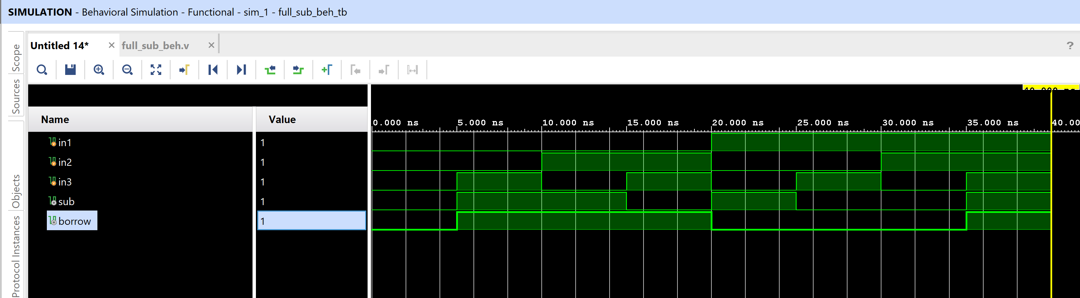

**Output console :**

0 in1=0 in2=0 in3=0 borrow=0 sub=0

5 in1=0 in2=0 in3=1 borrow=1 sub=1

10 in1=0 in2=1 in3=0 borrow=1 sub=1

15 in1=0 in2=1 in3=1 borrow=1 sub=0

20 in1=1 in2=0 in3=0 borrow=0 sub=1

25 in1=1 in2=0 in3=1 borrow=0 sub=0

30 in1=1 in2=1 in3=0 borrow=0 sub=0

35 in1=1 in2=1 in3=1 borrow=1 sub=1

**Code snippet for Full Subtractor STRUCTURAL flow modelling.**

**Design code :**

module full_sub_str(sub,borrow,in1,in2,in3);

input in1, in2,in3;

output sub,borrow;

wire sub,borrow;

wire temp1,temp2,temp3;

xor(sub,in1,in2,in3);

and(temp3,~in1,in2);

and(temp1,in2,in3);

and(temp2,~in1,in3);

or(borrow,temp3,temp1,temp2);

endmodule

**Testbench code :**

module full_sub_str_tb();

wire sub,borrow;

reg in1,in2,in3;

full_sub_str u0(sub,borrow,in1,in2,in3);

initial begin

in1=0; in2=0; in3=0;

#5 in1=0; in2=0; in3=1;

#5 in1=0; in2=1; in3=0;

#5 in1=0; in2=1; in3=1;

#5 in1=1; in2=0; in3=0;

#5 in1=1; in2=0; in3=1;

#5 in1=1; in2=1; in3=0;

#5 in1=1; in2=1; in3=1;

#5 $finish;

end

initial begin

$monitor ($time, "\t" , "in1=%d in2=%d in3=%d borrow=%d sub=%d", in1,in2,in3,borrow,sub);

end

endmodule

**Output waveform :**

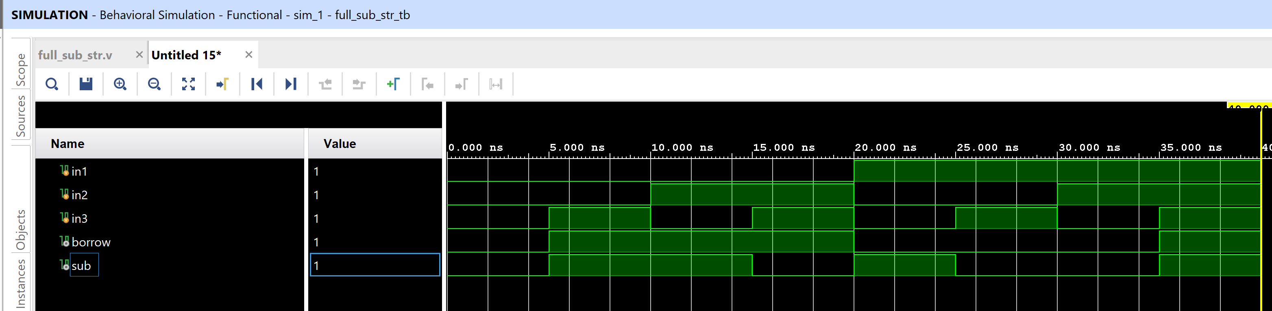

**Output console :**

0 in1=0 in2=0 in3=0 borrow=0 sub=0

5 in1=0 in2=0 in3=1 borrow=1 sub=1

10 in1=0 in2=1 in3=0 borrow=1 sub=1

15 in1=0 in2=1 in3=1 borrow=1 sub=0

20 in1=1 in2=0 in3=0 borrow=0 sub=1

25 in1=1 in2=0 in3=1 borrow=0 sub=0

30 in1=1 in2=1 in3=0 borrow=0 sub=0

35 in1=1 in2=1 in3=1 borrow=1 sub=1

**=============================== END=========================================**