**Introduction to Combinational Circuit Simulation Lab: 3**

***Half Subtractor***

***Student : Chandani Lapasia***

***User id : fpga0522-chan50***

**Code snippet for Half Subtractor DATA flow modelling.**

**Design:**

module half_sub(sub,borrow,in1,in2);

input in1, in2;

output sub, borrow;

assign sub= in1 ^ in2;

assign borrow=(~in1 && in2);

endmodule

**Testbench:**

module test_tb();

reg in1,in2;

wire sub, borrow;

half_sub u0 (sub,borrow,in1,in2);

initial begin

in1=0; in2=0;

#10 in1=0; in2=1;

#10 in1=1; in2=0;

#10 in1=1; in2=1;

end

initial begin

$monitor($time, "in1=%d in2=%d borrow=%d sub=%d", in1, in2,borrow, sub);

end

endmodule

**Output waveform:**

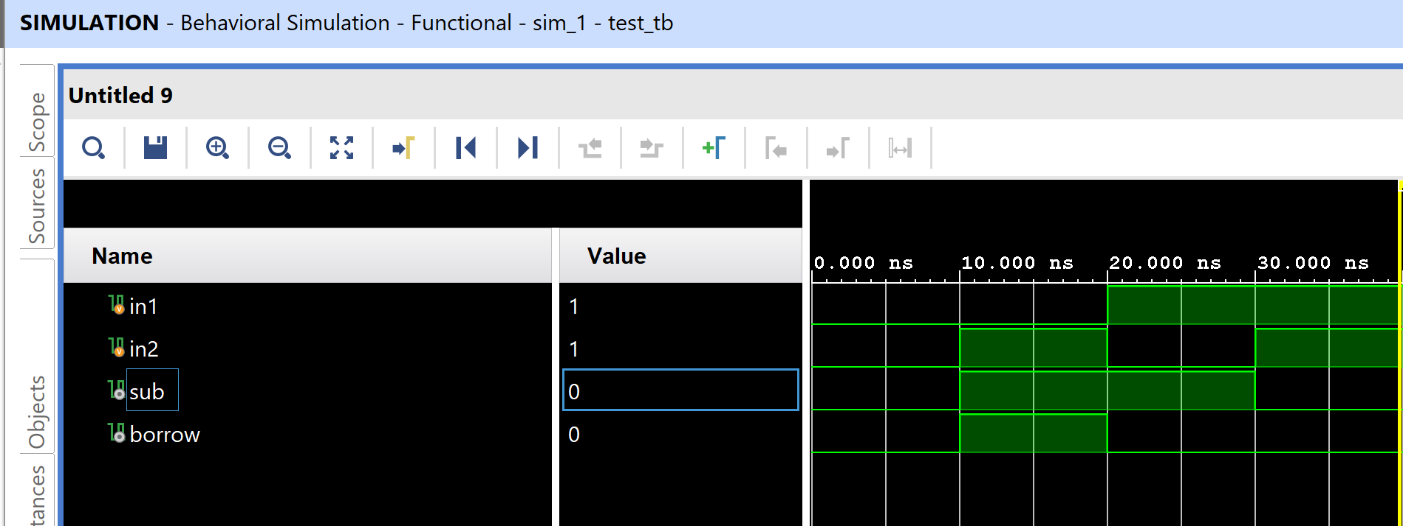

**Output console :**

0 in1=0 in2=0 borrow=0 sub=0

10 in1=0 in2=1 borrow=1 sub=1

20 in1=1 in2=0 borrow=0 sub=1

30 in1=1 in2=1 borrow=0 sub=0

**Code snippet for Half Subtractor BEHAVORAL flow modelling.**

**Design code :**

module half_sub_beh(borrow,sub,in1,in2);

input in1, in2;

output sub, borrow;

reg sub,borrow;

always @(in1 or in2)

begin

sub= in1^in2;

borrow= ((~in1) && in2);

end

endmodule

**Testbench code :**

module tb_half_sub();

reg in1, in2;

wire borrow, sub;

half_sub_beh u0(borrow,sub,in1,in2);

initial begin

in1=0; in2=0;

#10 in1=0; in2=1;

#10 in1=1; in2=0;

#10 in1=1; in2=1;

end

initial begin

$monitor($time, "in1=%d in2=%d borrow=%d sub=%d", in1, in2,borrow, sub);

end

endmodule

**Output waveform :**

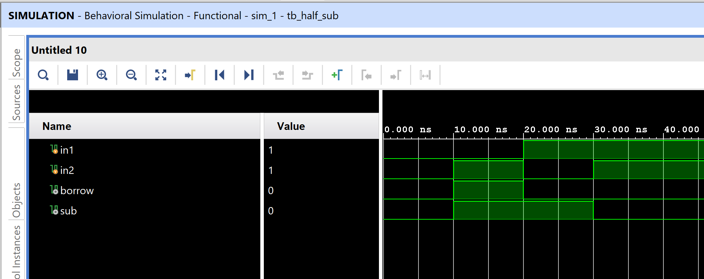

**Output console :**

0 in1=0 in2=0 borrow=0 sub=0

10 in1=0 in2=1 borrow=1 sub=1

20 in1=1 in2=0 borrow=0 sub=1

30 in1=1 in2=1 borrow=0 sub=0

**Code snippet for Half Subtractor STRUCTURAL flow modelling.**

**Design code :**

module half_sub_str(borrow,sub,in1,in2);

input in1, in2;

output sub, borrow;

xor(sub,in1,in2);

not(temp,in1);

and(borrow,temp,in2);

endmodule

**Testbench code :**

module tb_half_sub();

reg in1, in2;

wire borrow, sub;

half_sub_str u0(borrow,sub,in1,in2);

initial begin

in1=0; in2=0;

#10 in1=0; in2=1;

#10 in1=1; in2=0;

#10 in1=1; in2=1;

end

initial begin

$monitor($time, "in1=%d in2=%d borrow=%d sub=%d", in1, in2,borrow, sub);

end

endmodule

**Output waveform :**

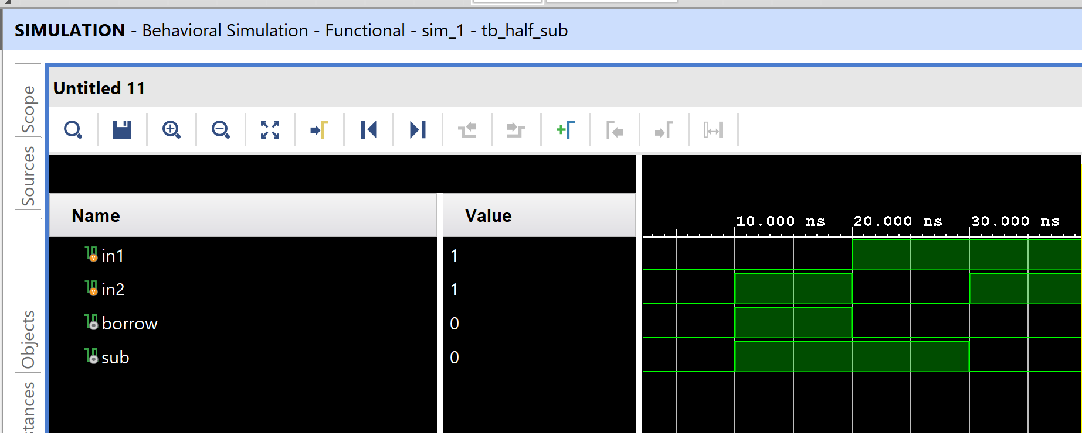

**Output console :**

0 in1=0 in2=0 borrow=0 sub=0

10 in1=0 in2=1 borrow=1 sub=1

20 in1=1 in2=0 borrow=0 sub=1

30 in1=1 in2=1 borrow=0 sub=0

**=============================== END=========================================**