VEHICLE:-TATA ACE GOLD CNG MOB:-9029196881

`
Date:- 03 / 04 / 2026
M/s. Larios ceramic Pvt.Ltd
Date | Description |  | Amount
10/03/2026 | Bhiwandi to andheri west delivery |  | 2500
13/03/2026 | Kanjur to bhiwandi & bhiwandi to malad delivery and andheri sampling |  | 3500
14/03/2026 | Bhiwandi to Bombay malawar hill delivery |  | 3000
24/03/2026 | Bhiwandi to borivali 3 delivery and daisar 1 delivery |  | 3000
 |  | Total | 12,000/-
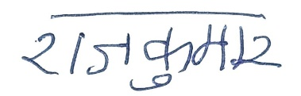
Customer’s / Receiver’s Sign.
For M/s. Rajkumar Tempo Service
Authorised Sign.

