**Q1.**

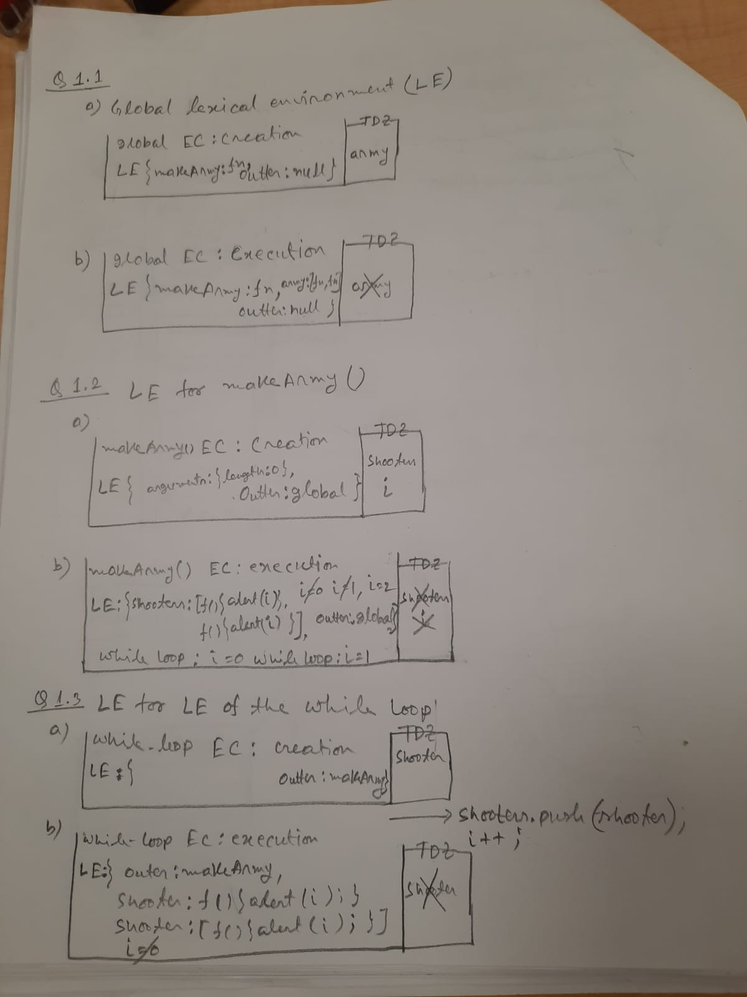

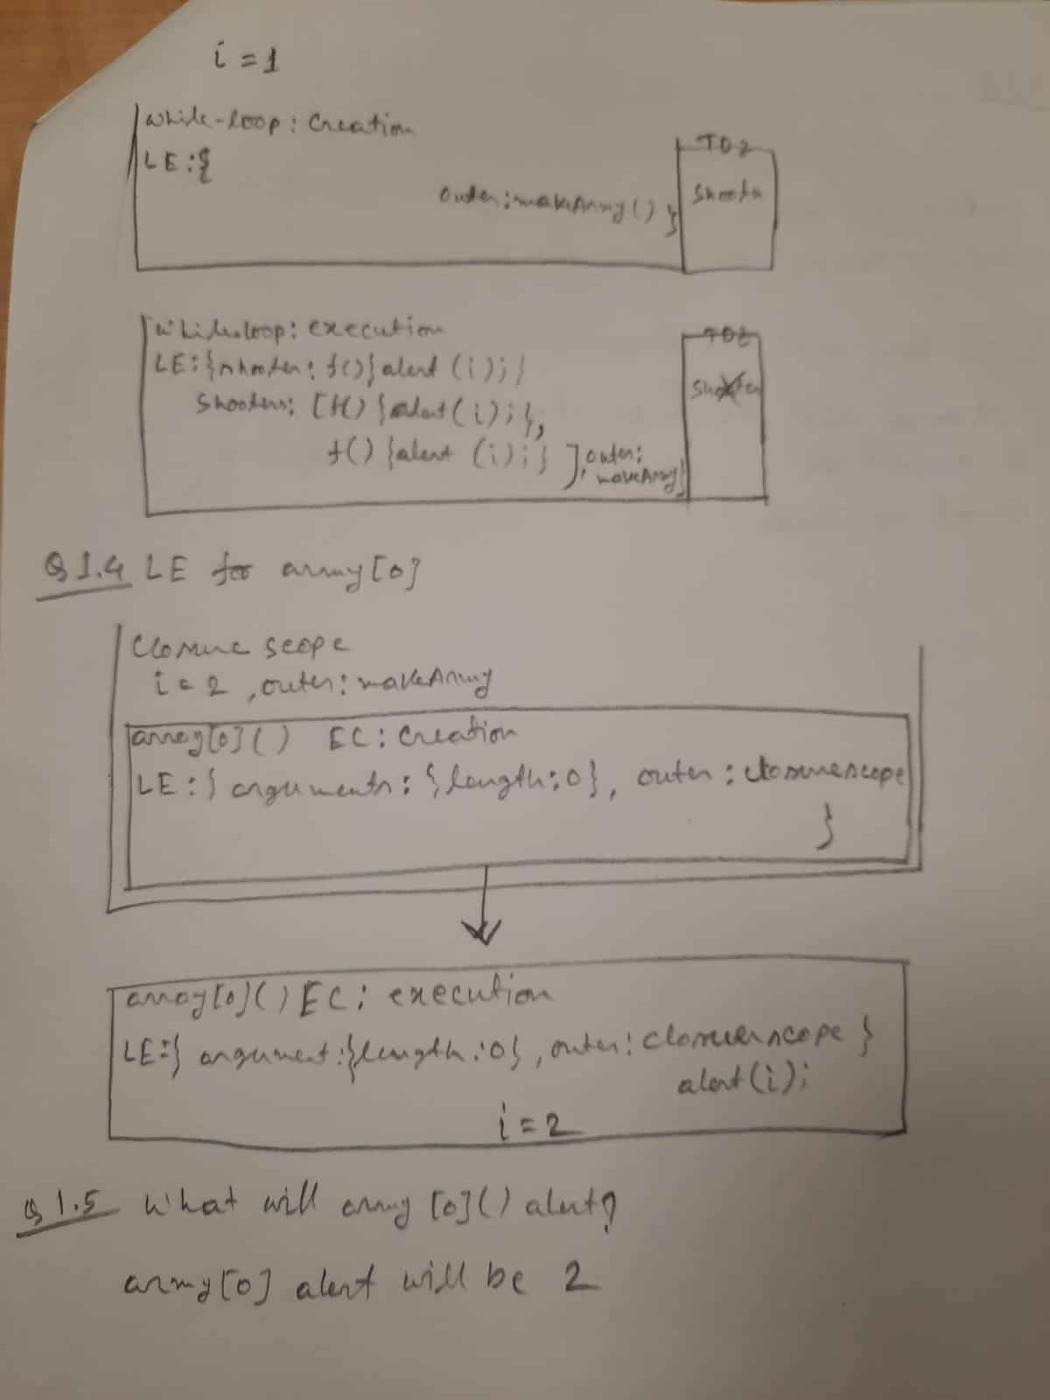

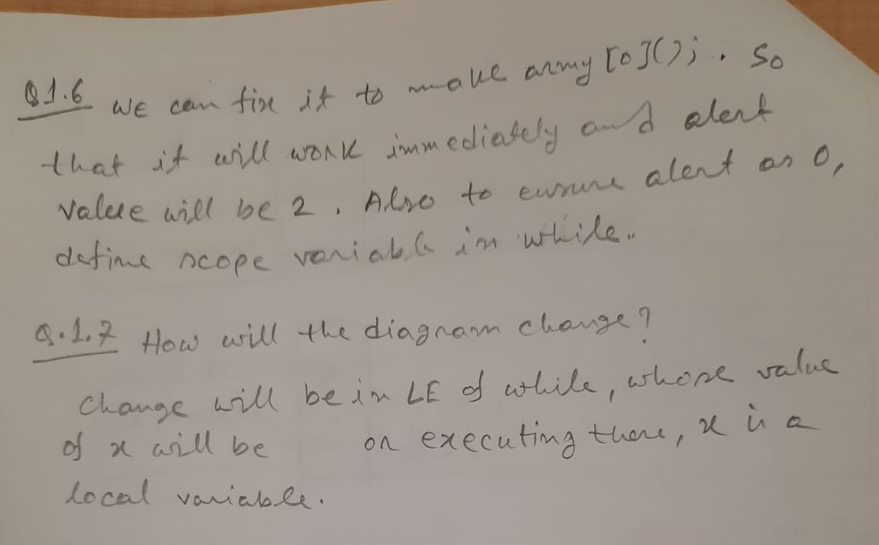

//revised code

function makeArmy() {

  let shooters = [];

  let i = 0;

  while (i < 2) {

let x=i;

    let shooter = function () {

      alert(x);

    };

    shooters.push(shooter);

    i++;

  }

  return shooters;

}

let army = makeArmy();

army[0]();

**Q2:**

Write a function *printNumbers(from, to)* that outputs a number every second, starting from *from* and ending with *to.*

const printNumbers = function (from, to) {

let base = 1;

    while(from <= to){

      setTimeout(function(x){

        console.log(x);

      },base*1000,from);

      from++;

base++;

    }

  return;

};

printNumbers(3, 9);

**Question 3:** In the code there's a *setTimeOut* call scheduled, then a heavy calculation is run, that takes more than 100ms to finish.

When will the scheduled function run?

The *setTimeout* function will run as soon as possible after completing the current code execution. Hence, the correct answer is the schedule will be called **“After the loop”**

What is alert going to show?

The Alert is going show result as: 100000000

let i = 0;

setTimeout(()=> {console.log(i)}, 100); //1000000000

//assume that the time to execute this function is > 100ms

for(let j=0; j<1000000000; j++){

    i++;

}