**Q1.What is DevOps?**

DevOps is the combination of cultural philosophies, practices, and tools that increases an organization’s ability to deliver applications and services at

high velocity: evolving and improving products at a faster pace than organizations using traditional software development and infrastructure

management processes. This speed enables organizations to better serve their customers and compete more effectively in the market.

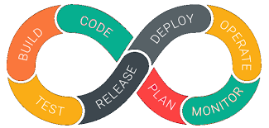

Fig:1

DevOps is a software development culture that unites development, operations, and quality assurance processes into a continuous set of actions.

It facilitates cross-functional communication, end-to-end responsibility, and collaboration, and is a natural extension of the Agile methodology.

**Q2.Mention what the key aspects or principles behind DevOps are?**

Following are the key aspects or principle behind DevOps are:-

1) Infrastructure as code

2) Continuous deployment

3) Automation

4) Monitoring

5) Security

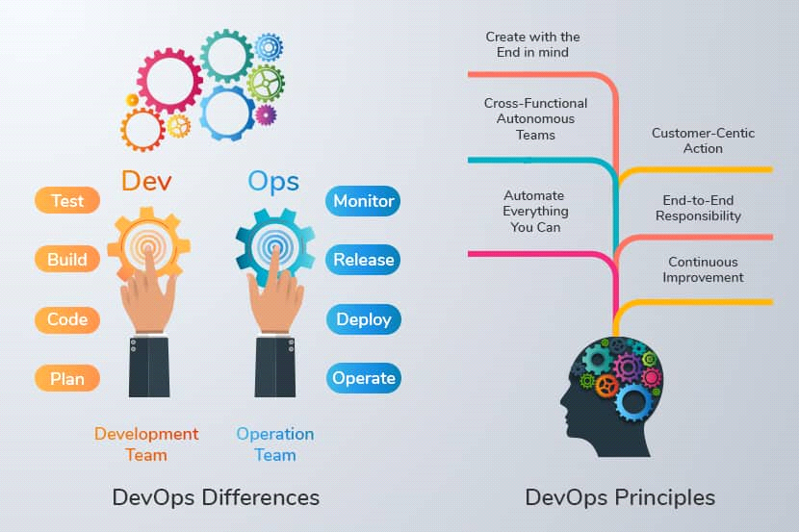

Fig:2

**Q3.What are the different phases in DevOps?**

Following are the different phases of DevOps:-

1) Continuous development

2) Integration

3) Testing

4) Monitoring

5) Feedback

6) Delivery

6) Deployment

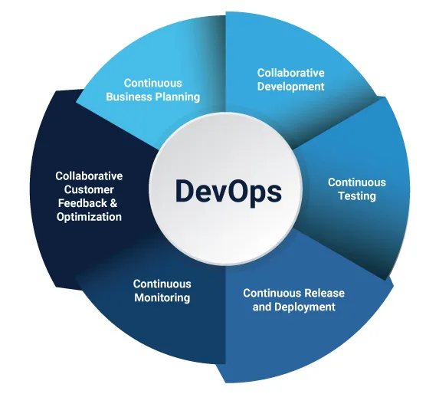

Fig:3

**Q4.Which are some of the most popular DevOps tools?**

Following are the some most popular DevOps tools:-

1) Jenkins

2) Nagios

3) Chef

4) Kubernetes

5) Docker

6) Ansible

7) Git and Github

8) Terraform

9) Puppet

10 ) Splunk

11) Selenium

12) Ant

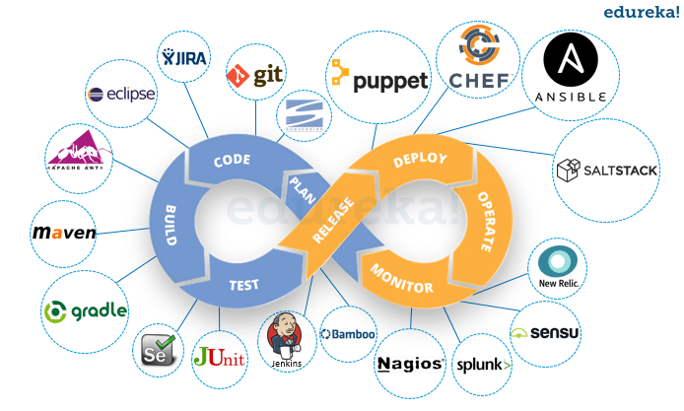

Fig:4

**Q5.Mention some of the core benefits of DevOps?**

There are five core benefits of DevOps:-

1) Renews focus on the customers. A key reason for the move to DevOps is that it gets the team back in the mindset of the customer.

2) Unites teams for faster product shipments.

3) Simplifies development focus.

4) Introduces automation to the development process.

5) Supports end-to-end responsibility.