LOW FREQUENCY OPERATION REPORT

Executive Summary & General Notes:

[Text Box] option: Default text (Single Event]: On [Date], there was a sustained low-frequency event from [Start Time] hrs. to [End Time] hrs.. Frequency was below 49.9hz for [hh]hrs [mm] min and minimum frequency was touched [Min Freq]
Frequency Plot
Violation MESSAGES ISSUED  17 Alert • 9 Emergency • 2 Extreme Emergency  4 Non-Compliance • 10 Warning | MAJOR OVER-DRAWAL  Bihar: 776 MW | DVC: 386 MW | West Bengal: 192 MW

2. State Performance Details
Reporting window: 17:00–20:00 Hrs.
Reporting Period  Reporting Period | State Name  State Name | Min. Freq.  (Hz) & Time  Min. Freq.  (Hz) & Time | Freq <49.5 Hz |  |  |  | Freq <49.7 Hz |  |  |  | Freq <49.9 Hz
Reporting Period  Reporting Period | State Name  State Name | Min. Freq.  (Hz) & Time  Min. Freq.  (Hz) & Time | Duration: — Min |  |  |  | Duration: — Min |  |  |  | Duration: — Min
Reporting Period  Reporting Period | State Name  State Name | Min. Freq.  (Hz) & Time  Min. Freq.  (Hz) & Time | OD/UI Duration  (Min & %) | Avg. OD/UI  (MW) | Max OD/UI  (MW) | Violation  Messages | OD/UI Duration  (Min & %) | Avg. OD/UI  (MW) | Max OD/UI  (MW) | Violation  Messages | OD/UI Duration  (Min & %) | Avg. OD/UI  (MW) | Max OD/UI  (MW) | Violation  Messages
 | Bihar | — | — | — | — | — | — | — | — | — | — | — | — | —
 | DVC | — | — | — | — | — | — | — | — | — | — | — | — | —
 | Jharkhand | — | — | — | — | — | — | — | — | — | — | — | — | —
 | Odisha | — | — | — | — | — | — | — | — | — | — | — | — | —
 | West Bengal | — | — | — | — | — | — | — | — | — | — | — | — | —
 | Sikkim | — | — | — | — | — | — | — | — | — | — | — | — | —

3. Central Sector Generator Performance Details
Scope: Only generators with under-injection are listed. Reporting window: 17:00–20:00 Hrs.
Reporting Period | Generator Name  (Agency) | Min. Freq.  (Hz) & Time | Freq <49.5 Hz |  |  |  | Freq <49.7 Hz |  |  |  | Freq <49.9 Hz
Reporting Period | Generator Name  (Agency) | Min. Freq.  (Hz) & Time | Duration: — Min |  |  |  | Duration: — Min |  |  |  | Duration: — Min
Reporting Period | Generator Name  (Agency) | Min. Freq.  (Hz) & Time | UI Duration  (Min & %) | Avg. UI  (MW) | Max UI  (MW) | Violation  Messages | UI Duration  (Min & %) | Avg. UI  (MW) | Max UI  (MW) | Violation  Messages | UI Duration  (Min & %) | Avg. UI  (MW) | Max UI  (MW) | Violation  Messages
04-Oct-2026 | FSTPP III (ISGS)  500 MW | — | — | — | — | — | — | — | — | — | — | — | — | —

4. Action & Chronology of Events:

Text Box
Event chronology table (include all messages & Physical regulatory option

5. Action of Deference Mechanism (ADMS & UFR):

Data will be fetched from CRMS (Future provision)

Annexure 1 – State-wise Low Frequency Analysis
State: BIHAR | Analysis window: ----
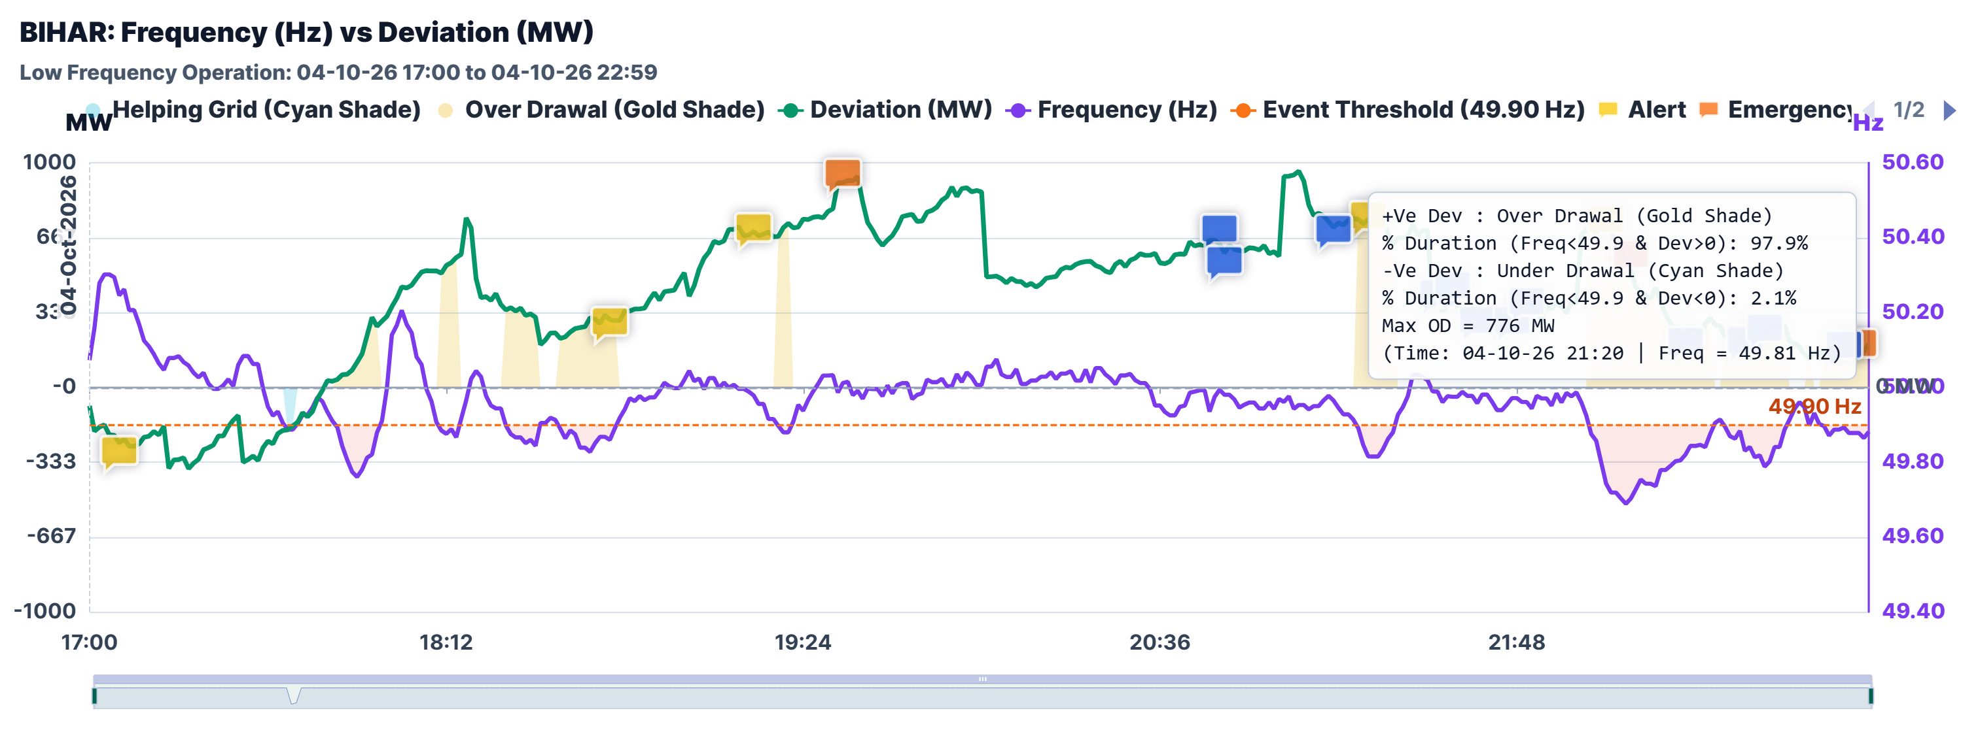
Figure 1. Source analysis figure.

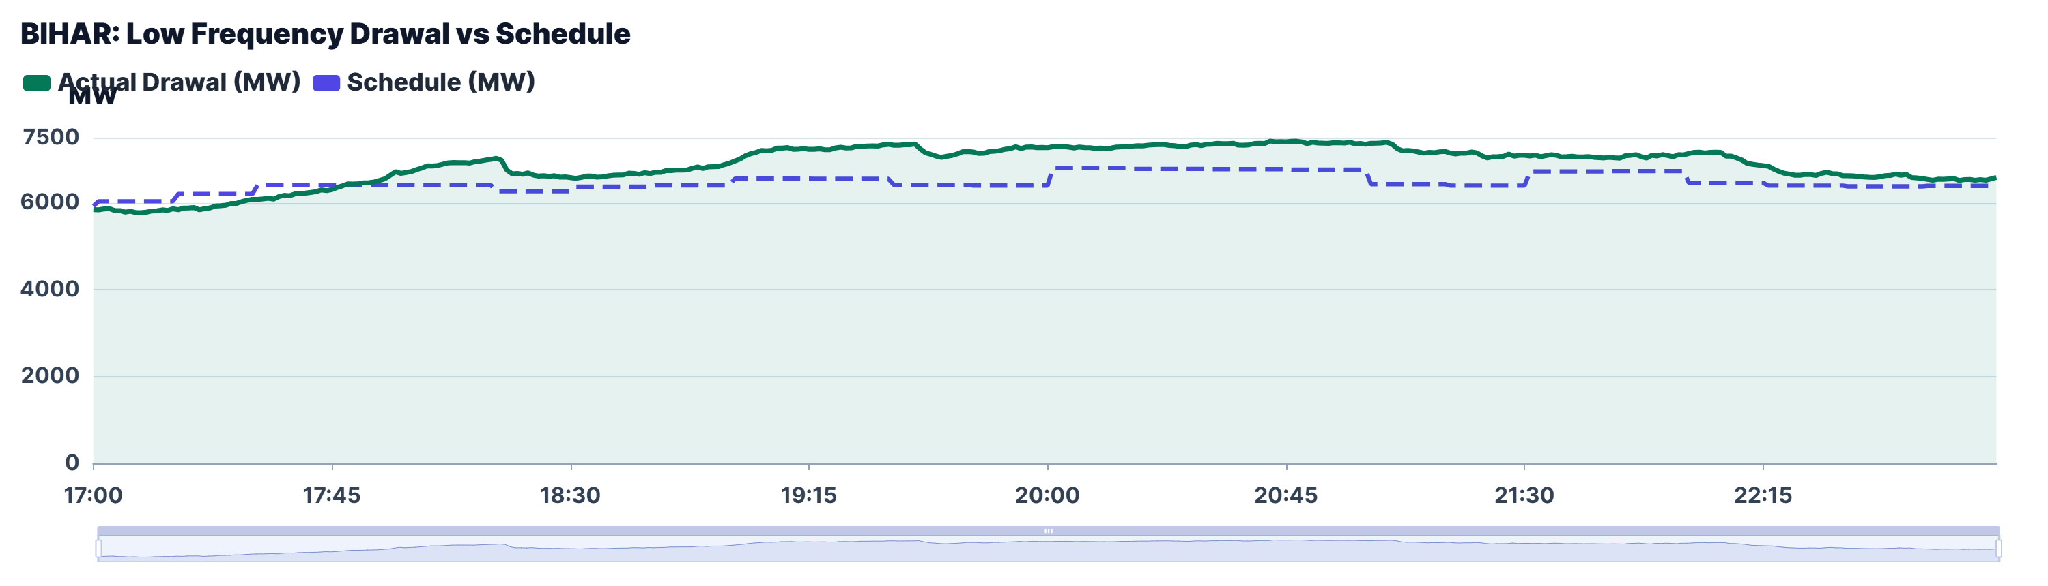
Figure 2. Source analysis figure.

CRMS Messages Issued
State-wise messages

Annexure 2 – Generator-wise Low Frequency Analysis
Generator: FSTPP ST-I & II (St. 2, 1) (ISGS | WEST BENGAL) | Analysis window: 04-Oct-2026, 17:00–22:59 Hrs.
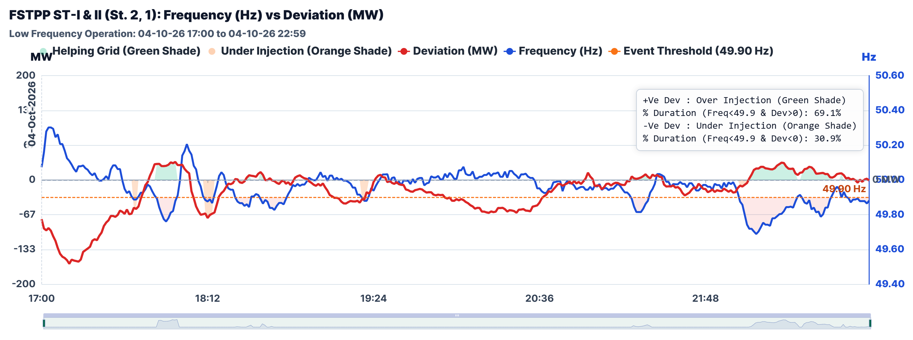
Figure 1. Source analysis figure.

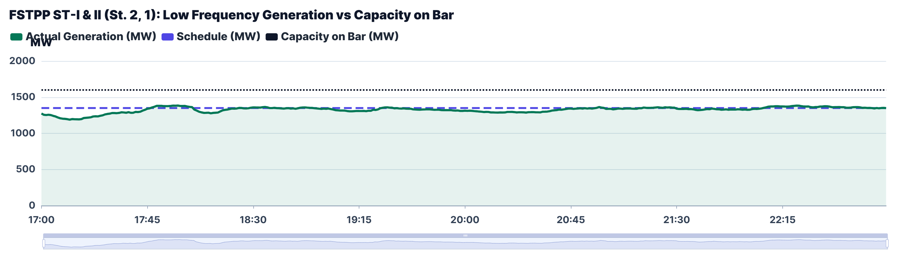
Figure 2. Source analysis figure.

CRMS Messages Issued

