LOW FREQUENCY OPERATION REPORT

Executive Summary & General Notes:

[Text Box] option:
Frequency Plot
Violation MESSAGES ISSUED  17 Alert • 9 Emergency • 2 Extreme Emergency  4 Non-Compliance • 10 Warning | MAJOR OVER-DRAWAL  Bihar: 776 MW | DVC: 386 MW | West Bengal: 192 MW

Frequency Analysis:
based on the entire 24 hours of the month
Indicator | Sep-26
Lowest frequency | 49.413 Hz at 18:39 hrs on 15.09.2026
Time below 49.90 Hz | 6,791 minutes (15.7%) on all 30 days
Time below 49.70 Hz | 1,058 minutes (2.4%) on 12 days
Time below 49.50 Hz | 1,058 minutes (2.4%) on 12 days
Within the IEGC band (49.90–50.05 Hz) | 68.7% of the time; above 50.05 Hz: 15.6%
UFR Stage-I operation reported | Text Box
Largest over-drawal below 49.90 Hz | Gujarat: 1,788 MW; Rajasthan: 1,256 MW; Tamil Nadu: 1,239 MW; Maharashtra: 1,037 MW
Largest over-drawal below 49.50 Hz | Gujarat: 1,788 MW; Rajasthan: 1,256 MW; Tamil Nadu: 1,239 MW; Maharashtra: 1,037 MW
ADMS Conditions met / operated (filed logic) | Text Box

Frequency Duration Analysis (based on entire 24 hrs of the month):
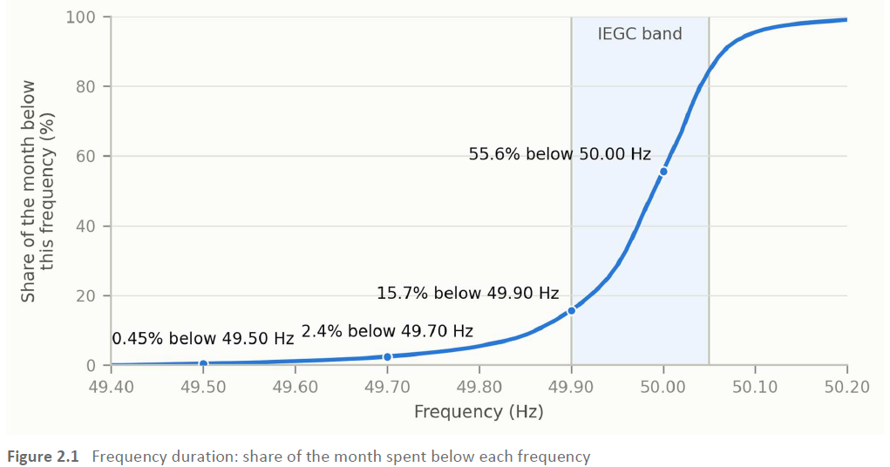
Heat map of the frequency:
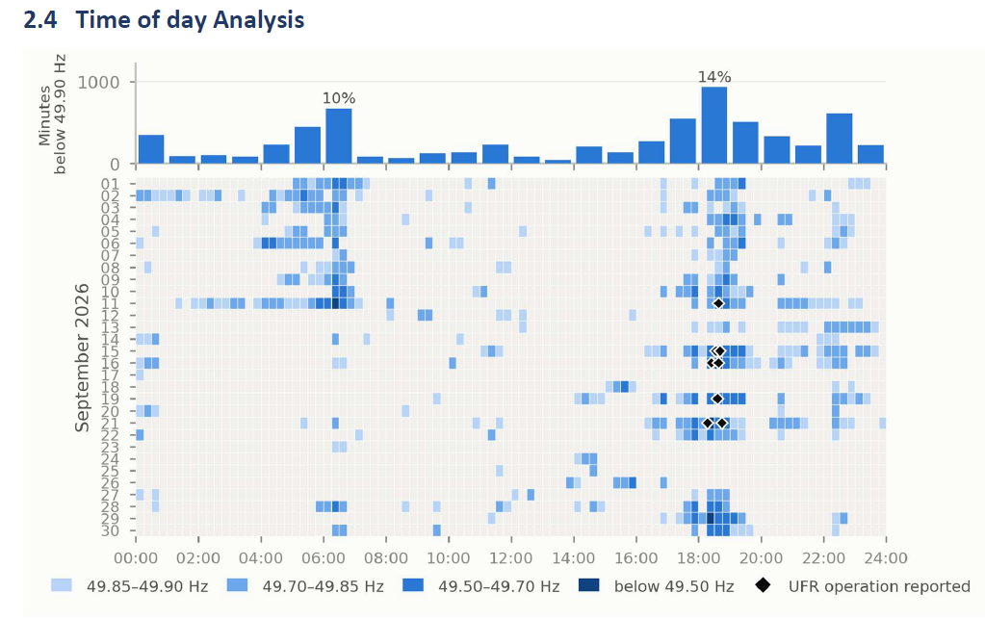
Annexure 1: Daily frequency time series with marking of Frequency <49.9 area. (Each day)

State Performance Details:
States Over Drawl Analysis:
Plot (Side bar chart) like below image
Logic: Black line for Max OD & orange bar for OD during lowest frequency.
State OD for the month
Reporting window: Time period of Slot 1 (for the entire month)
Reporting Period  Reporting Period | State Name  State Name | Min. Freq.  (Hz) & Time  Min. Freq.  (Hz) & Time | Freq <49.5 Hz |  |  |  | Freq <49.7 Hz |  |  |  | Freq <49.9 Hz
Reporting Period  Reporting Period | State Name  State Name | Min. Freq.  (Hz) & Time  Min. Freq.  (Hz) & Time | Duration: Min |  |  |  | Duration: — Min |  |  |  | Duration: — Min
Reporting Period  Reporting Period | State Name  State Name | Min. Freq.  (Hz) & Time  Min. Freq.  (Hz) & Time | OD/UI Duration  (Min & %) | Avg. OD/UI  (MW) | Max OD/UI  (MW) | Violation  Messages | OD/UI Duration  (Min & %) | Avg. OD/UI  (MW) | Max OD/UI  (MW) | Violation  Messages | OD/UI Duration  (Min & %) | Avg. OD/UI  (MW) | Max OD/UI  (MW) | Violation  Messages
 | Bihar | — | — | — | — | — | — | — | — | — | — | — | — | —
 | DVC | — | — | — | — | — | — | — | — | — | — | — | — | —
 | Jharkhand | — | — | — | — | — | — | — | — | — | — | — | — | —
 | Odisha | — | — | — | — | — | — | — | — | — | — | — | — | —
 | West Bengal | — | — | — | — | — | — | — | — | — | — | — | — | —
 | Sikkim | — | — | — | — | — | — | — | — | — | — | — | — | —

Annexure 2.1 (Daily Details of state performance)
Reporting window: Time period of Slot 2 (entire month)
Reporting Period  Reporting Period | State Name  State Name | Min. Freq.  (Hz) & Time  Min. Freq.  (Hz) & Time | Freq <49.5 Hz |  |  |  | Freq <49.7 Hz |  |  |  | Freq <49.9 Hz
Reporting Period  Reporting Period | State Name  State Name | Min. Freq.  (Hz) & Time  Min. Freq.  (Hz) & Time | Duration: — Min |  |  |  | Duration: — Min |  |  |  | Duration: — Min
Reporting Period  Reporting Period | State Name  State Name | Min. Freq.  (Hz) & Time  Min. Freq.  (Hz) & Time | OD/UI Duration  (Min & %) | Avg. OD/UI  (MW) | Max OD/UI  (MW) | Violation  Messages | OD/UI Duration  (Min & %) | Avg. OD/UI  (MW) | Max OD/UI  (MW) | Violation  Messages | OD/UI Duration  (Min & %) | Avg. OD/UI  (MW) | Max OD/UI  (MW) | Violation  Messages
 | Bihar | — | — | — | — | — | — | — | — | — | — | — | — | —
 | DVC | — | — | — | — | — | — | — | — | — | — | — | — | —
 | Jharkhand | — | — | — | — | — | — | — | — | — | — | — | — | —
 | Odisha | — | — | — | — | — | — | — | — | — | — | — | — | —
 | West Bengal | — | — | — | — | — | — | — | — | — | — | — | — | —
 | Sikkim | — | — | — | — | — | — | — | — | — | — | — | — | —

Annexure 2.2 (Daily Details of state performance)
Heat map of overdrawal by state (1. Based on Maximum OD)
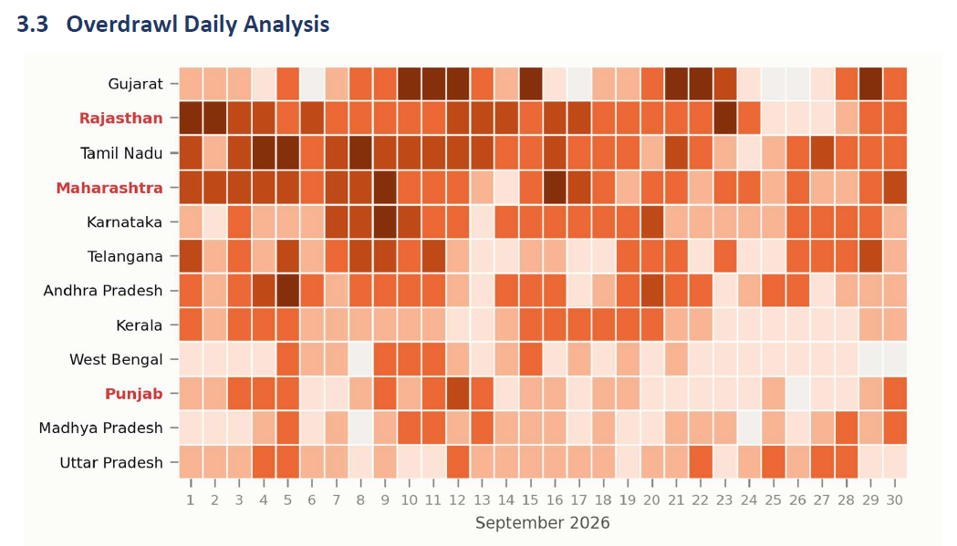
Heat map of overdrawal by state (1. Based on % of duration of OD when freq <49.9)
Annexure 2.3 (Plot of each state OD & Messages already using old reports)

3. Central Sector Generator Performance Details
Scope: Only generators with under-injection are listed. Reporting window: Slot1
Reporting Period | Generator Name  (Agency) | Min. Freq.  (Hz) & Time | Freq <49.5 Hz |  |  |  | Freq <49.7 Hz |  |  |  | Freq <49.9 Hz
Reporting Period | Generator Name  (Agency) | Min. Freq.  (Hz) & Time | Duration: — Min |  |  |  | Duration: — Min |  |  |  | Duration: — Min
Reporting Period | Generator Name  (Agency) | Min. Freq.  (Hz) & Time | UI Duration  (Min & %) | Avg. UI  (MW) | Max UI  (MW) | Violation  Messages | UI Duration  (Min & %) | Avg. UI  (MW) | Max UI  (MW) | Violation  Messages | UI Duration  (Min & %) | Avg. UI  (MW) | Max UI  (MW) | Violation  Messages
04-Oct-2026 | FSTPP III (ISGS)  500 MW | — | — | — | — | — | — | — | — | — | — | — | — | —

Scope: Only generators with under-injection are listed. Reporting window: Slot2
Reporting Period | Generator Name  (Agency) | Min. Freq.  (Hz) & Time | Freq <49.5 Hz |  |  |  | Freq <49.7 Hz |  |  |  | Freq <49.9 Hz
Reporting Period | Generator Name  (Agency) | Min. Freq.  (Hz) & Time | Duration: — Min |  |  |  | Duration: — Min |  |  |  | Duration: — Min
Reporting Period | Generator Name  (Agency) | Min. Freq.  (Hz) & Time | UI Duration  (Min & %) | Avg. UI  (MW) | Max UI  (MW) | Violation  Messages | UI Duration  (Min & %) | Avg. UI  (MW) | Max UI  (MW) | Violation  Messages | UI Duration  (Min & %) | Avg. UI  (MW) | Max UI  (MW) | Violation  Messages
04-Oct-2026 | FSTPP III (ISGS)  500 MW | — | — | — | — | — | — | — | — | — | — | — | — | —

4. Action & Chronology of Events:
Total no of messages issued:
Entity | Total Message | Frequency Violation |  |  |  | Deviation violation
Entity | Total Message | Non Compliance | Extreme Emergency | Emergency | Alert | Warning | Emergency
 | State
Bihar | 7 | 3 | 3 | 1 | 0 | 0
DVC | 8 | 2 | 4 | 1 | 1 | 0
Odisha | 3 | 0 | 2 | 0 | 1 | 0
Jharkhand | 3 | 1 | 2 | 0 | 0 | 0
West Bengal | 10 | 4 | 3 | 2 | 1 | 0
 | Generators
DARLIPALI (NTPC) | 2 | 0 | 2 | 0 | 0 | 0
BARH | 2 | 0 | 1 | 1 | 0 | 0
IBEUL | 1 | 0 | 0 | 1 | 0 | 0
JITPL | 2 | 0 | 0 | 1 | 1 | 0
NABINAGAR(NPGC) | 2 | 0 | 0 | 1 | 1 | 0
NKSTPP | 1 | 0 | 0 | 1 | 0 | 0
TSTPP | 1 | 0 | 1 | 0 | 0 | 0

Event chronology table (include all messages & Physical regulatory option) – Each slot of day separate table in Annexure 4

5. Action of Deference Mechanism (ADMS & UFR):

Data will be fetched from CRMS (Future provision)

