LibraryFlow ERP Project Report

LibraryFlow ERP
BCA V Semester Mini Project
Chandan | Roll No. 243501033 | Section A, Group A2

Submission detail | Information
Student name(s) and roll number(s) | Chandan, Roll No. 243501033
Course code | Not supplied in the project materials
Course name | Computer Graphics Mini Project (per supplied guidelines)
Programme and semester | BCA V Semester, Section A, Group A2
Faculty / department | Faculty of Computer Science
Faculty guide | Not supplied in the project materials
Academic year | 2026-27
Report prepared | 16 October 2026

BCA V Semester project report | Academic year 2026-27 | Report date: 16 October 2026

Abstract
LibraryFlow ERP is a browser-based application for managing a single college library. It maintains a searchable book catalogue, student member register and issue/return history in MariaDB. Built with PHP 8, mysqli, Apache, HTML, CSS and vanilla JavaScript, it provides dashboard totals, book and member record management, combined search, lending reports and staff access with administrator and librarian roles. Administrators can create, deactivate, reactivate, reset or permanently remove librarian accounts; administrator accounts are protected. The lending workflow checks copy availability, rejects duplicate returns, blocks new issues while an open loan is overdue, and applies a 10-day borrowing hold after a late return. Staff can show or hide password entries, set new passwords with at least eight characters including lowercase, uppercase and a special character, and request one-use email reset links that expire after one hour. Prepared statements, server-side validation, CSRF protection, password hashing, session checks and rate limits protect account and database operations. The public source includes the schema and a 1,000-entry Project Gutenberg catalogue seed; the real student roster and local credentials are excluded. The isolated HTTP suite passed 103 checks on PHP 8.2.12 and MariaDB 10.4.32, with separate checks for migration idempotency and reset-token hashing and expiry. This report documents the system design, algorithms, database, interface, results, limitations and setup. LibraryFlow is a web application, not a Turtle/Pygame drawing or animation project. Production hosting and manual classroom screenshots remain pending.
Word count: 231. Keywords: library management, PHP, MariaDB, CRUD, issue and return, inventory reporting.

1 Introduction

1.1 Background and motivation
A college library manages a changing collection of titles and copies alongside a register of borrowers and lending events. When these records are kept in separate paper registers or spreadsheets, staff can spend time reconciling copy counts, searching for a borrower, and identifying open or overdue loans. LibraryFlow brings the catalogue, member register and loan history into one relational database and calculates availability from that history.

1.2 Problem statement
The project addresses the risk of slow lookup and inconsistent inventory when book, member and lending records are maintained separately. The system needs to let a local operator find a title or member, record an eligible issue and return, preserve transaction history, and review current inventory and loan status.

1.3 Objectives
- Provide complete create, read, update and delete workflows for books and members.
- Search books by title, author or identifier and search members by name, code or identifier.
- Allow an issue only when the member exists, dates are valid, a copy is available and no overdue loan or late-return hold blocks borrowing.
- Record a return once and retain the issue record for history.
- Calculate available and overdue counts from stored inventory and open issue records.
- Provide a dashboard, issue register and reports for a local single-library demonstration.

1.4 Scope and exclusions
The baseline covers one local library, authenticated administrator and librarian accounts, book and member records, issue and return transactions, search, dashboard totals, reports, password visibility controls and one-use password recovery. One book row represents one title and its total physical copies. Administrators can create librarian accounts, set passwords, deactivate or reactivate access, or permanently remove librarian accounts; administrator accounts are protected from those actions. New passwords require at least 8 characters including lowercase, uppercase and a special character. An overdue open loan blocks new issues, and a late return starts a 10-day hold after return. Password reset links expire after one hour and depend on configured email delivery. The project excludes multiple branches, fines, payments, reservations, reminders, barcode scanning, multi-factor authentication and public production hosting. Privacy and terms pages need institution-specific approval; production hosting, monitoring, backup recovery and mail delivery remain to be configured.

2 Methodology

2.1 Development method and tools
The application uses server-rendered PHP pages. A staff member signs in through Apache; shared PHP bootstrap code starts the session, applies security headers and checks authentication and role access. PHP validates inputs and business rules, uses mysqli prepared statements with MariaDB, and returns HTML styled with CSS. Vanilla JavaScript provides small interface interactions. Automated checks used XAMPP on D: with PHP 8.2.12, MariaDB 10.4.32 and Apache 2.4.58; the XAMPP package release was not recorded.
Layer or tool | Observed project environment or role
XAMPP | 8.2.12 package; local Apache and MariaDB stack
Apache | 2.4.58
PHP | 8.2.12; mysqli extension available
Database | MariaDB 10.4.32; InnoDB and utf8mb4 schema
Interface | HTML5, CSS and vanilla JavaScript
Browser / editor / computer model | Not recorded in supplied project evidence

2.2 Application workflow
Staff authenticate with hashed passwords. New-password forms show a live checklist for the eight-character minimum, lowercase, uppercase and special-character rules; login does not show that checklist. Password fields can be shown or hidden. Administrators can set librarian passwords, deactivate or reactivate librarian access, and permanently remove librarian accounts; administrator accounts are protected from these controls. Staff can request one-use recovery links by email; links expire after one hour, and administrators can set a librarian password if mail delivery is unavailable. Book and member submissions are validated on the server. Search uses parameterized queries. Issue and return actions use transactions and row locks to enforce stock, overdue, hold and duplicate-return rules.

2.3 Algorithms and business logic
Operation | Processing logic
Create or update a book/member | Receive POST data; validate required fields and formats; verify uniqueness and copy constraints; execute a prepared write; redirect with a status message.
Delete a book/member (administrator only) | Require administrator role, POST and a session CSRF token; confirm the record; retain it when issue history exists; rely on foreign-key RESTRICT for integrity.
Issue a book | Validate IDs and dates; require due date on or after issue date; begin transaction; lock book and member rows; reject an open overdue issue or active 10-day hold from a prior late return; check the open issue count; reject if no copy remains; insert issue row; commit.
Return a book | Require POST and CSRF token; lock issue row; reject missing or already-returned records; set return_date to today if not before issue_date; when return_date is later than due_date, derive a 10-day borrowing hold from the issue history; commit.
Availability and overdue | Issued = count of open issue rows. Available = total_copies minus issued. Overdue = open issue with due_date earlier than today.

2.4 Step-by-step input and output flow
1. A staff member signs in as an administrator or librarian; a successful sign-in opens the dashboard.
2. The signed-in staff member selects Search, Dashboard, Books, Members, Issue/Return or Reports. Administrators can also manage librarian access from Staff access and set passwords from the same account list.
3. The browser sends GET requests for lists and filters and POST requests for changes.
4. PHP checks the role, CSRF token, input and module rules before a protected write.
5. PHP reads or updates MariaDB using mysqli prepared statements and foreign-key relationships.
6. The server returns current rows, validation messages, status messages or an empty state; CSS styles the interface and database-derived totals.

2.5 Coordinate system and graphics library
This project does not draw geometric scenes or animate objects. It has no program-defined Cartesian canvas and does not use Turtle, Pygame, Matplotlib or another graphics library. Its visual output is a browser interface arranged with HTML document flow and the CSS box model within the viewport. The diagrams in this report explain system and data flow; they are not screenshots of the running application. The report follows the supplied structure while describing the actual web application accurately.

2.6 System flowchart
The flowchart summarizes module selection, validation and transactional lending after a staff member has signed in.
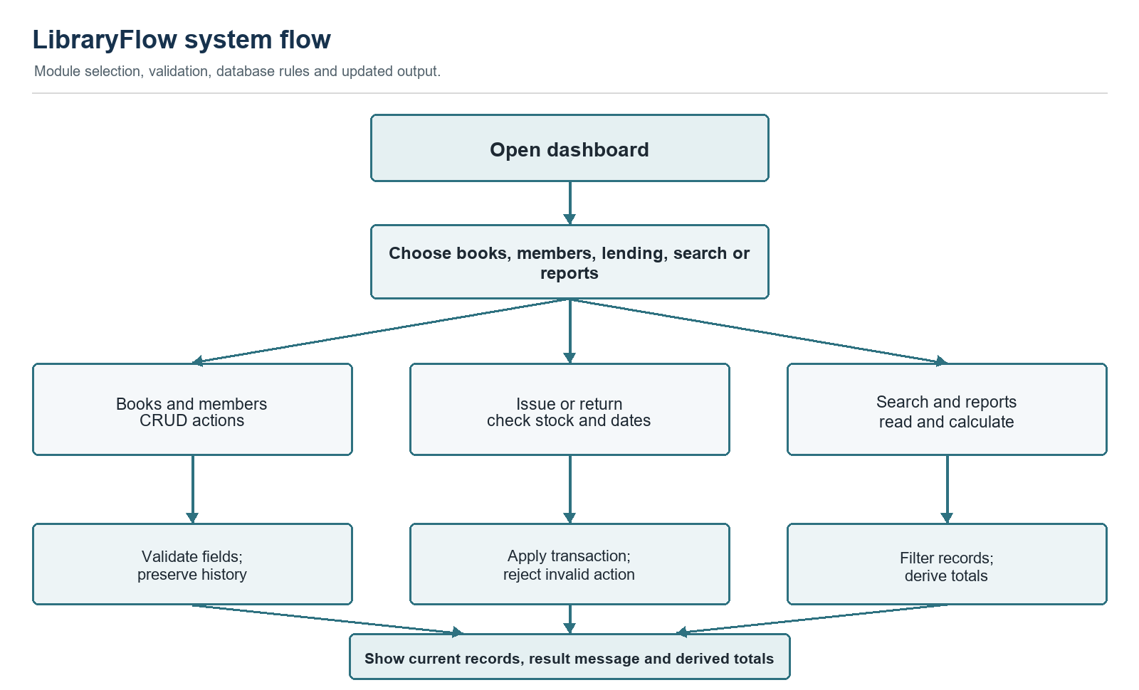
Figure 1. LibraryFlow system flow

2.7 Data flow diagram level 0
An authenticated local staff user, acting as administrator or librarian, provides catalogue, member, search and lending inputs. LibraryFlow reads and writes the local database and returns lists, validation messages, loan status and summaries.
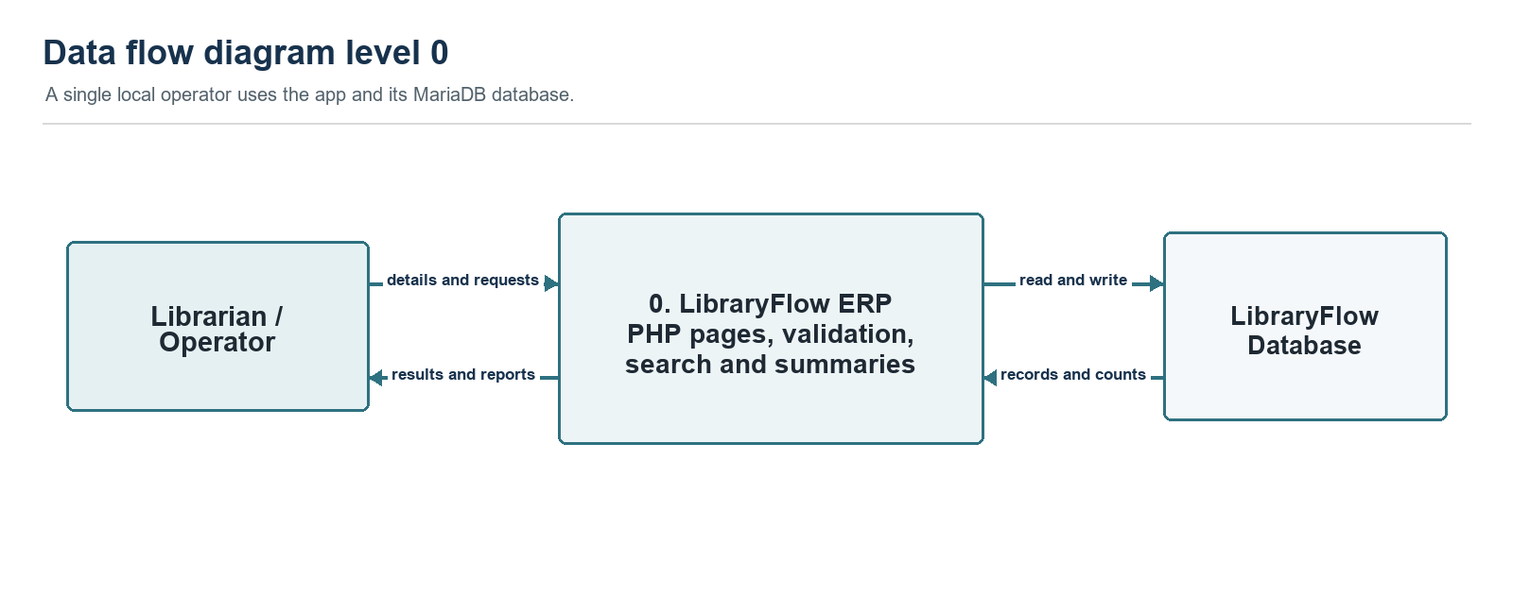
Figure 2. Context data flow diagram

2.8 Data flow diagram level 1
Level 1 describes catalogue maintenance, member maintenance, lending, search and report generation. Authentication is enforced by the shared PHP bootstrap; staff accounts and login-throttling keys are stored separately from circulation records.
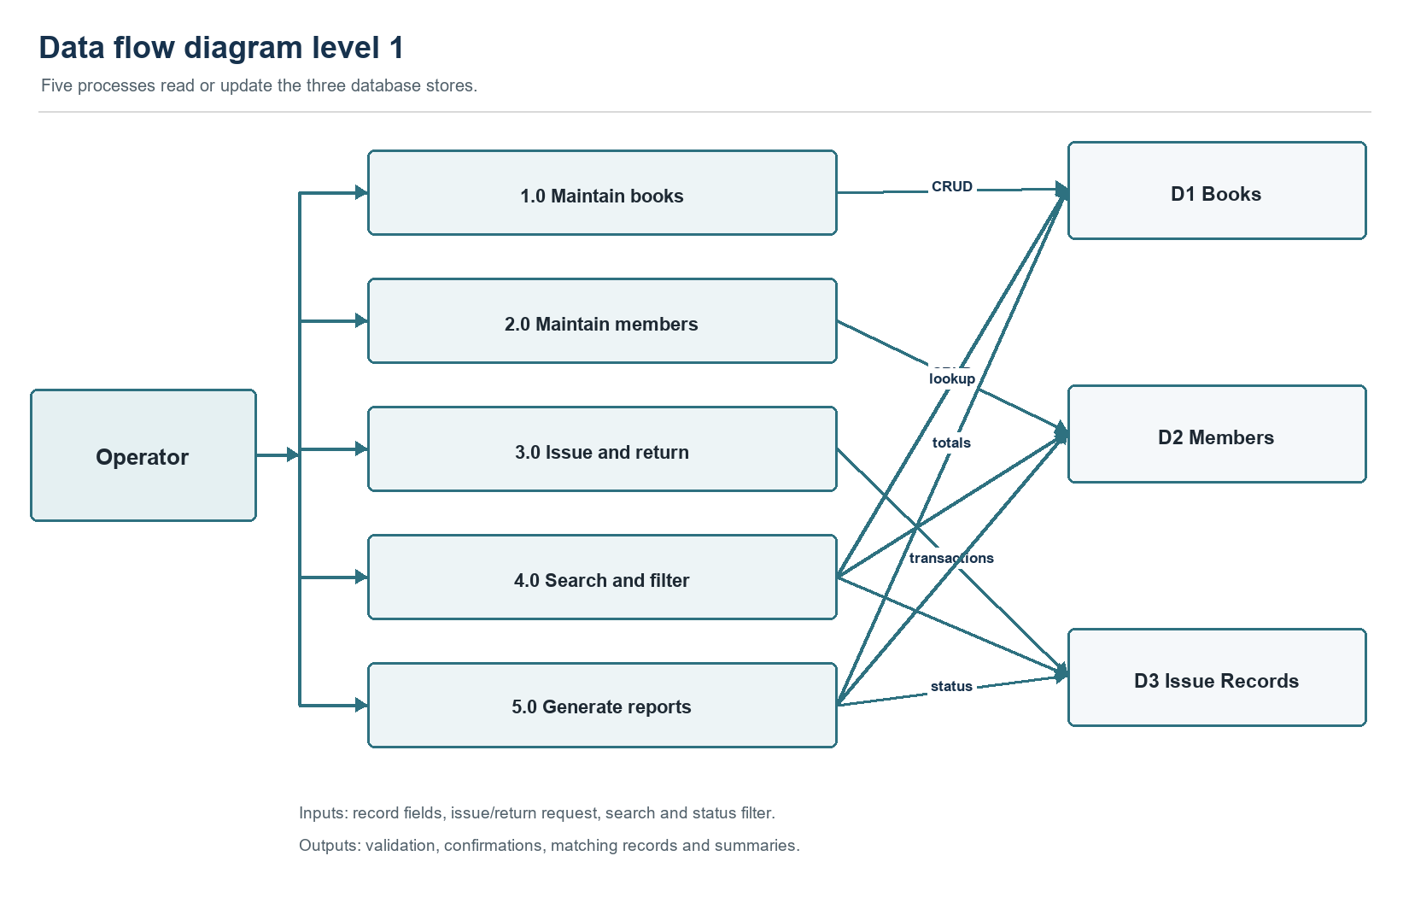
Figure 3. Level 1 data flow diagram

2.9 Entity relationship diagram
Books and Members each have a one-to-many relationship with Issue Records. The diagram focuses on circulation; Users, Login Attempts, Password Reset Tokens and Password Reset Rate Limits support staff authentication and recovery. A referenced book or member cannot be deleted.
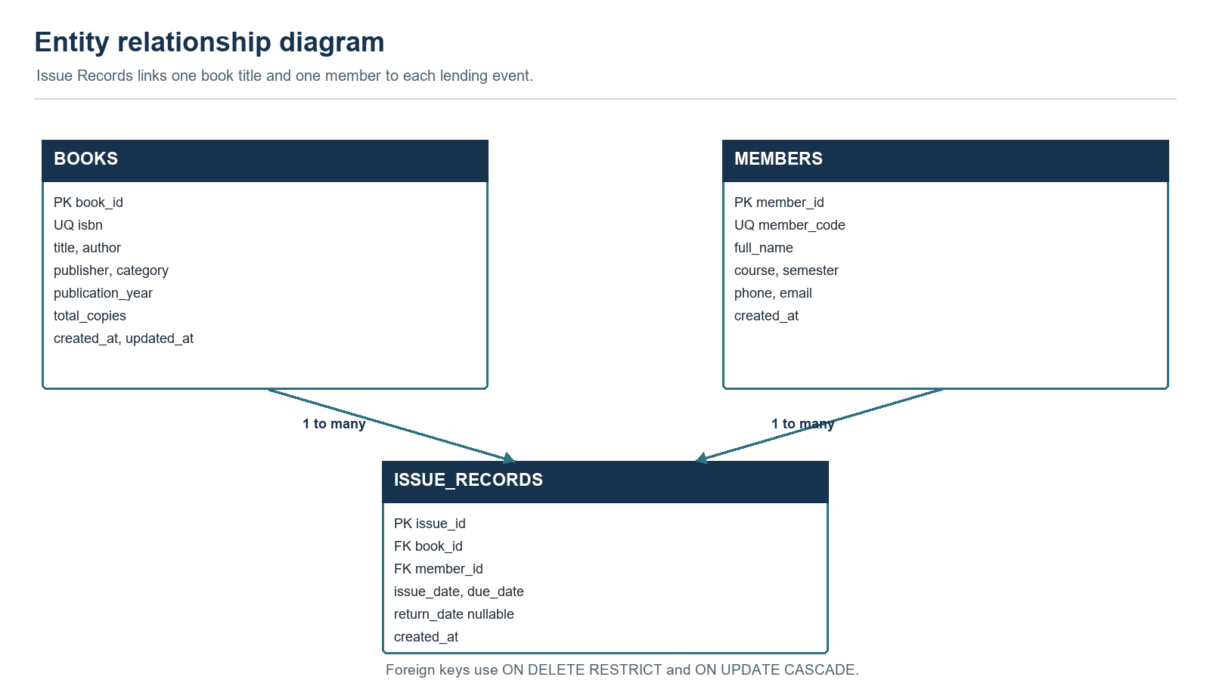
Figure 4. Entity relationship diagram

2.10 Database table structure
The diagram presents the three core circulation tables. Additional tables store staff users, hashed sign-in throttling keys, hashed one-use reset tokens and reset-request rate limits. The schema uses unsigned auto-incrementing primary keys, unique ISBN and member-code keys, indexes for search and status lookups, and foreign keys with ON DELETE RESTRICT and ON UPDATE CASCADE.
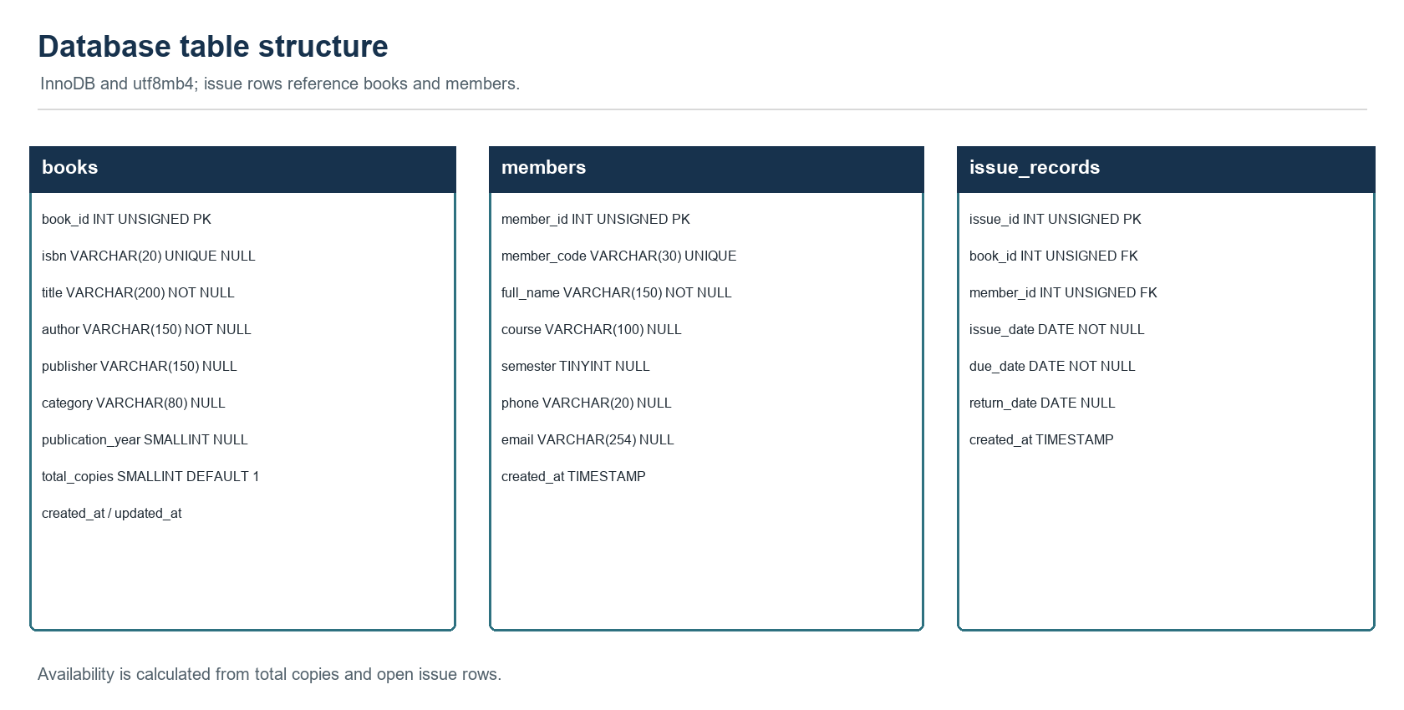
Figure 5. Database table structure

2.11 Application architecture
The architecture diagram shows browser requests passing through Apache and PHP modules to MariaDB. Shared bootstrap and helper code enforce sign-in, roles, security headers, database access, escaping, validation support and CSRF fields.
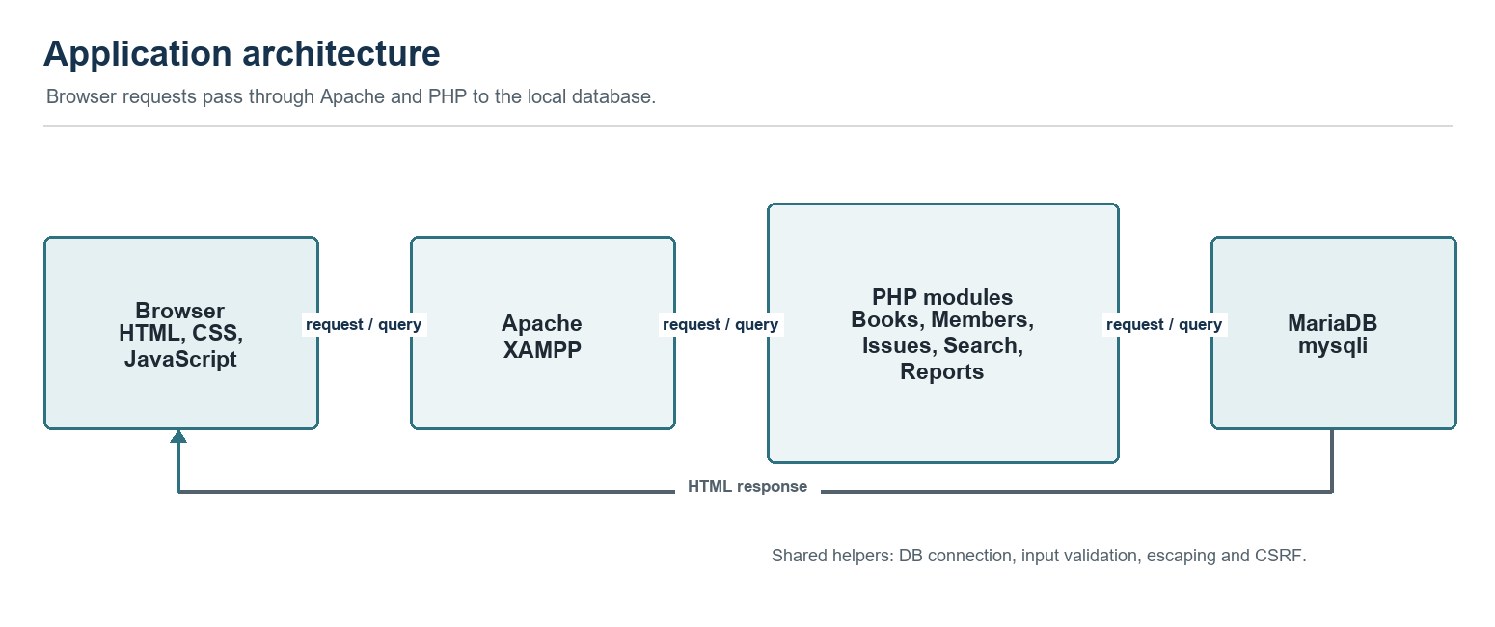
Figure 6. Application architecture

3 Results and Analysis

3.1 Implemented screens and operations
Screen or module | Implementation observed in project files
Dashboard | Database-derived title, copy, member, open-loan and overdue summaries; recent issues.
Books | Searchable catalogue; create, list and edit; administrator-only delete; total, issued and available copies.
Members | Member register with create, list and edit; administrator-only delete; unique member codes.
Issue/Return | Issue form, open/returned/overdue filters and one-time return action.
Search | Combined lookup across books and members with partial text and numeric-ID matching.
Reports | Inventory totals by title, filtered totals, issue-status filter and print action.
Staff access | Authenticates administrators and librarians, throttles failed sign-ins, supports show/hide and self-service password recovery, and lets administrators set librarian passwords, deactivate/reactivate access or permanently remove librarian accounts. Administrator accounts are protected.

3.2 Project data
The public catalogue seed contains 1,000 Project Gutenberg catalogue entries with titles, authors, subjects and ebook release years. Those years identify digital ebook releases and are not necessarily original print years. ISBNs are blank when the source does not provide them. Real student roster data is excluded from the public repository and this report's published data files. The public seed creates no student members and no issue history; the isolated HTTP suite creates synthetic records in a separate test database.
Record type | Count | Interpretation
Book catalogue | 1,000 | Project Gutenberg catalogue metadata; ebook release years are not necessarily print years.
Members | Not included in public source | Real college roster data stays local and is excluded from the public repository.
Issue records | 0 in public sample seed | No fabricated loan history is seeded; enter genuine transactions locally.

3.3 Functional analysis
Copy availability is not stored twice. The application calculates it from total copies and open issue rows, reducing the risk that a separate number becomes stale. Issue transactions lock the selected book and member rows before checking open issues and inserting a loan. The server rejects new issues when a member has an overdue open loan or an active 10-day hold from a late return. Foreign keys preserve valid references, while RESTRICT protects historical transactions.
Book and member input is checked on the server. SQL values use prepared statements and displayed values are HTML-escaped. Staff passwords are hashed, new-password forms enforce the eight-character, lowercase, uppercase and special-character policy, repeated failed sign-ins and reset requests are rate-limited, state-changing forms include CSRF tokens, and access is role-checked. Only administrators can delete books or members and manage librarian accounts. Administrator management actions target librarian accounts only; password changes, resets and deactivation invalidate existing librarian sessions. These are implementation checks, not an external security audit or production-readiness claim.

3.4 Visual output and performance observations
The output is a functional browser-based administrative interface rather than a geometric drawing or animation. It includes a shared page layout, forms, tables, status labels, empty states and responsive styling. No measured response times, load test or viewport compatibility test was supplied, so no quantitative performance claim is made. No UI screenshots are included in the public repository; capture genuine screens with synthetic records for the final classroom submission.

3.5 Verification status
Evidence area | Status when report was prepared
Schema and roster seed | Schema import reviewed; the public catalogue seed contains 1,000 entries and no student or loan records.
Source implementation review | Current routes, database schema, authentication, security helpers and seeds reviewed; PHP lint passed for 27 files.
Browser acceptance cases | 103 HTTP checks passed against a fresh isolated synthetic database; separate migration and reset-token hash/expiry checks passed.
Application screenshots | Not included in public repository; capture genuine screens using synthetic records for classroom submission.
Response-time or load measurements | Not performed; no performance figures are claimed.

3.6 Limitations
- Staff sign-in, administrator/librarian roles and one-use email password recovery are implemented. Recovery mail requires a configured mail transport. Multi-factor sign-in, an audit log and borrower accounts are outside the current baseline.
- Real student roster files, local credentials and real lending history are excluded from the public repository. The public catalogue seed contains no student members or fabricated loans.
- The default due-date period is 14 calendar days; the library or faculty should confirm the policy.
- No fines, reservations, audit log, barcode support, export workflow or multi-branch model.
- The isolated HTTP suite passed 103 checks; separate migration and reset-token hashing/expiry checks also passed. Earlier local Apache access checks passed. A manual classroom-computer walkthrough and genuine screenshots remain to be completed.

4 Conclusion and Future Scope
The public GitHub repository contains the PHP application, schema, synthetic catalogue seed, setup guidance and this report. The real student roster, local credentials, database backups and test-only records are excluded.
The project demonstrates PHP-MariaDB integration, prepared queries, server-side validation, protected administrator accounts, librarian management, relational constraints, transactional lending logic, late-return holds, email recovery and browser-based reporting. In an isolated synthetic database, 103 HTTP checks passed; separate checks confirmed migration repeatability, reset-token hashing and expiry. Earlier local XAMPP Apache checks confirmed that private source and data files are not downloadable. A manual classroom demonstration and genuine screenshots are still needed for final assessment.

4.1 Future improvements
- Add an audit trail for manual corrections, multi-factor sign-in, reservations, barcode lookup, pagination and export after validating report totals. Agree on loan, fine and reminder policies before implementing those features. Configure a supported SMTP service for password recovery and complete deployment-specific privacy and terms reviews.
- Provide accessible, small-screen layouts and measure performance after representative records and hosting are in place.
- Add barcode lookup, pagination and export after validating report totals.
- Add verified accessibility and small-screen checks, followed by measured performance tests.

5 References
1. LibraryFlow ERP Product Requirements Document, supplied specification for the BCA V Semester project.
2. PHP documentation, MySQLi prepared statements: https://www.php.net/manual/en/mysqli.quickstart.prepared-statements.php
3. MariaDB Documentation, InnoDB foreign keys: https://mariadb.com/kb/en/foreign-keys/
4. MDN Web Docs, CSS: https://developer.mozilla.org/en-US/docs/Web/CSS
5. Project Gutenberg, offline catalogs: https://www.gutenberg.org/ebooks/offline_catalogs.html
6. LibraryFlow README, database/libraryflow.sql and database/libraryflow_demo_data.sql.

6 Appendices

Appendix A. Local setup and demonstration procedure
1. Keep the project under Apache's document root, for example D:\XAMPP\htdocs\libraryflow. Use the matching folder name in the local URL.
2. Open the XAMPP Control Panel installed on D: and start Apache and MySQL. Resolve any port conflict first.
3. Open http://localhost/phpmyadmin and import database/libraryflow.sql. Import database/libraryflow_demo_data.sql for the catalogue. The public repository has no real-student roster file; use only a separately supplied, institution-approved local import if one is available.
4. If database settings differ, copy config/local.php.example to config/local.php and enter local credentials. Keep config/local.php out of source control.
5. From the same computer, open http://localhost/libraryflow/setup.php and create the first administrator. Then sign in at http://localhost/libraryflow/login.php and verify the modules.
For self-service password recovery, configure public_url and mail_from in config/local.php and configure PHP mail transport. Apply database/migrations/20261016_password_reset.sql to an existing database; a fresh schema import already includes these tables. Enter only institution-approved member data and genuine lending transactions on the trusted local system.

Appendix B. Repository and evidence checklist
Submission item | Current record
GitHub repository URL | https://github.com/chandanprajapat-7568/LibraryFlow
Team names, roll numbers and contributions | Chandan, 243501033, Section A, Group A2; requirements review, local setup/data review, feature feedback and report coordination. Confirm any additional team contributions with faculty.
Dashboard screenshot | Not included; capture with synthetic data before final classroom submission.
Books CRUD and search | Not included; capture create, list, update and safe-delete outcomes with synthetic data.
Member CRUD and search | Not included; capture create, search, update and blocked delete with synthetic data.
Issue, return and report | Not included; capture issue, return, filters and summary with synthetic data.
Acceptance results | 103 isolated HTTP checks and separate migration/token checks passed; complete the manual classroom walkthrough.
GitHub repository: https://github.com/chandanprajapat-7568/LibraryFlow. The repository contains the source, non-sensitive schema/catalogue data and this report; the real student roster and local credentials are excluded.

Appendix C. Database data dictionary
Table | Column | SQL type | Constraint or rule | Purpose
books | book_id | INT UNSIGNED | PK; auto increment | Book title identifier
books | isbn | VARCHAR(20) | Nullable; unique | International book number
books | title | VARCHAR(200) | Required | Title
books | author | VARCHAR(150) | Required | Author
books | publisher | VARCHAR(150) | Nullable | Publisher/source
books | category | VARCHAR(80) | Nullable | Subject/category
books | publication_year | SMALLINT UNSIGNED | Nullable | Catalog seed uses ebook release year
books | total_copies | SMALLINT UNSIGNED | Required; default 1 | Total physical copies
books | created_at | TIMESTAMP | Required; default current timestamp | Creation time
books | updated_at | TIMESTAMP | Required; auto-updated | Last update time
members | member_id | INT UNSIGNED | PK; auto increment | Member identifier
members | member_code | VARCHAR(30) | Required; unique | Library member code
members | full_name | VARCHAR(150) | Required | Borrower name
members | course | VARCHAR(100) | Nullable | Course
members | semester | TINYINT UNSIGNED | Nullable | Semester
members | phone | VARCHAR(20) | Nullable | Optional contact
members | email | VARCHAR(254) | Nullable | Optional email
members | created_at | TIMESTAMP | Required; default current timestamp | Creation time
issue_records | issue_id | INT UNSIGNED | PK; auto increment | Loan identifier
issue_records | book_id | INT UNSIGNED | Required; FK books | Title loaned
issue_records | member_id | INT UNSIGNED | Required; FK members | Borrower
issue_records | issue_date | DATE | Required | Issue date
issue_records | due_date | DATE | Required | Scheduled return date
issue_records | return_date | DATE | Nullable | Null while open
issue_records | created_at | TIMESTAMP | Required; default current timestamp | Creation time
users | user_id | INT UNSIGNED | PK; auto increment | Staff user identifier
users | display_name | VARCHAR(100) | Required | Name shown in staff screens
users | email | VARCHAR(254) | Required; unique | Staff sign-in address
users | password_hash | VARCHAR(255) | Required | PHP password hash; no plain-text password
users | role | ENUM('admin','librarian') | Required | Staff permissions
users | is_active | TINYINT(1) | Required; default 1 | Whether sign-in is allowed
users | session_version | INT UNSIGNED | Required; default 0 | Invalidates prior sessions after password change
users | created_at | TIMESTAMP | Required; default current timestamp | Account creation time
users | last_login_at | TIMESTAMP | Nullable | Most recent successful sign-in
login_attempts | attempt_key | CHAR(64) | PK | Hashed sign-in throttling key
login_attempts | failed_attempts | TINYINT UNSIGNED | Required; default 0 | Failed attempts in the current window
login_attempts | window_started_at | DATETIME | Required | Start of the throttling window
login_attempts | locked_until | DATETIME | Nullable | End of a temporary sign-in lock
password_reset_tokens | token_id | BIGINT UNSIGNED | PK; auto increment | Reset-token identifier
password_reset_tokens | user_id | INT UNSIGNED | FK users; required | Staff account requesting recovery
password_reset_tokens | token_hash | CHAR(64) | Unique; required | SHA-256 hash of one-use token
password_reset_tokens | created_at | TIMESTAMP | Required; default current timestamp | Token creation time
password_reset_tokens | expires_at | DATETIME | Required | One-hour token expiry
password_reset_rate_limits | attempt_key | CHAR(64) | PK | Hashed reset-request rate-limit key
password_reset_rate_limits | window_started_at | DATETIME | Required | Start of rate-limit window
password_reset_rate_limits | request_count | TINYINT UNSIGNED | Required | Requests in the current window

