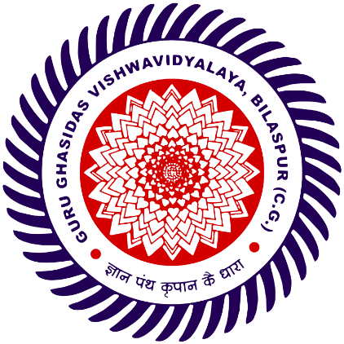
Guru Ghasidas Vishwavidyalaya, Bilaspur

Department of Computer Science & Information Technology
MCA – 3rd Semester ( 2024-2026 )

A Project Report On
Instagram Clone Website
(Minor Project)

Under The Guidance of Dr. Babita Majhi
Associate Professor in Dept. of CSIT
Co-Ordinator of MCA

Submitted by :–
Name - Chandan Kumar
Roll No – 24072124
Enrolment No – GGV/24/05022
Class – MCA 3rd Sem
Session – 2024-2026
____________________
Signature - Dr. Babita Majhi
Submitted Date – 16/12/2025

