SR.No | CONTENT | PAGE No.
1 | Declaration | 2
2 | Certificate | 3
3 | Acknowledgement | 4
4 | Abstract | 5
5 | Introduction | 6
6 | Objective | 7
7 | Resource Requirement | 8-9
8 | Feasibility Study | 10
9 | System Planning & SDLC | 11-12
10 | Project Analysis | 13-14
11 | Project Feature | 15-16
12 | Project File Structure | 17-19
13 | API Routes | 20-22
14 | Output | 23-26
13 | Testing | 27-28
14 | Advantage & Disadvantage | 29
15 | Future Scope & Enhancement | 30
16 | Conclusion | 31
17 | Bibliography | 32
18 | Important Links

DECLARATION

I am Chandan Kumar, a student of Master of Computer Applications (MCA), 3rd Semester at Guru Ghasidas Vishwavidyalaya, Bilaspur, hereby declare that the project titled “Instagram Clone” is a result of my own independent work and effort. This project has been developed as a part of the minor project and has not been submitted previously for the award of any other degree or diploma to any other university or institution.
All information and content presented in this project report has been collected and referenced from genuine sources and publicly available documentation. Wherever external help or resources have been used, due credit has been given in the Bibliography and Acknowledgement sections of this report.
This work was carried out under the guidance of Dr. Babita Majhi, Associate Professor, Department of Computer Science and Information Technology (CSIT), GGV Bilaspur and co-ordinator of MCA Dept., whose support and mentorship is gratefully acknowledged.
I understand that any violation of academic integrity and originality may lead to disciplinary actions as per university guidelines.

Date: 16/12/2025
Place: Bilaspur
Student Details:
Name: Chandan Kumar
Roll No: 24072124
Enrolment No: GGV/24/05022
Semester: MCA 3rd Sem

_____________________
( Signature of Student )

CERTIFICATE

This is to certify that the project entitled “Instagram Clone” submitted by Chandan Kumar, Roll no. 24072124 a student of Master of Computer Applications (MCA), 3rd Semester at Guru Ghasidas Vishwavidyalaya, Bilaspur, is a record of the minor project work carried out during the academic session under my guidance.
The work embodied in this project is original and has not been submitted for the award of any other degree.
This work was carried out under the guidance of Dr. Babita Majhi, Associate Professor, Department of Computer Science and Information Technology (CSIT), GGV Bilaspur and co-ordinator of MCA Dept., whose support and mentorship is gratefully acknowledged

Date: 16/12/2025
Place: Bilaspur
Student Details:
Name: Chandan Kumar
Roll No: 24072124
Enrolment No: GGV/24/05022
Semester: MCA 3rd Sem

_____________________ _______________________
Dr. Babita Majhi Dr. Pushplata Pujari
(Project Guide) (Head of Department)

______________________
Project Examiner

ACKNOWLEDGEMENT

I would like to express my sincere gratitude to all those who supported and guided me during the development of my minor project titled “Instagram Clone”, submitted as part of the MCA 3rd Semester curriculum at Guru Ghasidas Vishwavidyalaya, Bilaspur.
First and foremost, I would like to express my deepest thanks to Dr. Babita Majhi, Associate Professor, Department of Computer Science and Information Technology (CSIT) and Coordinator of the MCA Department, who served as my project guide. Her consistent encouragement, expert knowledge in web technologies, and valuable feedback helped shape this project into a successful academic endeavour. Her mentorship throughout the project cycle—from planning and development to documentation—was instrumental in enhancing my understanding and confidence.
I also extend my heartfelt appreciation to Dr. Pushplata Pujari, Professor and Head of Department (HOD), CSIT, GGV Bilaspur, for providing the necessary academic environment, resources, and infrastructure that facilitated the smooth execution of this project.
My sincere thanks go to all the faculty members of the Department of CSIT for imparting their knowledge and supporting us throughout the semester. I would also like to acknowledge the encouragement and support provided by my classmates and friends, who offered their insights, testing help, and motivation.
Last but not least, I thank my family for their constant moral support and encouragement throughout this learning journey.
This project not only strengthened my technical skills in Full Stack Web Development using the MERN stack (MongoDB, Express.js, React, Node.js), but also provided hands-on experience with Redux for state management, Socket.io for real-time communication, and Tailwind CSS for modern UI design. It taught me the value of structured planning, problem-solving, and clean coding practices.

ABSTRACT

In the modern era of digital communication and social networking, media sharing platforms have become the primary mode of interaction and content consumption. While there are numerous established social media applications available, understanding the underlying architecture of scalable, real-time communication systems is essential for modern software development.
This project, titled “Instagram Clone”, addresses the demand for seamless social interaction by providing a robust, full-stack web application that replicates the core functionalities of a major social networking platform.
The objective of this project is to develop a responsive and dynamic web application that enables users to create accounts, share multimedia content, interact with peers, and communicate in real-time without latency. The application leverages the MERN Stack (MongoDB, Express.js, React, Node.js) to ensure a unified JavaScript development environment from front-end to back-end.
Key features include secure user authentication, image uploading and storage via Cloudinary, and a dynamic feed that supports creating, liking, and bookmarking posts. A standout feature of this application is the integration of Socket.io, which facilitates real-time one-on-one messaging and instant notifications for user interactions, significantly enhancing user engagement. The user interface is designed using Tailwind CSS and Shadcn UI components, ensuring a modern, responsive experience across all devices.
This project not only demonstrates the practical application of Full Stack Web Development but also emphasizes the importance of state management using Redux Toolkit, database modeling with Mongoose, and secure API architecture. It serves as a comprehensive platform for educational use and further enhancements, such as video stories, AI-driven content recommendations, and advanced privacy settings.

INTRODUCTION

In recent years, web technologies have evolved significantly, transitioning from static content pages to dynamic, real-time Single Page Applications (SPAs). Among these advancements, social networking platforms have become integral to digital communication, demanding high availability, instant data synchronization, and seamless user experiences across devices. Unlike traditional web pages that require frequent reloads, modern SPAs offer a fluid, app-like experience directly in the browser.
The “Instagram Clone” project is a robust, full-stack social media application designed to replicate the core functionalities of a major networking platform. Developed using the MERN Stack (MongoDB, Express.js, React, Node.js), this application operates on a client-server architecture, ensuring secure data handling and scalable performance. Unlike client-side-only tools, this project utilizes a dedicated backend to manage user authentication, data persistence, and media storage via Cloudinary.
The user interface is styled using Tailwind CSS and Shadcn UI components, ensuring a modern, intuitive, and responsive design accessible to all users. Key features include secure user registration and login, the ability to create and upload posts with captions, and interactive elements such as liking, commenting, and bookmarking content.
A defining feature of this project is the integration of Socket.io to enable real-time communication. This technology powers instant one-on-one messaging and provides live notifications when users interact with posts, significantly enhancing user engagement. Additionally, the project utilizes Redux Toolkit and Redux Persist for efficient state management, ensuring that user sessions and application states are preserved even after page reloads.
The primary motivation behind this project is to demonstrate the capability of full-stack development in building complex, interactive applications. It provides hands-on experience with RESTful API design, database modeling with Mongoose, state management, and real-time event handling—skills that are essential for any modern software engineer.

OBJECTIVE

The primary objective of the “Instagram Clone” project is to design and develop a robust, full-stack social networking application that replicates the core functionalities of a modern media-sharing platform. This project aims to showcase the integration of front-end and back-end web technologies to create a seamless, interactive, and real-time user experience. The key objectives of this project are as follows:
1. Full-Stack Application Development To develop a scalable Single Page Application (SPA) using the MERN Stack (MongoDB, Express.js, React, Node.js), demonstrating the ability to connect a dynamic front-end with a secure and efficient back-end architecture.
2. Real-Time Communication System To implement real-time, bi-directional communication capabilities using Socket.io. This includes enabling instant one-on-one messaging between users and providing real-time notifications for likes, comments, and interactions without requiring page refreshes.
3. Secure User Authentication & Authorization To design a secure authentication system using JWT (JSON Web Tokens) and bcrypt for password hashing. This ensures that users can securely register, log in, and access protected routes, maintaining data integrity and privacy.
4. Advanced State Management To utilize Redux Toolkit and Redux Persist for managing complex application states globally. This includes handling user sessions, chat history, and notification states efficiently across different components and page reloads.
5. Cloud-Based Media Management To integrate Cloudinary for the efficient storage and retrieval of media assets. This objective focuses on handling image uploads (profile pictures and posts), optimization, and serving media content via a Content Delivery Network (CDN).
6. Modern & Responsive UI Design To design a clean, intuitive, and responsive user interface using Tailwind CSS and Shadcn UI components. The goal is to ensure the application provides a consistent and visually appealing experience across various devices, including desktops and mobile phones.
7. Interactive Social Features To implement core social networking functionalities such as creating posts with captions, liking and commenting on posts, bookmarking content, and following/unfollowing users, utilizing a well-structured RESTful API.

RESOURCE REQUIREMENT

The development and deployment of the “Instagram Clone” project require a combination of hardware and software resources, as well as specific development tools and libraries suitable for a full-stack application. Unlike simple client-side projects, this application utilizes a client-server architecture requiring a runtime environment, database connectivity, and cloud storage integration. The resources used in the project are listed below:
1. Human Resources
• Developer: Responsible for frontend design, backend logic, database modeling, and testing.
• Guide/Mentor: Provided technical guidance and reviewed project progress.
• Peer Support: For testing real-time features (chat/notifications), UI feedback, and collaborative debugging.
2. Hardware Requirements To efficiently run the React frontend and Node.js backend servers simultaneously, the following hardware specifications were utilized:
Component | Specification
Processor | Intel Core i5 or higher (recommended for concurrent server execution)
RAM | Minimum 4 GB (8 GB recommended)
Storage | 2 GB free disk space (for node_modules and development tools)
Display | 13" or larger (for responsive UI testing)
Internet | Mandatory (Required for MongoDB Atlas, Cloudinary image upload, and Socket.io connection)
3. Software Requirements The following software environment was required to build and execute the application:
Software | Purpose
Operating System | Windows 10/11, macOS, or Linux
Web Browser | Google Chrome / Microsoft Edge (for Redux DevTools and React Developer Tools)
Code Editor | VS Code (Visual Studio Code)
Runtime Environment | Node.js (v14 or higher) for executing backend JavaScript
API Testing | Browser DevTools / Postman (for testing REST API endpoints)
Database GUI | MongoDB Compass (optional) for visualizing database collections
4. Development Tools & Libraries The project was built using the MERN Stack and various open-source libraries:
Tool / Library | Purpose
MongoDB & Mongoose | NoSQL database and Object Data Modeling (ODM) for storing users, posts, and messages.
Express.js | Web application framework for handling API routes and middleware.
React.js | Frontend library for building the interactive user interface and Single Page Application (SPA).
Node.js | JavaScript runtime for server-side logic.
Socket.io | Library for enabling real-time, bi-directional communication (Chat & Notifications).
Redux Toolkit | For global state management (User auth, Chat history, Posts).
Tailwind CSS | Utility-first CSS framework for responsive and modern styling.
Cloudinary | Cloud-based service for uploading and optimizing images (Profile pictures, Posts).
Shadcn UI / Radix | Pre-built accessible UI components (Dialogs, Avatars, Buttons).
Multer | Middleware for handling multipart/form-data for file uploads
FEASIBILITY STUDY

A feasibility study is a critical step in software development that evaluates whether a project is practically and economically viable. For the "Instagram Clone" project, the study has been conducted across various dimensions to assess its success potential and sustainability. The following types of feasibility have been analyzed.
1. Technical Feasibility This project is technically feasible as it utilizes the robust and industry-standard MERN Stack (MongoDB, Express.js, React, Node.js). These technologies are widely supported, open-source, and scalable. The backend utilizes Node.js and Express for handling API requests and MongoDB for flexible data storage of users and posts. For complex features like real-time communication, the project implements Socket.io, which is a standard library for WebSocket connections. Image management is handled via Cloudinary, eliminating the need for complex local file server maintenance. The frontend is built with Vite and React, ensuring a modern, fast, and component-based development environment that is compatible with all modern browsers.
2. Operational Feasibility The application is designed to be highly operational and user-friendly, mimicking the intuitive interface of popular social media platforms. The user interface utilizes Tailwind CSS and Shadcn UI components (such as Avatars, Dialogs, and Buttons) to ensure a clean, responsive layout that adapts to different screen sizes. Operational efficiency is further enhanced by Redux Toolkit for global state management, ensuring seamless transitions between pages like Home, Profile, and Chat without page reloads. Features like real-time notifications for likes and messages provide immediate feedback, making the system robust and engaging for end-users.
3. Economic Feasibility From a financial standpoint, the project is highly economical. All core technologies used in this application—including the MERN stack libraries and Redux—are open-source and freely available.
• Database: MongoDB can be hosted using free-tier clusters.
• Storage: Image storage is managed through Cloudinary, which offers a free tier for developers.
• Development Tools: Editors like VS Code and testing browsers are free.
4. Time Feasibility The project implementation is structured using a modular architecture, separating concerns into Controllers, Models, and Routes, which streamlines the development and debugging process. The use of reusable UI components (e.g., Post.jsx, CommentDialog.jsx) and pre-built hooks (e.g., useGetAllPost) significantly reduces coding time. Consequently, the development, testing, and deployment of the application are achievable within the allocated academic timeline.

SYSTEM PLANNING & DEVELOPMENT LIFECYCLE (SDLC)

The Software Development Life Cycle (SDLC) is a structured approach followed during the software development process to ensure the delivery of a high-quality product. For the Instagram Clone, the Waterfall Model was chosen due to its simplicity and suitability for academic projects where requirements are well-understood beforehand.
The project followed the following SDLC phases:
1. Requirement Analysis In this phase, the functional and non-functional requirements of the social media application were defined based on the core features of Instagram:
• User Authentication: Users must be able to register, login, and logout securely using JWT (JSON Web Tokens).
• Content Management: Users should be able to create posts with images and captions, which are stored securely.
• Interactivity: The system must support liking/disliking posts, commenting, and bookmarking content.
• Real-Time Communication: Users require a chat interface for instant messaging and real-time notifications for interactions.
• Social Connections: A system to follow and unfollow other users.
2. System Design Based on the requirements, the system architecture and layout were planned using the MERN Stack architecture:
• Backend Design: Designed a RESTful API using Node.js and Express. The database schema was modeled using Mongoose to define relationships between Users, Posts, Comments, and Conversations.
• Frontend Design: A Single Page Application (SPA) structure was planned using React and Vite. The UI layout utilizes Tailwind CSS and Shadcn UI components (e.g., Dialogs, Avatars) for a responsive design.
• State Management: Redux Toolkit was selected to manage global states such as authentication status (authSlice), chat messages (chatSlice), and posts (postSlice).
• Real-Time Architecture: Socket.io was integrated into the design to handle bidirectional communication for the chat feature and live notifications.

3. Implementation (Coding) Development was carried out in a modular structure:
• Database & Storage: MongoDB was connected for data persistence, and Cloudinary was integrated for cloud-based image storage and optimization.
• Backend Logic: Controllers were implemented to handle specific logic (e.g., post.controller.js for handling likes and comments, message.controller.js for chat logic). Middlewares like isAuthenticated and multer were coded to handle security and file uploads.
• Frontend Development: React components were built for key pages like Home.jsx, Profile.jsx, and ChatPage.jsx. Custom hooks (e.g., useGetAllPost, useGetRTM) were created to separate logic from UI.
• API Integration: Axios was configured with credentials to enable secure communication between the client and server.
4. Testing Manual testing was performed to ensure the system functions as expected:
• Authentication Testing: Verified that users cannot access protected routes (like the Feed or Profile) without logging in.
• Functional Testing: Validated that posts appear immediately upon creation and that likes/comments update the UI instantly using Redux state changes.
• Real-Time Testing: Verified that messages sent from one user appear instantly on the receiver’s screen without refreshing, confirming the Socket.io integration.
• UI/UX Testing: Checked responsiveness on different screen sizes using the Tailwind CSS utility classes.
5. Deployment The application was designed for deployment on cloud platforms.
• Configuration: Environment variables (PORT, MONGO_URI, CLOUD_NAME) were configured to secure sensitive credentials.
• Build Process: The frontend is built using Vite (npm run build) to generate static assets, which are then served by the Express backend in production.
• Hosting: The code references deployment URLs (e.g., Render) in the API calls, indicating the application is live-ready.
6. Maintenance The modular codebase allows for easy maintenance and future enhancements, such as:
• Scalability: Optimizing MongoDB queries for larger datasets.
• Feature Expansion: Adding "Stories" or "Reels" by creating new Mongoose models and Redux slices.
• Performance: improving image loading speeds and Socket.io connection stability.

PROJECT ANALYSIS

The Project Analysis phase plays a crucial role in identifying the problem domain, analyzing user needs, and defining the scope and functionality of the application. This step ensures that the solution being developed aligns with the intended purpose and provides a strong foundation for design and implementation. For the Instagram Clone, the following aspects were analyzed:
1. Problem Identification In the current digital landscape, social media platforms are integral to communication. However, understanding the underlying architecture of such platforms—handling real-time data, managing complex database relationships, and securing user sessions—is a significant challenge for developers.
• Building a scalable social platform requires managing binary data (images) efficiently without overloading the server.
• Users expect instant feedback (likes, messages) without refreshing pages, which traditional HTTP requests cannot provide alone.
• Securely managing state across a client-side application (frontend) and server-side API (backend) is complex. Thus, this project addresses the need for a full-stack, real-time social media application that integrates modern technologies to solve these connectivity and data management challenges.
2. User Needs Based on the analysis of social media use cases and the implemented controllers, the following user requirements were identified:
• Secure Access: Users need to register and login securely to protect their personal data,.
• Content Creation: Users want to share life moments by uploading images with captions.
• Social Interaction: Users need to express validation through likes and engage in conversations via comments.
• Real-Time Communication: Users expect instant messaging capabilities to chat with friends privately,.
• Network Building: Users need the ability to follow or unfollow others to curate their feed.
• Personalization: Users require profile customization options, including bio and profile picture updates.
3. Scope of the Project The scope of the project is defined by the MERN stack capabilities and the specific features implemented in the source code:
• Authentication: JWT-based stateless authentication with HTTP-only cookies.
• Database Management: Storing relational data (Users, Posts, Comments, Conversations) using MongoDB,.
• Media Handling: Cloud-based image storage using Cloudinary to ensure application lightness,.
• Real-Time Engine: Bidirectional communication for chat and notifications using Socket.io.
4. Functional Requirements
• User System: Registration, Login, Logout, and Profile Management.
• Post Management: Create posts with image optimization (using sharp), delete posts, and bookmark posts,,.
• Feed Generation: Display a home feed of posts and a list of suggested users to follow,.
• Interaction System: Like/Dislike functionality and commenting system with real-time updates,.
• Chat System: One-on-one messaging interface with online/offline user status indicators,.
5. Non-Functional Requirements
• Security: Passwords must be hashed using bcryptjs before storage. API endpoints must be protected via isAuthenticated middleware.
• Performance: Images must be resized and optimized before upload to reduce bandwidth usage.
• Responsiveness: The UI must adapt to various screen sizes using Tailwind CSS and responsive components,.
6. Technology Suitability
• MongoDB: Chosen for its flexibility in handling unstructured data and complex relationships between users and posts using Mongoose references.
• Express & Node.js: Selected to build a fast, non-blocking REST API that shares the same language (JavaScript) with the frontend.
• React (Vite): Ideal for building a dynamic SPA where components (like Feed, Profile, Chat) update without page reloads.
• Socket.io: Essential for the "Real-Time" requirement, enabling instant message delivery and live notification events (e.g., 'getOnlineUsers', 'notification'),.
• Redux Toolkit: Necessary for managing complex global states such as authentication status (authSlice) and chat history (chatSlice) across the application,.
PROJECT FEATURE

The Instagram Clone is a feature-rich social media application designed to replicate the core functionalities of a modern photo-sharing platform. The system is built using the MERN Stack (MongoDB, Express, React, Node.js) and includes the following key features:
1. Secure User Authentication & Authorization The application implements a robust security system using JSON Web Tokens (JWT) for stateless authentication. Passwords are secured using bcryptjs hashing before storage in the database. Upon login, a token is generated and stored in an HTTP-only cookie, ensuring secure session management. The system includes middleware (isAuthenticated.js) to protect private routes, ensuring that only logged-in users can access the feed, profile, and chat features.
2. Content Creation & Media Management Users can upload high-quality images with captions to share with their followers. The backend utilizes Multer for handling file uploads and integrates Sharp for image optimization (resizing and formatting) to ensure performance. All media assets are securely stored in the cloud using Cloudinary, which provides scalable storage and optimized delivery urls.
3. Interactive Social Engagement The platform supports extensive user interaction, allowing users to engage with content dynamically:
• Like/Dislike System: Users can like or dislike posts, with the total like count updating instantly.
• Commenting System: A dedicated dialog interface allows users to view and add comments to posts, fostering community discussion.
• Bookmarking: Users can save posts to their private "Saved" collection for future reference.
4. Real-Time Messaging System A distinct feature of this project is the one-on-one chat interface powered by Socket.io. This enables bidirectional, real-time communication between users.
• Instant Delivery: Messages appear instantly on the receiver's screen without requiring a page refresh.
• Online Status: The application tracks and displays the "Online/Offline" status of users in real-time using socket events (getOnlineUsers).
5. Live Notification System To enhance user engagement, the system features a real-time notification engine. When a user likes a post, a notification event is emitted via Socket.io to the post owner immediately. These notifications are managed globally using Redux Toolkit (rtnSlice), causing a red badge to appear on the sidebar to alert the user of new interactions.
6. User Profile & Network Management Users have access to a comprehensive profile system where they can view their posts, follower counts, and following counts.
• Profile Customization: Users can edit their personal details, including their bio, gender, and profile picture.
• Social Graph: The "Follow/Unfollow" mechanism allows users to curate their feed by connecting with other users. A "Suggested Users" sidebar recommends new connections to help grow the user's network.
7. Responsive User Interface (UI) The frontend is built with React and styled using Tailwind CSS, ensuring a fully responsive design that adapts to various screen sizes. It utilizes modern UI components (Shadcn UI) such as Dialogs, Avatars, and Popovers to provide a polished, professional user experience.

PROJECT FILE STRUCTURE

backend
controllers
message.controller.js
post.controller.js
user.controller.js
middlewares
isAuthenticated.js
multer.js
models
comment.models.js
conversation.model.js
message.model.js
post.model.js
user.model.js
node_modules
routes
message.route.js
post.route.js
user.route.js
socket
socket.js
utils
cloudinary.js
datauri.js
db.js
.env
index.js
package-lock.json
package.json
frontend
node_modules
public
src
assets
react.svg
components
ui
avatar.jsx
badge.jsx
button.jsx
dialog.jsx
input.jsx
label.jsx
popover.jsx
select.jsx
sonner.jsx
textarea.jsx
ChartPage.jsx
Comment.jsx
CommentDialog.jsx
CreatePost.jsx
EditProfile.jsx
Feed.jsx
Home.jsx
LeftSidebar.jsx
Login.jsx
MainLayout.jsx
Messages.jsx
Post.jsx
Posts.jsx
Profile.jsx
ProjectedRoutes.jsx
RightSidebar.jsx
Signup.jsx
SuggestedUsers.jsx
hooks
useGetAllMessage.jsx
useGetAllPost.jsx
useGetRTM.jsx
useGetSuggestedUsers.jsx
useGetUserProfile.jsx
lib
utils.js
redux
authSlice.js
chatSlice.js
postSlice.js
rtnSlice.js
socketSlice.js
store.js
App.css
App.jsx
index.css
main.jsx
.eslintrc.cjs
components.json
index.html
jsconfig.json
package-lock.json
package.json
postcss.config.js
tailwind.config.js
vite.config.js
README.md

API ROUTES

Testing is a crucial phase in the software development lifecycle to ensure that the application functions correctly, meets the specified requirements, and delivers a smooth user experience. The Instagram Clone was tested using manual testing techniques and API endpoint verification to ensure the stability of the MERN stack architecture. Below are the details of the testing process.
1. Testing Methodology
• API Route Testing: Each backend endpoint (User, Post, Message) was tested to verify data retrieval, storage, and authentication status.
• Manual UI Testing: The React frontend was tested for responsiveness, navigation, and state management using Redux Toolkit.
• Real-Time Testing: Verification of Socket.io connections for instant messaging and live notifications across different browser sessions.
• Security Testing: Verified that protected routes (e.g., /api/v1/post/addpost) cannot be accessed without a valid JWT token stored in HTTP-only cookies.
2. Test Environment | Component | Tools Used | | :--- | :--- | | Operating System | Windows 10 / 11 | | Browsers Tested | Google Chrome, Microsoft Edge | | Server Environment | Node.js (Localhost:3000) | | Database | MongoDB Atlas (Cloud) | | Media Storage | Cloudinary |
3. Test Cases & Results (API Routes)
The following test cases cover all implemented API routes found in user.route.js, post.route.js, and message.route.js.

Test Case | API Route Endpoint | Expected Result | Status
User Registration | POST /api/v1/user/register | User created in MongoDB; Password hashed using bcryptjs. | Passed
User Login | POST /api/  v1/user/login | Validates credentials; returns success message and sets JWT cookie. | Passed
User Logout | GET /api/v1/user/logout | Clears the session cookie (token); user redirected to login. | Passed
Get User Profile | GET /api/v1/user/:id/profile | Fetches user details, posts, and bookmarks populate data. | Passed
Edit Profile | POST /api/v1/user/profile/edit | Updates bio/gender and uploads profile picture to Cloudinary via Multer. | Passed
Get Suggested Users | GET /api/v1/user/suggested | Returns a list of users not currently followed by the logged-in user. | Passed
Follow/Unfollow | POST /api/v1/user/followorunfollow/:id | Toggles follow status; updates followers and following arrays. | Passed
Create Post | POST /api/v1/post/addpost | Uploads image, creates post, and updates user's post array. | Passed
Get Feed Posts | GET /api/v1/post/all | Retrieves all posts sorted by creation date with author details. | Passed
Get User Posts | GET /api/v1/post/userpost/all | Retrieves only the posts created by the logged-in user. | Passed
Like Post | GET /api/v1/post/:id/like | Increments like count; triggers Socket.io notification event. | Passed
Dislike Post | GET /api/v1/post/:id/dislike | Decrements like count; removes user ID from likes array. | Passed
Add Comment | POST /api/v1/post/:id/comment | Adds a text comment to the post and updates the database. | Passed
Get Comments | POST /api/v1/post/:id/comment/all | Retrieves all comments associated with a specific post ID. | Passed
Delete Post | DELETE /api/v1/post/delete/:id | Removes post from DB and user array; ensures only owner can delete. | Passed
Bookmark Post | GET /api/v1/post/:id/bookmark | Toggles post ID in the user's bookmarks array. | Passed
Send Message | POST /api/v1/message/send/:id | Saves message to DB; emits newMessage socket event to receiver. | Passed
Get Messages | GET /api/v1/message/all/:id | Retrieves the conversation history between two users. | Passed

OUTPUT

Server Run for Backend
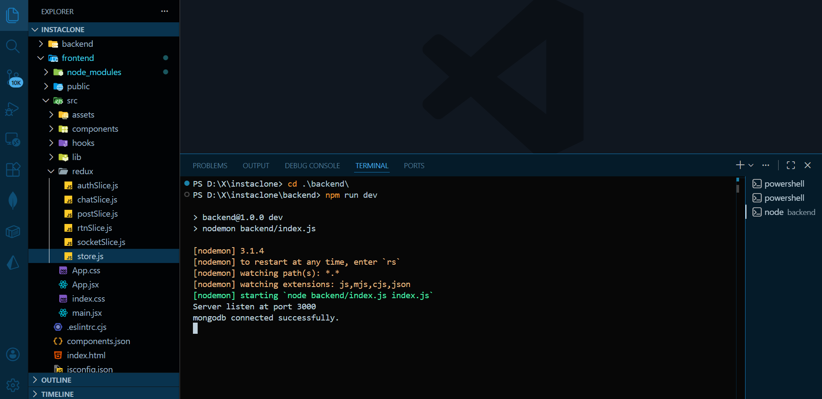

Server Run for Frontend
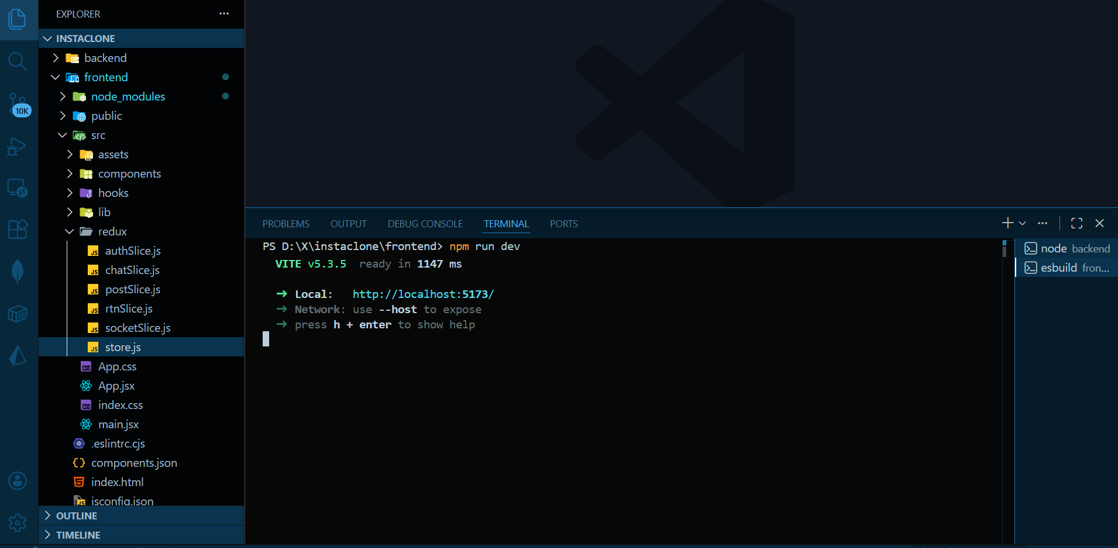

Signup Page UI
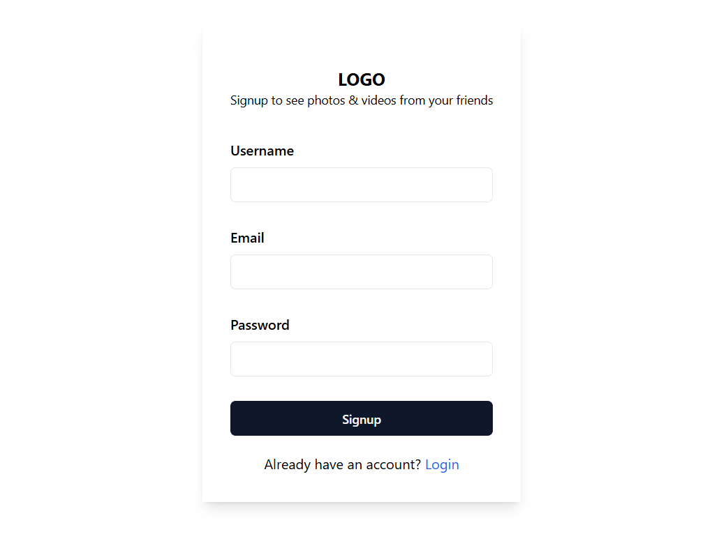
Login Page UI

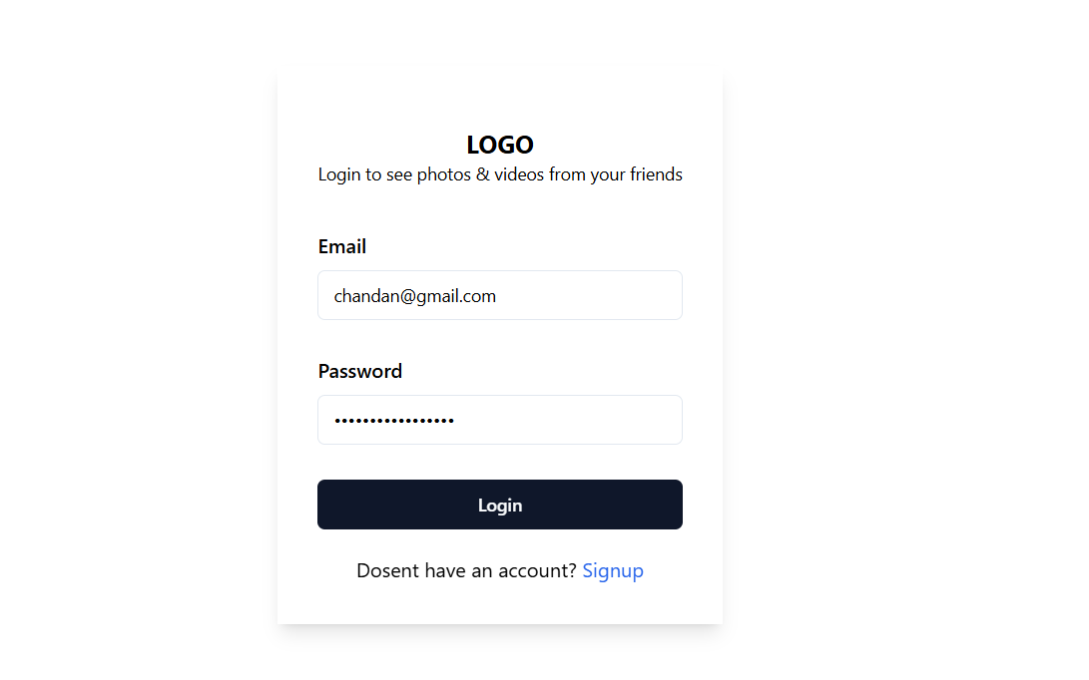

Home Page UI
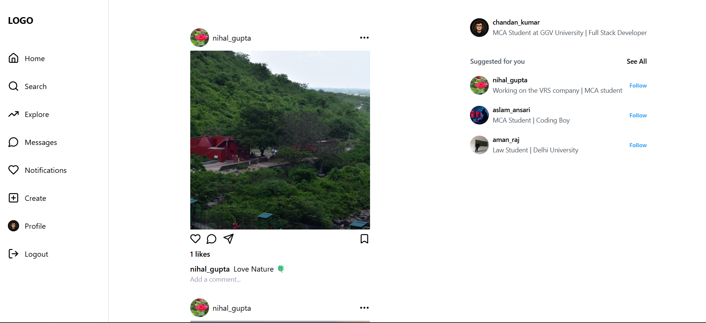
Profile Page UI
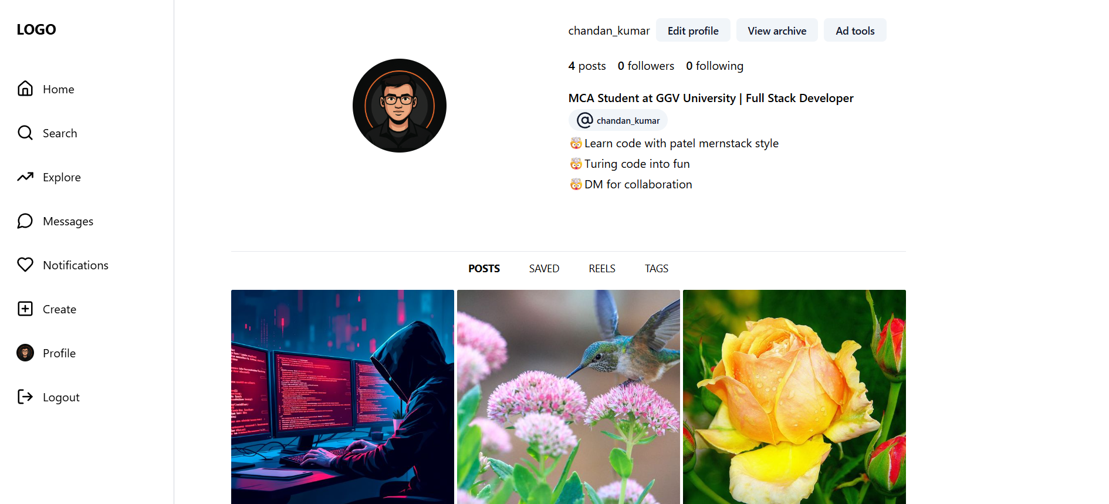
Edit Profil Page UI
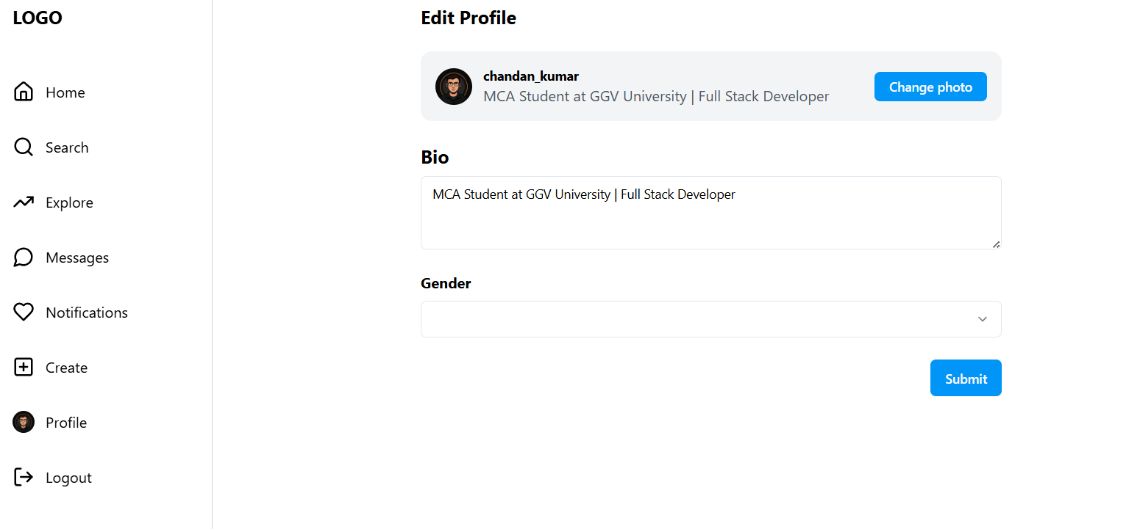
Create Post Page UI
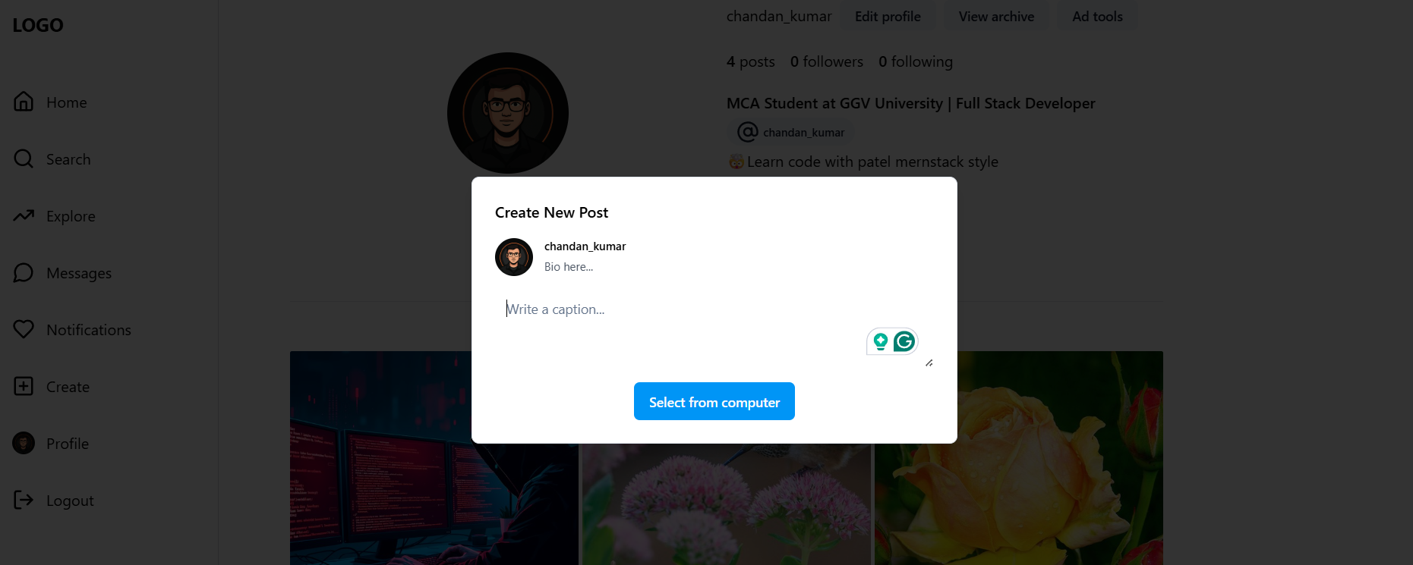

Chat Messages Page UI
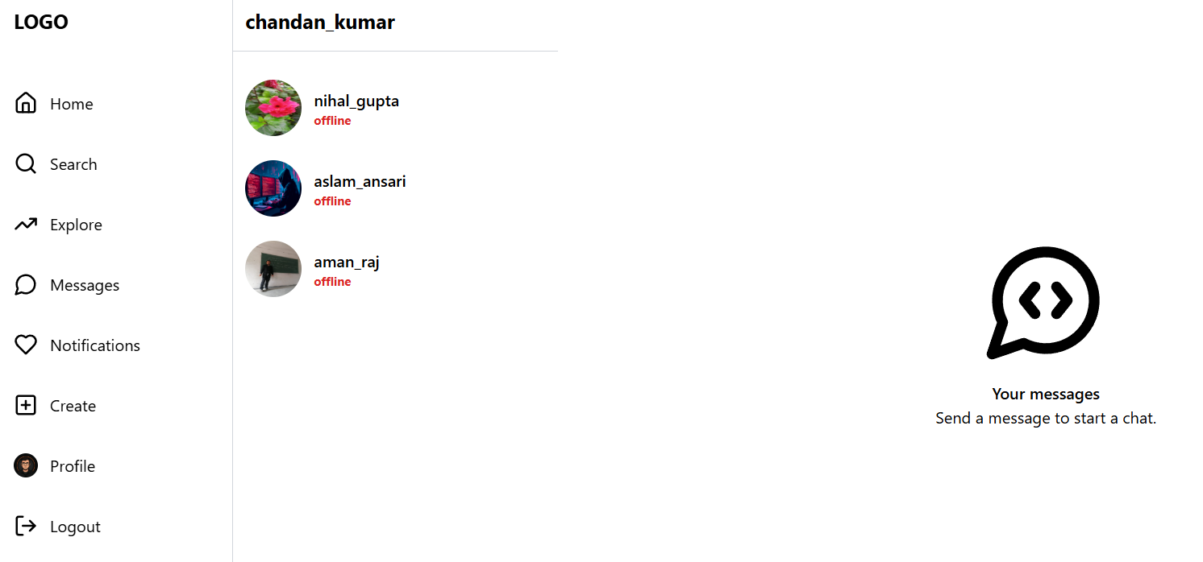

TESTING

Testing is a crucial phase in the software development lifecycle to ensure that the application functions correctly, meets the specified requirements, and delivers a smooth user experience. The Instagram Clone was primarily tested using manual testing techniques to verify the integration between the MERN stack components (Frontend, Backend, Database) and real-time features. Below are the details of the testing process.
1. Testing Methodology
• Manual Testing: This was performed to verify the User Interface (UI) workflow, such as logging in, navigating between the Feed and Profile, and opening modal dialogs.
• Functional Testing: The backend API endpoints (e.g., /api/v1/user/login, /api/v1/post/addpost) were tested to ensure data is correctly stored in MongoDB and images are uploaded to Cloudinary,.
• Real-Time Testing: Multiple browser windows were used to simulate different users to test the bi-directional communication (Chat and Notifications) via Socket.io,.
• Responsiveness Testing: The application was tested on different screen sizes to ensure Tailwind CSS classes adapted correctly for mobile and desktop views.
2. Test Environment
Component | Tools Used
Operating System | Windows 10 / 11
Browsers Tested | Google Chrome, Microsoft Edge
Development Tools | VS Code, Chrome Developer Tools (Console/Network Tab)
Server Environment | Node.js (Localhost:3000)
Database | MongoDB Atlas (Cloud)
3. Test Cases & Results
Test Case | Expected Result | Status
User Registration | User data is saved in MongoDB with a hashed password, and a success message is returned. | Passed
User Login | Server generates a JWT token and stores it in an HTTP-only cookie for session management. | Passed
Create Post (Image Upload) | Image is optimized by sharp, uploaded to Cloudinary, and displayed on the Feed,. | Passed
Like a Post | Like count increases immediately, and a real-time notification is sent to the post owner via Socket.io. | Passed
Real-Time Chat | Message sent from User A appears instantly on User B's screen without refreshing the page,. | Passed
Edit Profile | Bio and Profile Picture update successfully and reflect on the Profile page,. | Passed
Protected Routes | Attempting to access the Home or Chat page without logging in redirects the user to the Login page,. | Passed
Comment System | Comment appears in the dialog box immediately after submission, updating the Redux state. | Passed
Follow/Unfollow | Clicking Follow updates the user's "Following" list and the target's "Followers" count. | Passed
4. Bugs/Issues Found
• Socket Connection Latency: On slower network connections, there was a slight delay in the "Online" status badge appearing for users.
• Image Upload Time: Uploading very high-resolution images took longer than expected before the sharp optimization was tuned.
• Token Expiry: Users were not automatically logged out immediately upon token expiry until a page refresh occurred.

ADVANTAGE & DISADVANTAGE

Advantages
1. Completely Client-Side (No Server Needed) The application performs all operations within the user’s browser, meaning no backend or hosting server is required. This reduces deployment costs and complexity.
2. Fast and Lightweight Since no data is transferred over a network, the application responds in real-time and performs quickly. It is capable of running on low-end systems provided they have a modern browser.
3. User-Friendly Interface Built using Bootstrap, the application features a responsive and clean design that is easy to navigate for both technical and non-technical users.
4. Real-Time Filter Application Filters and effects are applied instantly to the uploaded image using the HTML5 canvas and the CamanJS library.
5. Auto-Save with localStorage The application automatically saves the user's progress to the browser's localStorage, allowing work to resume even after a page refresh and preventing accidental data loss.
6. Cross-Browser Compatibility The app works consistently across major browsers like Chrome, Firefox, and Edge, and is accessible on desktops, laptops, and mobile devices.
7. No Installation Required The tool works entirely in the browser (by opening the HTML file or hosting it), making it ideal for simple tasks or academic demos without software installation.
Disadvantages
1. No Advanced Editing Tools The application lacks advanced features such as cropping, rotating, drawing, or text overlays, supporting only basic filters and effects.
2. Performance Limitations with Large Images Rendering large images on the canvas may cause older browsers to lag or crash, making the tool unsuitable for professional-grade image processing.
3. No Undo/Redo Support There is no functionality to step backward through changes; once a filter is applied, the only option is to use the "Revert" button to reset the image entirely,.
4. No Permanent Cloud Storage Images are saved only temporarily in localStorage, which is wiped if the user clears browser data. There is no external backup or login functionality.
5. Limited Accessibility Features The user interface may not be fully optimized for screen readers or users with disabilities.
FUTURE SCOPE & ENHANCEMENT

1. Advanced Editing Tools (Cropping & Resizing)
Currently, the application allows for filtering but lacks structural editing capabilities. Future versions could include tools to crop, rotate, and flip images
2. Drag-and-Drop Upload
To modernize the user interface and make it more intuitive, the current file input element could be replaced or augmented with a drag-and-drop area. This would allow users to simply drag images from their desktop directly into the browser to begin editing.
3. Undo/Redo Functionality
A critical enhancement for usability is the implementation of a history stack. This would enable "Undo" and "Redo" buttons, allowing users to step backward or forward through their recent actions.
4. Cloud Integration
The project can be expanded to integrate with cloud services like Google Drive or Firebase. This would allow users to save their edited images to the cloud and share them easily, making the application suitable for collaborative work or multi-device usage.
5. AI-Based Filters and Auto-Enhancements
Integrating Artificial Intelligence (AI) or Machine Learning (ML) models would significantly make the app smarter. Future features could include:
• Auto-enhance: Automatically adjusting settings based on image content.
• Smart Suggestions: Suggesting the best filter for a specific photo.
• Advanced Retouching: Features like background removal or portrait retouching.
6. Custom Filter Builder
To empower creative users, the app could include a feature that lets users create their own filter presets.
7. Multi-Language Support
To reach a global audience, the application can be updated with internationalization (i18n) support, allowing the interface to be translated into multiple languages.

CONCLUSION

The development of the Instagram Clone Application has been a comprehensive exercise in Full Stack Web Development, successfully bridging the gap between a dynamic frontend and a robust backend. This project demonstrates the practical implementation of the MERN stack (MongoDB, Express.js, React.js, Node.js) to create a fully functional social media platform that mimics the core capabilities of a real-world application.
Throughout the lifecycle of this project, several advanced web technologies were integrated to ensure performance and scalability. The backend architecture was built using Node.js and Express, featuring secure user authentication via JWT (JSON Web Tokens) and efficient data modeling with Mongoose to handle complex relationships between users, posts, and comments. Furthermore, the integration of Cloudinary enabled seamless image uploading and storage, a critical requirement for a media-centric application.
On the client side, the application utilized React.js to create a highly responsive user interface, styled with Tailwind CSS and ShadCN UI components for a modern aesthetic. The implementation of Redux Toolkit played a vital role in managing global state, ensuring data consistency across features like user authentication profiles, chat history, and real-time notifications.
The project successfully fulfilled its primary objectives, delivering key features such as:
• User Management: Secure signup, login, and profile customization.
• Content Interaction: The ability to create posts, like, comment, and bookmark content.
• Social Connectivity: A functioning follow/unfollow system and suggested user algorithms.
• Real-Time Communication: The integration of Socket.io provided instant messaging capabilities and real-time notifications for likes and interactions, significantly enhancing user engagement.
In summary, this Instagram Clone project not only served as a successful implementation of a complex social platform but also provided invaluable hands-on experience in handling real-time data flow, state management, and secure API development. It stands as a scalable foundation that can be further enhanced with features like video reels, story archives, and advanced content algorithms, showcasing the vast potential of modern web development technologies.

BIBLIOGRAPHY
IMPORTANT LINKS

