
Gym Membership Application Form

KRATOS
Fitness Club

- Please fill out all necessary details including your method of payment and the direct debit mandate, (if applicable). It is important that the medical questionnaire is completed and signed as well as the terms and conditions of the contract.

- The minimum age for members is 16 unless approved by the Gym Manager.

- Concession rates apply to disabled users.

- We will need to take a photo of you at reception to put with your membership details.

IMPORTANT - DATA PROTECTION

Kratos fitness club collects and processes information about gym members. The Data Protection Act 1998 requires Kratos fitness club to obtain your agreement before this can be done. In signing this form you are giving consent for your personal and sensitive information to be processed under the rules and safeguards laid down by the 1998 Act. Kratos fitness club has procedures in place to ensure that all information held about you will be dealt with confidentially, held securely and only processed in accordance with Kratos fitness club’s notification to the Information Commissioner, who administers the Act. Kratos fitness club may wish to contact you for marketing purposes. If you do not wish to be contacted in this way, please tick this box

Thank you for taking time to complete your application carefully and we look forward to welcoming you to our gym.

Personal details

Surname:

First name: Date of birth: 

Address:

Postcode:

Home number: |  |  |  |  |  |  |  | Mobile number:
Email:
Do you declare a disability? |  |  | Yes |  | No
If yes, please specify:

Emergency contact details

Contact name: Home number: 

Relationship: Mobile number: 

OFFICE USE ONLY

Induction date:  Membership type:

Membership Number:  Payment type:

Staff name: Staff signature:


KRATOS
Fitness Club

Membership type

With our 'Anytime' and 'Off Peak' memberships as well as different payment options, we offer a choice that is either most cost effective or more convenient for you.

Anytime membership entitles the member to use the gym at any time during opening hours.

Off Peak membership entitles the member to use the gym from 8.30am - 4pm Monday to Friday and all day on Saturday and Sunday.

All gym members are required to undergo an induction before using the gym.

Please indicate the type of membership you require by ticking the relevant box.

3, 6 or 12 month membership


Type | Anytime | Off Peak
3 months | $60 | $45
6 months | $110 | $80
12 months | $220 | $165
Disability 3 months | $42 | $31.50
Disability 6 months | $77 | $56
Disability 12 months | $154 | $112
Student 3 months | $45
Student 6 months | $80
Student 12 months | $165
Kratos Student (monthly) | $15
Direct debit membership
Type | Anytime | Off Peak
Monthly* | $20 | $15
Disability (monthly)* | $14 | $10.50
Student (monthly)* | $15

*minimum of 6 months membership

KRATOS
Fitness Club
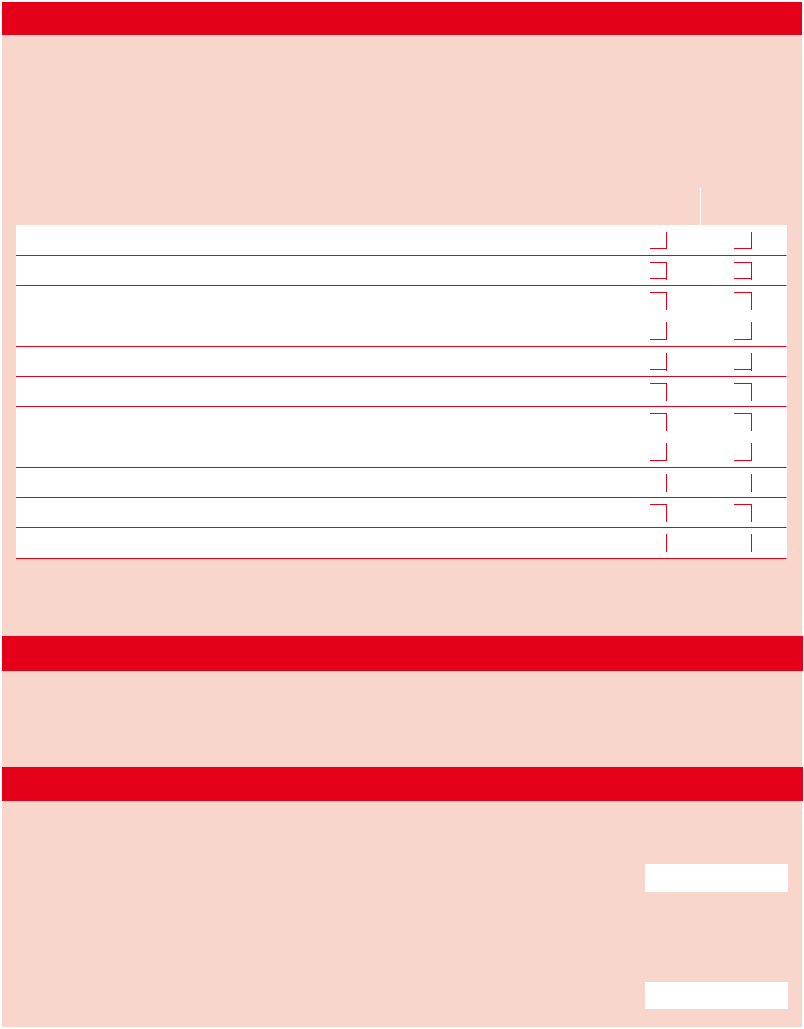

Consent to exercise

- Exercising is an essential part of maintaining a healthy lifestyle. Some people however are unable to participate fully due to illness or other medically restrictive reasons. It is therefore important that the following questions are answered fully and honestly to enable us to ensure that our members can exercise safely.

- Please ensure that you sign the declaration below.

- If you are under 18 a parent or guardian must also sign.

- If you are unable to sign for any other reason, a nominated responsible person may do so on your behalf

Physical Activity Readiness Questionnaire (PARQ) | Yes | No

Have you, for any reason, been unable to exercise in the past?

Has your physician ever advised you against exercising?

Have you ever suffered from any cardiac (heart) related illness?

Have you ever suffered from respiratory difficulties?

Have you ever suffered from fainting, migraines or loss of balance?

Have you ever suffered from any bone, joint or muscle related disease?

Is there any history of heart disease in your family?

Have you experienced chest pain whilst exercising?

Do you have high blood pressure?

Do you have elevated cholesterol levels?

Are you currently taking prescribed medication?

If you answered ‘yes’ to any of the above, please give details below. All information is held in strictest confidence and accessible only by the gym manager and relevant staff.

Your doctor’s details

Doctor’s name: Surgery name: 

Surgery number:  Surgery address:

Declaration of consent to exercise

I confirm that all the answers above are true to the best of my knowledge and I believe I am able to participate in exercise at Kratos fitness club.

Signature: Date: / /

The person making this application is under 18 or unable to sign themselves. Therefore I confirm that I will be taking responsibility for this person’s declaration.

Name: Relationship:
Signature: Date: / /

Terms and conditions

Please read the following carefully and sign the declaration below. If you are under 18 a parent or guardian must also sign. If you are unable to sign for any other reason, a nominated responsible person may do so on your behalf.

- You must ‘swipe in’ at reception using your membership card upon arrival. Without your membership card, you will be unable to use the gym.

- If a card is lost, a replacement will be made on receipt of £2 to cover our administrative costs.

- Off peak members are restricted to the use of the gym facilities between the hours of 8.30am and 4pm, Monday to Friday, and all day on Saturday and Sunday.

- Members who opt for a direct debit membership agree to join for a minimum of 6 months. The first month is payable in advance by cash or credit/debit card. This 6 month period is considered paid for after the 5th payment via direct debit. From then on the membership will roll over on a monthly basis. This will continue until the membership is terminated. Direct debits will be taken on the first Friday of each month.

- To cancel a direct debit membership, members must give one month’s written notice. Prepaid memberships are non-refundable. There is a 7 day cooling off period for new gym members who take out the direct debit option. The first month’s payment is non-refundable. The 7 days starts form the date of induction.

- The gym is for the use of Kratos fitness club only, therefore guests are not allowed.

- During busy periods please limit your time on popular equipment such as the treadmills.

- For reasons of health and safety, members must adhere strictly to the following:

  - All free weights are to be returned to their racks after use.

  - Cups and mugs are not allowed in the gym or studio.

  - Members should bring a small towel to wipe down machinery after use.

  - Tracksuits or shorts and t-shirts must be worn at all times.

  - Suitable footwear should be worn at all times.

  - Offensive language or behaviour will not be tolerated.

  - Clashing weights, excessive noises and mistreatment of equipment will not be tolerated.

- Anyone thought to be under the influence of alcohol or drugs will be ejected and their membership will be reviewed.

- If, for any reason, a direct debit payment fails to credit our account, membership will be suspended until payment resumes or another payment method is used.

- Kratos fitness club management reserve the right to exclude any member they deem not to be adhering to any of the above or who by their actions poses a health and safety risk to others.

Declaration

I confirm that all the answers above are true to the best of my knowledge and I believe I am able to participate in exercise at Kratos fitness club.

Signature: Date: / /

The person making this application is under 18 or unable to sign themselves. Therefore I confirm that I will be taking responsibility for this person’s declaration.

Name: |  |  | Relationship:
Signature: |  |  |  |  | Date:
 |  |  |  |  | Date: | / | /

How did you hear about us?

Friend / family | Website / online search engine
Leaflet | Driving / walking past
Other (please specify):

Kratos fitness club

Kratos Lane

Kuvempunagar

Mysuru

Tel: 0821 078 1697

Website: www.kratosfitnessclub.co.in

Email: fitness.club@kratos.org

