# Background

Soybean is a major oilseed crop produced and consumed worldwide and one of the most economically important crops in the United States, the world’s largest soybean Producer.

The crop is cultivated on an estimated 6% of the world’s arable land.

Soybean is among the five most important food crops in the world. The majority of the world’s soybeans are crushed or processed into soybean oil and meal.

An estimated 2% (= 3 MMT) of the entire global soybean production is consumed by humans as food.

## Economic Impact of soybean diseases

The profitability of soybean production has been negatively impacted by soybean diseases. The economic impacts of 23 common soybean diseases were estimated in 28 soybean-producing states in the U.S., from 1996 to 2016 (the entire data set consisted of 13,524 data points).

The main effects of state, year, pre- and post-discovery of soybean rust, region, and zones based on yield, harvest area, and production, were significant on “total economic loss” as a function of diseases.

Across states and years, the soybean cyst nematode, charcoal rot, and seedling diseases were the most economically damaging diseases while soybean rust, bacterial blight, and southern blight were the least economically damaging. A significantly greater mean loss (51%) was observed in states/years after the discovery of soybean rust (2004 to 2016) compared to the pre-discovery (1996 to 2003).

## Effect in United States

As per the United States Department of Agriculture—National Agricultural Statistics Service (USDA-NASS), the total soybean area planted in the U.S in 2018 was 36 million hectares while the total production was **123 million metric tons**

Soybean production is constantly challenged by various abiotic and biotic factors including unpredictable weather, **diseases**, insect pests, weeds, and variable soil quality.

Among the various biotic constraints, plant diseases are detrimental to soybean production, negatively impacting yield and quality.

* From 1996 to 2016, the total estimated economic loss due to soybean diseases in the U.S. was $95.48 billion, with $80.89 billion and $14.59 billion accounting for the northern and southern U.S.
* Over the entire time period, the average annual economic loss due to soybean diseases in the U.S. reached nearly **$4.55 billion**, with approximately 85% of the losses occurring in the northern U.S.
* The total estimated **metric ton** lost ranged from **10.07 million** in 2012 to **13.94 million** in 2014. The average annual yield losses due to soybean diseases in the U.S. were estimated to be approximately 11% of the total production.

# Analysis

## Principle components analysis (PCA)

**Identification of the most important soybean diseases and categorical predictors using multivariate approaches**

Identification of the most important soybean diseases and categorical predictors using multivariate approaches. The principle components analysis (PCA) revealed that

1. The percent contribution of the **first five principal components** (dimensions) to the total explained variance was 48.23, 12.88, 8.63, 5.62, and 4.28, respectively, explaining approximately 80% of the total variation.
2. **The ten disease variables that contributed most to the first two principle components** were brown stem rot, charcoal rot, Diaporthe-Phomopsis, Fusarium wilt, Phytophthora root and stem rot, Sclerotinia stem rot (white mold), seedling diseases, Septoria brown spot, soybean cyst nematode, and sudden death syndrome.
3. Among these, the **soybean cyst nematode** contributed the most (79%) to the first principle component while the second principle component was predominantly represented by **charcoal rot** (56%).

As revealed via the factor analysis with the mixed data (FAMD) approach, the variables state, region, and harvest zone, respectively contributed the most to the first dimension while year and pre- and post-discovery of soybean rust were the two most contributing factors to the second dimension (Table 2). Although the data points (a data point = total economic loss associated with all disease in a particular year for a given state) did not show a clear clustering pattern based on state, a clear separation was observed with year, where eight years (from 1996 to 2003) were clustered together while the remaining years (from 2004 to 2016) formed a separate cluster (Fig 1A and 1B). Similarly, data points were clearly clustered based upon the region (south and north) as well as the pre- and post-discovery of soybean rust.

## Analysis of variance (ANOVA) and correlation analysis

The main effects of year, region, state, pre- and post-discovery of soybean rust, yield zone, harvest zone, and production zone were significant on the total economic losses due to all diseases.

With respect to the year, the greatest mean losses were observed in 2012 while the lowest were in 2005, a 245% increase between the two years.

The mean loss in 2012 was significantly greater compared to mean losses in 1999, 2000, 2001, and 2005. Mean losses associated with the rest of the years were not significantly different from each other.

**Wisconsin** had the greatest mean losses while the lowest were recorded in **Maryland**. About **$350 dollar per hector**. The losses in Wisconsin were 11.8 times greater than the losses observed in Maryland.

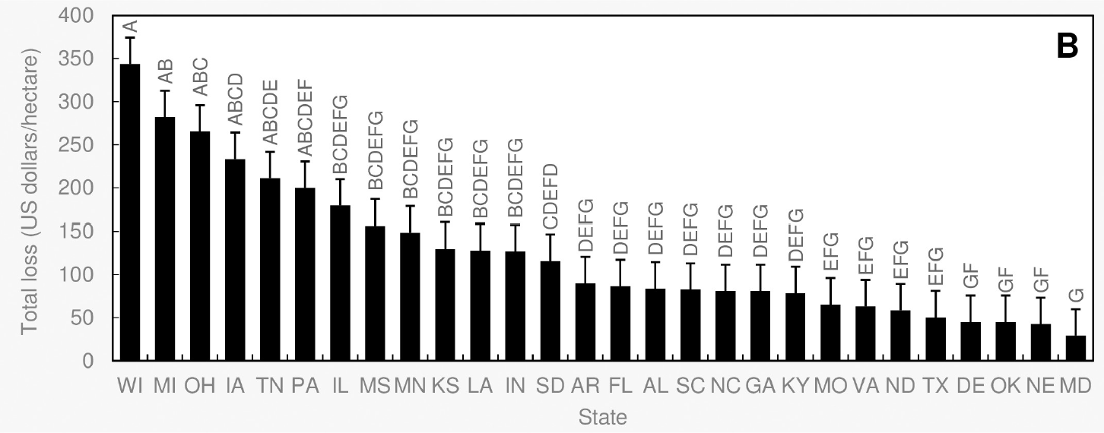

Comparing the two regions across all years, the northern losses were significantly greater in comparison to the south. As a percentage, the north reported a 106% greater loss compared to south.

# Application of the solution

## Factors for fungicide application

There are three factors you should consider when assessing the crop in-season for a fungicide application:

* What were the conditions of that field last season? What diseases may have been present the last time that crop species was grown there?
* High disease pressure can carry over from one growing season to the next in the form of soil or residues pathogens.
* How does that crop look this season?
* Thick plant stands are more prone to locking disease in the canopies. Fungicides help the plant survive disease pressure and can help lock in the yield potential, protecting it against yield robbers.
* What is the economic value of the crop?
* Disease result in billions of dollars in economic losses and management inputs each year.

## Conclusion

Mid-June to mid-July is the ideal window for assessing disease and spraying a fungicide to protect your crop. The disease triangle can be an excellent tool for helping to make most of your fungicide decision ahead of time and it’s a tool I use very often with farmers.

If you do end up needing to spray, by using this tool you’ll be ready to hit the crop at the appropriate, most effective time. If you think there might even be a chance that you’ll need a fungicide, pencil it into your plan. Talk to your rep about whether the present conditions might be an issue for disease. There’s no harm in being proactive.