Running Sample Flink Application:

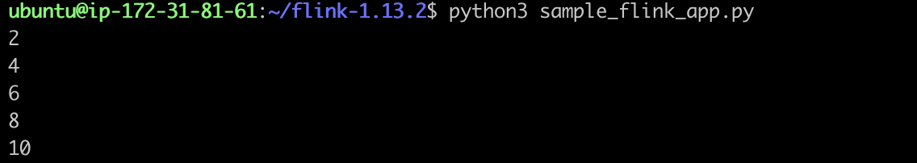

Running Producer and Consumer Together:

