# **Design**

## **High Level Design**

**Architecture Design**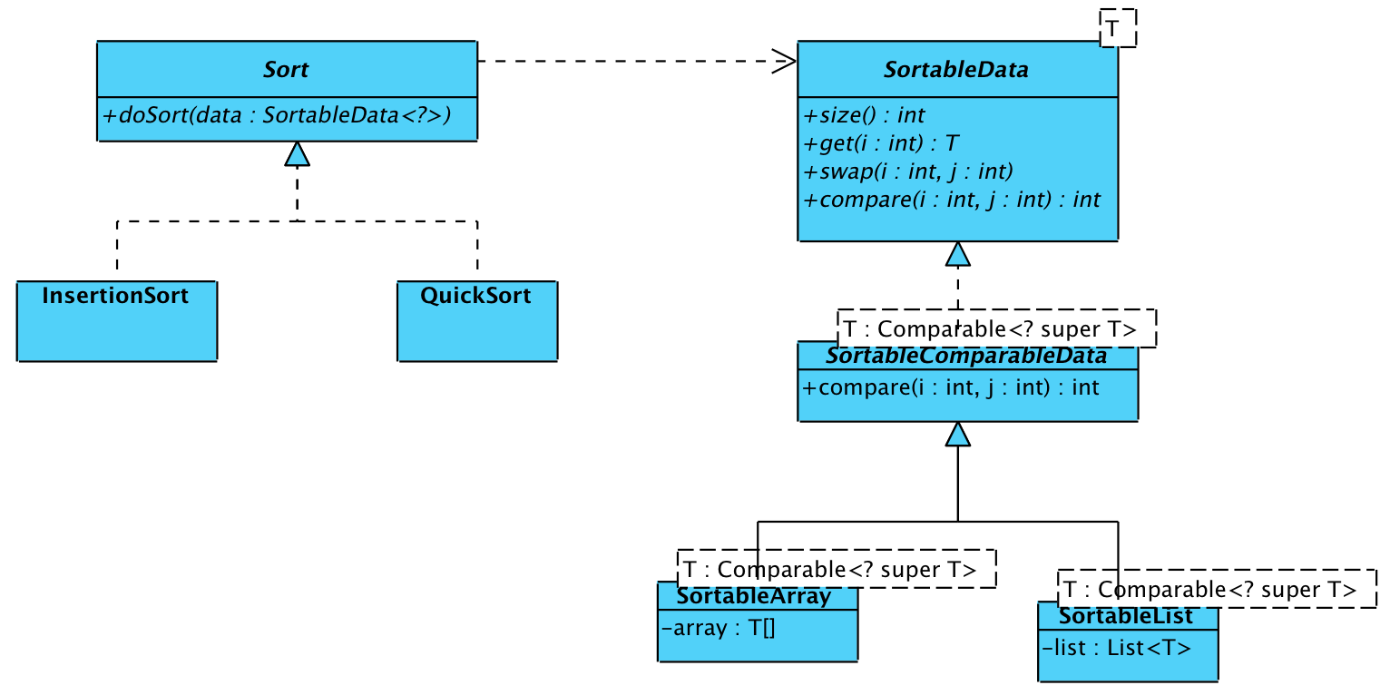

#### **Bubble Sort :**

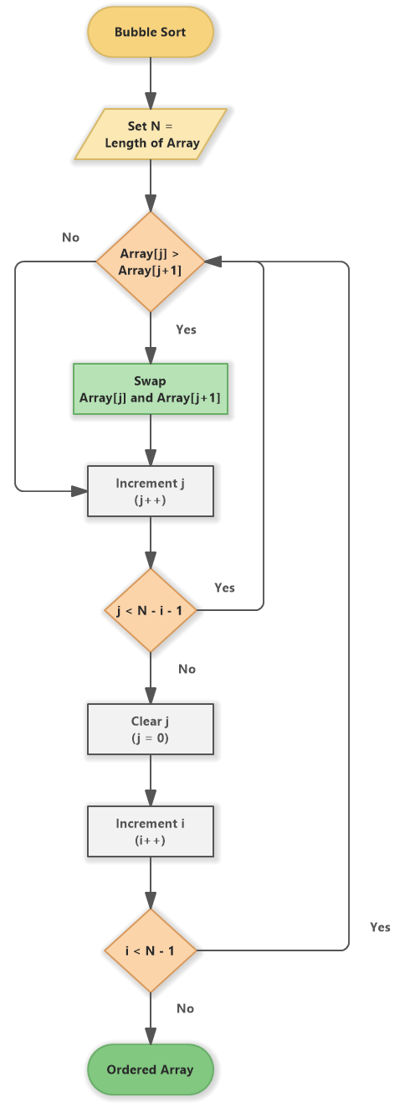

#### **Insertion Sort :**

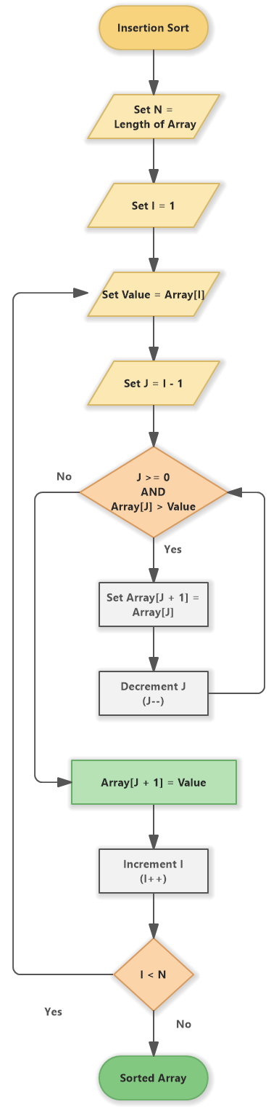

#### **Quick Sort :**

#### **Merge Sort :**

